Steps to calculate n and sigma using calculation
- STEP 1: To find power at different distance using below formula
$$P_{r}\left(d_{i}\right)=P_{r}\left(d_{0}\right)-10n\log_{10}\left(\frac{d_{i}}{d_{0}}\right)$$

Where, i = 1 to 20 (for our experiment)

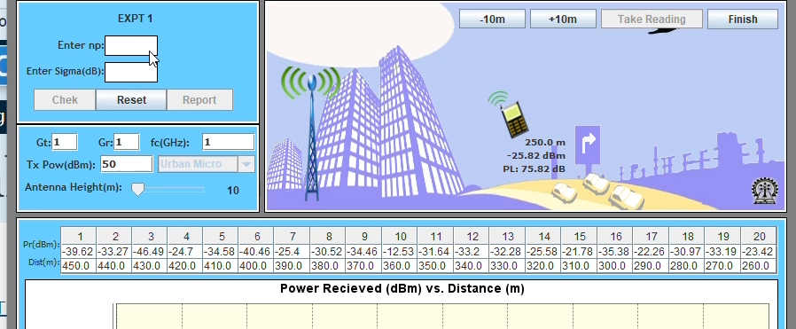
$d_{i}$ = distance
$P_{r}\left(d_{i}\right)=$ power at distance di
$P_{r}\left(d_{0}\right)=0\text{ dBm}$ at $d_{0}=100\text{ m}$ (assumption for our experiment)
So we will have $P_{r}\left(d_{1}\right)$ to $P_{r}\left(d_{20}\right)$ in terms of n
$P_{r}\left(d_{1}\right)=0-10n\log_{10}\left(\frac{d_{1}}{100}\right)=-10n\log_{10}\left(\frac{450}{100}\right)= -6.53212n$
$P_{r}\left(d_{2}\right)=0-10n\log_{10}\left(\frac{d_{2}}{100}\right)=-6.43453n$
$P_{r}\left(d_{3}\right)=0-10n\log_{10}\left(\frac{d_{3}}{100}\right)=-6.33468n$
$P_{r}\left(d_{4}\right)=0-10n\log_{10}\left(\frac{d_{4}}{100}\right)=-6.23249n$
$P_{r}\left(d_{5}\right)=0-10n\log_{10}\left(\frac{d_{5}}{100}\right)=-6.12784n$
$P_{r}\left(d_{6}\right)=0-10n\log_{10}\left(\frac{d_{6}}{100}\right)=-6.02060n$
Here d₁ to d₆ is from experiment
- Now calculate Minimum mean square error (MMSE) and n
MMSE is J(n)
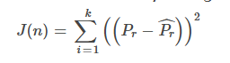
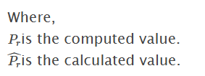
computed value is from experiment
calculated is from above step 1.
Here $J\left(n\right)$ is calculated$\begin{aligned}J\left(n\right)=&{\left(-39.62+6.53213n\right)}^{2} \\ (1569.744-258.79n+42.667n^{2}) \\ +{\left(-33.27+6.43453n\right)}^{2} \\ (1106.893-214.0592n+41.396n^{2}) \\ +{\left(-46.49+6.33468n\right)}^{2} \\ (2161.3201-294.2817n+40.1322n^{2}) \\ +{\left(-24.70+6.23249n\right)}^{2} \\ (610.09-153.94n+38.8439n^{2}) \\ +{\left(-34.58+6.12784n\right)}^{2} \\ (1195.7764-211.900n+37.550n^{2}) \\ +{\left(-40.46+6.02060n\right)}^{2} \\ (1637.0116-243.5934n+36.2476n^{2}) \\ & \\ & \\ & \\ & \\ & \\ & \\ & \\ & \\ & \\ & \\ & \\ & \\ & \\ &\end{aligned}$
Use the below formula on each square
$${\left(a+bn\right)}^{2}=a^{2}+2abn+b^{2}n^{2}$$
so we get finally $J\left(n\right)$ as
$$J\left(n\right)=236.8367n^{2}-1,376.5643n+8,280.8351$$ Differentiate with respect to n:
$$\frac{dJ\left(n\right)}{dn}=2\left(236.8367\right)n-1,376.5643 \\ \frac{dJ\left(n\right)}{dn}=473.6734n-1,376.5643 \\ \boxed{\frac{dJ\left(n\right)}{dn}=0}$$
$$473.6734n-1,376.5643=0 \\ n=\frac{1,376.5643}{473.6734} \\ n=2.9061$$
Now $J\left(n\right)$ is
$$J\left(n\right)=236.8367n^{2}-1,376.5643n+8,280.8351$$
$$J\left(5.59245\right)=6,280.5863$$
- Now find sigma using below formula
$$σ^{2}=\frac{J\left(n\right)}{N} \\ N= \\ σ^{2}=\frac{6,280.5863}{6} \\ σ^{2}=1,046.7643{\text{ dB}}^{2} \\ σ=\sqrt{1,046.7643} \\ σ=32.35\text{dB}$$( Note : - In exam, only 6 readings are enough for path loss fading. so, we will have i = 1 to 6.
N = 6. Rest Entire procedure remains the same. This all above calculation we have to do on paper with calculator)

https://chatgpt.com/s/t_6ae8ee4745d881918d32939d72ce25b6
Frequency reuse
Just use this formula to verify value of N
$N=i^{2}+ij+j^{2}$
for us i=2 and j=1 . therefore $N=2^{2}+2X1+1^{2}$=7

