Introduction 2
I. Building a Basic Model in Parallel MOOSE 2
Enhancement of Basic MOOSE Model 2
II. Multi-Neuron Simulation 4
Use of Parallel Flag 5
Root node parser 5
Moose Command Distribution 6
Root Node 6
Non-Root Node 6
Inter Neuron Communication 8
SynChan & SpikeGen 8
MPI in SpikeGen and SynChan: 9
Planarconnect 9
Approaches tried for simulation 12
Decreasing the Fan – out and Fan - in of neurons 12
Moose Visualization 12
List of files Changed for Multiple neuron simulation 13
New Added Files 13
Modified Files 13
III. Commands added for Parallel model 14
Appendix 15
A. parallel_squid.g Script File 15
B. Script File Execution : 25
C. MOOSE Commands 27
D. Moose Classes: 44

Introduction

This document explains the parallelized Multi-neuron simulation in Moose.

I. Building a Basic Model in Parallel MOOSE

The most basic model of MOOSE can be considered as single neuron with only one compartment.
Intuitively, the first modification is done by increasing the number of compartments. Once a relatively more complex neuron is built, one would then try to model multiple such neurons and their collective in the form of a neuronal network. Additon of SpikeGen and SynChan to these neurons would then help emulate synapses. The entire simulation would then be run as a parallelized application. As of date, such parallel models run fine with a network of a few thousand neurons.
Neurons communicate (sending and receiving spikes) using “SynChan” and “SpikeGen” objects. SynChan and SpikeGen creation and the creation of messages between them is specified in terms of commands in a Script file. Further detail on commands is provided in part III of this document.

Enhancement of Basic MOOSE Model

Enhancements to a basic single-compartment model could include:

- Multiple compartments per neuron attached serially.
- HH channels (Na and K channels) attached to all/ some of the compartments of each neurons.
- Multiple neurons and each neuron having one or more than one compartments with/ without HH channels attached.
- All the neurons connected to each other by Synapse.
- Connections do not necessarily have to be all-to-all; synapses could also be randomly setup among neurons.

Setting up a synapse between a pair of neurons

- SynChan attached to the 1st compartment of the neuron to receive the spike (voltage tick ) value from the other neuron.
- SpikeGen attached to the last compartment of the neuron to send the spike (voltage tick) value to the other neuron's SynChan.

Changes specified above for the enhancement would be done in the script (input) file.

Some of the functions / messages which need to added for these changes are:

- link_compartment function for linking one compartment to another compartment of a neuron. This will basically link the compartments by sending axial resistance as the message between the 2 compartments. This is done by adding the command that will add the messages between the 2 compartments.
addmsg {path1}/raxial {path2}/axial

- make_channel – For making the HH Channels. For adding the alpha and beta values for the voltage calculation of HH channels, this function needs to called while creating the compartment (from make_compartment if we want to attach the HH channel to the compartment).
e.g. create HHChannel {path}/Na
setfield {path}/Na/xGate/A xmin {VMIN}

- Functions that would calculate the alpha and beta values of the HH channels (Na and K channels) .

e.g. calc_Na_m_A – This function will calculate the alpha value on the basis of mathematical formula of the Na channel for m gate.

There would be similar functions like this for calculating the alpha and beta values of all the gates ( 2 for Na – m and h gate, 1 for K – n gate). There are in all a total of 6 functions for calculation of alpha and beta values both Na and K channels.

- make_neuron – This function will make a neuron with multiple compartments by calling make_compartment function in a loop.

make_neuron /neuron

- Creation of SpikeGen and SynChan objects

e.g. create ParSpikeGen /channel/spkgn

create ParSynChan /channel/syncn

- Attaching SpikeGen and SynChan objects to the compartments of the neurons needs to be done by adding the messages as

e.g. addmsg {path}/c{N_COMPARTMENT}/VmSrc /channel/spkgn/Vm

addmsg /channel/syncn/IkSrc {path}/c1/injectMsg

Last compartment of the neuron's Vm is attached to the SpikGen's Vm field, which will send the Vm value as the message from the last compartment of the neuron to the SpikeGen object.

SynChan object's Ik (current) field is attached to the 1st compartment (c1) of the injectMsg field, which will send the Ik value of the SynChan object (coming from the SpikeGen object) to the 1st compartment of the neuron. The message sent is the current value from SynChan to compartment.

- Random connection between neurons can be done by calling the planarconnect command in the script file that will give the random connections between the neurons (between the spikegen and synchan objects)

planarconnect /channel/spkgn /channel/syncn

- Each neuron with synapse needs to be attached with the weight and delay.

planardelay /channel/syncn 0.005

planarweight /channel/syncn 1

- Attaching clocks to HH-channel, SpikeGen and SynChan objects:

useclock {path}/##[TYPE=HHChannel] 0
useclock /channel/spkgn 0

useclock /channel/syncn 0

useclock command will attach the particular clock with the objects. Like Clock 0 is attached to all the objects of HHChannel, spikgen and synchan channels.

- Constants needs to be added for the synapse.
e.g. Gk, Ek, tau values

II. Multi-Neuron Simulation

Multi-neuron simulation in moose involves a huge network of interconnected neurons. Every neuron is connected to zero or large number of neurons in the network.

Some chemical reactions occur in every neuron. Depending on these chemical reactions each neuron sends out a electrical spike within its compartment and to all other connected neurons via synapse.

A neuron receives spikes from other connected neurons. Such incoming spikes contribute to the chemical reactions happening inside the neuron and in turn lead to change in membrane potential of the neuron.

A multi-neuron simulation in moose tries to simulate the above case in which each neuron is connected to zero or large number of other neurons. This simulation requires parallelization to run the moose neuro simulator on a cluster. The following explain the implementation of these parallelization efforts.

Multi-neuron simulation in parallel moose is implemented as one neuron per process (processor / core). Thus every process executes a single neuron simulation.
Action potential in one neuron leads to a spike being sent to other neurons through synapses. While modeling this simulation for multiple processes, synaptic transmission is implemented through MPI function calls.

Real time visualization support is added to Moose to show the real time simulation output of neurons in terms of graphs by plotting the voltage values of the neurons vs the time step of the simulation. This is implemented by the help of gnuplot utility.

Use of Parallel Flag

Moose can be compiled either in parallel or serial mode. If the parallelization flag is turned off then Moose works in serial mode with no dependency on MPI.
If the parallelization flag is turned on then all the parallelization related code is included. The generated Moose executable now needs to be run with MPI library.
Parallelization thus can be made optional.

Root node parser

Moose parser parses the input script file and creates moose objects. In parallelized moose the parser on the root node reads and parses the input script file. This parser then sends each command to all other processes (broadcast to all the processes using MPI_BCAST). This ensures creating Moose objects on different processes.

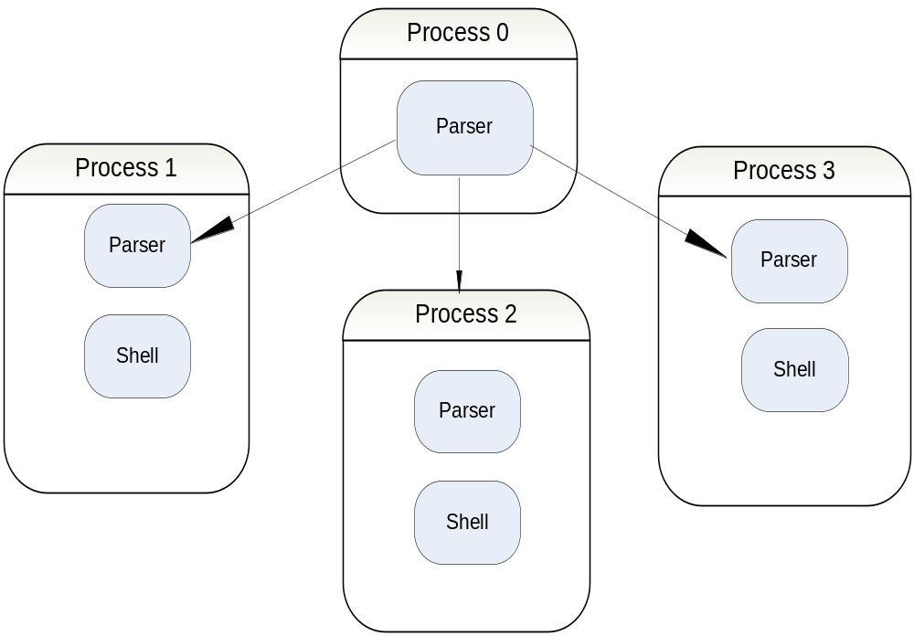

Moose Command Distribution

Root Node

The parser on the root process of parallel moose parses the input script file and sends out commands to the shell of non-root processes.
The parser sends every command to all non-root processes by default through MPI broadcast (MPI_BCAST).

Non-Root Node

The parser on the non root process of parallel moose parses the input script file for respective process according to “setrank” command and sends out these commands to the shell of respective non-root processes.

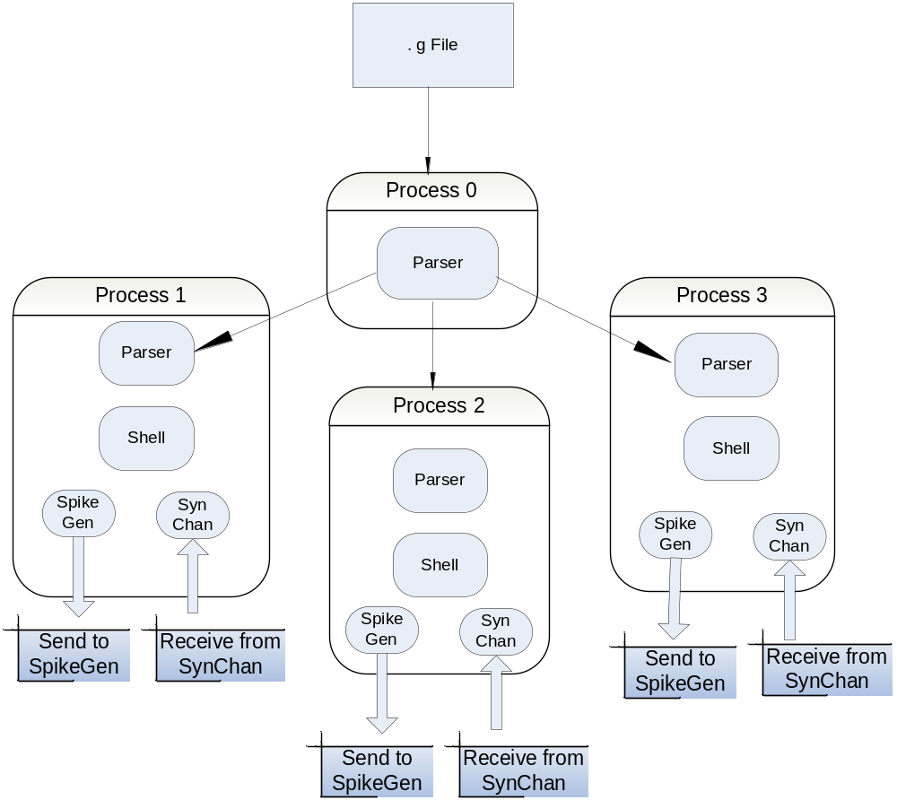

Setrank

The “setrank” command is used to set the target process rank while sending a command.
e.g. If a “setrank 1” command is executed all subsequent commands are sent only to the process with rank 1 until next “setrank 0” command is found in script file. When a “setrank 0” command is executed all commands that follow, in the script file, are executed at root process as well as all non root processes.

All objects related to a single neuron are created by a single non-root process. The “setrank” command is used to direct the neuron creation to a single process.

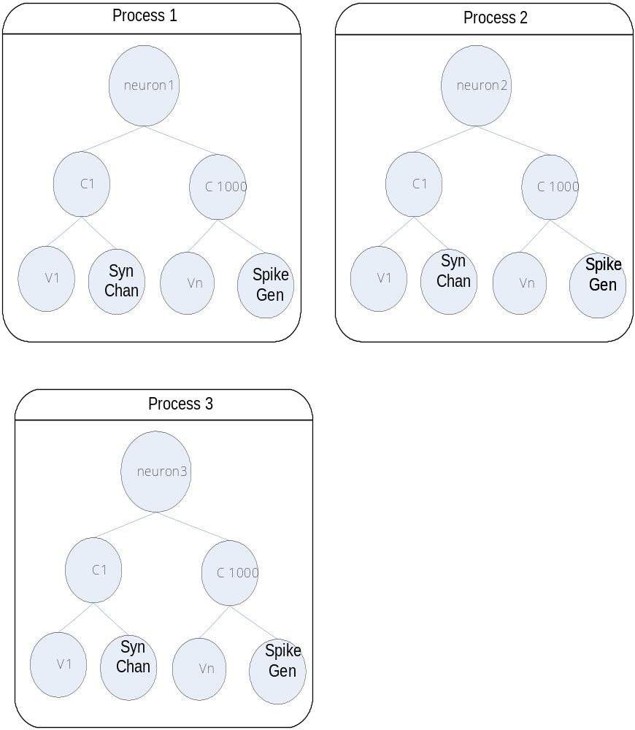

Inter Neuron Communication

Neurons communicate using “SynChan” object for receiving and “SpikeGen” object for sending out spikes values.

SynChan & SpikeGen

For each Neuron SynChan & SpikeGen objects are created.
SynChan and SpikeGen creation and the creation of messages between them is specified in the Script file.

A neuron sends out a voltage spike (tick value) to other neuron(s) using a “SpikeGen” object and the receiving neuron accepts a voltage spike (tick value) from other neuron(s) using a “SynChan” object. Refer to the following diagram for the objects related to one neuron.

Each neuron is created on a separate process. The parser of the root node ensures that each non-root process creates exactly one neuron.

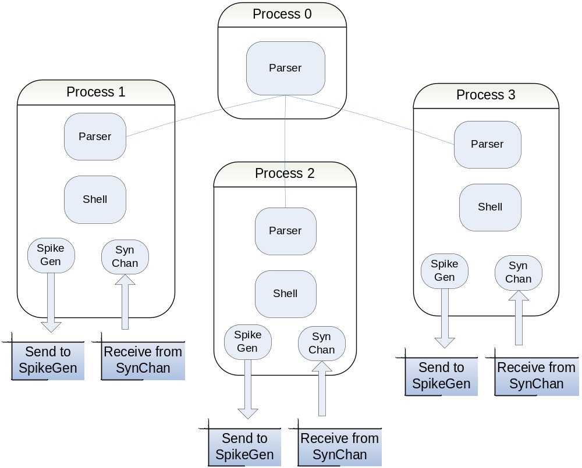

MPI in SpikeGen and SynChan:

Communication between neurons is done at Synapse (consists of pre – synaptic and post – synaptic terminals), where the sending neuron sends the spike to the synapse and receiving neuron takes the spike value from the synapse. For modeling this Synapse on multiprocess parallel computing architecture we have SpikeGen and SynChan classes which will act as a pre - synaptic and post – synaptic terminals of Synapse and those classes send and receive messages (spike or tick value) by the MPI calls.

At SpikeGen:

SpikeGen gets the voltage value of the last compartment of the neuron and sends the tick value on the basis of voltage and current time (voltage is greater than threshold and current time >= last spike + refract Time). If the condition is satisfied then the current tick value is sent to the other connected neurons through MPI_Isend as this is the non blocking send to the other processes (SynChan objects will get the data at other end) in a loop one by one to whom ever it wants to send.

At SynChan:

SynChan will do the non blocking receive. When the tick value (spike) is send from SpikeGen the SynChan will do the MPI_Irecv for the non blocking receive from SpikeGen ( MPI_Isend). The data (tick value and the delay) of each MPI_Irecv would be added up in the priority queue of the SynChan on the basis of the tick value and the delay associated with the neuron. There is a existing logic in the SynChan class for popping the queue on the basis of its expiry time and delay.

Planarconnect

The “planarconnect” command is used to decide inter neuron connections randomly.
The command has source path & destination path as its arguments. This command is handled as a special case in parallel moose.

Planarconnect srcPath destPath

On encountering this command the parser on the root process generates a list of connections randomly.

It calls the random function to decide the number of connections which a particular neuron would have to connect to other neurons. On the number of connections (which are generated randomly for each neuron) the random function is again called that will give the list of random numbers corresponding to the processes (less than max number of processes) to which the particular neuron would connect.

The parser of the root process sends to the shell of each non-root process, the “planarconnect” command with the following additional arguments:

- list of ranks it will receive spikes from
- list of ranks it will send spikes to

The “SpikeGen” object sends out a spike by executing a “MPI_Isend” (non blocking) to the list of ranks it is supplied with. Similarly the “SynChan” object receives a spike by executing a non blocking “MPI_Irecv” on every scheduler tick.

E.g. Following table gives random connections generated between SynChan & SpikeGen of different Neurons. This information will be generated by Planarconnect command.

Neuron | SynChan | SpikeGen
1 | 2,3 | 4,5
2 | 3,5 | 1
3 | 4 | 1,2
4 | 1 | 3
5 | 1 | 2

planarconnect command for these Neurons are :

Neuron 1 : Planarconnect srcPath destPath 2,3 4,5

Neuron 2 : Planarconnect srcPath destPath 3,5 1

Neuron 3 : Planarconnect srcPath destPath 4 2

Neuron 4 : Planarconnect srcPath destPath 1 3

Neuron 5 : Planarconnect srcPath destPath 1 2

Following diagram shows random connections for SynChan & SpikeGen by referring
to previous table.

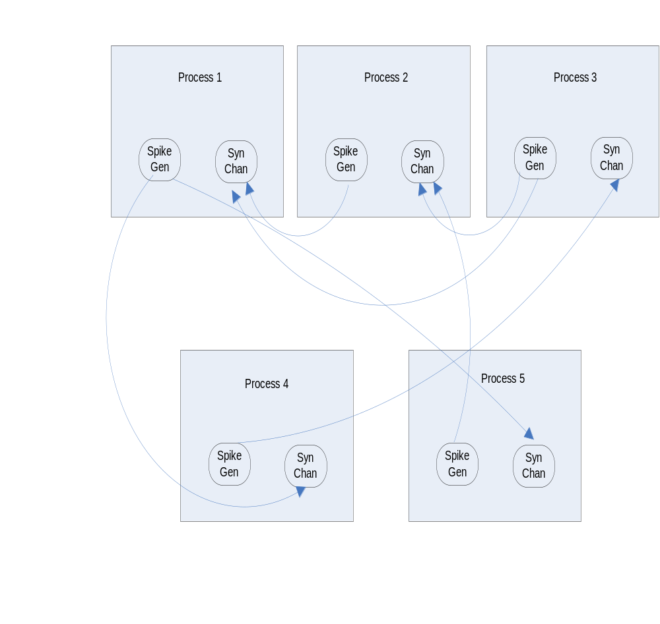

Approaches tried for simulation

Decreasing the Fan – out and Fan - in of neurons

Random number generator decides the connectivity between the neurons on the basis of maximum number of connections a particular neuron can have. For each neuron the random function is called that will give the random number (connection value) starting from 0 to Max number of process (as max number of processes is equal to max number of neurons considering one neuron per process). On the basis of that random number generated called as connection, again random function is called that will give the list of random numbers, the number of random numbers generated is equal to connection to which a particular neuron would connect.

E.g. Neuron 1 on process 1 having maximum 5 neurons and 6 process ( including 1 root process on which neuron would not be created).
Lets say Random function first gives 4 as the connection value for neuron 1.
Again on connection (random number = 4) random function would be called that give list of 4 number like 2,3,4,5 i.e. Neuron 1 would connect to Neuron 2, neuron 3, neuron 4 and neuron 5 and its connection size is 4.
Similarly this would happen for all the neuron from 2 to 5.

This is simplest case when maximum number of neurons is just 5 and their connection would not be any how more than 4. So in worst case the maximum number of connections between all the 5 neurons would be 4*4*4*4*4 (4^4) = 1024.
When number of neurons increases, the fanout and fan-in issue can occur (maximum number of connections neuron can have) which in turn would result in network congestions.

Consider a case when we have 10000 neuron and all the neurons talk to each other that means the maximum number of connections between the neurons in worst case would be 10000^10000. But this would lead to congestion and simulation will never end. Even in case when we will take the average no of connections of the neurons it would be having 10000 * 10000 connections.

So for running a large simulation of a few thousand neurons, we could reduce the maximum fan-out possible to a lower value – this would give us sub all-to-all connectivity, but would also help simulate a large network faster.

Moose Visualization

Real time visualization is implemented in parallel Moose. A non-root process sends out the generated data (voltage values) to the root process.
The root process maintains a list of recent entries till a specific limit.

The root process displays the plot of voltage / time using the “gnuplot” utility. This graph is updated each time the selected non-root process sends out data to the root process.

The real time visualization can started with the “show Neuron-number:index” command, where Neuron-number is the rank of the process containing the neuron and index is the index value of the table object associated.

List of files Changed for Multiple neuron simulation

New Added Files

- /biophysics/ ParSpikeGen.cpp
- /biophysics/ ParSpikeGen.h
- /biophysics/ ParSynChan.cpp
- /biophysics/ ParSynChan.h
- /builtins/ ParInterpol.cpp
- /builtins/ ParInterpol.h
- /genesis_parser/ ParGenesisParser.cpp
- /genesis_parser/ ParGenesisParser.h
- /scheduling/ ParTick.cpp
- /scheduling/ ParTick.h
- /shell/ ParShell.cpp
- /shell/ ParShell.h

Modified Files

- /biophysics/ Makefile
- /builtins/ Makefile
- /genesis_parser/ GenesisParserWrapper.cpp
- /genesis_parser/ Makefile
- /maindir/main.cpp
- /scheduling/ Tick.cpp
- /scheduling/ Makefile
- /shell/ Makefile
- Makefile

III. Commands added for Parallel model

1 | setrank | do_setrank  (GenesisParserWrapper.cpp) | NA | The “setrank” command is used to set the target process rank while sending a command. | /moose/genesis_parser/GenesisParserWrapper.cpp | Setrank  < process number >  e.g. Setrank1
2 | planarconnect | do_planarconnect  (GenesisParserWrapper.cpp) | planarconnect  (shell/shell.cpp) | The “planarconnect” command is used to decide inter neuron connections randomly.  The command has source path & destination path as its arguments. This command is handled as a special case in parallel moose. | moose/genesis_parser/GenesisParserWrapper.cpp | Planarconnect  srcPath destPath
3 | planardelay | do_planardelay  (GenesisParserWrapper.cpp) | Planardelay  (shell/shell.cpp) | This command adds delay to the source element. | moose/genesis_parser/GenesisParserWrapper.cpp | planardelay <srcelements> <delay>
4 | planarweight | do_planarweight | Planarweight  (shell/shell.cpp) | This command adds weight to the source element. | moose/genesis_parser/GenesisParserWrapper.cpp | planarweight <srcelements> <weight>

Appendix

A. parallel_squid.g Script File

//moose

// This is an almost perfect match to the old GENESIS squid model

// output with default parameter values. It simulates, as the Squid

// demo does, a stimulus of 0.1 uA starting at time 5 msec and

// lasting for 40 msec. There is a final 5 msec after the stimulus.

// Most of this file is setting up the parameters and the HH tables.

// Later I'll implement and extended version of the HHGate that knows

// the funny X_alpha and other terms that the GENESIS version uses.

float VMIN = -0.1

float VMAX = 0.05

int NDIVS = 150

float v = VMIN

float dv = ( VMAX - VMIN ) / NDIVS

float SIMDT = 1e-5

float PLOTDT = 1e-4

float RUNTIME = 0.5

float EREST = -0.07

float VLEAK = EREST + 0.010613

float VK = EREST -0.012

float VNa = EREST + 0.115

float GLEAK = 0.3e-3

float GK = 36e-3

float GNa = 120e-3

int N_COMPARTMENT = 10

float CABLE_LENGTH = 1e-3

float DIAMETER = 1e-6

float LENGTH = {CABLE_LENGTH} / {N_COMPARTMENT}

float INJECT = 0.1e-6

int iNeuronIndex

/*float RM = 424.4e3 Original squid values

float RA = 7639.44e3

float CM = 0.007854e-6*/

float RA = 1.0

float RM = 4.0

float CM = 0.01

GK = 0.282743e-3

GNa = 0.94248e-3

function calc_Na_m_A( v )

float v

if ( { abs { {EREST} + 0.025 - v } } < 1e-6 )

v = v + 1e-6

end

return { ( 0.1e6 * ( {EREST} + 0.025 - v ) ) / ( { exp { ( {EREST} + 0.025 - v )/ 0.01 } } - 1.0 ) }

end

function calc_Na_m_B( v )

float v

return { 4.0e3 * { exp { ( {EREST} - v ) / 0.018 } } }

end

function calc_Na_h_A( v )

float v

return { 70.0 * { exp { ( {EREST} - v ) / 0.020 } } }

end

function calc_Na_h_B( v )

float v

return { 1.0e3 / ( { exp { ( 0.030 + {EREST} - v )/ 0.01 } } + 1.0 ) }

end

function calc_K_n_A( v )

float v

if ( { abs { 0.01 + {EREST} - v } } < 1e-6 )

v = v + 1e-6

end

return { ( 1.0e4 * ( 0.01 + {EREST} - v ) ) / ( { exp { ( 0.01 + {EREST} - v )/ 0.01 } } - 1.0 ) }

end

function calc_K_n_B( v )

float v

return { 0.125e3 * { exp { ({EREST} - v ) / 0.08 } } }

end

function make_channel (path)

str path

int iIndex

create HHChannel {path}/Na

setfield {path}/Na Ek {VNa}

setfield {path}/Na Gbar {GNa}

setfield {path}/Na Xpower 3

setfield {path}/Na Ypower 1

create HHChannel {path}/K

setfield {path}/K Ek {VK}

setfield {path}/K Gbar {GK}

setfield {path}/K Xpower 4

addmsg {path}/channel {path}/Na/channel

addmsg {path}/channel {path}/K/channel

setfield {path}/Na/xGate/A xmin {VMIN}

setfield {path}/Na/xGate/B xmin {VMIN}

setfield {path}/Na/yGate/A xmin {VMIN}

setfield {path}/Na/yGate/B xmin {VMIN}

setfield {path}/K/xGate/A xmin {VMIN}

setfield {path}/K/xGate/B xmin {VMIN}

setfield {path}/Na/xGate/A xmax {VMAX}

setfield {path}/Na/xGate/B xmax {VMAX}

setfield {path}/Na/yGate/A xmax {VMAX}

setfield {path}/Na/yGate/B xmax {VMAX}

setfield {path}/K/xGate/A xmax {VMAX}

setfield {path}/K/xGate/B xmax {VMAX}

setfield {path}/Na/xGate/A xdivs {NDIVS}

setfield {path}/Na/xGate/B xdivs {NDIVS}

setfield {path}/Na/yGate/A xdivs {NDIVS}

setfield {path}/Na/yGate/B xdivs {NDIVS}

setfield {path}/K/xGate/A xdivs {NDIVS}

setfield {path}/K/xGate/B xdivs {NDIVS}

v = {VMIN}

for ( iIndex = 0 ; iIndex <= NDIVS; iIndex = iIndex + 1 )

setfield {path}/Na/xGate/A table[{iIndex}] { calc_Na_m_A { v } }

setfield {path}/Na/xGate/B table[{iIndex}] { { calc_Na_m_A { v } } + { calc_Na_m_B { v } } }

setfield {path}/Na/yGate/A table[{iIndex}] { calc_Na_h_A { v } }

setfield {path}/Na/yGate/B table[{iIndex}] { { calc_Na_h_A { v } } + { calc_Na_h_B { v } } }

setfield {path}/K/xGate/A table[{iIndex}] { calc_K_n_A { v } }

setfield {path}/K/xGate/B table[{iIndex}] { { calc_K_n_A { v } } + { calc_K_n_B { v } } }

// echo {v} { calc_K_n_B { v } }

v = {v} + {dv}

// echo {v}

end

end // make_channel

function link_compartment(path1, path2)

str path1, path2

addmsg {path1}/raxial {path2}/axial

end

function make_compartment (path, index, inject)

str path

int index

float inject

float PI = 3.141592654

float PI_D_L = {PI} * {DIAMETER} * {LENGTH}

float Ra = 4.0 * {LENGTH} * {RA} / {PI_D_L}

float Rm = {RM} / {PI_D_L}

float Cm = {CM} * {PI_D_L}

create Compartment {path}

setfield {path} Rm {Rm}

setfield {path} Ra {Ra}

setfield {path} Cm {Cm}

setfield {path} Em {VLEAK}

setfield {path} diameter {DIAMETER}

setfield {path} length {LENGTH}

setfield {path} initVm {EREST}

setfield {path} inject {inject}

make_channel {path}

echo "Created Compartment: "{path}

end //make_compartment

function make_neuron (path)

str path

int iComptIndex

make_compartment {path}/c1 1 0

for(iComptIndex=2; iComptIndex <= {N_COMPARTMENT}; iComptIndex = iComptIndex + 1)

make_compartment {path}/c{iComptIndex} {iComptIndex} 0

link_compartment {path}/c{iComptIndex-1} {path}/c{iComptIndex}

end

create ParSpikeGen /channel/spkgn

create ParSynChan /channel/syncn

create ParTable {path}/V1

create ParTable {path}/Vm

setfield {path}/V1 stepmode 3

setfield {path}/Vm stepmode 3

setfield {path}/V1 index 1

setfield {path}/Vm index 2

setfield /channel/syncn "tau1" 1.0e-3

setfield /channel/syncn "tau2" 1.0e-3

setfield /channel/syncn "Gbar" 0.9e-3

setfield /channel/syncn "Ek" -0.010

setfield /channel/spkgn "threshold" 0

//setfield /channel/spkgn "refractT" 40e-5

setfield /channel/spkgn "refractT" 40e-3

setfield /channel/spkgn "amplitude" 1.0

setfield /channel/spkgn "Vm" -0.065

addmsg {path}/V1/inputRequest {path}/c1/Vm

addmsg {path}/Vm/inputRequest {path}/c{N_COMPARTMENT}/Vm

addmsg {path}/c{N_COMPARTMENT}/VmSrc /channel/spkgn/Vm

addmsg /channel/syncn/IkSrc {path}/c1/injectMsg

//useclock {path}/squid,{path}/squid/# 0

useclock {path}/##[TYPE=Compartment] 0

useclock {path}/##[TYPE=HHChannel] 0

useclock {path}/##[TYPE=ParTable] 1

useclock /channel/spkgn 0

useclock /channel/syncn 0

end

setclock 0 {SIMDT} 0

setclock 1 {PLOTDT} 0

create Neutral /channel

create Neutral /neuron

make_neuron /neuron

planarconnect /channel/spkgn /channel/syncn

echo "Multi neuron model setup"

reset

planardelay /channel/syncn 0.005

planarweight /channel/syncn 1

setrank 1

setfield /neuron/c1 inject {INJECT}

setrank 0

step 1.16 -t

//step 0.160 -t

//step 1.16 -t

//setfield /neuron1/c1 inject 0

//step 0.005 -t

/*echo "Dumping plot files"

for(iNeuronIndex =1 ; iNeuronIndex < 4; iNeuronIndex = iNeuronIndex +1)

setrank {iNeuronIndex}

setfield /neuron/V1 print "squid.plot0"{iNeuronIndex}

setfield /neuron/Vm print "squid.plotx"{iNeuronIndex}

end

setrank 0

echo "Plot files dumped to squid.plot*"*/

quit

B. Script File Execution :

The following explains the execution of the script corresponding to every script statement.

1) setclock 0 {SIMDT} 0 :

2) setclock 1 {PLOTDT} 0 :

These sets the clocks t0, t1 with different “dt” and stages. Note that clock t0 and t1 are at the same stage.

3) create Neutral /channel :

This creates an object of class Neutral. This object is placed in the instantiation tree under the root node.

4) create Neutral /neuron

This creates an object of class Neutral. This object is placed in the instantiation tree under the root node. i.e. Different objects of neurons are created. e.g. neuron1,neuron2,neuron3 ...etc

5) make_neuron /neuron

The make_neuron function get called for the neuron. i.e. Here creation of the compartments and linking of these compartments for neuron is done.SynChan and SpikeGen objects are also created.

6) planarconnect /channel/spkgn /channel/syncn :
The “planarconnect” command is used to decide inter neuron connections randomly. On encountering this command the parser on the root process generates a list of connections randomly for both “spkgn” and “syncn” channel objects.

7) reset :

This moose command resets data of all Moose classes. The “reinit” function for all the created Moose classes is called by the scheduler. All Moose classes flush their data on calling this function and i nitialize their data members with default values.

8) planardelay /channel/syncn 0.005 :

This adds delay of 0.005 to syncn object of channel.

9) planarweight /channel/syncn 1 :

This adds weight of 1 to syncn object of channel.

10) setrank 1 :

When a “setrank 1” command is executed all following commands are sent only to the process with rank 1.

11) setfield /neuron1/c1 inject {INJECT} :

This updates the “inject” field of the c1 of neuron1 to value of “INJECT”.

12) setrank 0 :

When a “setrank 0” command is executed all following commands are executed at root process as well as all non root processes.

13) step 1.16 -t :

This starts the Moose simulation with 1.16 as SIMLENGTH.

C. MOOSE Commands

S.No. | Command Name | Function called in Genesis Parser | Function called outside Genesis Parser | Description | Location | Usage
1 | abs | a. do_abs (GenesisParserWrapper.cpp) | fabs | Returns the absolute value | /moose/genesis_parser/GenesisParserWrapper.cpp | abs <number>
2 | addalias | a. do_alias (GenesisParserWrapper.cpp)  b. alias (GenesisParser.cpp) | alias | Can add alias for the list of commands supported by moose | /moose/genesis_parser/GenesisParserWrapper.cpp | addalias aliasname src E.g. addalias a abs
3 | addfield | do_addfield (GenesisParserWrapper.cpp) | NA | Can add the field | /moose/genesis_parser/GenesisParserWrapper.cpp | addfield [element] field-name -indirect element field -description text
4 | addmsg | a. do_add (GenesisParserWrapper.cpp)  b. doAdd (GenesisParserWrapper.cpp)  c. innerAdd (GenesisParserWrapper.cpp)  d. sliMessage (GenesisParserWrapper.cpp) | add (/shell/shell.h) | Add the message from source to destination. | /moose/genesis_parser/GenesisParserWrapper.cpp | addmsg src dest  old: addmsg source-element dest-delement msg-type [msg-fields]
5 | addtask | a. do_addtask (GenesisParserWrapper.cpp)  b. do_useclock (GenesisParserWrapper.cpp)  c. useclock (GenesisParserWrapper.cpp) | a. send3 (basecode/send.h)  b. useClock (shell/shell.cpp) | Add the task  This sets up the scheduler to keep track of all specified  objects in the wild card. | /moose/genesis_parser/GenesisParserWrapper.cpp | addtask Task path -action action
6 | Alias | a. do_alias (GenesisParserWrapper.cpp)  b. alias (GenesisParser.cpp) |  | Show all the alias for the commands supported by moose | /moose/genesis_parser/GenesisParserWrapper.cpp | Alias
7 | argc | doArgc (GenesisParserWrapper.cpp) |  | Take the count of command line arguments | /moose/genesis_parser/GenesisParserWrapper.cpp | argc
8 | argv | doArgv (GenesisParserWrapper.cpp) |  | Takes the command line arguments in vector | /moose/genesis_parser/GenesisParserWrapper.cpp | argv
9 | call | a. do_call (GenesisParserWrapper.cpp)  b. tabCreate (GenesisParserWrapper.cpp) | a. send3 (basecode/send.h)  b. setField (shell/shell.cpp) | call function handle TABFILL, LOAD and TABCREATE calls  tabCreate handles the allocation of tables.  setField function handles request to set a field value. | /moose/genesis_parser/GenesisParserWrapper.cpp | call path field/Action [args...]  E.g.  For channels the GENESIS command is something like  call /squid/Na TABCREATE X {NDIVS} {VMIN} {VMAX}  For tables this is  call /Vm TABCREATE {NDIVS} {XMIN} {XMAX}
10 | Ce | a. do_ce (GenesisParserWrapper.cpp) | a. send1 (basecode/send.h)  b. setCwe (shell/shell.cpp) | Create Element | /moose/genesis_parser/GenesisParserWrapper.cpp | ce Element . E.g. ce E1
11 | complete_loading | a. do_complete_loading (GenesisParserWrapper.cpp) |  |  | /moose/genesis_parser/GenesisParserWrapper.cpp
12 | copy | a. do_copy (GenesisParserWrapper.cpp)  b. parseCopyMove (GenesisParserWrapper.cpp) |  | Copy from source to destination  parseCopyMove function figures out destination and name for moves and copies. The rules are:  1. Target can be existing element, in which case name is retained.  In this case the child name is set to the empty string "".  2. Target might not exist. In this case the parent of the target  must exist, and the object e is going to be renamed. This new  name is returned in the child name. | /moose/genesis_parser/GenesisParserWrapper.cpp | Copy src dest
13 | copy_halo | a. do_copy_halo (GenesisParserWrapper.cpp) |  |  | /moose/genesis_parser/GenesisParserWrapper.cpp | copy_halo src dest
14 | copy_shallow | a. do_copy_shallow (GenesisParserWrapper.cpp) |  |  | /moose/genesis_parser/GenesisParserWrapper.cpp | copy_ shallow src dest
15 | cos | a. do_cos (GenesisParserWrapper.cpp) |  | Gives the cos value | /moose/genesis_parser/GenesisParserWrapper.cpp | Cos <number>
15 | create | a. do_create (GenesisParserWrapper.cpp)  b. sliClassNameConvert (GenesisParserWrapper.cpp) | a. send3 (basecode/send.h) | Creates the object of the class  sliClassNameConvert fuction converts the class name into class names readable by moose.  E.g. of classes are attached in the Appendix. | /moose/genesis_parser/GenesisParserWrapper.cpp | create class name E.g. Create Enzyme E1 ;
16 | delete | a. do_delete (GenesisParserWrapper.cpp) | send1 (basecode/ValueFtype.h) | Delete the element | /moose/genesis_parser/GenesisParserWrapper.cpp | delete Element/path E.g. delete E1
17 | deletemsg | a. do_drop (GenesisParserWrapper.cpp) | send1(basecode/send.h) | Drop the message | /moose/genesis_parser/GenesisParserWrapper.cpp | deletemsg src dest
18 | echo | a. do_echo (GenesisParserWrapper.cpp) |  | Echo the argument/variable | /moose/genesis_parser/GenesisParserWrapper.cpp | echo <argument>
19 | el | a. do_element_list (GenesisParserWrapper.cpp)  b. elementList (GenesisParserWrapper.cpp)  c. copyString (GenesisParserWrapper.cpp) | send2 (basecode/send.h) | This function returns a space-separated list of individual element paths generated from the wild card list of the 'path' argument.  The path argument can be a comma-separated series of individual  element paths, or wild card paths.  There is no guarantee about ordering of the result.  There is a guarantee about there being no repeats. | /moose/genesis_parser/GenesisParserWrapper.cpp | el path
20 | element_list | a. do_element_list (GenesisParserWrapper.cpp)  b. elementList (GenesisParserWrapper.cpp)  c. copyString (GenesisParserWrapper.cpp) | send2 (basecode/send.h) | This function returns a space-separated list of individual element paths generated from the wild card list of the 'path' argument.  The path argument can be a comma-separated series of individual  element paths, or wild card paths.  There is no guarantee about ordering of the result.  There is a guarantee about there being no repeats. | /moose/genesis_parser/GenesisParserWrapper.cpp | element_list path
21 | exists | a. do_exists (GenesisParserWrapper.cpp)  b. fieldExists (GenesisParserWrapper.cpp) | send2 (basecode/send.h) |  | /moose/genesis_parser/GenesisParserWrapper.cpp | exists element [field]
22 | exp | a. do_exp (GenesisParserWrapper.cpp) | exp | expression | /moose/genesis_parser/GenesisParserWrapper.cpp | exp <number>
23 | getfield | a. do_get (GenesisParserWrapper.cpp)  b. doGet  (GenesisParserWrapper.cpp)  c. copyString (GenesisParserWrapper.cpp) | a. send 0  b. send2 (basecode/send.h) | Get the field values | /moose/genesis_parser/GenesisParserWrapper.cpp | getfield [element] field
24 | getmsg | a. do_getmsg (GenesisParserWrapper.cpp)  b. copyString (GenesisParserWrapper.cpp) |  | Get the message | /moose/genesis_parser/GenesisParserWrapper.cpp | getmsg element -incoming -outgoing -slot msg-number slot-number-count -type msg-number -destination msg-number -source msg-number -find srcelem type
25 | gf | a. do_get (GenesisParserWrapper.cpp)  b. doGet  (GenesisParserWrapper.cpp)  c. copyString (GenesisParserWrapper.cpp) | a. send 0  b. send2 (basecode/send.h) | Get the field values | /moose/genesis_parser/GenesisParserWrapper.cpp | gf [element] field
26 | isa | a. do_isa (GenesisParserWrapper.cpp) |  |  | /moose/genesis_parser/GenesisParserWrapper.cpp | isa type field
27 | le | a. do_le (GenesisParserWrapper.cpp)  b. doLe (GenesisParserWrapper.cpp) | a. send 0  b. send1 (basecode/send.h) | List the elements created | /moose/genesis_parser/GenesisParserWrapper.cpp | le
28 | listcommands | a. do_listcommands (GenesisParserWrapper.cpp)  b. listcommands (GenesisParser.cpp) |  | List all the commands supported by Moose | /moose/genesis_parser/GenesisParserWrapper.cpp | listcommands
29 | listobjects | a. do_listobjects (GenesisParserWrapper.cpp) |  |  | /moose/genesis_parser/GenesisParserWrapper.cpp | listobjects
30 | loadtab | a. doShellCommand (GenesisParserWrapper.cpp) |  |  | /moose/genesis_parser/GenesisParserWrapper.cpp | loadtab
31 | log | a. do_log (GenesisParserWrapper.cpp) | log () | Returns the log value of the argument | /moose/genesis_parser/GenesisParserWrapper.cpp | log <number>
32 | log0 | a. do_log10 (GenesisParserWrapper.cpp) | Log10 () | Returns the log10 value | /moose/genesis_parser/GenesisParserWrapper.cpp | log10 <number>
33 | move | a. do_move (GenesisParserWrapper.cpp)  b. parseCopyMove (GenesisParserWrapper.cpp) |  | This function figures out destination and name for moves  and copies. The rules are:  1. Target can be existing element, in which case name is retained.  In this case the childname is set to the empty string "".  2. Target might not exist. In this case the parent of the target must exist, and the object e is going to be renamed. This new name is returned in the childname. | /moose/genesis_parser/GenesisParserWrapper.cpp | move src dest
34 | pope | a. do_pope (GenesisParserWrapper.cpp) |  |  | /moose/genesis_parser/GenesisParserWrapper.cpp | pope Element
35 | pow | a. do_pow (GenesisParserWrapper.cpp) |  |  | /moose/genesis_parser/GenesisParserWrapper.cpp | exp base exponent
36 | pushe | a. do_pushe (GenesisParserWrapper.cpp) |  |  | /moose/genesis_parser/GenesisParserWrapper.cpp | pushe Element
37 | pwe | a. do_pwe (GenesisParserWrapper.cpp)  b. doPwe (GenesisParser.cpp) | a. send 0  (basecode/send.h) | Here we need to wait for the shell to service this message request and put the requested value in the local cwe_. | /moose/genesis_parser/GenesisParserWrapper.cpp | pwe
38 | quit | a. do_quit (GenesisParserWrapper.cpp) | exit (0) | Quits from the moose executable | /moose/genesis_parser/GenesisParserWrapper.cpp | Quit
39 | readcell | a. do_readcell (GenesisParserWrapper.cpp) | a. send2 (basecode/send.h)  b. readCell (shell/shell.cpp) | Reads the cell | /moose/genesis_parser/GenesisParserWrapper.cpp | readcell filename cellpath
40 | readdump | a. doReadDump (GenesisParserWrapper.cpp) | a. send1 (basecode/send.h)  b. readDumpFile (shell/shell.cpp) | readDumpFile loads in a simulation from a GENESIS simdump file.  Works specially for reading in Kinetikit dump files.  In many old simulations the dump files are loaded in as regular script  files. Here it is the job of the GENESIS parser to detect that these  are simDump files and treat them accordingly In a few cases the simulation commands and the simdump file have been  mixed up in a single file. MOOSE does not handle such cases.  This uses a local instance of SimDump, and does not interfere  with the private version in the Shell. | /moose/genesis_parser/GenesisParserWrapper.cpp | readdump file
41 | reset | a. do_reset (GenesisParserWrapper.cpp) | send0  (basecode/send.h) | Resets the value | /moose/genesis_parser/GenesisParserWrapper.cpp | Reset
42 | setclock | a. do_setclock (GenesisParserWrapper.cpp) | a. send3 (basecode/send.h)  b. setClock (shell/shell.cpp) | Assigns dt and optionally stage to a clock tick. If the Tick does  not exist, create it. The ClockJob and Tick0 are created by default. | /moose/genesis_parser/GenesisParserWrapper.cpp | setclock clockNum dt [stage]
43 | setfield | a. do_set (GenesisParserWrapper.cpp)  b. doSet (GenesisParserWrapper.cpp) | a. send0  b. send2  c. send3 (basecode/send.h)  d. setVecField (shell/shell.cpp) | Sets the field  setVecField function handles request to set identical field value for a  vector of objects. Used for the GENESIS SET function. | /moose/genesis_parser/GenesisParserWrapper.cpp | setfield [path] field value ...
44 | setup_tabchan | a. do_setupalpha (GenesisParserWrapper.cpp)  b. setupChanFunc (GenesisParserWrapper.cpp)  c. findChanGateId (GenesisParserWrapper.cpp) | Send2  (basecode/send.h) | In MOOSE we only have tabchannels with gates, more like the good old tabgates and vdep_channels. | /moose/genesis_parser/GenesisParserWrapper.cpp | setup_tabchan channel-element gate AA AB AC AD AF BA BB BC BD BF -size n -range min max
45 | setupalpha | a. do_setupalpha (GenesisParserWrapper.cpp)  b. setupChanFunc (GenesisParserWrapper.cpp)  c. findChanGateId (GenesisParserWrapper.cpp) | Send2  (basecode/send.h) | In MOOSE we only have tabchannels with gates, more like the good old tabgates and vdep_channels. | /moose/genesis_parser/GenesisParserWrapper.cpp | setupalpha channel-element gate AA AB AC AD AF BA BB BC BD BF -size n -range min max
46 | setuptau | a. do_setuptau (GenesisParserWrapper.cpp)  b. setupChanFunc (GenesisParserWrapper.cpp)  c. findChanGateId (GenesisParserWrapper.cpp) | Send2  (basecode/send.h) | In MOOSE we only have tabchannels with gates, more like the good old tabgates and vdep_channels. | /moose/genesis_parser/GenesisParserWrapper.cpp | setuptau channel-element gate AA AB AC AD AF BA BB BC BD BF -size n -range min max
47 | shf | a. do_show (GenesisParserWrapper.cpp)  b. doShow (GenesisParserWrapper.cpp)  c. showAllFields (GenesisParserWrapper.cpp) | a. send0  b. send2 (basecode/send.h) | Show the fields  doShow function decide if it is a specific field, or all.  If specific, get the value for that specific field and print it.  If all, first get the list of all fields (which is a field too),  then get the value for each specific field in turn.  The first arg could be a field, or it could be the object.  showAllFields function shows values for all fields of an element. It  sends out a request for the FieldList, which comes back as one big  string. It parses out the string and requests values for each field  in turn to print out. | /moose/genesis_parser/GenesisParserWrapper.cpp | showfield [object/wildcard] [fields] –all
48 | showclocks | a. do_showclocks (GenesisParserWrapper.cpp)  b. showClocks (GenesisParserWrapper.cpp) | a. send0 (basecode/send.h) | Show the clocks | /moose/genesis_parser/GenesisParserWrapper.cpp | showclocks
49 | showfield | a. do_show (GenesisParserWrapper.cpp)  b. doShow (GenesisParserWrapper.cpp)  c. showAllFields (GenesisParserWrapper.cpp) | a. send0  b. send2 (basecode/send.h) | Show the fields  doShow function decide if it is a specific field, or all.  If specific, get the value for that specific field and print it.  If all, first get the list of all fields (which is a field too),  then get the value for each specific field in turn.  The first arg could be a field, or it could be the object.  showAllFields function shows values for all fields of an element. It  sends out a request for the FieldList, which comes back as one big  string. It parses out the string and requests values for each field  in turn to print out. | /moose/genesis_parser/GenesisParserWrapper.cpp | showfield [object/wildcard] [fields] –all
50 | showmsg | a. do_showmsg (GenesisParserWrapper.cpp)  b. doShowMsg (GenesisParserWrapper.cpp) | a. send0  b. send2  c. send3  (basecode/send.h)  d. list Messages (shell/shell.cpp) | Displays information about incoming/outgoing messages.  List Messages builds a list of messages associated with the  specified element on the named field, and sends it back to  the calling parser. It extracts the  target element from the connections, and puts this into a  vector of unsigned nits. | /moose/genesis_parser/GenesisParserWrapper.cpp | showman  Form of output is  INCOMING MESSAGES onto <bypath>  MSG[0]: into <Westfield> from [<path1>, <path2>, ...].<Schofield>  OUTGOING MESSAGES  MSG[0]: from <Schofield> into [<path1>, <path2>, ...].<Westfield>
51 | simdump | a. doWriteDump (GenesisParserWrapper.cpp) | a. send2  (basecode/send.h)  b. writeDumpFile  (shell/shell.cpp) | writeDumpFile takes the specified comma-separated path and generates an old-style GENESIS simdump file. Used mostly for dumping kinetic models to kit format.  This is equivalent to the simdump command from the GENESIS parser.  This uses the private SimDump object on the Shell because the simObjDump function may need to set its state. | /moose/genesis_parser/GenesisParserWrapper.cpp | simdump file -path path –all
52 | simobjdump | a. doSimObjDump (GenesisParserWrapper.cpp) | a. send1  (basecode/send.h)  b. simObjDump (shell/shell.cpp) | simObjDump function sets up the sequence of fields used in a dumpfile  This uses the private SimDump object on the Shell because the  writeDumpFile and simObjDump functions may need to use this state  information.  First argument is the function call, second is the name of the class. | /moose/genesis_parser/GenesisParserWrapper.cpp | simobjdump object -coords -default –noDUMP
53 | simundump | a. doSimUndump (GenesisParserWrapper.cpp) | a. send1  (basecode/send.h)  b. simUndump (shell/Shell.cpp) | simUndump function reads in a single dumpfile line.  It is only for the special case where the GenesisParser is reading  a dumpfile as if it were a script file.  This uses the private SimDump object on the Shell because the  simObjDump function may need to set its state. | /moose/genesis_parser/GenesisParserWrapper.cpp | simundump object element ... x y z
54 | sin | do_sin (GenesisParserWrapper.cpp) | sin | Returns the sin values of number. | /moose/genesis_parser/GenesisParserWrapper.cpp | sin number
55 | sqrt | do_sqrt (GenesisParserWrapper.cpp) | sqrt | Returns the square root value | /moose/genesis_parser/GenesisParserWrapper.cpp | sqrt number
56 | step | a. do_step (GenesisParserWrapper.cpp)\  b. step | a. send0  b. send1  (basecode/send.h)  c. step (shell/Shell.cpp) | This fills up a vector of doubles with the clock duration.  Find the shortest distance. | /moose/genesis_parser/GenesisParserWrapper.cpp | step time/nsteps [-t -s(default ]
57 | stop | do_stop (GenesisParserWrapper.cpp) | a. send0  b. stop (shell/shell.cpp) |  | /moose/genesis_parser/GenesisParserWrapper.cpp | stop
58 | tab2file | do_tab2file (GenesisParserWrapper.cpp) | a. send3  (basecode/send.h)  b. setField (shell/shell.cpp) | This function handles request to set a field value. | /moose/genesis_parser/GenesisParserWrapper.cpp | tab2file file-name element table -table2 table -table3 table -mode mode -nentries n -overwrite  mode can be y, xy, alpha, beta, tau, minf index. 'y' is default
60 | tan | do_tan (GenesisParserWrapper.cpp) | tan | Returns the tan values of number | /moose/genesis_parser/GenesisParserWrapper.cpp | tan <number>
61 | tweakalpha | a. do_tweakalpha  (GenesisParserWrapper.cpp)  b. tweakChanFunc  (GenesisParserWrapper.cpp)  c. findChanGateId (GenesisParserWrapper.cpp) | send1 (basecode/send.h) | In MOOSE we only have tabchannels with gates, more like the good old tabgates and vdep_channels. | /moose/genesis_parser/GenesisParserWrapper.cpp | tweakalpha channel-element gate
62 | tweaktau | a. do_tweaktau  (GenesisParserWrapper.cpp)  b. tweakChanFunc  (GenesisParserWrapper.cpp)  c. findChanGateId  (GenesisParserWrapper.cpp) | send1(basecode/send.h) | In MOOSE we only have tabchannels with gates, more like the good old tabgates and vdep_channels. | /moose/genesis_parser/GenesisParserWrapper.cpp | tweaktau channel-element gate
63 | useclock | a. do_useclock  b. useClock  (GenesisParserWrapper.cpp) | a. send2  b. send3  (basecode/send.h)  c. useClock (shell/shell.cpp) | Sets up the path controlled by a given clock tick. The final  argument sets up the target finfo for the message. Usually this is 'process' but some objects need multi-phase clocking so we add the 'function' argument to specify what the target finfo is.  The function does a unique merge of the path  with the existing targets of the clock tick by checking if the  elements on the path are already tied to this tick. (This avoids  the N^2 problem of matching them against the list). If they are  on some other tick that message is dropped and this new one added.  The function does not reinit the clocks or reschedule them: the  simulation can resume right away.  It is the job of the parser to provide defaults  and to decode the path list from wildcards. | /moose/genesis_parser/GenesisParserWrapper.cpp | useclock path clockNum [funcname]
64 | x1setuphighlight | do_x1setuphighlight | NA | Not implemented | Not implemented | Not implemented
65 | xcolorscale | do_ xcolorscale | NA | Not implemented | Not implemented | Not implemented
66 | xhide | do_xhide | NA | Not implemented | Not implemented | Not implemented
67 | xsendevent | do_ xsendevent | NA | Not implemented | Not implemented | Not implemented
68 | xshow | do_xshow | NA | Not implemented | Not implemented | Not implemented
69 | xshowontop | do_xshowontop | NA | Not implemented | Not implemented | Not implemented
70 | xupdate | do_xupdate | NA | Not implemented | Not implemented | Not implemented

D. Moose Classes:

classnames[ "neutral" ] = "Neutral";
classnames[ "pool" ] = "Molecule";
classnames[ "kpool" ] = "Molecule";
classnames[ "reac" ] = "Reaction";
classnames[ "kreac" ] = "Reaction";
classnames[ "enz" ] = "Enzyme";
classnames[ "kenz" ] = "Enzyme";
classnames[ "kchan" ] = "ConcChan";
classnames[ "conc_chan" ] = "ConcChan";
classnames[ "Ca_concen" ] = "CaConc";
classnames[ "compartment" ] = "Compartment";
classnames[ "hh_channel" ] = "HHChannel";
classnames[ "tabchannel" ] = "HHChannel";
classnames[ "vdep_channel" ] = "HHChannel";
classnames[ "vdep_gate" ] = "HHGate";
classnames[ "table" ] = "Table";
classnames[ "xbutton" ] = "Sli";
classnames[ "xdialog" ] = "Sli";
classnames[ "xlabel" ] = "Sli";
classnames[ "xform" ] = "Sli";
classnames[ "xtoggle" ] = "Sli";
classnames[ "xshape" ] = "Sli";
classnames[ "xgraph" ] = "Sli";
classnames[ "x1dialog" ] = "Sli";
classnames[ "x1button" ] = "Sli";
classnames[ "x1shape" ] = "Sli";
classnames[ "xtext" ] = "Sli";

Referring to above Moose commands & Moose Classes the Moose Script file can be prepared.

