PyMOOSE HowTo

Document History: 2009-06-12 – Initial Draft – Subhasis Ray, NCBS, Bangalore

Introduction:

The Multiscale Object Oriented Simulation Environment (MOOSE) is a general purpose simulator for computational neuroscience and chemical kinetics. It is backward compatible with the popular simulator GENESIS and inherits its parser and command line interface. Thus can parse GENESIS scripting language and GENESIS scripts can be run on it. But the future programming interface for MOOSE is Python and currently it is available as a module for Python, called PyMOOSE. This enables one to use freely available third party Python libraries along with MOOSE for expanding the programming capabilities.

Prerequisites for using this document:
It is assumed that the user knows how to run Unix commands in a shell and set environment variables for the shell. Also, the user should be able to install packages in a Linux system.

Compilation:
In Python libraries are loaded at run time. Thus, MOOSE has to be compiled as dynamically linked library for use with Python. The MOOSE build process allows one to compile it either as a statically standalone executable with GENESIS-like command line interface, or as a dynamically linked Python library (PyMOOSE).

Prerequisites:
- Python development libraries: in Debian apt based systems (like Ubuntu) it can be installed like:
sudo apt-get install python2.5-dev

- (optional) swig : version 1.3.x
- (optional) gsl library
- (optional) readline library
- Regular compilation tools: gcc, g++, make, ld

Procedure:
- Download moose sources from subversion:
svn co https://moose.svn.sourceforge.net/svnroot/moose/moose/trunk moose

- Go to the moose directory and give the make command:
make pymoose

This will create the bare bone python libraries. To link with GNU Scientific Library pass the option USE_GSL to make:
make pymoose USE_GSL=1

See the Makefile in the moose directory for details of the options. There may be many warnings about the swig wrappers. Ignore them.

- Check the moose/pymoose directory for the build output files: moose.py and _moose.so.

- Set your PYTHONPATH environment variable to the pymoose directory.

- Fire up the Python interpreter and try importing moose:

Python 2.5.2 (r252:60911, Jul 31 2008, 17:31:22)
[GCC 4.2.3 (Ubuntu 4.2.3-2ubuntu7)] on linux2
Type "help", "copyright", "credits" or "license" for more information.
>>> import moose
Warning: Failed to find slot: fluxSrc
Warning: Failed to find slot: xGate.lookup
Warning: Failed to find slot: yGate.lookup
Warning: Failed to find slot: zGate.lookup
SIMPATH = .:/home/subha
1789 FuncVecs built for the first time
Trying to find shell with name shell
>>>

- Now you can try instantiating some moose objects:

>>> c = moose.Compartment('comp')
>>> c.Ra
1.0
>>> c.Rm
1.0
>>> c.Vm
-0.059999999999999998
>>>

You can try running some command line examples: go to the moose/pymoose/examples directory. It has several subdirectories. To run the squid demo:
cd squid
python squid.py

This should generate several data files: testSquid*.plot containing a single column of voltage values at each time step of the simulation. You can use any plotting software to plot this data. (* is one of the variables in the simulation: Vm, IK, INa, GK, GNa, etc.)

Running GUI examples:

Prerequisites:
- Python Qt4 library (PyQt4) – this is the main library used for GUI development.
sudo apt-get install python-qt4
python-qt4 package depends on several other packages. apt should automatically resolve the dependencies.
- PyQwt5-Qt4 – this is a plotting library based on Qt which allows one to make publication quality graphs.
sudo apt-get install python-qwt5-qt4
- Additionally, you may want to install the fast array library for python: numpy
- One additional python library that provides matlab like functionality: matplotlib

Running the Squid Demo GUI:
- First check that the libraries are installed properly and Python can find them:
Fire up Python and try to import PyQt4 and its components:
>>> import PyQt4
>>> from PyQt4 import QtGui, QtCore
>>>

- Now exit Python and run the qtSquid.py script in the moose/pymoose/examples/squid directory. This should fire up a window like this:

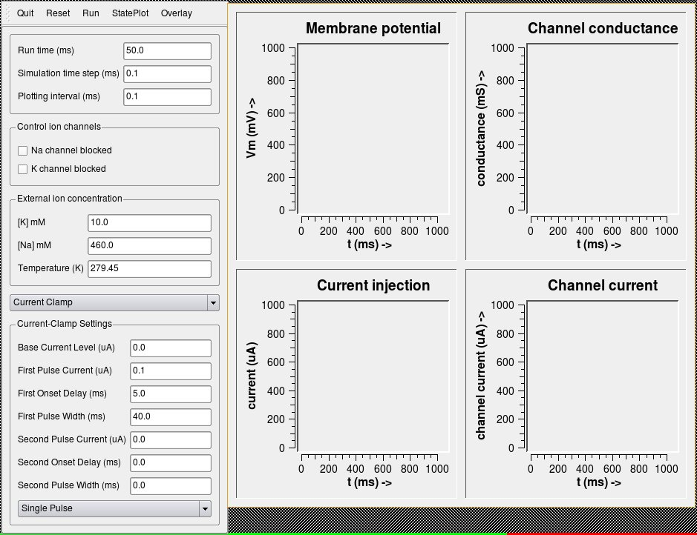

- Now to actually run the simulation you have to reset and then run. Click the Reset button on top menu and then click the Run button. This should fill the empty graph widgets with some plots:

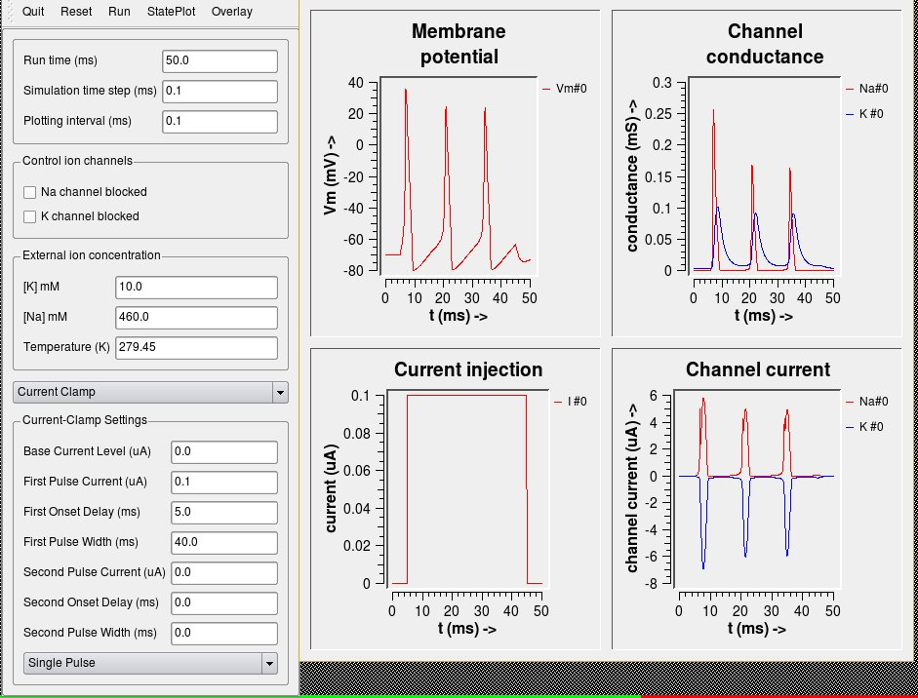
- To quit the application click the quit button.

Running the Izhikevich model:
There is another simple GUI demo which simulates the various types of neuronal firing behaviour using Izhikevich model. Follow these steps to run it:

cd moose/pymoose/examples/izhikevich
python Izhikevich.py

This will fire up a window with an array of buttons. Each button is for simulating a specific firing behaviour:
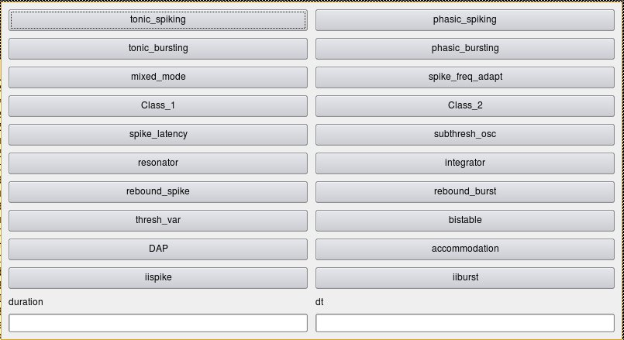
Click any button to run and plot the corresponding firing pattern:

