
UNITED INSTITUTE OF MANAGEMENT
(Faculty of Undergraduate Studies)
Affiliated to – Prof. Rajendra Singh (Rajju Bhaiya) University, Prayagraj, UP

Topic of the Project Report –
A Study on Customer Satisfaction towards Food Delivery Apps (Zomato)


Submitted for partial fulfillment for award of the degree in
BACHELOR OF BUSINESS ADMINISTRATION
(BBA)
Submitted to
Research Faculty Guide-
Mr. Yogesh Chandra Joshi
(Assistant Professor)

Submitted by-
Unnati Sahu (2412101301346)
Shubhanshu Agrawal (2412101301321)
Shivansh Jaiswal (2412101301300)
ACKNOWLEDGEMENT

We would like to thank our Principal Dr. Devendra Kumar Tiwari for his immense support and blessings. I would like to thank our Head of Department Dr. Chandra Shekhar for his support. I would like to express my special thanks of gratitude to my research guide Mr. Yogesh Chandra Joshi , Assistant Professor of Department of Bachelor of Business Administration for his valuable suggestions and guidance and for giving us the golden opportunity to do this wonderful research project on the topic: A STUDY ON CONSUMER SATISFACTION TOWARDS FOOD DELIVERY APPS (Zomato), without his help it would have been difficult for us to have reached this state of completion of my project report. Also, I would like to thank our respected Academic Coordinator Mr. Ashish Verma and our respected faculty member Mrs. Shikha Dwivedi and our batchmates who helped me a lot in the preparation of this project. I wish to acknowledge the help of all those who have provided me information, guidance and other help during my research period.

TABLE OF CONTENTS
Front Matter
1.1 Title Page ............................................................. i
1.2 Certificate / Submitted To (Guide / Department) .............. ii
1.3 Declaration ............................................................. iii
1.4 Acknowledgement ..................................................... iv
1.5 Abstract ................................................................. v
1.6 List of Contents (Index) ................................................ vi
1.7 List of Tables .......................................................... vii
1.8 List of Figures / Charts ............................................... viii
1.9 List of Abbreviations / Glossary .................................... ix
1.10 Executive Summary (Optional) ..................................... x
Chapter 1 — Introduction
2.1 Introduction of the Study ............................................... 1
2.2 Background of the Study (Context, Industry Growth) .......... 2
2.3 Rationale / Need for the Study ....................................... 3
2.4 Scope and Limitations of the Study .................................. 4
2.5 Definitions of Key Terms ................................................ 5
2.6 Organisation of the Study ............................................... 6
Consumer Perception & Satisfaction — Conceptual Section
3.1 Consumer Perception — Concept and Stages ....................... 7
3.2 Factors Affecting Consumer Perception .............................. 8
3.3 Consumer Satisfaction — Definition and Importance ............ 9
3.4 Consumer Satisfaction Surveys — Purpose and Types .......... 10
Chapter 2 — Literature Review
4.1 Introduction to Literature Review .................................... 11
4.2 Online Food Delivery Industry — Global and Indian Perspective ..... 12
4.3 Empirical Studies on Customer Satisfaction ......................... 13
4.4 Theoretical Frameworks Used in the Study ........................... 14
4.4.1 Marketing Mix Theory (4Ps / 7Ps) ............................ 15
4.4.2 Customer Engagement Theory .................................. 16
4.4.3 SERVQUAL and Service Quality Models ...................... 17
4.4.4 Expectation–Disconfirmation Theory (Oliver) ............... 18
4.5 Marketing Mix Strategies of Major Apps ............................... 19
4.5.1 Product Strategy .................................................. 20
4.5.2 Price Strategy ..................................................... 21
4.5.3 Place Strategy ..................................................... 22
4.5.4 Promotion Strategy ................................................ 23
4.6 Customer Engagement in Online Food Delivery .................. 24
4.7 Comparative Studies — Zomato vs Swiggy vs Others ............. 25
4.8 Technological Influence and Digital Marketing Trends .......... 26
4.9 Challenges and Opportunities in the Industry ....................... 27
4.10 Research Gap and Summary ............................................ 28
Chapter 3 — Objectives of the Study
5.1 Main Objective ............................................................ 29
5.2 Specific Objectives ....................................................... 30
5.2.1 Assess Overall Consumer Satisfaction ....................... 31
5.2.2 Identify Key Factors Influencing Satisfaction .............. 32
5.2.3 Study Perceptions of Service Quality, Delivery, App Usability ......... 33
5.2.4 Analyze Pricing / Discount Impact ............................ 34
5.2.5 Evaluate Customer Service & Complaint Resolution ...... 35
5.2.6 Compare Platforms ................................................ 36
5.2.7 Study Link Between Satisfaction & Loyalty ................ 37
5.2.8 Analyse Demographic Influences ............................. 38
5.2.9 Identify Common Problems and Challenges ................ 39
5.2.10 Examine Role of Technology and Innovation ............ 40
5.2.11 Analyse Convenience and Accessibility ................... 41
5.2.12 Examine Brand Image / Reputation ........................ 42
5.2.13 Suggest Practical Measures .................................. 43
5.2.14 Contribute to Academic & Industry Understanding ..... 44
Chapter 4 — Research Methodology
6.1 Research Design (Descriptive, Cross-Sectional) .................... 45
6.2 Population and Sampling Frame ...................................... 46
6.3 Sampling Method (Quota–Stratified Convenience Sampling) .... 47
6.4 Sample Size (Cochran’s Formula) ....................................... 48
6.5 Research Instrument (Google Form) .................................. 49
6.6 Measurement and Coding Scheme .................................... 50
6.7 Validity and Reliability (Factor Analysis, Cronbach’s Alpha) ..... 51
6.8 Data Collection Procedure ................................................ 52
6.9 Data Analysis Plan (Descriptive & Inferential Tests) .............. 53
6.10 Ethical Considerations (Consent & Confidentiality) .............. 54
Chapter 5 — Data Analysis and Interpretation
7.1 Introduction to Analysis .................................................. 55
7.2 Demographic Profile ...................................................... 56
7.2.1 Gender Distribution .............................................. 57
7.2.2 Age Distribution .................................................... 58
7.2.3 Occupation ............................................................ 59
7.2.4 Income / Other Demographics ................................. 60
7.3 App Usage & Behaviour .................................................... 61
7.3.1 Preferred App ......................................................... 62
7.3.2 Frequency of Usage ............................................... 63
7.3.3 Preferred Payment Methods .................................... 64
7.4 Satisfaction Measures ...................................................... 65
7.4.1 Overall Satisfaction Distribution ............................. 66
7.4.2 Item-Wise Satisfaction .......................................... 67
7.4.3 Overall Satisfaction Index — Interpretation ............... 68
7.5 Factors Influencing App Choice .......................................... 69
7.6 Recommendation Behaviour ............................................. 70
7.7 Inferential Analysis .......................................................... 71
7.7.1 t-Tests / ANOVA Results .......................................... 72
7.7.2 Chi-Square Tests .................................................... 73
7.7.3 Correlation & Regression Analysis ............................ 74
7.8 Tables and Charts ............................................................ 75
7.9 Consolidated Interpretation / Summary .............................. 76
Chapter 6 — Findings and Suggestions
8.1 Introduction ................................................................. 77
8.2 Major Findings .............................................................. 78
8.3 Discussion ................................................................. 79
8.4 Practical Suggestions / Managerial Implications ................... 80
8.4.1 Improve Food Quality Assurance ............................. 81
8.4.2 Strengthen Customer Support .................................. 82
8.4.3 Focus on Delivery Speed & Order Accuracy ............... 83
8.4.4 Personalized Discounts & Loyalty Programs .............. 84
8.4.5 Enhance App UI/UX & Payment Reliability ............... 85
8.4.6 Promote Digital Payment & Sustainability ................. 86
8.4.7 Marketing Outreach for Older Consumers ................ 87
8.5 Limitations of the Study .................................................. 88
8.6 Suggestions for Future Research ...................................... 89
Chapter 7 — Conclusion
9.1 Summary of the Research ................................................ 90
9.2 Final Conclusion & Implications ........................................ 91
References / Bibliography
10.1 Books & Journals ......................................................... 92
10.2 Reports & Online Sources ............................................. 93
10.3 Websites (Zomato, Swiggy, Uber Eats, Grubhub) ............... 94

Appendices
A. Questionnaire (Google Form) .............................................. 95
B. Consent Form ............................................................... 96
C. Raw Data Summary ....................................................... 97
D. Additional Charts & Tables .............................................. 98
E. Reliability & Validity Output .............................................. 99
F. Ethical Clearance ............................................................ 100

DECLARATION

I hereby declare that the research work entitled “A Study on Customer Satisfaction Towards Food Delivery Apps (Zomato)” is an original piece of work carried out by me in partial fulfillment of the requirements for the award of a degree. This study has been conducted under the guidance and supervision of Mr. Yogesh Chandra Joshi , Assistant Professor , Department of Bachelor of Business Administration , United Institute of Management (FUGS)

I further declare that this report has not been previously submitted to any other university or institution for the award of any degree, diploma, or certificate. The data and information presented in this research are based on genuine sources and primary data collected through the survey conducted for this study. All references and sources of information have been duly acknowledged in the bibliography section.

I take complete responsibility for the authenticity of the contents of this report.
Place: ___________________
Date: ___________________

Signature of the Student: ___________________
Name of the Student: ___________________
Roll No.: ___________________
Department: ___________________
Institution Name: ___________________

ABSTRACT
Technology has grown so fast that it has completely changed the way products and services are made and delivered to match what customers want, especially in the e-commerce world. These days, online platforms make it super easy for people to get what they need right at their doorstep, all thanks to modern technology. One of the latest and most popular trends in this field is online food delivery. The best part about it is that anyone can use it — you don’t need to be very tech-savvy or know any special language. Just knowing how to use a mobile app or website is enough to place an order.
Even though the Covid-19 pandemic caused a lot of trouble for the food delivery business, it bounced back quickly and continued to grow. As per a 2020 McKinsey report, the global online food delivery market grew from $115.07 billion in 2020 to $126.91 billion in 2021, with a growth rate of 10.3%. In India, platforms like Zomato, Swiggy, Food panda, Travel Khana, and Uber eats are quite popular, but most people prefer Zomato or Swiggy because they’re available almost everywhere and offer quick, reliable services.
This project tries to understand how customers feel about Zomato’s online food delivery and how satisfied they are with its service. The information was gathered using a questionnaire and a few interviews, and the results have revealed some really interesting insights that are discussed in this report.

CHAPTER -1

INTRODUCTION OF THE STUDY
In today’s fast-moving and technology-driven world, everything around us has become more comfortable and convenient. One of the best examples of this progress is how people order food nowadays. Earlier, customers had to personally visit restaurants or call them to place an order, but with the rise of food delivery applications, this whole process has become much simpler. Now, with just a few taps on a smartphone, anyone can browse menus, select their favorite dishes, and get food delivered right to their doorstep. These apps have brought a big change in the food industry by building a strong digital connection between customers and restaurants.
Applications like Zomato, Swiggy, Uber Eats, Food panda, and several others have gained massive popularity among people of different age groups. They make food ordering easier by offering multiple restaurant choices, digital payment methods, exciting deals, real-time delivery tracking, and most importantly, quick and reliable service. Because of these features, more customers prefer ordering food online rather than going out to eat. These platforms not only make life simpler for users but also help restaurants and delivery partners grow their businesses.
As competition among these apps keeps increasing, customer satisfaction has become the most important factor for long-term success. A customer who enjoys the service and finds it reliable will continue to use the same app and even suggest it to friends and family. On the other hand, a bad experience can easily drive customers to switch to other platforms. Therefore, it becomes essential for these companies to understand what their users expect, what difficulties they face, and what can be improved to enhance their experience.
Customer satisfaction in this field depends on several important factors like speed of delivery, food freshness, app design, payment options, customer service, and the overall ease of use. When these aspects are well-managed, customers develop trust and loyalty toward the app. By studying customer satisfaction, companies can figure out how well their service is performing and find ways to improve the quality of their offerings.
This project aims to analyze how happy customers are with food delivery applications and what factors influence their satisfaction levels. The study mainly focuses on well-known apps such as Zomato and Swiggy, which are widely used across India. The data collected through surveys and personal interactions will help in understanding customer opinions, preferences, and the issues they face while using these platforms.

Consumer Perception
Consumer perception is the way individuals observe, interpret, and form opinions about a product, service, or brand. It is not always based on objective facts but is shaped by personal experiences, marketing messages, and opinions shared by others. Each consumer may perceive the same product differently depending on their prior experiences, expectations, and personal preferences.
For instance, when considering a food delivery app like Zomato or Swiggy, a customer’s perception may depend on delivery speed, app usability, responsiveness of customer service, or even recommendations from friends and family. Positive experiences lead to favorable perceptions, while negative experiences create an unfavorable view.
Perception significantly affects consumer behavior. Even high-quality services may fail to retain customers if the perception is poor. Therefore, cultivating a positive consumer perception is essential for the long-term success of a business.
Consumer perception typically evolves through three stages:
- Exposure: The consumer first becomes aware of a product or service through advertisements, social media, or word of mouth.
- Attention: The consumer notices and focuses on features or aspects that interest them.
- Interpretation: The consumer forms an opinion based on prior experiences, expectations, and personal understanding.
A positive perception builds trust and loyalty, while a negative perception can damage a brand’s reputation. Businesses continuously work on shaping favorable perceptions through marketing strategies, quality service, and clear communication.

Factors Affecting Consumer Perception
Various internal and external factors influence how consumers perceive a brand or product. These factors guide their judgments and decisions:
a) Psychological Factors:
A consumer’s mindset, mood, and beliefs significantly influence perception. For example, a person in a positive frame of mind may view a service more favorably than someone feeling frustrated or stressed.
b) Past Experiences:
Previous interactions with a product or service strongly affect perception. Positive experiences encourage repeat engagement, while negative ones can leave a lasting unfavorable impression.
c) Cultural and Social Influence:
Cultural background, traditions, and social environment shape consumer choices and preferences. Family, friends, and social circles also influence how a consumer perceives a product or brand.
d) Marketing and Promotions:
The way a brand communicates through advertisements, social media campaigns, and influencer endorsements affects perception. Creative and clear messaging helps create a strong and positive image in the minds of consumers.
e) Brand Reputation:
Trusted and established brands are more likely to enjoy favorable perception. Consumers associate such brands with reliability, quality, and value.
f) Price and Perceived Value:
Consumers compare cost against benefits. Reasonable pricing enhances perception, while high or hidden costs can create negative impressions.
g) Customer Support:
How a company responds to complaints, queries, or post-service issues plays a vital role. Prompt, courteous support leaves a positive impact.
All these factors together determine how consumers view a brand and influence whether they continue using its products or services.

Consumer Satisfaction
Consumer satisfaction is the measure of how happy or content a customer feels after using a product or service. It reflects the extent to which a product or service meets or exceeds expectations. Fulfilled expectations result in satisfaction, while unmet expectations cause disappointment.
Satisfaction is not limited to the quality of the product itself; it includes the overall experience, from ordering to delivery and post-service support. In food delivery services, factors such as delivery time, order accuracy, food temperature, packaging, and customer service contribute to satisfaction.
High levels of satisfaction foster loyalty, repeat usage, and positive word-of-mouth. Conversely, dissatisfied customers may discontinue using a service and share negative feedback. Understanding consumer satisfaction is crucial for businesses to maintain and improve service quality.
Key aspects of consumer satisfaction include:
- Strengthening long-term customer relationships
- Serving as an indicator of service quality
- Providing feedback for improvement
- Enhancing trust and brand loyalty

Consumer Satisfaction Surveys
A consumer satisfaction survey is a tool used by businesses to gather feedback directly from customers regarding their experience with a product or service. It helps identify satisfaction levels and areas needing improvement.
Surveys can be conducted through questionnaires, interviews, or online forms. In food delivery, sample survey questions might include:
- How satisfied were you with the delivery time?
- Was the food delivered hot and fresh?
- How easy was it to use the mobile app?
- Would you recommend this service to others?
Responses from these surveys guide companies in improving services and addressing issues effectively.

Purpose of Consumer Satisfaction Surveys
The main purpose of conducting these surveys is to understand customer experiences and expectations. Specific goals include:
- Identifying Customer Needs: Understand what customers truly expect from a service.
- Evaluating Service Performance: Measure whether services meet or exceed expectations.
- Detecting Areas for Improvement: Identify weak points in the service process.
- Enhancing Customer Loyalty: Strengthen relationships by addressing customer concerns.
- Monitoring Progress: Compare satisfaction over time to measure growth or decline.
Surveys act as a bridge between the company and its customers, ensuring businesses stay aligned with consumer expectations.

Objectives of Consumer Satisfaction Surveys
Consumer satisfaction surveys generally aim to:
- Assess customer opinions on service quality, pricing, and delivery.
- Determine overall satisfaction and loyalty levels.
- Understand customer behavior and preferences.
- Examine the impact of factors like app usability, offers, and service speed on satisfaction.
- Provide actionable insights to improve operational and marketing strategies.
- Maintain positive relationships with customers by acknowledging their feedback.
By achieving these objectives, companies can enhance service quality and improve customer retention.

Factors Influencing Consumer Satisfaction
Several factors influence how satisfied a customer is with a product or service:
a) Service/Product Quality:
Meeting or exceeding expectations is essential. For food delivery, this includes accurate orders, fresh food, and proper packaging.
b) Price and Value:
Fair pricing and value for money boost satisfaction. Hidden charges or excessive pricing cause dissatisfaction.
c) Delivery Experience:
Timely deliveries, polite delivery personnel, and correct order handling improve satisfaction. Delays or errors reduce it.
d) App Features and Usability:
A user-friendly, fast, and well-designed app increases satisfaction. Technical issues or confusing navigation can frustrate customers.
e) Customer Support:
Quick, courteous responses to complaints or queries help build trust and satisfaction.
f) Offers and Discounts:
Attractive deals make customers feel valued. Inconsistent or misleading offers can cause dissatisfaction.
g) Brand Trust and Image:
A brand with a positive image and transparent operations tends to enjoy higher customer satisfaction.
h) Consistency:
Consistently delivering quality services builds trust and fosters long-term loyalty.

FOOD DELIVERY APPS
Swiggy
- Origin & Headquarters: Founded in 2014 by Sriharsha Majety, Nandan Reddy, and Rahul Jaimini in Bengaluru, India.
- Services: Offers food delivery, grocery delivery through Instamart, and dining reservations via Dine out.
- Valuation: As of November 2024, Swiggy went public with an IPO priced at ₹390 per share, valuing the company at approximately $11.3 billion.
- Revenue: For the fiscal year 2024–25, Swiggy reported a revenue of ₹4,961 crore, marking a 54% year-on-year increase.
- Profit/Loss: In Q1 2025, Swiggy reported a net loss of ₹1,197 crore, despite the significant revenue growth.

Zomato (Eternal Ltd)
- Origin & Headquarters: Established in 2008 by Deepinder Goyal and Pankaj Chaddah in Gurgaon, Haryana, India, initially as FoodieBay.
- Services: Provides food delivery, table reservations, and restaurant discovery services.
- Valuation: As of May 2025, Zomato's parent company, Eternal Ltd, achieved a market capitalization of ₹3.26 lakh crore, positioning it among India's top 25 most valuable companies.
- Revenue: In FY 2024–25, Zomato reported a revenue of ₹24.09 billion, reflecting a 17% year-on-year growth.
- Profit/Loss: The company experienced a 78% decline in fourth-quarter profit, attributed to increased investments in its quick commerce unit, Blinkit.

Uber Eats
- Origin & Headquarters: Launched in 2014 as a subsidiary of Uber Technologies Inc., headquartered in San Francisco, California, USA.
- Services: Offers food delivery services in various countries, integrated with the Uber app.
- Revenue: In 2024, Uber Eats generated $13.7 billion in revenue, marking a 13.2% year-on-year increase.
- Profit/Loss: Uber Technologies, the parent company, reported a net income of $9.8 billion in 2024, driven by gains from tax valuation releases and revaluations of equity investments.

Grubhub
- Origin & Headquarters: Founded in 2004 by Matt Maloney and Mike Evans in Chicago, Illinois, USA.
- Services: Provides online food ordering and delivery services across the United States.
- Valuation: In November 2024, Grubhub was acquired by Wonder Group Inc. for $650 million, a significant decrease from its previous valuation of $7.3 billion when acquired by Just Eat Takeaway in 2021.
- Revenue: In 2023, Grubhub reported a revenue of $2.1 billion, a 15% decrease year-on-year.
- Profit/Loss: The company faced operational losses amounting to €1.155 billion in 2024, primarily due to asset revaluation under IFRS 5 standards.

CHAPTER -2

Literature Review
2.1 Introduction
This growth has reshaped the global service industry owing to rapid digitalization, changing lifestyles of consumers, and an increase in the usage of mobile technologies. In India, this transformation has been led by key players such as Zomato and Swiggy that have reoriented the way consumers access and experience food. Literature on online food delivery services has evolved from logistics and service efficiency-related aspects to the exploration of marketing mix strategies, customer engagement, and satisfaction. This chapter reviews existing literature on these themes, with a specific focus on Zomato's operations in Bangalore. It integrates theoretical and empirical perspectives for an understanding of how the marketing mix of Zomato influences customer engagement and satisfaction, which contributes to its competitive advantage in the food delivery ecosystem.

2.2 Online Food Delivery Industry in India
The fast emergence of urbanization, digital payment adoption, and increased smartphone penetration has resulted in rapid growth in the Indian online food delivery industry. According to Statista (2024), by 2026, the Indian online food delivery market will reach over USD 25 billion, wherein Zomato and Swiggy will account for more than 85% of the total share. Scholars such as Kumar and Singh (2021) have mentioned that the COVID-19 pandemic accelerates such sectors further, as consumers turned to online ordering for convenience and safety.
Zomato was founded in 2008 by Deepinder Goyal and Pankaj Chaddah. It started as a restaurant discovery platform and further developed into a complete food delivery and service aggregator. According to Gupta & Arora (2020), with its digital infrastructure and partnerships with thousands of restaurants across cities like Bangalore, Zomato has established itself as a leader in the Indian market. As revealed by studies, customers increasingly relate the brand Zomato with convenience, variety, and reliability.
In Bangalore, a metropolitan hub with high internet literacy and fast-paced lifestyles, Zomato's strategies have aligned well with consumer expectations of speed, personalization, and affordability. Some comparative studies, such as Sharma & Kaur (2022), demonstrate how consumers in Bangalore give more importance to the speed of delivery, usability of the app, and proper tracking rather than being sensitive toward prices; this indeed has shifted from transactional to experiential consumption.

Theoretical Frameworks
2.3.1 Marketing Mix Theory (4Ps/7Ps)
The marketing mix is the foundation upon which firms create a combination of product, price, place, and promotion to effectively satisfy customer needs. These models further evolved to include 7Ps: people, process, and physical evidence, which were more applicable to service
industries. In digital food delivery, the marketing mix has a critical impact on crafting a truly holistic customer experience.
According to Dastane (2020), convenience, interface design, and customer service quality represent digital equivalents of the classical marketing mix in service-based e-businesses. For Zomato, each one of these elements has an immediate effect on end-customer satisfaction and retention: from an easy-to-use user interface (Product) to dynamic pricing practices (Mishra & Sharma, 2021).

2.3.2 Customer Engagement Theory
Customer engagement was defined by Brodie et al. (2011) as the emotional, cognitive, and behavioral connection between consumers and a brand. In the context of Zomato, this manifests through frequent app interactions, reviews, referrals, and repeat purchases. As noted by Vivek et al. (2012), engagement leads to loyalty and advocacy, a crucial factor in competitive online marketplaces.
Examples of such digital platforms include Zomato, which uses gamification, personalized recommendations, and loyalty programs to increase user engagement. According to the studies of Dwivedi, a high level of engagement ensures better customer lifetime value and word-of-mouth advertising, thus directly influencing business outcomes.

2.3.3 Service Quality and Customer Satisfaction Models
Parasuraman, Zeithaml, and Berry's 1988 SERVQUAL model identifies the dimensions of service quality: tangibility, reliability, responsiveness, assurance, and empathy. Online delivery services adapt these through technological reliability (app performance), responsiveness (customer support), and empathy (personalized care). Zomato's real-time tracking and customer support features reflect these dimensions.
Theories of customer satisfaction, such as Oliver's (1999) Expectation-Disconfirmation Theory, describe how satisfaction is realized when service performance is equal or above expectations. In this regard, in the case of Zomato, these factors include timely delivery, correctness of orders, and efficiency in service recovery on occasions of errors (Kumar & Sahu, 2020).

2.4 Marketing Mix Strategies of Zomato
2.4.1 Product Strategy
Its product offering includes restaurant discovery, cloud kitchens, Zomato Pro subscriptions, and Zomato Gold loyalty programs, among others, in addition to food delivery. According to Jain and Gupta (2020), this helps Zomato in attracting both the end consumers and the restaurant partners.

The interface and technological usability of the Zomato app are considered key product features that create value in convenience through instinctive design and real-time updates, according to Patel & Ghosh (2021). Continuous product innovation, such as voice ordering and AI recommendations, helps in keeping up with changed consumer behavior in Bangalore's tech-savvy demography.

2.4.2 Price Strategy
Zomato uses dynamic pricing models influenced by restaurant pricing, delivery time, and distance. According to the study by Mehta and Thomas (2022), it was found that customers view the pricing of Zomato as being quite fair and competitive, especially during their promotional campaigns. Discount codes and subscription models increase customer retention through perceived value, such as those from Zomato Pro.
Compared to Swiggy, which has a greater tendency toward surge-based pricing with delivery fee increases, Zomato thus has consistent pricing and bundle offers, such as free delivery and cashback, that augment price satisfaction. According to studies, transparency in pricing is one of the most vital elements influencing trust in digital platforms.

2.4.3 Place Strategy
Considering that it is a digital-first platform, the “place” strategy of Zomato refers to the automated integration of restaurants, logistics, and consumers through an efficient digital supply chain. Its widespread coverage in Bangalore ensures accessibility across diverse zones, from residential areas to corporate districts.
According to Singh and Bansal (2020), the logistics algorithm of Zomato optimizes delivery routes with the least time wastage and consequently enhances efficiency. Introduction of "Zomato Hyperpure" for restaurant supplies also ensures backward integration, promoting quality consistency and partner loyalty (Kumar & Bhatt, 2022).

2.4.4 Promotion Strategy
Zomato's promotional strategy focuses on emotional and digital storytelling. Campaigns like "Feeding India" and "Order for Hunger" socially connect with customers, whereas comic in-app notifications develop the brand personality of the company.
Promotion by Zomato predominantly rests on social media. According to studies done by Ramesh and Thomas (2022), user-generated content upsurges consumer trust through reviews and ratings. In the case of Zomato, its push notifications, collaboration with influencers, and meme-based marketing generate high recall among youth, most particularly in metropolitan cities like Bangalore.

2.5 Customer Engagement in Online Food Delivery
In the context of online food delivery, customer engagement is multi-dimensional, as it involves affective, cognitive, and behavioral participation in different ways. Zomato encourages this through engaging mobile app features, review systems, loyalty programs, and social media interactions.
Empirical studies identify that engaged customers show greater repurchase intention and positive word-of-mouth. The gamification features offered by Zomato include badges and levels for reviewers to motivate their contributions in creating a community among users.
Personalized offers, transparency in communication, and customer empowerment drive engagement in the market at Bangalore, according to Raghav and Verma (2022). Responsiveness by Zomato to complaints through chatbots and with real-time problem solutions instills trust and strengthens emotional bonding with customers.

2.6 Comparative Analysis: Zomato vs. Swiggy and Others
While Zomato and Swiggy dominate India's online food delivery market, their strategies are poles apart. Swiggy focuses on logistics excellence and instant delivery, while Zomato focuses on marketing innovation and customer engagement (Nair & Joseph, 2021).
Comparing research between the two, Prasad & Menon (2022 were able to show that the brand communication and app interface of Zomato scored high in terms of emotional connection, while Swiggy was ahead on operational reliability. Uber Eats, before exiting India, communicated global integration but did not localize its offerings well (Khatri, 2020).
In Bangalore, consumers perceive Zomato as more entertaining and engaging, whereas Swiggy is regarded to be more efficient. Sharma & Kaur, 2022. Thus, Zomato’s different marketing mix is contributing to its competitive differentiation in customer engagement.

2.7 Technological Influence and Digital Marketing Trends
The technology forms the backbone of the business model of Zomato. Zomato utilizes artificial intelligence, data analytics, and GPS to enhance customer experience. According to Dey and Singh (2021), various studies have found that through real-time data, Zomato can predict peak demand and hence optimally allocate resources.
Personalization, influencer marketing, and integrated CRM systems—these are some major trends in digital marketing that reshape engagement. According to Bansal and Gupta (2023), Zomato can provide personalized push notifications through its data-driven approach and customized food recommendations.

The tech-driven consumer base in Bangalore resonates with such features. In addition, the integration of social media allows for continuous engagement to be created through interactive posts, contests, and meme marketing strategies that have been shown to enhance emotional connection.

2.8 Challenges and Opportunities
But the success notwithstanding, Zomato faces issues over customer retention, consistency in quality of food, and price sustainability. Increasing competition and high commission fees have strained relations with partner restaurants.
Furthermore, changing delivery charges and inconsistent quality of the dishes served by partner restaurants also hurt satisfaction. According to scholars, ensuring service quality for large-scale operations requires an effective performance monitoring and feedback mechanism.
Still, opportunities abound. Zomato can tap into emerging technologies like predictive analytics and drone delivery as a means of differentiation by Navayanan and Pillai (2023). Increasing "Zomato Hyperpure" and sustainability initiatives could further boost its brand reputation and stakeholder trust.

2.9 Research Gap and Summary
While there is much literature about online food delivery, customer satisfaction, and service quality, very few empirical studies are available regarding Zomato's marketing mix strategies and their links to customer engagement from a local market perspective, like Bangalore. Most of these studies adopt broader national or comparative perspectives without taking micro-level dynamics of consumer perception into consideration in metropolitan regions.
Moreover, while marketing mix frameworks have been highly researched in the context of traditional industries, their adoption in digital service ecosystems such as Zomato has been underexplored until now (Rana & Dey, 2022). There is also a need for integrating customer engagement theories with marketing strategies to understand how emotional and behavioral engagement influences satisfaction and loyalty in online platforms.
This research will, therefore, examine how Zomato's product, price, place, and promotion marketing mix elements empirically influence customer engagement and satisfaction in the Bangalore area. Theoretically and practically, the research contributes to the understanding of how digital marketing practices shape consumer-brand relationships in the emerging online food delivery industry.

CHAPTER -3

Objectives of the Study
In recent times, the online food delivery sector has witnessed remarkable growth, becoming one of the most dynamic parts of the digital economy. With advancements in technology, evolving lifestyles, and widespread internet access, food delivery applications have changed how people order and enjoy food. Well-known platforms like Swiggy, Zomato, Uber Eats, and Grubhub have revolutionized the food service industry by offering users convenience, variety, and quick service. However, the long-term success of these platforms primarily relies on customer satisfaction, which drives customer loyalty, repeat orders, and positive brand reputation.
In this light, the study titled “A Study on Consumer Satisfaction Toward Food Delivery Apps” focuses on understanding the various aspects that influence users’ satisfaction, their preferences, and perceptions regarding these platforms. The objectives of the study are outlined as follows:

1. To assess the overall level of consumer satisfaction toward food delivery applications
The foremost goal of the study is to evaluate how satisfied consumers are with their experiences while using food delivery apps. Customer satisfaction may depend on different factors, such as delivery quality, accuracy, reliability, convenience, and technological efficiency.
This objective aims to find out whether users are genuinely satisfied or if there are gaps between their expectations and what they actually experience. By understanding satisfaction levels, companies can identify areas of improvement and strengthen their customer relationships to maintain competitiveness.

2. To identify the key factors that influence consumer satisfaction
Satisfaction does not depend on a single element but rather a combination of many factors. This part of the study will focus on identifying which specific aspects have the most significant impact on satisfaction, such as:
- Speed and punctuality of delivery
- Quality and freshness of the food
- Ease of navigating the app interface
- Behavior and professionalism of delivery agents
- Packaging standards and hygiene
- Pricing policies and discounts
- Security and smoothness of online payment systems
Recognizing these factors will help companies understand which areas customers value the most and where improvements can bring maximum satisfaction.

3. To study consumer perceptions of service quality, delivery performance, and app usability
This objective explores how customers perceive the overall service quality provided by food delivery platforms. It examines factors like the simplicity of the app, order accuracy, user-friendliness, and delivery consistency.
The study also aims to understand whether users find these services efficient and dependable, or whether they experience frustrations like delays or technical issues. Evaluating these perceptions helps platforms enhance the quality of interaction and user experience.

4. To analyze the impact of pricing, discounts, and promotional offers on satisfaction
Pricing and promotional strategies play a vital role in attracting and retaining users. Many consumers prefer these platforms because of offers, cashback, and loyalty benefits.
This objective evaluates how much these offers actually contribute to satisfaction—whether they create long-term loyalty or only temporary interest. It also examines the trade-off between price and service quality, helping businesses find a balance between affordability and superior service.

5. To evaluate customer service and complaint resolution systems
A company’s approach to handling complaints often defines its reputation. This objective focuses on understanding how efficiently customer grievances are managed—considering response time, staff politeness, and issue resolution accuracy.
Even when service failures occur, a quick and fair resolution can restore trust and satisfaction. Hence, this study aims to assess how effective current customer support systems are in maintaining consumer confidence.

6. To compare satisfaction levels across different food delivery platforms
Since the market is shared by multiple players like Zomato, Swiggy, Uber Eats, and Grubhub, it becomes essential to compare their performance in terms of customer satisfaction.
This comparison helps identify which platform performs better and why. It highlights best practices, customer preferences, and areas where competitors can improve to gain a better market position.

7. To analyze the link between consumer satisfaction and customer loyalty
One of the main outcomes of satisfaction is loyalty. This objective seeks to explore whether happy customers tend to reorder from the same app and recommend it to others.
The study also tries to find out if customers remain loyal to one platform or switch due to discounts, offers, or restaurant options. Understanding this link helps companies plan long-term retention strategies.

8. To study the influence of demographic factors on satisfaction levels
Consumer preferences vary with demographics such as age, income, gender, education, and occupation. For example, students might focus on affordability, while working professionals may prioritize timely delivery.
This objective aims to find out how these demographic differences affect satisfaction levels, which can help companies design targeted marketing campaigns and customized services.

9. To identify common problems and challenges faced by users
Although food delivery apps are convenient, they are not without issues. Customers often face challenges like delayed delivery, incorrect orders, app crashes, or payment glitches.
This part of the research identifies the common pain points and examines how these issues affect satisfaction. Addressing these challenges helps improve the service experience and builds greater reliability and trust among users.

10. To examine the role of technology and innovation in enhancing satisfaction
Technology is the backbone of these digital platforms. This objective focuses on how advanced technologies—like GPS tracking, AI recommendations, and digital payment systems—affect user satisfaction.
It explores whether users truly find these innovations useful and whether they enhance the convenience and experience of food delivery. The findings can guide platforms in investing in the right kind of technological improvements.

11. To analyze the importance of convenience and accessibility
Convenience is the main reason behind the popularity of these apps. This objective assesses how easy it is for users to place orders, access the app anytime, and get food delivered at their preferred location.
It also explores whether customers view these apps as time-saving solutions or just alternatives when dining out isn’t possible. This helps in understanding how convenience shapes satisfaction.

12. To examine the role of brand image and reputation
A platform’s brand image greatly influences how consumers perceive it. Factors like social media presence, online reviews, influencer endorsements, and public trust all affect satisfaction levels.
This objective looks into how a positive or negative brand reputation impacts user loyalty and whether consumers’ trust in a brand makes them more likely to continue using its services.

13. To suggest practical measures to enhance customer satisfaction
Based on the data and insights gathered, this study aims to suggest realistic and effective strategies for improving satisfaction. Some potential recommendations may include:
- Improving delivery logistics and timing
- Enhancing customer service training
- Simplifying app design and navigation
- Offering transparent pricing and value-driven offers
- Introducing eco-friendly and safe packaging
These strategies can help companies build stronger relationships with their customers and create a more positive image in the market.

14. To contribute to academic and industry understanding
Finally, the study seeks to make a meaningful contribution to both academic research and the food delivery industry. By examining changing consumer behavior, it helps researchers, marketers, and policymakers better understand how digital food services affect modern lifestyles and decision-making.
The insights from this study can be useful for future research, as well as for companies aiming to design customer-centric business strategies.

Research Methodology
12. Ethical Considerations1. Title of the Study
A Study on Customer Satisfaction Towards Food Delivery Apps (Zomato)

2. Objectives of the Study
The main purpose of this study is to evaluate customer satisfaction with food delivery applications, focusing particularly on Zomato .
The specific objectives are as follows:
- To measure users’ overall satisfaction with food delivery apps.
- To examine satisfaction levels across various service parameters such as food quality, delivery time, app interface, promotional offers, customer service, and order accuracy.
- To identify the factors that influence users’ Zomato.
- To explore how demographic factors such as age, occupation, and income relate to frequency and type of app usage.
- To provide practical suggestions for improving customer satisfaction and service quality.

3. Research Design
The research follows a descriptive cross-sectional survey design, utilizing a structured online questionnaire administered through Google Forms. This design helps capture respondents’ opinions and perceptions at a single point in time, providing a clear picture of customer satisfaction levels and related factors.

4. Population and Sampling Frame
The population for this research consists of active users of online food delivery applications, particularly Zomato and Swiggy.
The sampling frame includes individuals who can be reached online through platforms such as social media, email lists, and WhatsApp groups, and who have experience using these applications for ordering food.

5. Sampling Method and Justification
Considering the academic nature of the study and limited availability of resources, quota-stratified convenience sampling has been used.
Under this method:
- Respondents are selected based on their easy accessibility to the researcher (convenience).
- Quotas are set for key demographic segments like age, gender, and occupation to ensure balanced representation across groups.
This approach is both practical and efficient for collecting diverse data from online users when a complete sampling frame is unavailable.

6. Sample Size
To determine the sample size, Cochran’s formula was applied:
$$n_{0}=\frac{Z^{2}×p×q}{e^{2}}$$
Where:
- $Z=1.96$(95% confidence level)
- $p=0.5$(estimated proportion)
- $q=1-p=0.5$
- $e=0.05$(margin of error)
Calculation:
$$n_{0}=\frac{3.8416×0.25}{0.0025}=384.16$$
Thus, the recommended sample size is approximately 385 respondents. For practical feasibility, a minimum of 300 responses is considered acceptable, while 385 ensures higher accuracy and generalizability.

7. Research Instrument
The research instrument used was a structured questionnaire prepared through Google Forms, divided into four sections:
- Demographics (Gender, Age, Occupation, Income, etc.)
- App Usage Patterns (Most used app, frequency, spending, type of food ordered, etc.)
- Satisfaction Parameters (Delivery time, food quality, app interface, discounts, customer service, order accuracy, overall satisfaction — measured using Likert scales).
- Choice Drivers and Recommendations (Key factors influencing app preference and likelihood of recommendation).

8. Measurement and Coding Scheme
Responses were converted into numerical codes to facilitate statistical analysis.
For instance:
- Gender: Male = 1, Female = 2, Prefer not to say = 3
- Age: Below 18 = 1, 18–25 = 2, 26–35 = 3, Above 36 = 4
- Satisfaction levels: Excellent = 4, Good = 3, Average = 2, Poor = 1
An Overall Satisfaction Index was created by averaging six key items: food quality, delivery time, app interface, discounts, customer service, and accuracy. Scores closer to 4.0 indicate higher satisfaction levels.

9. Validity and Reliability
- Content Validity: Ensured by expert review to confirm that the questionnaire adequately covers all major aspects of customer satisfaction.
- Construct Validity: To be verified through factor analysis after data collection to confirm whether items group under expected dimensions.
- Reliability: Measured using Cronbach’s Alpha, with a value of 0.70 or higher indicating good internal consistency among the satisfaction items.

10. Data Collection Procedure
The finalized Google Form was distributed via social media and online communication channels.
A pilot study with 20–30 participants helped assess clarity and timing before launching the full survey.
Data collection continued until the target number of responses was achieved.
The responses were then exported to Excel for cleaning and analysis.

11. Data Analysis Plan
The collected data were analyzed using statistical tools such as Excel or SPSS. The analysis involved:
- Data Cleaning: Removing incomplete or duplicate entries and recoding categorical responses.
- Descriptive Statistics: Calculating frequencies, percentages, means, and standard deviations for demographic and satisfaction variables.
- Reliability Analysis: Computing Cronbach’s alpha for internal consistency.
- Factor Analysis: To identify underlying satisfaction dimensions.
- Inferential Statistics:
  - t-tests and ANOVA to compare satisfaction across demographic groups.
  - Chi-square tests to explore relationships between categorical variables (e.g., app preference and recommendation).
  - Correlation and Regression Analysis to identify key predictors of overall satisfaction.
- Significance Level: The confidence level was set at 95%, with a p-value of <0.05 considered statistically significant.

All respondents participated voluntarily, and their identities were kept confidential. Email addresses (if collected) were used only for verification and not shared publicly.
Informed consent was obtained at the beginning of the questionnaire, ensuring transparency and ethical compliance.

CHAPTER -4

DATA ANALYSIS AND INTERPRETATION

4.1 Introduction
This chapter reports the findings from the online survey administered to assess customer satisfaction with food delivery applications—primarily Zomato and Swiggy. The final sample consists of 385 valid responses. Data were analyzed using descriptive statistics and visualized through tables and figures. The sections below present frequency distributions, charts, and an interpretation of the key results.

4.2 Gender Distribution
Category | Count
Female | 227
Male | 158

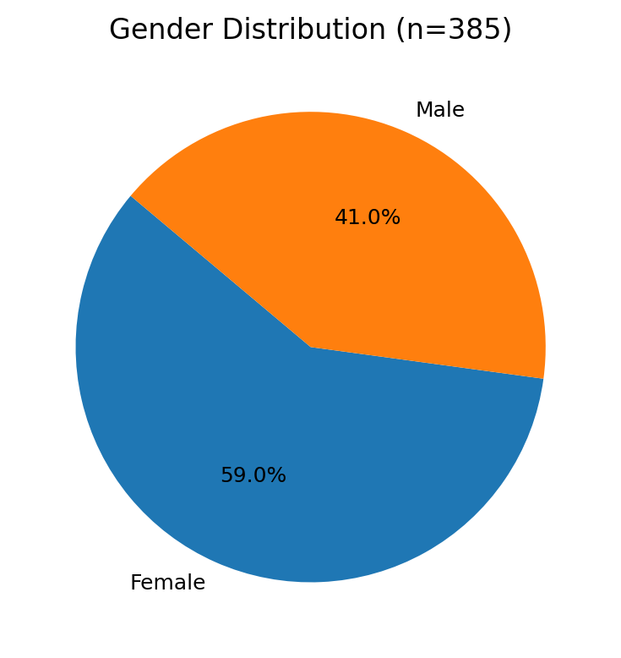

The sample (n=385) comprises 227 females (59.0%) and 158 males (41.0%). Females form a slightly larger share of respondents, which may reflect higher engagement with online ordering among young women in the survey network.

4.3 Age Distribution
Category | Count
18-25 | 308
26-35 | 58
Above 36 | 19

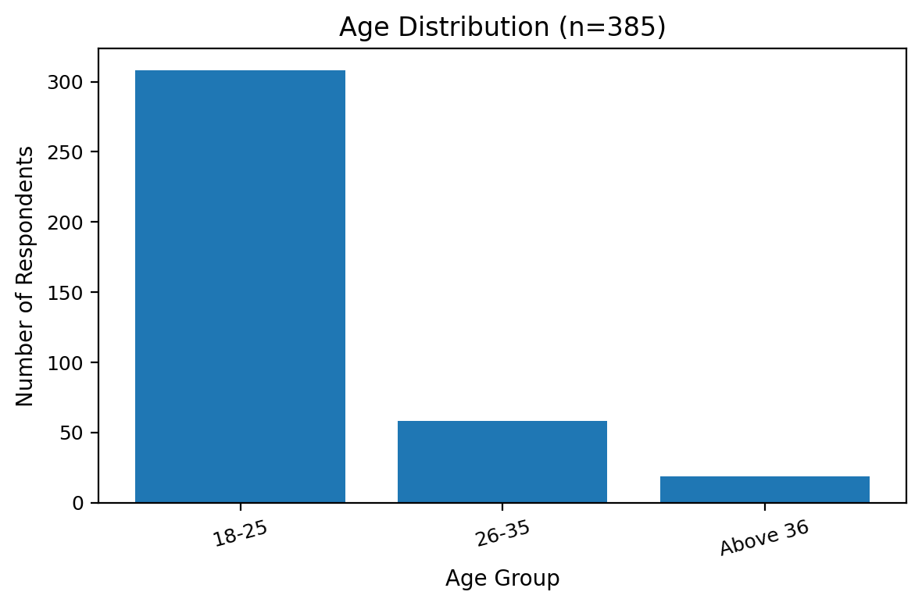

Most respondents are young adults: 308 participants (80.0%) are aged 18–25. The 26–35 group accounts for 58 respondents (15.1%), while those above 36 are 19 (4.9%). This concentration in younger cohorts suggests the findings mainly reflect youth behaviour and preferences.

4.4 Occupation of Respondents
Category | Count
Student | 289
Employee | 62
Self-employed | 19
Others | 15

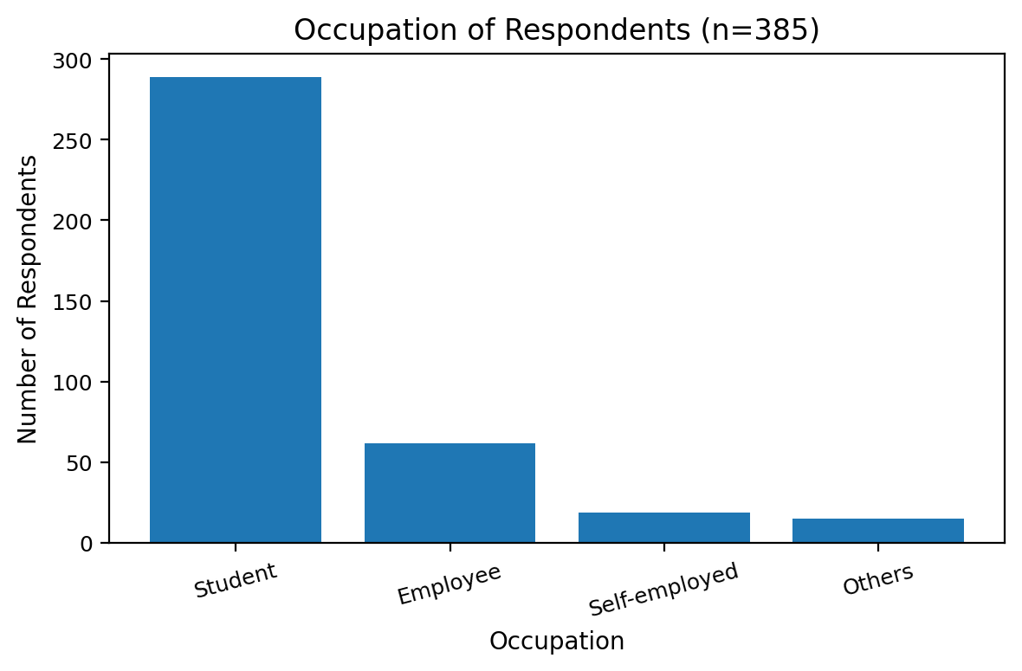

Students dominate the sample with 289 respondents (75.1%). Employees form the next largest group with 62 respondents (16.1%). High student representation aligns with the age profile and implies convenience and affordability are likely important factors.

4.5 Preferred Food Delivery Application
Category | Count
Zomato | 177
Swiggy | 42
Both | 166

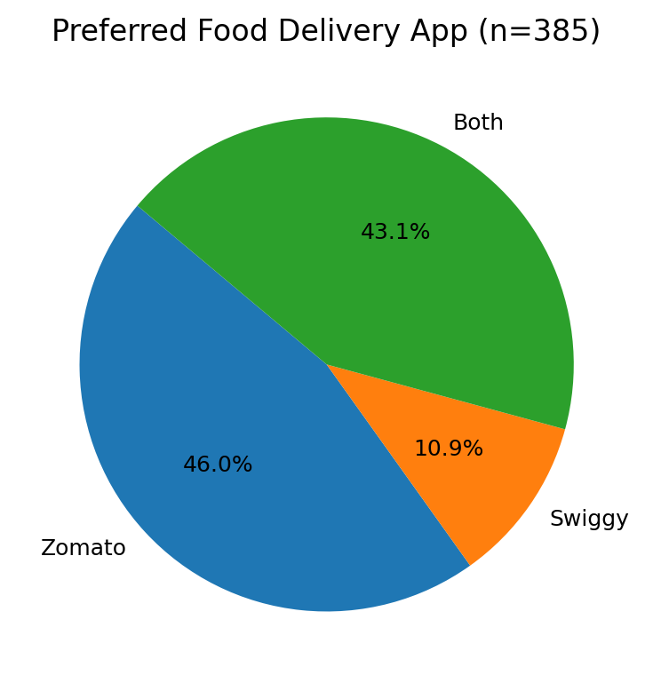

Regarding app preference, 177 respondents (46.0%) prefer Zomato, 42 (10.9%) prefer Swiggy, and 166 (43.1%) use both platforms. Zomato holds a marginal lead but many users are platform-agnostic and choose based on need.

4.6 Frequency of Usage
Category | Count
Daily | 27
Weekly | 96
Occasionally | 208
Rarely | 54

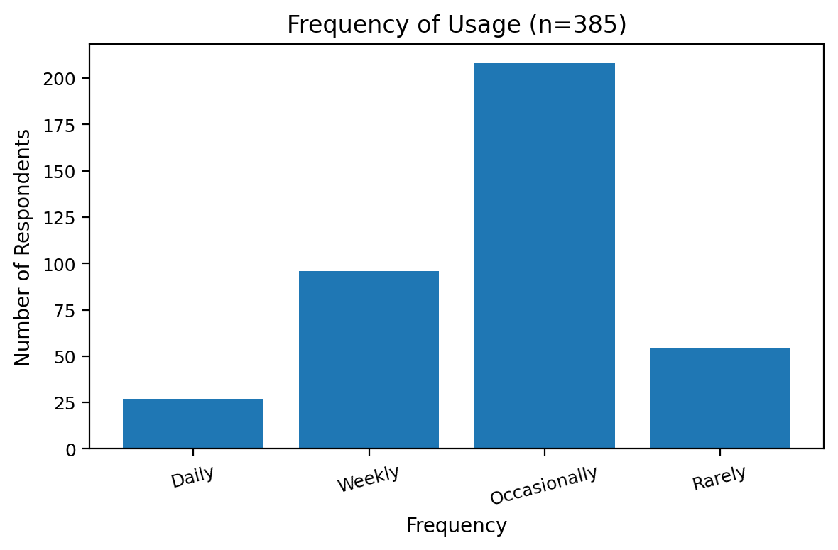

Usage frequency shows that 208 respondents (54.0%) order occasionally, while weekly users are 96 (24.9%). Daily orders are relatively rare (27, 7.0%), indicating app use is more for convenience than daily necessity.

4.7 Preferred Payment Method
Category | Count
UPI | 186
Cash on Delivery | 146
Card Payment | 38
Wallet | 15

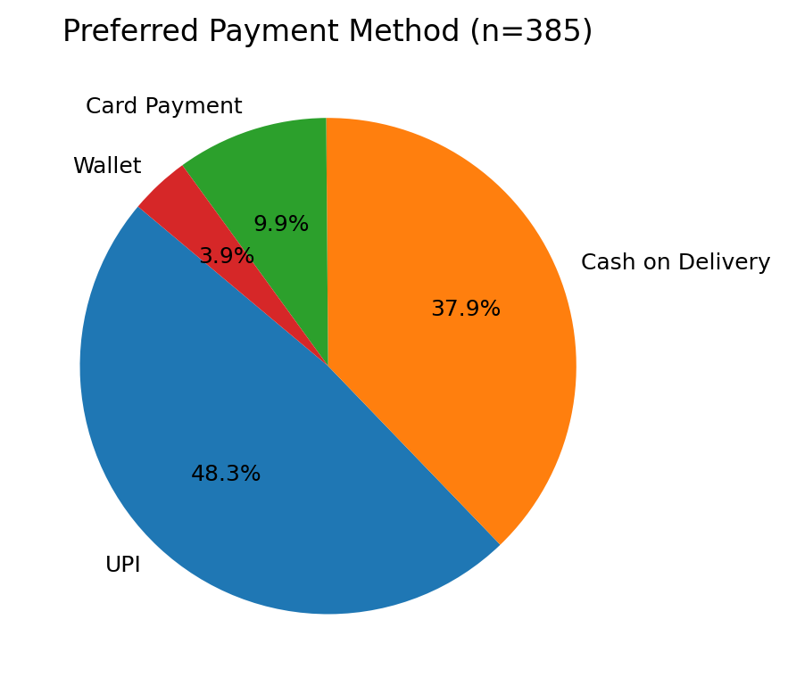

Digital payments dominate: UPI is used by 186 respondents (48.3%), followed by cash on delivery used by 146 respondents (37.9%). This trend highlights strong adoption of instant digital payments among the survey population.

4.9 Overall Satisfaction Level
Category | Count
Very Satisfied | 62
Satisfied | 253
Neutral | 58
Dissatisfied | 12

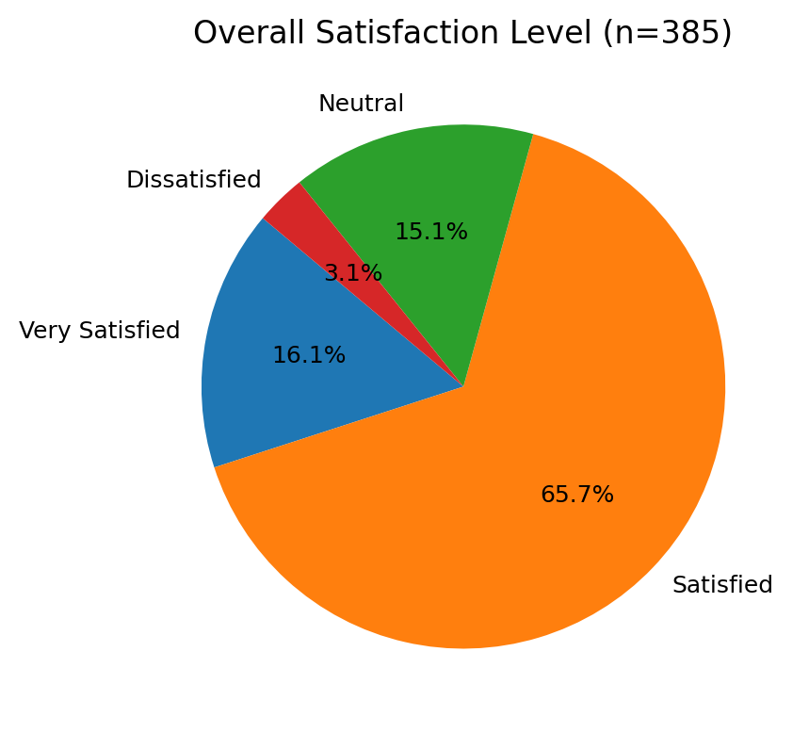

Overall satisfaction is positive: 253 respondents (65.7%) report being satisfied and 62 (16.1%) are very satisfied. Neutral and dissatisfied responses remain a minority, suggesting relatively high service approval among users.

4.10 Factors Influencing App Choice
Category | Count
Discounts | 139
Food Quality | 127
Fast Delivery | 81
App Interface | 38

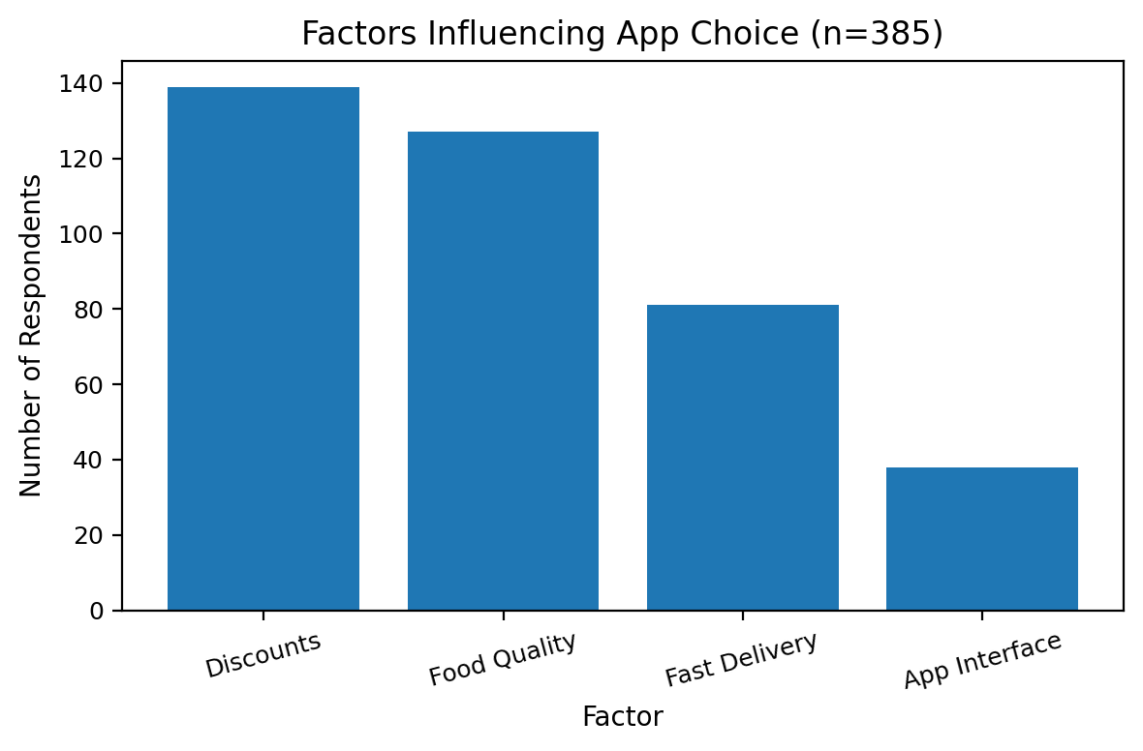

The prime factors influencing choice are discounts (139, 36.1%), food quality (127, 33.0%), and delivery speed (81, 21.0%). App interface has lower influence, indicating users prioritize tangible benefits and service over design alone.

4.11 Recommendation Behavior
Category | Count
Yes | 328
Maybe | 42
No | 15

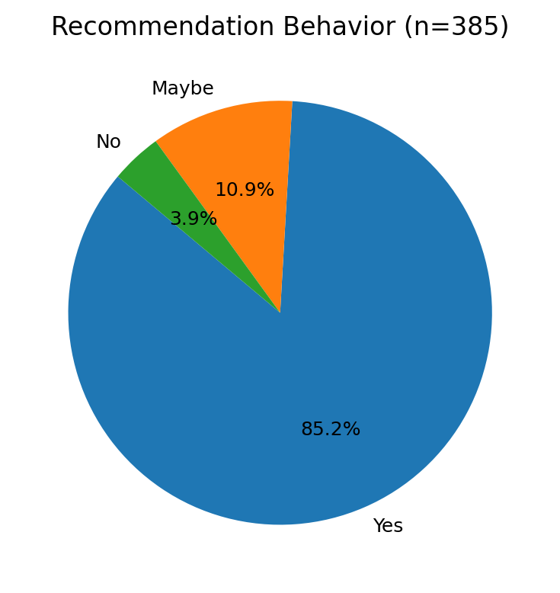

A strong 328 respondents (85.2%) said they would recommend their preferred app, indicating positive word-of-mouth potential. Only 15 respondents (3.9%) would not recommend the app.

4.12 Consolidated Interpretation
The survey of 385 respondents indicates a predominantly young, student-heavy respondent base with a slightly higher number of female participants. Zomato holds a modest preference advantage, but many users alternate between platforms. Occasional use is most common, and UPI is the leading payment method. Overall satisfaction is strong, driven mainly by food quality and delivery promptness. Discounts emerge as an important decision driver, suggesting promotional strategies influence user choice. Areas for improvement include customer support and targeted offers for frequent users. Given the demographic skew, findings should be interpreted with emphasis on younger consumers' behaviors.

FINDINGS AND SUGGESTIONS
CHAPTER -5
5.1 Introduction
This chapter outlines the key findings obtained from the analysis presented in Chapter 4. It summarizes the main insights regarding customer satisfaction with food delivery applications, specifically Zomato and Swiggy. Based on these outcomes, practical suggestions are also provided to help improve user experience, customer engagement, and overall satisfaction. The purpose of this chapter is to translate the analytical results into actionable recommendations that may assist food delivery platforms in refining their strategies and maintaining a competitive advantage.

5.2 Major Findings
Demographic Profile
- A total of 385 respondents participated in the study.
- The gender distribution shows that 59% were female and 41% were male, suggesting slightly greater participation of women in online food ordering activities.
- The 18–25 age group represented the largest share (80%), followed by 26–35 years (15.1%), indicating that younger adults form the core consumer base of food delivery services.
- The majority of participants were students (75.1%), highlighting that the convenience and affordability of food delivery apps appeal strongly to the youth segment.

App Preference
- Zomato (46%) emerged as the most preferred platform, followed closely by Swiggy (10.9%).
- A considerable proportion of respondents (43.1%) reported using both apps, implying that consumers make flexible choices depending on discounts, restaurant availability, or service convenience.

Usage Patterns
- More than half of the respondents (54%) order food occasionally, while 24.9% use the service weekly.
- Only 7% place orders daily, indicating that food delivery apps are primarily used for convenience or special occasions rather than as a routine meal option.
Payment Methods
- UPI (48.3%) is the most widely used payment mode, followed by cash on delivery (37.9%).
- The preference for digital payments demonstrates a growing acceptance of online financial transactions and aligns with India’s push toward a cashless economy.

Satisfaction Levels
- A majority of respondents reported being satisfied (65.7%) or very satisfied (16.1%) with their overall experience.
- Only a small fraction (3.1%) expressed dissatisfaction, showing that food delivery platforms enjoy a largely positive image among users.

Factors Influencing App Choice
- The most significant factors affecting app selection were discounts (36.1%), food quality (33%), and delivery speed (21%).
- The app interface (9.9%) had lesser influence, suggesting that users prioritize tangible benefits like offers and reliability over design aesthetics.

Recommendation Behavior
- A large majority (85.2%) of users stated they would recommend their preferred food delivery app to others.
- This indicates strong customer loyalty and satisfaction, as well as the potential for positive word-of-mouth promotion for both Zomato and Swiggy.

General Observations
- Users are highly price-conscious and respond actively to offers and promotional schemes.
- While overall satisfaction is strong, some aspects—particularly customer support, refund handling, and personalized deals—require attention to enhance user trust and retention.

5.3 Suggestions
Based on the findings, the following recommendations are proposed to strengthen customer satisfaction and operational efficiency for food delivery applications:
1. Improve Food Quality Assurance
- Conduct periodic reviews of partner restaurants to ensure consistency in food quality and hygiene.
- Introduce verified restaurant tags or quality certification badges to build customer confidence.
2. Strengthen Customer Support
- Implement real-time chat assistance or AI-driven help desks for quicker resolution of delivery and payment-related concerns.
- Train support staff to handle customer issues empathetically and maintain professionalism in all interactions.
3. Focus on Delivery Speed and Order Accuracy
- Enhance coordination between restaurants and delivery partners to minimize delays.
- Offer vouchers or compensation for incorrect or delayed orders to maintain credibility and user satisfaction.
4. Introduce Personalized Discounts and Loyalty Programs
- Utilize data analytics to design customized offers for frequent customers.
- Launch loyalty points, cashback schemes, or membership programs to encourage repeat orders.
5. Enhance User Interface Experience
- Simplify app navigation and improve overall usability.
- Add features such as smart recommendations, visual menus, and easy reordering options to enhance convenience.
6. Promote Digital Payment Adoption
- Encourage cashless transactions by offering cashback rewards for UPI or card payments.
- Ensure that payment gateways are secure and transaction failures are minimized.
7. Encourage Environmental Sustainability
- Promote eco-friendly packaging and provide users with “no-cutlery” options.
- Partner with restaurants that adopt green and sustainable practices.
8. Expand Outreach to Older Consumers
- Launch marketing initiatives aimed at working professionals and families to widen the customer base.
- Highlight safety, reliability, and convenience in promotional campaigns.
9. Build Distinct Brand Identity
- Since many customers use both Zomato and Swiggy, each platform should focus on its unique value proposition—for example, Zomato emphasizing variety and reviews, and Swiggy highlighting speed and reliability.

Conclusion
The study titled “A Study on Customer Satisfaction Towards Food Delivery Apps (Zomato and Swiggy)” was undertaken to understand the perceptions, preferences, and satisfaction levels of customers using online food delivery applications. In recent years, digital transformation and technological progress have significantly changed how people order and consume food. With the rise of apps like Zomato and Swiggy, the food delivery industry has become an inseparable part of modern lifestyles, particularly among urban consumers and youth. This research was designed to assess how satisfied users are with these platforms, what factors affect their satisfaction, and what improvements could further enhance their experience.
The analysis of data collected through the online questionnaire reveals several significant insights. The majority of respondents were between the ages of 18–25, and most of them were students, indicating that younger generations form the largest segment of food delivery app users. This demographic group values convenience, affordability, and speed, which are exactly the qualities that these apps provide. A slightly higher percentage of female users participated in the study, suggesting that women are equally, if not more, active in using digital platforms for ordering food.
When it comes to platform preference, Zomato emerged as the leading choice among respondents, with Swiggy closely following. Interestingly, a large number of users stated that they use both platforms interchangeably, depending on offers, availability of restaurants, and ease of use. This finding highlights that brand loyalty in the food delivery market is flexible and driven more by value and convenience than emotional attachment to a single platform. Users tend to compare offers and switch platforms easily when they find better deals, which emphasizes the importance of consistent service and customer engagement strategies for retaining customers.
The satisfaction level observed among respondents was generally high. More than 80% of users reported being either satisfied or highly satisfied with their overall experience. The major contributing factors to this satisfaction included timely delivery, good food quality, accurate orders, and smooth app navigation. These aspects directly affect the customer experience and determine whether users will continue to order from the same platform. On the other hand, areas like customer support, refund handling, and personalized recommendations were found to be less satisfactory and need improvement to maintain long-term customer loyalty.
The study also found that discounts, offers, and promotional campaigns play a vital role in shaping customer satisfaction and influencing app choice. Many respondents stated that they are motivated to order when attractive discounts are available. While this strategy effectively drives short-term sales, over-reliance on discounts may reduce profit margins. Therefore, platforms must find a balance between providing value to customers and maintaining business sustainability. Alongside discounts, factors such as packaging, delivery speed, and courteous behavior of delivery agents were also identified as important contributors to satisfaction.
Digital payments have become the most preferred mode of transaction, with UPI emerging as the most popular payment method among users. This reflects the growing trust and comfort of Indian consumers with digital finance and cashless transactions. However, ensuring payment security and minimizing transaction failures remain essential to sustaining this confidence.
From the findings, it is evident that customer satisfaction is multidimensional and influenced by several interrelated factors. It is not only the quality of food that matters but also how seamlessly the entire service experience—from ordering to delivery—is managed. A delay in delivery, poor packaging, or unresponsive customer care can negatively impact satisfaction even if the food itself meets expectations. Therefore, companies like Zomato and Swiggy need to ensure consistency in all aspects of their operations.
Moreover, personalization is becoming increasingly important. Today’s consumers appreciate when services are tailored to their preferences. Using data analytics to understand customer behavior, recommend meals, or design custom offers can help these companies build stronger connections with users. Another emerging expectation among consumers is environmental responsibility. Many users are becoming conscious of sustainable practices and prefer eco-friendly packaging. Hence, integrating sustainability into business operations could enhance the brand image and align with evolving consumer values.
This study also underscores the importance of effective customer support. Even though most respondents were satisfied, those who reported dissatisfaction often mentioned poor response times and lack of proper assistance during complaints or refunds. A responsive and empathetic support system can turn a negative experience into a positive one, restoring customer trust.
In conclusion, the findings of this research clearly demonstrate that food delivery apps like Zomato and Swiggy have redefined dining habits and set new standards for convenience in India’s food service industry. They have successfully captured the trust and attention of a vast segment of consumers by providing speed, accessibility, and variety at their fingertips. However, as competition intensifies, maintaining customer satisfaction will depend on continuous improvement, innovation, and customer-centric strategies.
Both companies should focus on improving service reliability, strengthening restaurant partnerships, enhancing customer service, and leveraging technology for personalization and efficiency. Additionally, promoting sustainable practices and maintaining transparent pricing can further build consumer trust and loyalty.
Overall, this study concludes that while the current satisfaction level among users is high, there remains considerable scope for growth and refinement. The key to success for food delivery platforms lies in their ability to listen to their customers, adapt quickly to their changing expectations, and consistently deliver value beyond just the product. As the digital economy continues to evolve, those platforms that can balance innovation, affordability, and customer care will continue to lead and define the future of the online food delivery industry in India.

BIBLIOGRAPHY
For completing this research report, I have referred to a number of books, journals, reports, and online sources which helped me in understanding the topic in depth and preparing the study in a detailed manner. The main references are mentioned below:
Books & Journals
- Kotler, P. and Keller, K. L. (2016). Marketing Management (15th Edition). Pearson Education, New Delhi.
- Schiffman, L. G. and Kanuk, L. L. (2015). Consumer Behaviour. Pearson Education, India.
- Solomon, M. R. (2018). Consumer Behaviour: Buying, Having and Being. Pearson India.
- Parasuraman, A., Zeithaml, V. A., and Berry, L. L. (1988). “SERVQUAL – A Multiple Item Scale for Measuring Customer Perceptions of Service Quality.” Journal of Retailing, 64(1), 12–40.
- Brodie, R. J., Hollebeek, L. D., Jurić, B., and Ilić, A. (2011). “Customer Engagement: Conceptual Framework and Research Implications.” Journal of Service Research, 14(3), 252–271.
- Oliver, R. L. (1999). “Whence Consumer Loyalty.” Journal of Marketing, 63, 33–44.
- Gupta, S. and Arora, N. (2020). “Customer Perception Toward Online Food Delivery Platforms in India.” International Journal of Management and Applied Science, 6(3), 45–50.
- Sharma, A. and Kaur, H. (2022). “Comparative Study of Zomato and Swiggy with Reference to Customer Satisfaction.” Journal of Business and Management Research, 12(4), 55–62.
Reports & Research Studies
9. Statista (2024). Online Food Delivery Market in India: Growth and Forecast 2024–2026. Retrieved from www.statista.com
10. McKinsey & Company (2021). Global Food Delivery Report 2021. Retrieved from www.mckinsey.com
11. EY India (2023). Digital Consumer Trends in India: Food, Delivery and Beyond. Ernst & Young Global Limited.
12. KPMG (2022). India’s Digital Appetite: The Rise of Online Food Delivery Platforms. KPMG Insights Series.
Websites & Online Articles
13. Zomato – Official Website: www.zomato.com
14. Swiggy – Official Website: www.swiggy.com
15. Uber Eats – Official Website: www.ubereats.com
16. Grubhub – Official Website: www.grubhub.com
17. The Economic Times (2024). “Zomato Q4 FY25 Results: Revenue Rises 17% with Focus on Blinkit Expansion.”
18. Business Standard (2025). “Swiggy IPO Valued at $11.3 Billion – Key Financial Highlights.”
19. NDTV Profit (2025). “India’s Online Food Delivery Sector Shows Rapid Growth Amid Urban Demand.”
20. Times of India (2024). “Digital India and the Rise of Food Ordering Among Youth.”
21. Financial Express (2023). “Customer Experience in the Online Food Market: Trends and Challenges.”
22. Forbes India (2025). “The Journey of Food Tech Startups: How Zomato and Swiggy Redefined Dining.”
Other References
23. Primary data collected through Google Forms (2025) on customer satisfaction towards food delivery apps.
24. Responses, feedback, and opinions shared by survey participants and online users.

