**Slot Ui Creation Manual**

Table of Contents

1. Introduction 1

2. Basic Ui Requirement 1

2.1 base_game.ui 1

2.1.1 Reel Panel 2

2.1.2 Payline Panel 4

2.1.3 Icon Animation Panel 4

2.1.4 Reel Mask Over Payline 4

2.1.5 Near Win Outline 4

2.1.6 Auto Spin Selector 5

2.1.7 Controller Panel 5

2.1.8 Full Basic hierarchy for base_game.ui 7

2.2 paytable.ui 8

2.2.1 Buttons 8

2.2.2 Pages 8

**Changes:**

|  |  |  |
| --- | --- | --- |
| **Name** | **Modified Date** | **Remarks** |
| Kway Woei Sing (Vincent) | 2015-06-04 | First creation. |
|  |  |  |
|  |  |  |
|  |  |  |

# Introduction

This document serves as a guideline in creating ui for different slot machines. Everything listed in this document are the minimum required element for the slot to be able to run normally. Additional elements can be added on top of those base ui layout to create unique ui for different themes.

# Basic Ui Requirement

In this section, we will list down all the basic requirement for different ui in a Slot Machine theme.

**NOTE: All layout should *CHECK* Enable and Virtual Mode. Only *CLICKABLE* object needs to uncheck Virtual Mode.**

## 2.1 base_game.ui

This ui will be use as the main ui in each slot machine. This ui contents most of the game play features element. We will break it down into several subsection and all this subsection are elements attached directly under the root Panel of base_game.ui.

**Note: See section 2.1.8 for the full layout.**

### 2.1.1 Reel Panel

We will need 2 panel layout for the reel to control the slot icons as well as layout to attach any necessary effects in the game.

1. m_NormalSpin layer for normal spin game play.

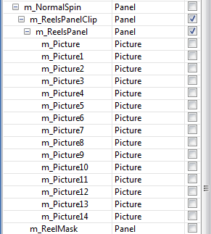

In this layout, we need the layout hierarchy as below.

**m_NormalSpin (Panel)**

**m_ReelsPanelClip (Panel)**

**m_ReelsPanel (Panel)**

**m_Picture(n) are optional. (Pictures)**

**m_ReelMask (Panel)**

1. m_FreeSpin layer for free spin game play.

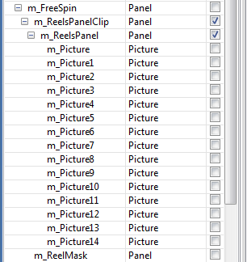

Free spin layout is same like normal spin, just that the root name changed to m_FreeSpin.

Both layout works the same in game, the program will use it to display different effects when necessary.

In this layout, we need the layout hierarchy as below.

**m_FreeSpin (Panel)**

**m_ReelsPanelClip (Panel)**

**m_ReelsPanel (Panel)**

**m_Picture(n) are optional. (Pictures)**

**m_ReelMask (Panel)**

### 2.1.2 Payline Panel

We use this panel to draw payline in game. This is just an empty panel attach directly under the root panel.

**Name: m_PayLinesPanel**

**Type: Panel**



### 2.1.3 Icon Animation Panel

This Panel used to attach animation for icons. This is just an empty panel attach directly under the root panel.

**Name: m_IconAnimationPanel**

**Type: Panel**



### 2.1.4 Reel Mask Over Payline

Layer to be used later. For future features.

**Name: m_ReelMaskOverPayLine**

**Type: Panel**



### 2.1.5 Near Win Outline

Layer to display near win sprite animation object.

**Name: m_SpriteNearWinOutline**

**Type: Sprite**



### 2.1.6 Auto Spin Selector

This is the auto spin selector Panel for player to choose the number of auto spin time in game. The hierarchy shown as below.

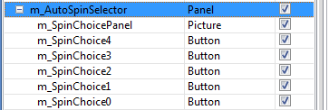

**m_AutoSpinSelector (Panel)**

**m_SpinChoicePanel (Picture – this is the background of the selector)**

**m_SpinChoice( 0 – n ) (Button – number of selection for this auto spin)**

For m_SpinChoice(n) the layout should be added from bottom to top. Start from 0 from the bottom to n-number to the top.

### 2.1.7 Controller Panel

This Panel has 2 Childs panel in it. Normal Spin Control Bar and Free Spin Control Bar.

This 2 bars are the main control for the slot game. Player uses these control bar to manipulate the game.



1. Normal Spin Control Bar

The slot game will display this bar whenever the player in Normal Spin Mode.

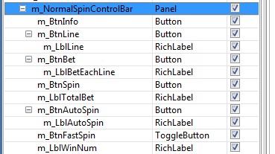

1. m_BtnSpin (Button – for normal spin).
2. m_BtnAutoSpin (Button – for auto spin).
   1. m_LblAutoSpin (RichLabel – to display the number of auto spin).
3. m_BtnFastSpin (ToggleButton – toggle the speed of the reel spin).
4. m_LblWinNum (RichLabel – to display win amount).
5. m_BtnLine (Button – switch number of lines to bet).
   1. m_LblLine (RichLabel – display number of lines to bet).
6. m_BtnBet (Button – button to switch bet amount).
   1. m_LblBetEachLine (RichLabel – display amount of bet).
7. m_LblTotalBet (RichLabel – display the total bet amount).
8. m_BtnInfo (Button – button to toggle help menu).
9. Free Spin Control Bar

This Bar will be display in Free Spin Mode.

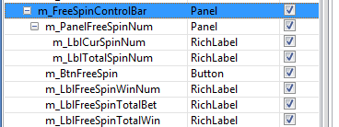

1. m_BtnFreeSpin (Button – this button only serve as a spin stopper).
2. m_LblFreeSpinTotalWin (RichLabel – to display total win in free spin).
3. m_LblFreeSpinWinNum (RichLabel – to display win amount in each spin).
4. m_LblFreeSpinTotalBet (RichLabel – to display total bet).
5. m_PanelFreeSpinNum (Panel – to display number of remaining spin).
   1. m_LblCurSpinNum (RichLabel – Current available spin).
   2. m_LblTotalSpinNum (RichLabel – Total available spin).

### 2.1.8 Full Basic hierarchy for base_game.ui

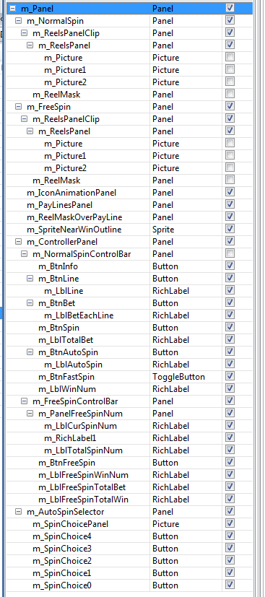

## 2.2 paytable.ui

This ui is use in the information panel. This ui contents how to play information for a particular slot machine. We will break it down into several subsection and all this subsection are elements attached directly under the root Panel of paytable.ui.

### 2.2.1 Buttons

We need 3 buttons to control the paytable pages.

m_BackBtn (Button) – back to game button.

m_NextBtn (Button) – next page button.

m_PrevBtn (Button) – previous page button.



### 2.2.2 Pages

Game play instructions are layered out in pages. Below shows the required hierarchy of the page panel. Page number needs to follow ascending order.

Name to Panel as m_Page(n)

