Contents
Objective 2
Flowchart 3
Key Requirements 4
1. Ticker Matching 4
2. Quantity Matching 4
3. Trade Direction Matching 4
4. Trade Value Validation 4
5. Broker-Specific Matching Logic 4
6. Instrument Details & Validations 4
Matching Logic Flow (Step-by-Step) 4
Unmatched Trade Handling 5
Reporting & Dashboards 5
Security & Access Control 5
Future Scope 6
Conclusion 6

Understanding Document for Cash-Futures Matching System

Objective
To ensure accurate matching and validation between cash and futures trades in terms of:
- Quantity
- Ticker Mapping
- Trade Direction
- Trade Value
This system will also incorporate broker-specific logic and instrument-level details to ensure complete and accurate trade reconciliation.
Flowchart
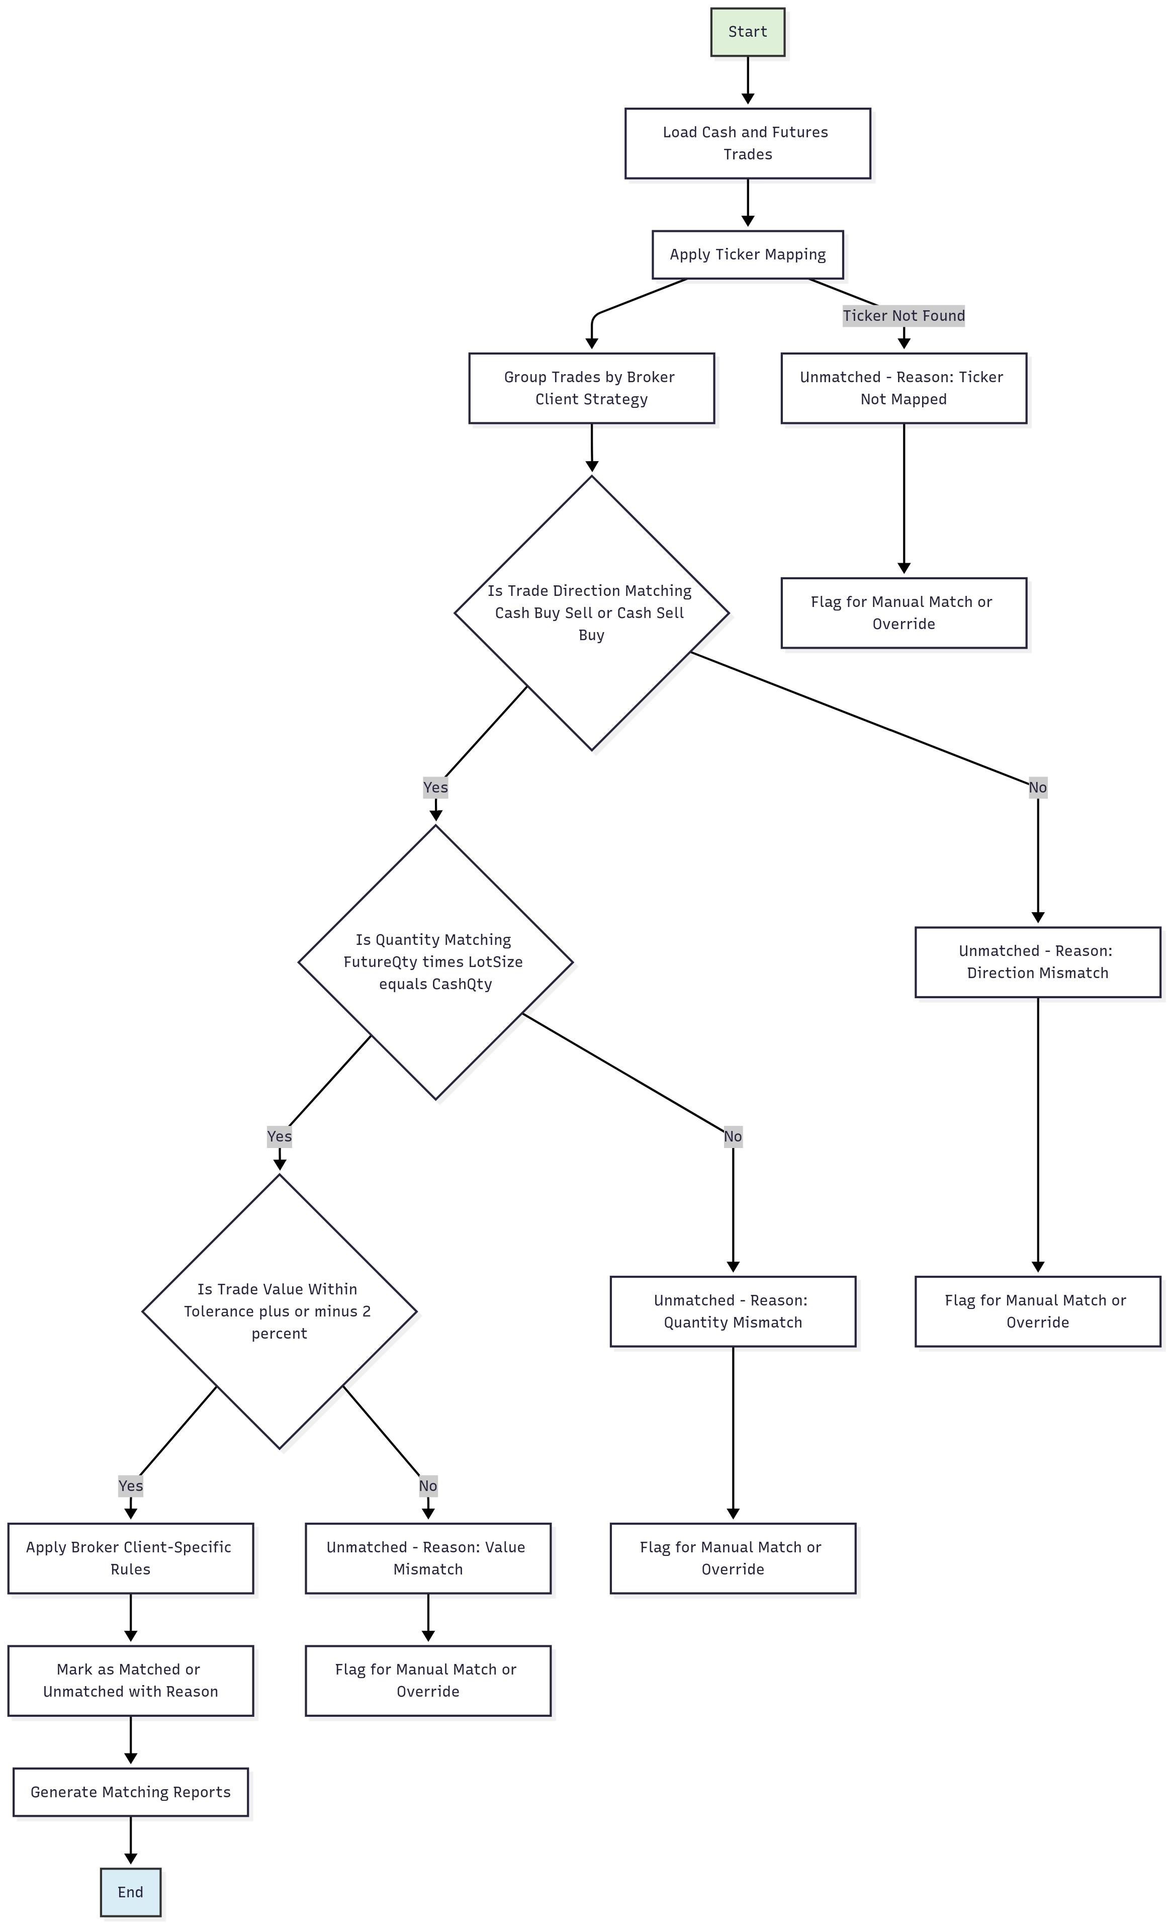

Key Requirements

1. Ticker Matching
- Match Cash Ticker with its corresponding Futures Ticker.
- Maintain a Ticker Mapping Master table that maps each cash instrument with its valid future instrument(s).
- Example: RELIANCE-EQ (Cash) → RELIANCE24JULFUT (Future)

2. Quantity Matching
- Validate that the traded quantity in the cash market is correctly matched with the lot size and quantity in the futures market.
- Example: 1500 shares in cash may match with 3 lots of 500 in futures.

3. Trade Direction Matching
- Ensure that the buy/sell direction is correctly aligned for both instruments:
- Cash Buy → Futures Sell
- Cash Sell → Futures Buy
- Trade direction rules may differ based on strategy type (e.g., arbitrage, hedge).

4. Trade Value Validation
- Calculate the trade value as:
- Trade Value = Quantity × Price
- Validate whether the trade values (cash vs future) are within an acceptable tolerance range.
- Example: Value difference allowed within ±2%

5. Broker-Specific Matching Logic
- Custom rules depending on the broker or client profile:
- Matching behavior
- Tolerance levels
- Priority rules (e.g., FIFO, LIFO)
- Option to define broker-specific configurations in the system.

6. Instrument Details & Validations
- Validate:
- Lot Size
- Expiry Date
- Instrument Type (Equity, Index, Commodity)
- Mismatches due to lot or expiry date must be flagged.

Matching Logic Flow (Step-by-Step)
1. Import Trades from the trading system (Cash & Futures).
2. Apply Ticker Mapping using master table.
3. Group Trades by:
- Broker
- Client
- Strategy
4. Perform Direction Validation.
5. Match Quantities (considering lot size).
6. Validate Trade Value (within tolerance).
7. Apply Broker-Specific Rules.
8. Mark as:
- Matched
- Unmatched
- Partially Matched
9. Generate reports and logs for further analysis.

Unmatched Trade Handling
- Highlight mismatches with clear reason codes, such as:
- "Ticker not mapped"
- "Direction mismatch"
- "Quantity mismatch"
- Allow users to perform:
- Manual Match
- Override
- Reprocessing

Reporting & Dashboards
- Daily Match Summary
- Broker-wise Matching Report
- Unmatched Trades Report
- Trade-wise Matching Log
- Filters:
- Date
- Ticker
- Client
- Broker

Security & Access Control
- Role-based access for:
- Admin
- Analyst
- Auditor
- Logs for:
- Manual changes
- Overrides
- Errors

Future Scope
- Real-time Matching Integration (OMS/EMS)
- ML-based Match Suggestions
- Auto-Matching Tolerance Engine
- Broker Portal/API Access

Conclusion
This system aims to bring accuracy, transparency, and efficiency in reconciling cash and futures trades with minimal manual intervention and robust reporting.

