1.TABLE COUNTRIES

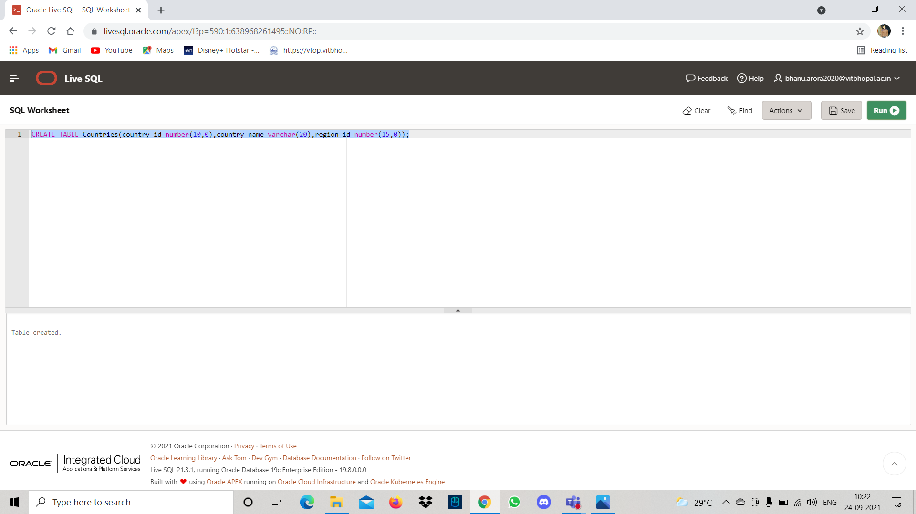

2.TABLE DEPARTMENT



INSERT IN DEPARTMENT

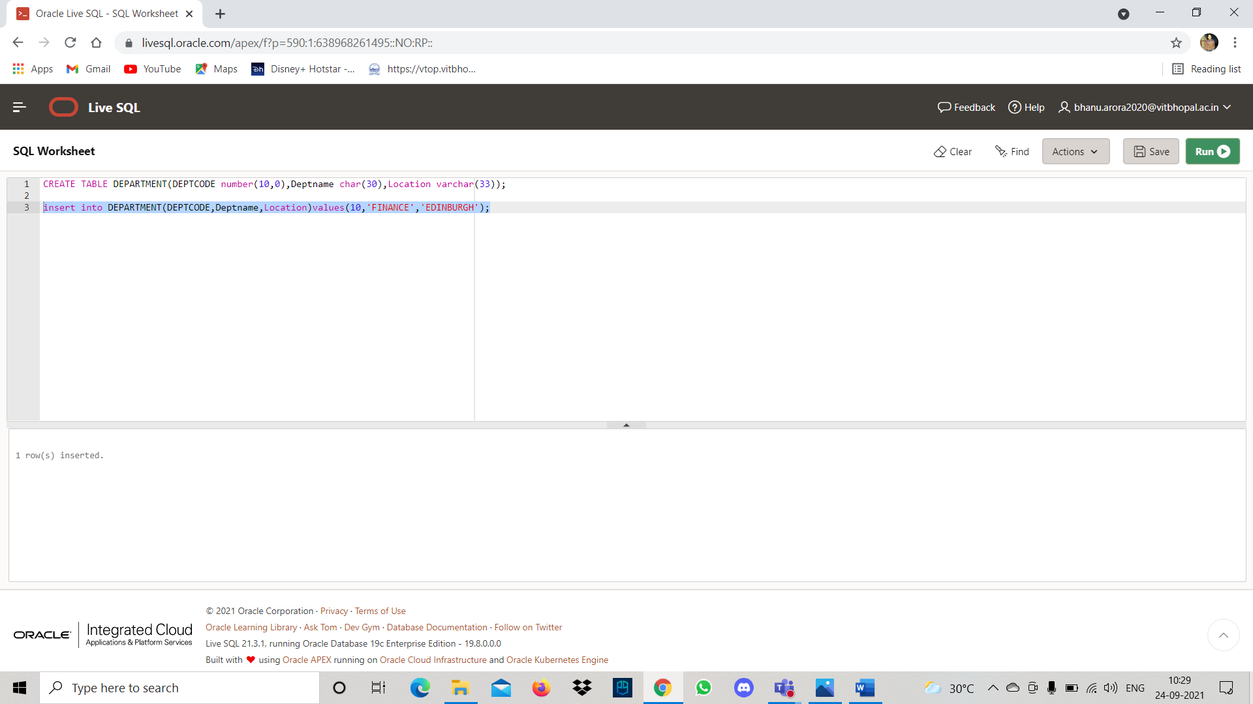

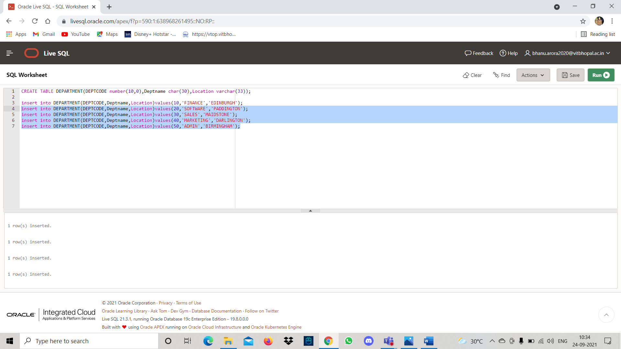

3.TABLE EMPLOYEE

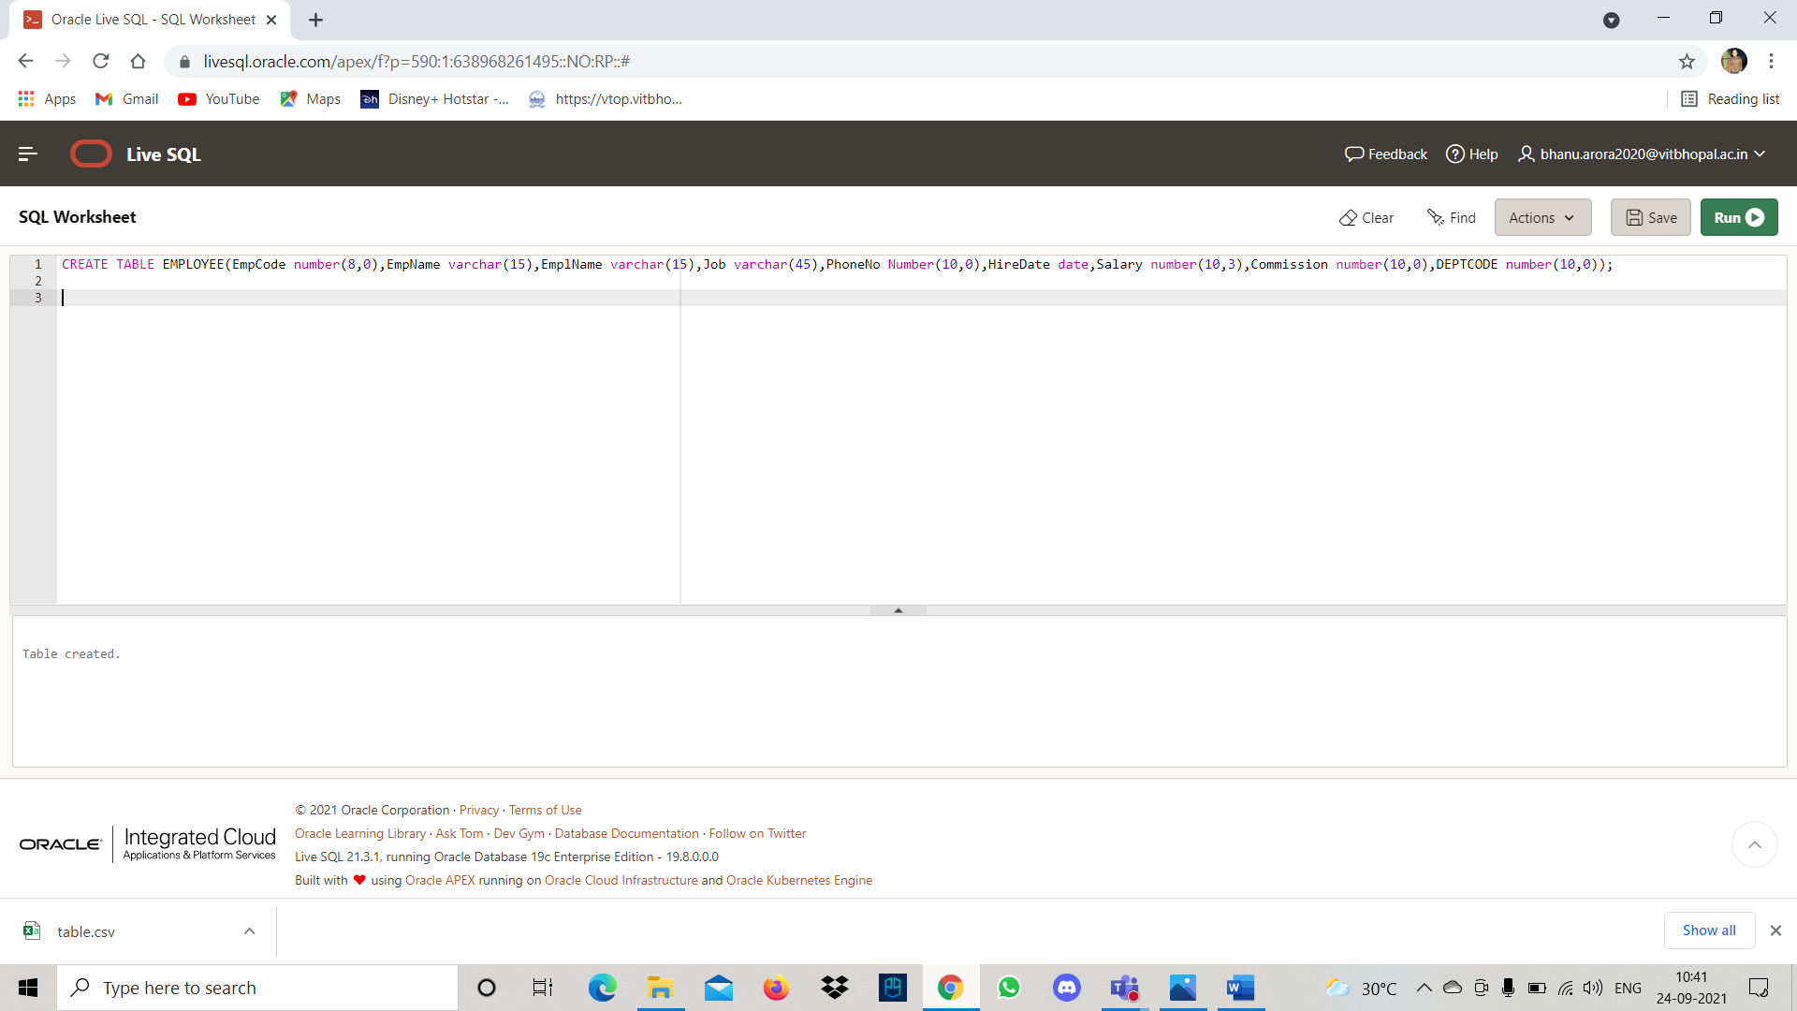

INSERT IN EMPLOYEE TABLE

