**ANSWERS**

Bhanu Chauhan

17BCE10112

bhanuchauhan669@gmail.com

SECTION: 1

For better understanding firstly I will be making tables with values given in Assessment.

Table: - Employee

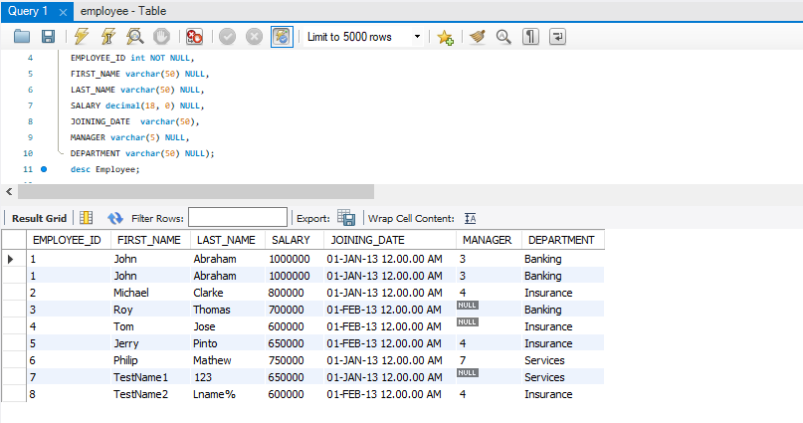

Table: - Incentives

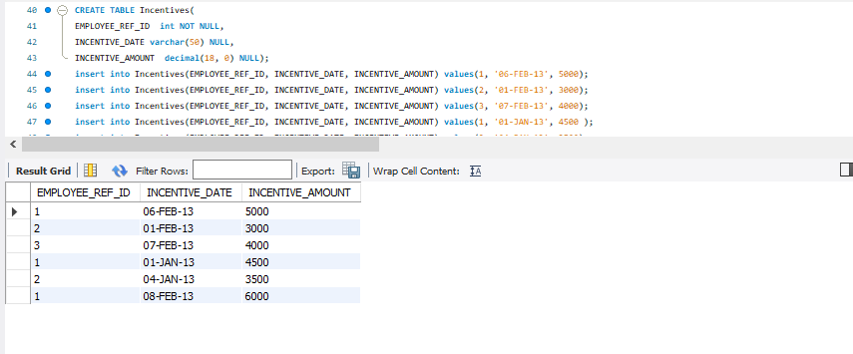

**­­­­**

1. Write a query to print the number of employees per department in the organization

**Ans:**

**SELECT DEPARTMENT, COUNT(*)**

**FROM Employee**

**GROUP BY DEPARTMENT;**

**Explanation:**

For printing no. of employee per department Group BY clause is used here. Group By

clause is used for grouping data with respect to column.

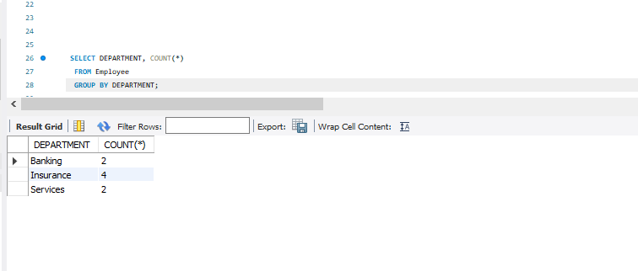

2. Write an SQL query to find the name of the top-level manager of each department

**Ans:**

**SELECT FIRST_NAME, LAST_NAME,**

**MAX(MANAGER) FROM Employee**

**GROUP BY DEPARTMENT;**

**Explaination:**

For finding top-level-manager of each department maximum value of Manager

column is taken after grouping with respect to Department column.

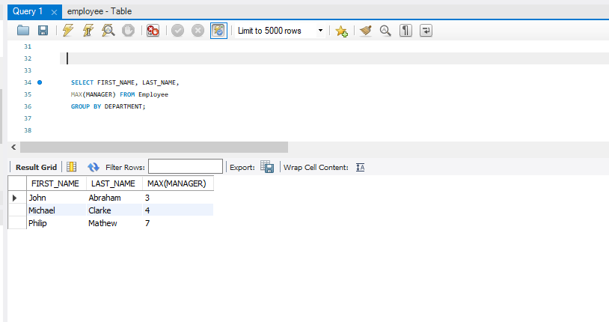

3.Write a query to find the total incentive received by a given employee in a given month.

**Ans:**

**SELECT a.EMPLOYEE_ID, sum(b.INCENTIVE_AMOUNT) AMOUNT**

**FROM Employee a, Incentives b**

**WHERE a.EMPLOYEE_ID = b.EMPLOYEE_REF_ID and**

**substring(b.INCENTIVE_DATE,4,3) = 'FEB' and a.EMPLOYEE_ID=1;**

**Explanation:** Here to find given employee’s total incentive in given month, firstly month is

extracted from the date after that sum all the incentives of the given employee id in particular

month. In answer I have taken Employee_ID as 1 for given employee and for given month FEB.

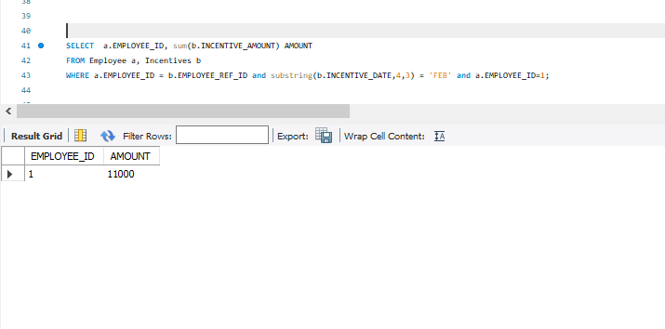

4. Write a query to find the month where employees got maximum incentive

**Ans:**

SELECT MAX(INCENTIVE_AMOUNT),

substring(INCENTIVE_DATE,4,3) Month

FROM Incentives;

**Explanation:** Firstly, the month is extracted from date and the month which is having maximum

incentive will be printed.

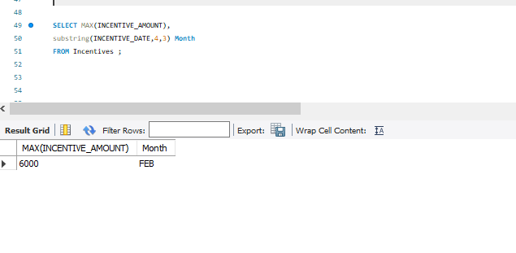

SECTION:2

1. You have two sand timers, which can show 4 minutes and 7 minutes respectively. Use both the sand timers (at a time or one

after other or any other combination) and measure a time of 9 minutes.

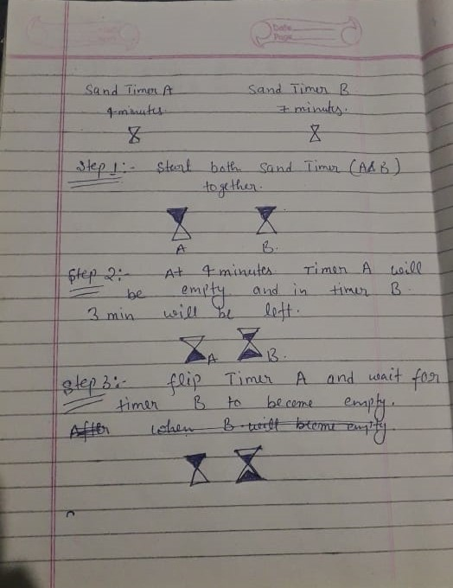 **Ans:**  For better Understandability I am attaching my notebook images for the solution of this question.

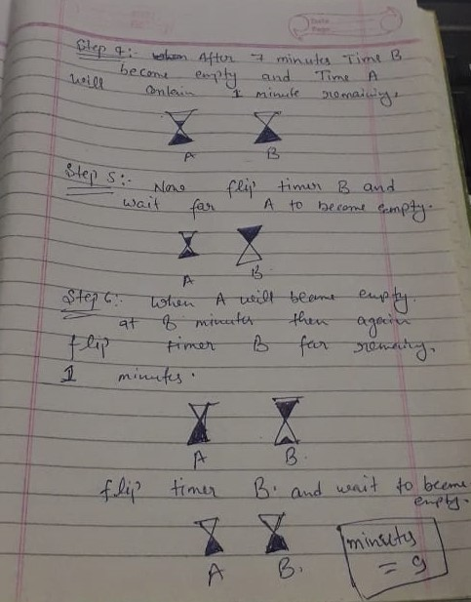

2. John and Mary are a married couple. They have two kids, one of them is a girl. Assume safely that the probability

of each gender is 1/2. What is the probability that the other kid is also a girl?

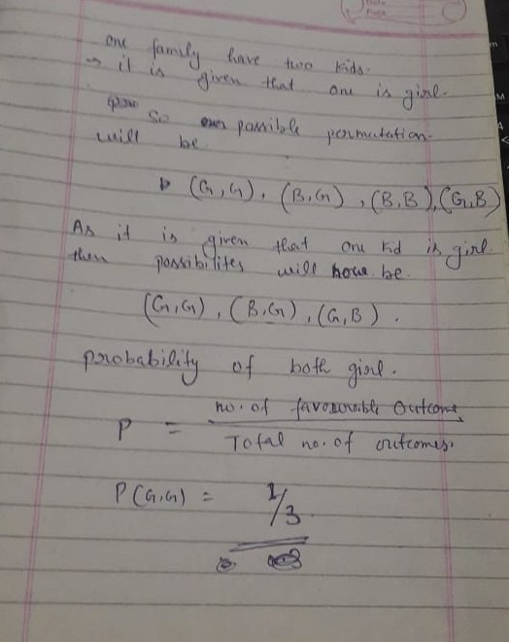 **Ans:**

3. Ron’s Cafe began advertising on our local radio station this year and was delighted to see its business increase

by 10 percent over last year's totals. Their success shows you how you can use radio advertising to make your

business more profitable.

**Ans:**

Nowadays, Advertisement is having a great impact on our life and increasing day by day. A big part of the company’s profit goes for advertisement. As our lifestyle is changing the advertisement are also changing. Before 30-40 decades when people used to hear the radio. Television was costly and at that time radio was the mode of entertainment. And if more the users were there, the advertisements which were broadcasted on the radio had great impact. But due to fast-growing technologies, nowadays the radio has outdated so the no. of advertisers and users both have decreased. So, In the above paragraph radio is advertising that due to advertisement on the radio, Ron’s café business increase is 10% as compared to last year. But here it is clearly seen that the Radio station is advertising itself with the help of Ron’s cafe.  It happens only because of technologies which are growing exponentially so the users of radio are nowadays shifted to television. If we will go into deep of advertisement then at last, we come to the conclusion that a huge amount of economy is wasting into the advertisement. The money which is invested in this advertisement is of no use, only used to increase the profit of the organization. If the money somehow can be preserved then it will help so much for the growth of the nation. If we are seeing any advertisement then it means that we are wasting our money. Suppose Oreo biscuit advertisement is there and anyone is seeing that ad, company is putting money into it. So, the cost of that product will increase and have to pay more. With this, we can conclude that “Burning money, for money”.