INT374 : DATA ANALYTICS WITH POWER BI

PROJECT REPORT
(Project Semester August-January 2025)

Mutual Fund Analysis

PERFORMANCE ANALYSIS

Discipline of CSE
Lovely School of Computer Science & Engineering
Lovely Professional University, Phagwara

Submitted by:
Name: Bhanu Prasad Reddy
Reg No : 12315755
Section: K23CD
Course Code: INT374

Under the Guidance of
Dr. Madhu Bala (31770)
Associate Professor

CERTIFICATE
This is to certify that Bhanu Prasad Reddy bearing Registration No. 12315755 has successfully completed the course project titled “Mutual Fund Analysis Using Power BI” under my guidance and supervision for the course INT374. The work presented is original and meets the academic requirements.
Dr. Madhu Bala (31770)
Associate Professor
School of Computer Science & Engineering
Lovely Professional University, Phagwara
Date:17/12/2025

DECLARATION
I,Bhanu Prasad Reddy, student of B.Tech Computer Science & Engineering under CSE Discipline at Lovely Professional University, Punjab, hereby declare that all the information furnished in this project report is based on my own intensive work and is genuine. This project work is original and has not been submitted elsewhere for any academic award.
Date: 17/12/2025
Registration No: 12315755
Signature:


Name: Bhanu Prasad Reddy

ACKNOWLEDGEMENT
I would like to express my sincere gratitude to my mentor Dr. Madhu Bala mam, Assistant Professor at Lovely Professional University, for their continuous support, guidance, and encouragement throughout the course of this project.
I would also like to thank all faculty members of the School of Computer Science and Engineering for providing the resources and learning environment that enabled me to undertake this research. Lastly, I extend my heartfelt thanks to my family and friends for their moral support and motivation.

TABLE OF CONTENTS
TITLE | Page no
- Introduction | 6
- Background of Mutual Fund Industry | 7
- Objectives of the Project | 8
- Source of Dataset | 8
- Tools and Technologies Used | 9
- Exploratory Data Analysis (EDA) Process | 10
- Dashboard Design (Design Framework) | 12
- Analysis on Dataset | 14 – 25
- 8.0 Overall Dashboard Overview | 14
- 8.1 Key Performance Indicator (KPI) Overview of Mutual Fund | 17
- 8.2 Return Analysis Across Fund Categories and Investment Horizons | 18
- 8.3 Cost vs Return Analysis (Expense Ratio vs Long-Term Returns) | 19
- 8.4 Detailed Mutual Fund Comparison Analysis | 21
- 8.5 Top Mutual Funds Recommendation Based on 5-Year Returns | 22
- 8.6 Lumpsum Investment Calculator and Investment Planning Analysis | 24
- Key Insights and Findings | 25
- Conclusion | 26
- Future Scope | 27
- References | 27
- LinkedIn | 28

1. INTRODUCTION
Investment and financial planning play a vital role in the economic well-being of individuals as well as the overall stability of a country’s financial system. With rising income levels, increasing financial awareness, and growing participation in capital markets, mutual funds have emerged as one of the most popular investment instruments among retail and institutional investors. Mutual funds offer diversification, professional fund management, liquidity, and accessibility, making them suitable for investors with varying risk appetites and financial goals. In a developing economy like India, mutual funds contribute significantly to capital formation and channel household savings into productive sectors of the economy.
The Indian mutual fund industry has witnessed rapid growth over the past few decades, driven by regulatory reforms, digital platforms, and increasing investor participation. Today, the industry offers a wide range of schemes such as equity funds, debt funds, hybrid funds, and thematic funds, each designed to meet specific investment objectives. However, the availability of numerous schemes across different Asset Management Companies (AMCs) also makes the investment decision process complex. Investors often find it challenging to compare funds based on performance, expense ratios, risk levels, and long-term return potential.
One of the key challenges in mutual fund analysis is the effective evaluation of both performance and cost efficiency. While higher returns are desirable, they must be assessed in relation to expense ratios and investment duration to determine the true value generated for investors. Traditional analysis methods using static tables, spreadsheets, or basic charts often fail to provide a comprehensive and interactive view of fund performance. Such methods make it difficult to identify top-performing funds, compare categories, and understand long-term investment outcomes in a clear and meaningful manner.
To overcome these limitations, there is a growing need for data-driven analytical tools that can transform complex financial data into intuitive and interactive insights. Business intelligence tools like Power BI enable users to analyze large datasets efficiently, apply advanced calculations, and visualize key performance indicators in a dynamic way. Power BI allows investors, analysts, and decision-makers to explore data through filters, slicers, and interactive dashboards, thereby enhancing understanding and supporting informed investment decisions..
In this project, Power BI is used as a data visualization and analytics tool to analyze mutual fund data related to fund categories, expense ratios, assets under management, and historical returns over different time horizons. The project focuses on developing interactive dashboards that highlight long-term fund performance, cost versus return relationships, and category-wise comparisons. In addition, an investment calculator is designed to estimate SIP and lumpsum investment outcomes, providing insights into invested amount, expected returns, and total portfolio value.
The dashboards developed as part of this project enable users to quickly identify top-performing mutual funds, evaluate cost efficiency, and compare investment strategies across different fund categories. By presenting financial data in a clear, structured, and visually meaningful manner, this project demonstrates how data analytics and visualization can enhance mutual fund analysis and support better financial planning and investment decision-making.

2. BACKGROUND OF MUTUAL FUND INDUSTRY
The mutual fund industry in India has emerged as a key component of the country’s financial system, offering investors a structured and professionally managed avenue for wealth creation. Mutual funds pool money from multiple investors and invest it in diversified portfolios of equities, debt instruments, or a combination of both. This structure enables investors to participate in financial markets with reduced risk through diversification and professional fund management. Over the years, mutual funds have gained popularity due to their transparency, liquidity, and suitability for investors with different financial goals and risk preferences.
The growth of the mutual fund industry has been supported by regulatory frameworks established by the Securities and Exchange Board of India (SEBI), along with initiatives to improve investor awareness and accessibility. The introduction of various fund categories such as equity funds, debt funds, hybrid funds, index funds, and sectoral funds has allowed investors to choose schemes based on their return expectations and risk appetite. Additionally, investment modes such as Systematic Investment Plans (SIPs) and lumpsum investments have made mutual funds more accessible to a wider population, including retail investors.
Over time, the industry has expanded significantly in terms of assets under management (AUM), number of schemes, and investor participation. Each fund category differs in its investment objective, risk level, expense ratio, and return potential. While equity-oriented funds focus on long-term capital appreciation, debt funds aim to provide stable income with lower risk, and hybrid funds balance risk and return through asset allocation. Understanding these differences is essential for evaluating fund performance and making informed investment decisions.
Assessing the performance of mutual funds requires an integrated analysis of multiple indicators such as historical returns, expense ratios, fund size, and investment duration. Evaluating these parameters together provides a more comprehensive understanding of a fund’s efficiency and suitability. An integrated approach helps investors identify top-performing funds, compare cost versus return efficiency, and recognize trends across different fund categories. Such analysis forms the foundation for effective financial planning and informed decision-making in the mutual fund investment process.

3. OBJECTIVES OF THE PROJECT
The key objectives of this project are:
- To analyze the long-term performance of mutual funds using historical return data.
- To identify top-performing mutual funds based on 5-year return analysis.
- To compare expense ratios against returns to evaluate cost efficiency of funds.
- To enable category-wise analysis of mutual funds such as equity, debt, and hybrid.
- To develop an interactive lumpsum investment calculator for return estimation.
- To present key investment metrics including invested amount, estimated returns, and total value.
- To provide an interactive and user-friendly Power BI dashboard for informed investment decision-making.

SOURCE OF DATASET
The dataset used in this project was obtained from Kaggle, a well-known open data platform that provides datasets for educational, research, and analytical purposes. Kaggle hosts datasets contributed by data practitioners, researchers, and analysts from across the world. Using a Kaggle dataset allows access to structured and comprehensive data suitable for performing exploratory data analysis and building analytical dashboards using business intelligence tools such as Power BI.
The dataset specifically focuses on mutual funds in India and was created by web scraping data from various publicly available online sources related to the Indian mutual fund industry. It contains detailed information on different mutual fund schemes managed by various Asset Management Companies (AMCs). The dataset is designed to support performance comparison, risk evaluation, and category-wise analysis of mutual funds, making it suitable for financial analytics and investment-related studies.
Link: https://www.kaggle.com/datasets/ravibarnawal/mutual-funds-india-detailed
The key attributes included in the dataset are as follows:
- Scheme Name, representing the name of the mutual fund scheme
- Minimum SIP and minimum lumpsum amounts required to start investing
- Expense ratio, expressed as a percentage of the scheme’s average Net Asset Value (NAV)
- Fund size, indicating the total assets under management by the fund
- Fund age, representing the number of years since the scheme’s inception
- Fund manager and AMC name, indicating the management and fund house details
- Risk and performance indicators such as Alpha, Beta, Sharpe Ratio, Sortino Ratio, and Standard Deviation
- Risk level classification ranging from low risk to very high risk
- Fund category and sub-category such as equity, debt, hybrid, large-cap, small-cap, and ELSS
- Historical return percentages for 1-year, 3-year, and 5-year periods
- Scheme rating on a scale of 0 to 5
The dataset contains data on hundreds of mutual fund schemes, providing sufficient volume and variety for meaningful analysis. This data size supports reliable comparison across fund categories, AMCs, and risk levels, and enables the identification of trends, performance patterns, and cost-efficiency differences. The dataset is intended for educational and research purposes, and the analysis carried out in this project is strictly for academic evaluation and learning objectives.

5. TOOLS AND TECHNOLOGIES USED
- Power BI Desktop: Power BI Desktop was used as the primary tool for this project to design interactive dashboards and visual reports. It was used to present complex mutual fund data in a clear and visually meaningful manner using tables, charts, slicers, KPI cards, and comparison visuals. Power BI enabled effective analysis of fund performance, expense ratios, category-wise trends, and investment outcomes.
- Power Query: Power Query was used for data cleaning and data transformation before analysis. It helped in handling missing values, removing duplicate fund records, standardizing column names, and converting data types into the required format. This process ensured that the mutual fund dataset was accurate, consistent, and suitable for reliable analysis.
- DAX (Data Analysis Expressions): DAX was used to create calculated measures and key performance indicators required for the dashboard. It helped in computing metrics such as average returns, ranking of funds based on 5-year returns, SIP and lumpsum investment calculations, total invested amount, estimated returns, and total portfolio value. DAX made the dashboard dynamic and responsive to slicers and user interactions.

6. EXPLORATORY DATA ANALYSIS (EDA) PROCESS
Exploratory Data Analysis (EDA) is an essential phase of the data analytics process, aimed at understanding the structure, quality, and characteristics of the dataset before performing detailed analysis and visualization. In this project, EDA was conducted on the mutual fund dataset using Power Query in Power BI to ensure data accuracy, consistency, and reliability
6.1 Understanding the Dataset Structure
The initial step involved examining the overall structure of the dataset, including the number of records, number of columns, and data types. The dataset contained information related to mutual fund schemes, investment requirements, fund size, risk metrics, performance ratios, and historical returns.
Columns were classified into:
- Categorical variables such as Scheme Name, AMC Name, Category, Sub-category, and Risk Level
- Numerical variables such as expense ratio, fund size, fund age, and return percentages
This step helped identify relevant fields required for performance analysis and dashboard design.
6.2 Handling Missing and Inconsistent Values
Missing and null values were identified using column quality indicators in Power Query. These missing entries were analyzed to determine their impact on calculations. Non-critical missing values were retained, while columns required for key analysis were carefully reviewed to ensure that missing data did not distort results.
6.3 Data Type Validation and Formatting
Data types were validated by inspecting each column and converting them to appropriate formats using the “Change Type” option in Power Query. Numerical fields such as expense ratio, fund size, investment amounts, and return percentages were converted from text to numeric data types to ensure accurate calculations and aggregations.
6.4 Standardization of Column Names
Column names were standardized by renaming them directly in Power Query to maintain clarity and consistency. This was done to improve readability and avoid confusion while creating measures and building visuals in Power BI.
6.5 Removal of Unnecessary Columns
Columns that were not relevant to the analytical objectives were removed using the “Remove Columns” feature in Power Query. This step simplified the data model, improved performance, and ensured that the analysis focused only on essential attributes.
6.6 Handling Duplicate Records
Duplicate records were identified by selecting key columns and using Power Query’s “Remove Duplicates” option. This ensured that each mutual fund scheme was represented only once, preventing inflated counts and incorrect aggregations.
6.7 Creation of Derived Columns
Derived columns were created using Power Query’s custom column feature to support analysis requirements. These transformations helped simplify calculations and prepared the data for efficient use in visuals and measures.
6.8 Final Data Validation for Dashboard Readiness
Before loading the data into the Power BI model, all applied steps were reviewed in the Applied Steps pane to ensure transformations were correctly executed. Sample records were cross-checked to confirm data accuracy and consistency.
This final review ensured that the dataset was clean, consistent, and analysis-ready, making it suitable for building interactive dashboards and deriving reliable insights.
6.9 Outcome of the EDA Process
The Exploratory Data Analysis process played a crucial role in the success of this project. By systematically cleaning, transforming, and validating the Mutual Fund dataset, EDA ensured that the insights generated through the Power BI dashboard were accurate and meaningful.
Overall, The EDA process resulted in a clean, structured, and analysis-ready dataset. By systematically inspecting, transforming, and validating the data, a strong foundation was established for creating reliable DAX measures, interactive dashboards, and meaningful investment insights.

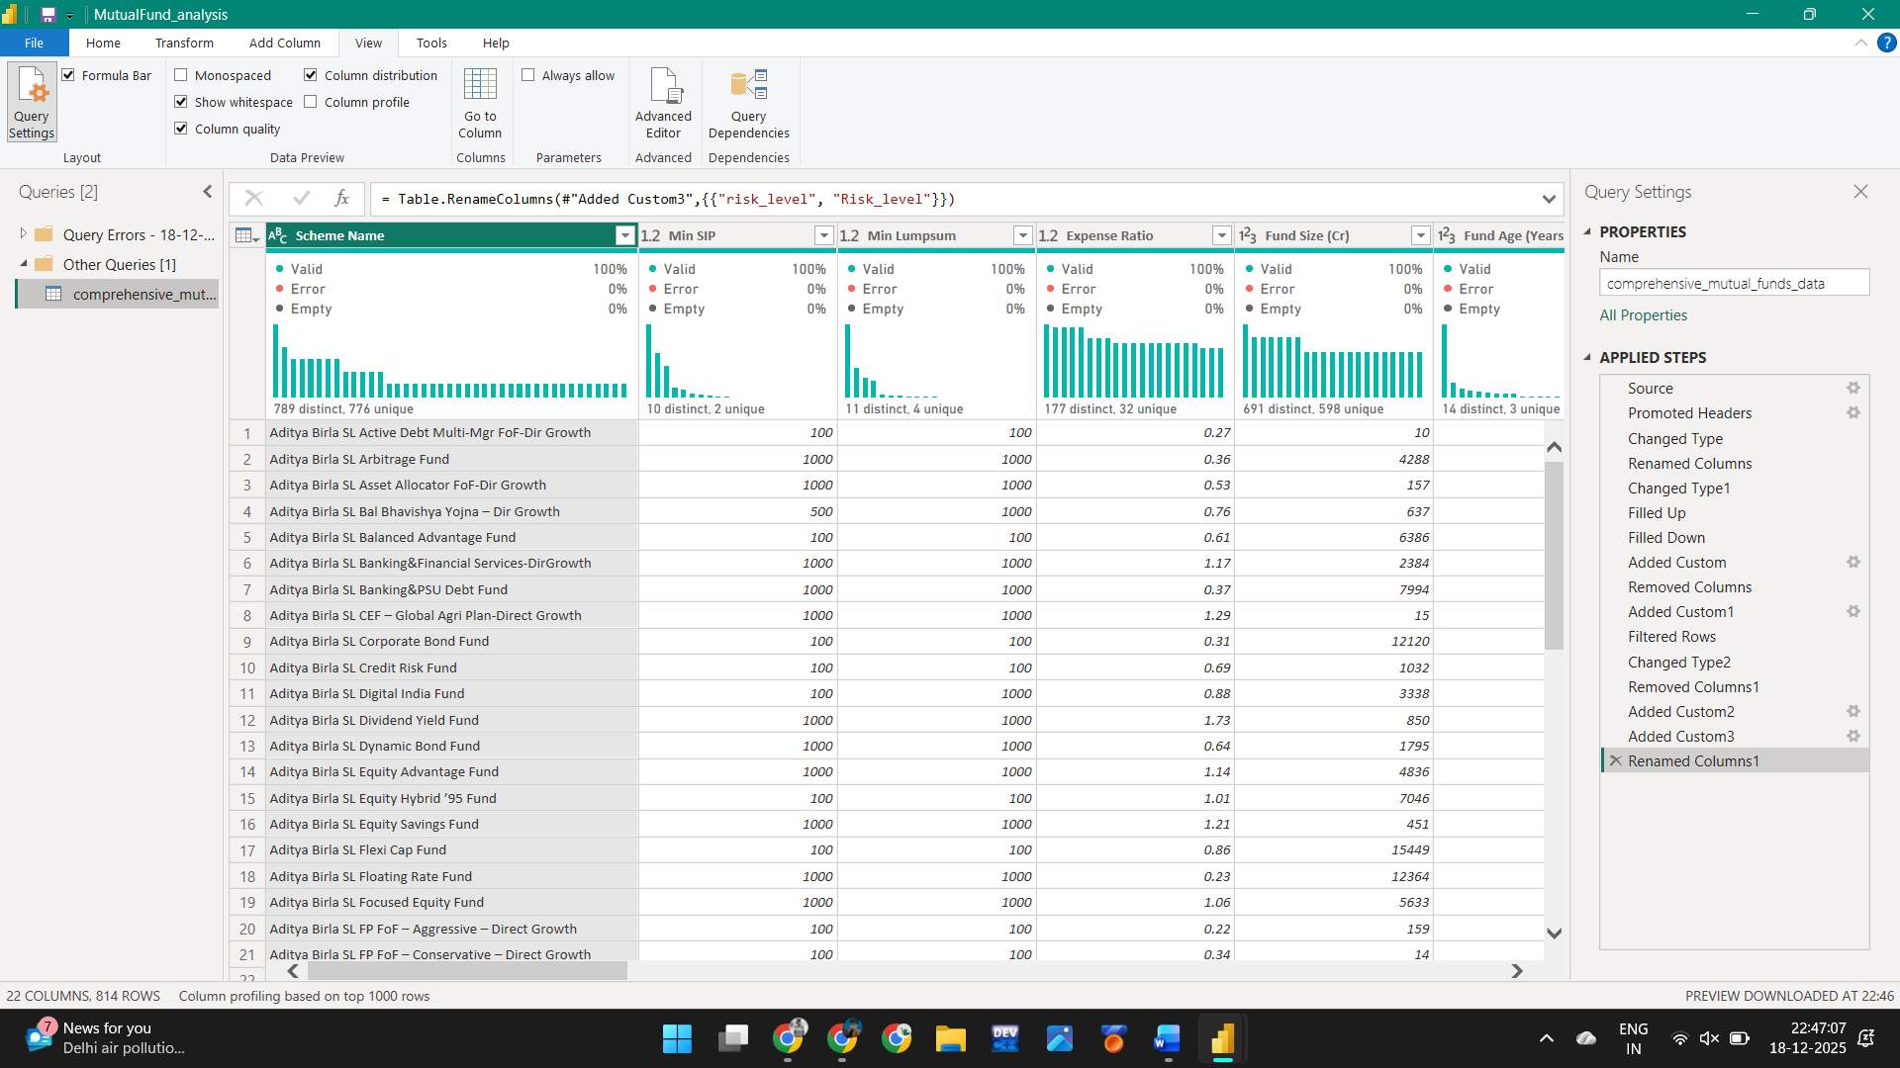

7. DASHBOARD DESIGN (DESIGN FRAMEWORK)
The dashboard design was developed using a structured data storytelling and dashboard design framework to ensure clarity, usability, and effective communication of insights. Instead of directly placing visuals in Power BI, the dashboard layout was first designed using Figma, a visual design and prototyping platform. This approach helped in planning the layout, defining visual hierarchy, and deciding the placement of key elements before implementation. Creating the framework in advance ensured a clean structure, reduced rework, and resulted in a professional and consistent dashboard design.
The first step in the framework was defining the purpose and audience of the dashboard. The dashboard is intended for investors and analysts who want to evaluate mutual fund performance, compare cost efficiency, and estimate investment outcomes. Based on this purpose, the design was planned to support quick decision-making rather than detailed technical analysis.
The layout follows common visual reading patterns such as the Z-pattern, where users naturally start from the top-left and move across and downward. For this reason, Key Performance Indicators (KPIs) such as invested amount, estimated returns, and total portfolio value were placed at the top of the dashboard. These KPIs provide an immediate summary of investment outcomes and help users quickly understand the most important results before exploring detailed visuals.

The dashboard follows a top-down analytical flow, where high-level insights are presented first, followed by more detailed analysis. After the KPI section, charts and tables were placed to show fund performance, expense ratio versus returns, and category-wise comparisons. This progressive flow allows users to first understand the overall picture and then drill down into specific fund-level details.
A key principle of the design framework was eliminating clutter and visual noise. Unnecessary gridlines, excessive colors, background images, and decorative elements were avoided. A consistent color theme was applied across all visuals to maintain visual harmony and readability. Color was used selectively to highlight important trends and differences, ensuring that attention is drawn only to meaningful insights.

Interactivity was an important component of the dashboard framework. Slicers and filters were added to allow users to dynamically explore the data based on fund category, investment type, and other attributes. This interactive design enables users to customize their analysis, compare different mutual funds, and evaluate different investment scenarios without navigating away from the dashboard.

Text elements such as titles and labels were designed to support clear storytelling. Instead of generic chart titles, descriptive and meaningful titles were used to explain what each visual represents. This ensures that the dashboard communicates insights clearly, even to users with limited technical or financial background.

Overall, the dashboard design framework integrates layout planning, visual best practices, and interactivity to transform complex mutual fund data into an intuitive and decision-oriented analytical tool. By designing the framework first in Figma and then implementing it in Power BI, the dashboard effectively supports data-driven investment analysis and informed decision-making.
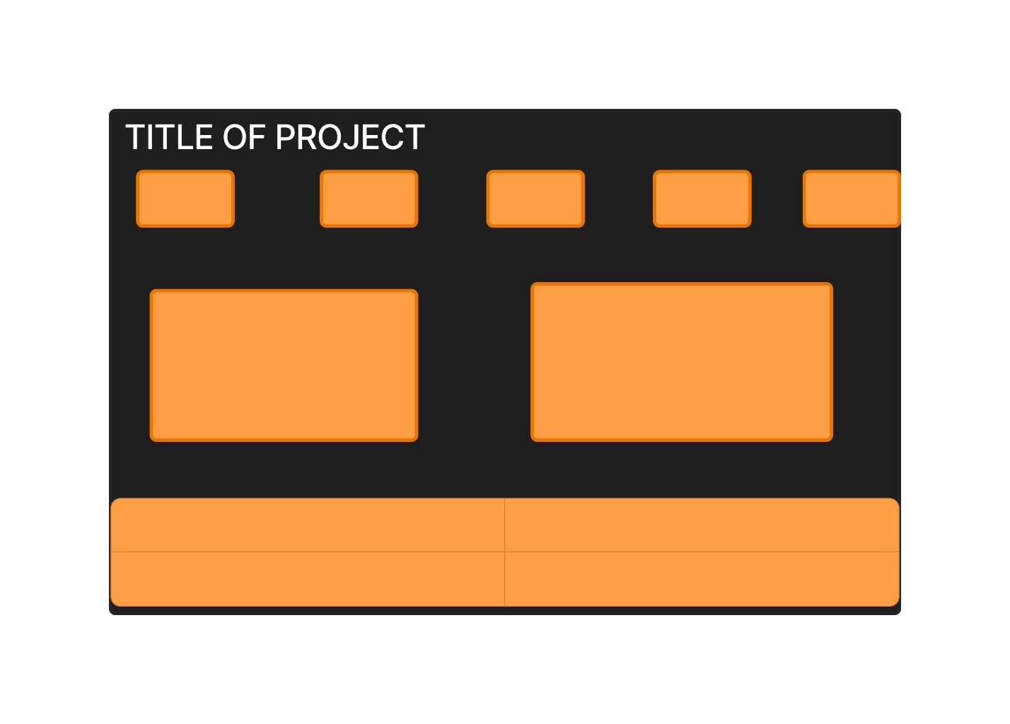

8. Analysis on Dataset

8.0 Overall Dashboard Overview
The Mutual Fund Analytics dashboard was designed as a two-page interactive analytical system to provide a comprehensive view of mutual fund performance and investment planning. The overall dashboard combines descriptive analytics with decision-support features, enabling users to both analyze historical fund performance and simulate future investment outcomes.
The first dashboard page focuses on mutual fund performance analysis across categories, risk levels, and fund houses. It provides a high-level summary of the dataset using KPI cards that display the total number of mutual fund schemes analyzed and the average returns over 1-year, 3-year, and 5-year periods. These KPIs give users an immediate understanding of overall market performance before exploring detailed insights.

Below the KPIs, visualizations are used to analyze return patterns across different fund categories and investment horizons. This helps in comparing how equity, debt, hybrid, and solution-oriented funds perform over short-term and long-term periods. A scatter plot is used to examine the relationship between expense ratio and long-term returns, allowing users to identify whether higher costs consistently result in better performance. A detailed table is also included to support fund-level comparison based on AMC, category, expense ratio, returns, risk level, fund size, and fund age.

The second dashboard page extends the analysis by focusing on mutual fund recommendations and investment planning. This page was added as an enhancement to the project to move beyond descriptive analysis and support practical decision-making. It includes an interactive lumpsum investment calculator, where users can adjust inputs such as investment amount, expected return rate, and investment duration. Based on these inputs, the dashboard dynamically calculates the invested amount, estimated returns, and total portfolio value.

To improve interpretability, the investment outcomes are visualized using KPI cards and a donut chart that compares invested amount versus estimated returns. In addition, a table displaying the top mutual funds based on 5-year returns is provided to support informed fund selection. A note is included to clarify that the calculations are based on historical data and user-defined assumptions, emphasizing that actual investment outcomes may vary due to market conditions.

Overall, the dashboard integrates performance analysis and investment planning into a unified analytical framework. The first page helps users understand historical trends and fund efficiency, while the second page enables scenario-based investment evaluation. This structured approach ensures that the dashboard not only presents data but also supports informed and practical investment decision-making

Figure 8.0: Mutual Fund Performance Analysis Dashboard
Figure 8.0.1: Mutual Fund Recommendation and Investment Calculator Dashboard

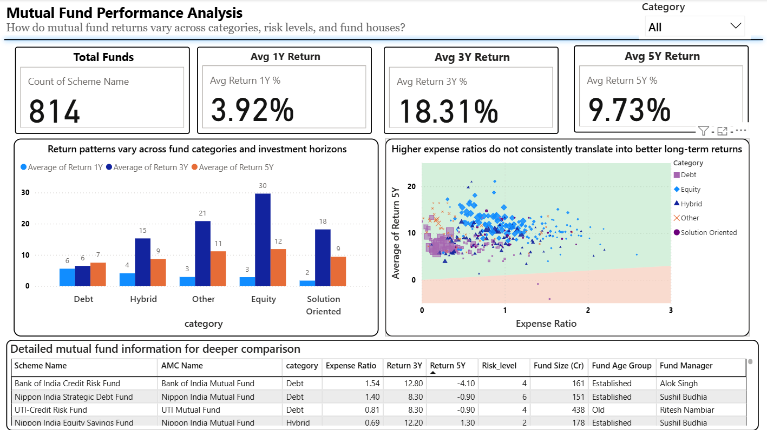

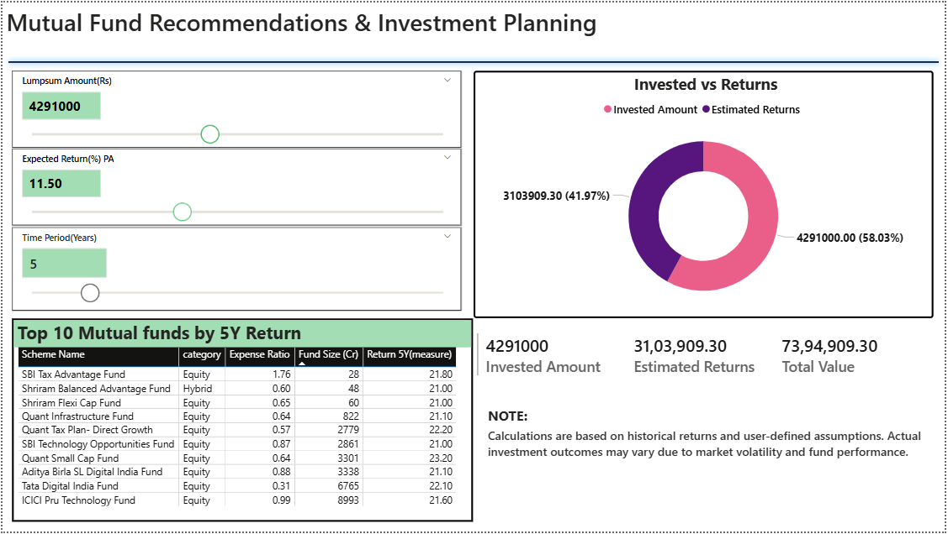

8.1 Key Performance Indicator (KPI) Overview of Mutual Fund Performance
Introduction
Key Performance Indicators (KPIs) play a critical role in summarizing large datasets into easily understandable metrics. In a mutual fund analytics context, KPIs help users quickly grasp the overall market situation before analyzing detailed visualizations. This section focuses on presenting high-level performance indicators that provide an instant snapshot of the mutual fund dataset.
Description of the KPI Visuals
At the top of the dashboard, KPI cards are used to display Total Funds, Average 1-Year Return, Average 3-Year Return, and Average 5-Year Return. These KPI cards were intentionally placed at the top of the dashboard to ensure immediate visibility and to follow a top-down analytical flow.
Each KPI was created using Power BI’s Card visual. The Total Funds KPI represents the count of mutual fund schemes in the dataset, while the return-based KPIs represent the average percentage returns across different investment horizons.
Key Metrics / Aspects Considered
The following KPIs were designed and displayed:
- Total Funds – Count of unique mutual fund schemes
- Average 1-Year Return (%) – Short-term performance indicator
- Average 3-Year Return (%) – Medium-term performance indicator
- Average 5-Year Return (%) – Long-term performance indicator

These metrics were selected to help users compare performance across different investment durations and understand overall market trends.
Figure 8.1: KPI Summary of Mutual Fund Performance
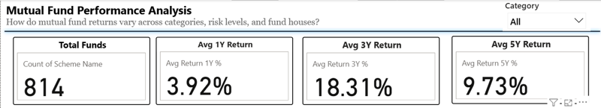

Interpretation and Key Observation
The KPI summary shows that the dataset consists of 814 mutual fund schemes, indicating a wide variety of investment options available in the market. The average return values increase with longer investment horizons, highlighting the importance of long-term investing in mutual funds.
The relatively lower average 1-year return compared to 3-year and 5-year returns reflects short-term market volatility, while higher long-term averages indicate better stability and growth potential over time. These KPIs provide a strong foundation for deeper analysis in subsequent sections of the dashboard.

8.2 Return Analysis Across Fund Categories and Investment Horizons
Introduction
Analyzing mutual fund returns across different categories and investment horizons is essential to understand how various types of funds perform over time. Different fund categories such as equity, debt, hybrid, and solution-oriented funds are designed for different risk appetites and investment goals. Comparing their short-term, medium-term, and long-term returns helps investors choose funds that align with their investment horizon and risk tolerance.
This analysis focuses on identifying how return patterns vary across fund categories over 1-year, 3-year, and 5-year periods.
Description of the Visual
The visual used for this objective is a clustered bar chart that compares the average returns of mutual fund categories across three different investment horizons: 1 year, 3 years, and 5 years. Each category is represented on the x-axis, while the y-axis shows the average return percentage. Different colored bars represent returns for different time periods, allowing easy comparison within and across categories.
Key Metrics / Aspects Considered
The following metrics were considered for this analysis:
- Average 1-Year Return (%)
- Average 3-Year Return (%)
- Average 5-Year Return (%)
- Mutual fund categories such as Debt, Hybrid, Equity, Solution Oriented, and Others
These metrics help in evaluating how performance changes with investment duration for each fund category.
Figure 8.2: Return Patterns Across Fund Categories and Investment Horizons

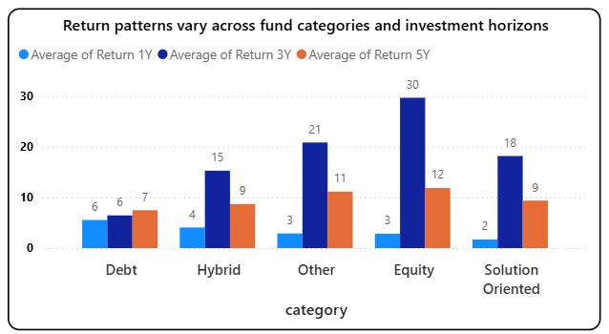
Interpretation and Key Observations
The analysis reveals that equity funds consistently deliver higher average returns over longer investment horizons, particularly in the 3-year and 5-year periods. This indicates that equity-oriented funds are more suitable for long-term wealth creation despite short-term volatility.
Debt funds show relatively stable but lower returns across all time horizons, making them suitable for conservative investors seeking lower risk. Hybrid funds offer moderate returns, balancing growth and stability by combining equity and debt components. Solution-oriented and other specialized funds demonstrate varied performance depending on their underlying investment strategies.
Overall, the chart highlights the importance of aligning fund category selection with investment horizon, as longer holding periods generally result in improved returns, especially for equity-based funds.

8.3 Cost vs Return Analysis (Expense Ratio vs Long-Term Returns)
Introduction
Expense ratio is an important factor in mutual fund selection, as it represents the annual cost charged by fund houses for managing investments. While higher expenses may be associated with active fund management, they do not always guarantee better returns. Analyzing the relationship between expense ratio and long-term returns helps investors understand whether higher costs actually translate into superior performance.
This analysis focuses on evaluating the relationship between expense ratio and average 5-year returns across different mutual fund categories.
Description of the Visual
The visual used for this objective is a scatter plot, where each point represents a mutual fund scheme. The x-axis displays the expense ratio, while the y-axis represents the average 5-year return. Different colors and shapes are used to distinguish fund categories such as equity, debt, hybrid, solution-oriented, and others. The scatter plot allows easy identification of trends, clusters, and outliers in fund performance.
Key Metrics / Aspects Considered
The following parameters were used for cost versus return analysis:
- Expense Ratio (%)
- Average 5-Year Return (%)
- Mutual fund category (Equity, Debt, Hybrid, Solution Oriented, Others)
These metrics together help evaluate the cost efficiency of mutual fund schemes.
Figure 8.3: Expense Ratio vs Average 5-Year Return
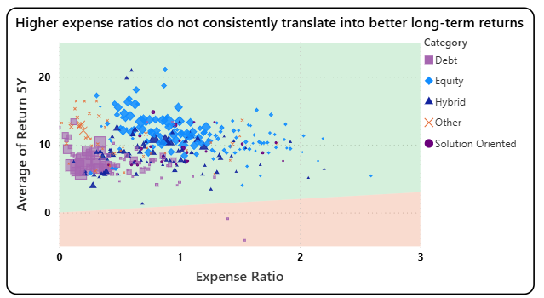
Interpretation and Key Observations
The analysis indicates that higher expense ratios do not consistently result in higher long-term returns. Many funds with relatively low expense ratios deliver competitive or even superior 5-year returns, particularly in the equity category. This suggests that cost efficiency plays a significant role in long-term investment performance.
Equity funds show a wide spread of returns across different expense levels, indicating that fund performance depends more on investment strategy and market exposure than on expense ratio alone. Debt funds generally cluster at lower expense ratios with moderate and stable returns, reflecting their conservative nature.
Overall, the scatter plot highlights the importance of considering expense ratio alongside returns, rather than assuming that higher costs lead to better performance. Investors can benefit by selecting funds that offer a favorable balance between cost and long-term returns.

8.4 Detailed Mutual Fund Comparison Analysis
Introduction
While aggregated metrics and charts provide high-level insights, detailed comparison at the individual fund level is essential for informed decision-making. Investors often need to evaluate specific mutual fund schemes by comparing multiple attributes such as returns, expense ratio, risk level, fund size, and fund management details. This section focuses on a detailed, scheme-level comparison to support deeper analysis and fund selection.
Description of the Visual
The visual used for this objective is a detailed table that displays mutual fund information at the scheme level. The table presents multiple attributes in a structured format, allowing users to compare funds side by side. Sorting and filtering features enable users to quickly identify top-performing funds or analyze funds based on specific criteria such as category or return performance.
Key Metrics / Aspects Considered
The following parameters were included in the detailed comparison:
• Scheme Name
• AMC (Asset Management Company) Name
• Fund Category
• Expense Ratio
• Return over 3-Year and 5-Year periods
• Risk Level
• Fund Size (in Crores)
• Fund Age Group
• Fund Manager
These attributes together provide a comprehensive view of both performance and risk characteristics of individual mutual fund schemes
Figure 8.4: Detailed Mutual Fund Comparison Table
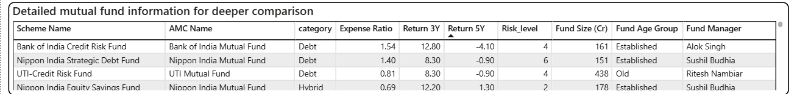
Interpretation and Key Observations
The table reveals significant variation in performance and risk across mutual fund schemes, even within the same category. Some funds exhibit strong long-term returns despite moderate expense ratios, highlighting efficient fund management. In contrast, certain funds with higher expense ratios do not necessarily deliver superior returns, reinforcing the importance of detailed comparison.
Overall, the detailed comparison table enables users to move beyond category-level insights and make scheme-specific evaluations, supporting informed and data-driven investment decisions.

8.5 Top Mutual Funds Recommendation Based on 5-Year Returns
Introduction
Identifying top-performing mutual funds is a key requirement for investors seeking long-term wealth creation. Long-term returns, particularly over a 5-year period, provide a more reliable indicator of a fund’s performance as they smooth out short-term market volatility. This objective focuses on recommending mutual funds based on their long-term return potential.
Description of the Visual
The visual used for this objective is a tabular representation that displays the Top 10 mutual fund schemes based on 5-year returns. The table includes important attributes such as scheme name, fund category, expense ratio, fund size, and 5-year return measure. The table is sorted in descending order of 5-year returns to highlight the best-performing funds.
Key Metrics / Aspects Considered
The following parameters were used for mutual fund recommendation:
• Return over 5-Year period (%)
• Fund Category
• Expense Ratio
• Fund Size (in Crores)
• Scheme Name
These metrics help in identifying funds that have delivered consistent long-term performance while also providing context regarding cost and scale.
Figure 8.5: Top 10 Mutual Funds by 5-Year Return
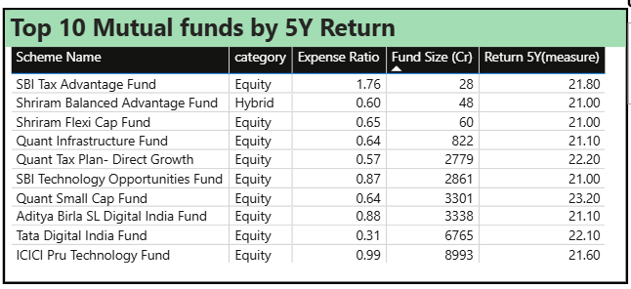
Interpretation and Key Observations
The analysis highlights that equity-oriented funds dominate the top 10 list, reinforcing the role of equity funds in long-term wealth creation. Several funds achieve strong 5-year returns despite moderate expense ratios, indicating efficient fund management rather than cost-driven performance.
The presence of large fund sizes among top-performing schemes suggests investor confidence and operational stability. This recommendation table enables users to quickly shortlist high-performing funds based on long-term returns while still considering cost and category factors.

8.6 Lumpsum Investment Calculator and Investment Planning Analysis
Introduction
Investment planning is not limited to selecting funds; it also involves estimating future returns based on investment amount, expected rate of return, and time horizon. A lumpsum investment calculator helps investors understand the potential growth of a one-time investment and supports better financial planning. This objective focuses on analyzing investment outcomes using an interactive lumpsum calculator.
Description of the Visual
The visual includes interactive input controls for lumpsum amount, expected annual return rate, and investment duration. Based on these inputs, KPI cards dynamically display the invested amount, estimated returns, and total portfolio value. A donut chart visually compares the invested amount against the estimated returns, enhancing interpretability.
Key Metrics / Aspects Considered
• Lumpsum Investment Amount
• Expected Annual Return Rate (%)
• Investment Duration (Years)
• Invested Amount
• Estimated Returns
• Total Portfolio Value
📸 Figure 8.6: Lumpsum Investment Calculator and Return Distribution
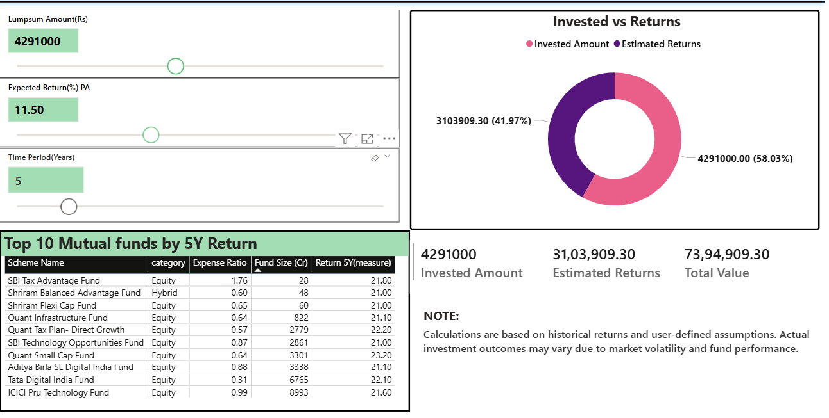
Interpretation and Key Observations
The investment calculator demonstrates how a lumpsum investment grows over time based on user-defined assumptions. The results show that a significant portion of the total portfolio value is contributed by compounded returns over longer durations. The donut chart clearly illustrates the proportion of invested amount versus generated returns, reinforcing the impact of compounding.
This analysis helps users experiment with different investment values and time horizons, making the dashboard not only analytical but also action-oriented. The inclusion of a disclaimer ensures transparency by clarifying that calculations are based on historical data and assumptions, and actual results may vary due to market conditions.

9. KEY INSIGHTS AND FINDINGS
The analysis performed using the Mutual Fund Analytics dashboard led to several important insights related to fund performance, cost efficiency, risk behavior, and investment planning. These insights help in understanding overall market trends and support informed investment decision-making.
• Long-term investment horizons deliver better performance:
The analysis shows that average returns increase significantly over longer investment periods. Equity-oriented mutual funds demonstrate higher average 3-year and 5-year returns compared to short-term returns, highlighting the importance of long-term investing.
• Equity funds outperform other categories over time:
Among all fund categories, equity funds consistently deliver higher long-term returns. Debt funds offer more stable but lower returns, while hybrid and solution-oriented funds provide a balance between growth and stability.
• Higher expense ratios do not guarantee higher returns:
The cost versus return analysis indicates that funds with higher expense ratios do not consistently generate better long-term returns. Several cost-efficient funds with lower expense ratios deliver competitive performance, emphasizing the importance of expense ratio consideration during fund selection
• Significant variation exists at the scheme level:
The detailed comparison table reveals that even within the same category, mutual fund schemes differ widely in returns, risk levels, and fund size. This highlights the need for scheme-level analysis rather than relying only on category averages.
• Top-performing funds are dominated by equity-oriented schemes:
The Top 10 mutual fund recommendation analysis shows that equity funds dominate the list based on 5-year returns. These funds combine strong long-term performance with varying expense ratios and fund sizes, providing multiple options for investors.
• Investment planning tools enhance decision-making:
The lumpsum investment calculator demonstrates the impact of compounding over time. The results show that a substantial portion of total portfolio value comes from estimated returns rather than invested capital, reinforcing the importance of early and long-term investment.
• Interactive dashboards improve insight discovery:
The use of slicers, filters, and interactive visuals allows users to explore data dynamically based on category, returns, and investment parameters. This interactivity enhances understanding and supports personalized investment analysis.
Overall, the insights derived from the dashboard confirm that long-term, cost-efficient, and well-analyzed investments are more likely to generate favorable outcomes. The dashboard successfully transforms complex mutual fund data into actionable insights for investors and analysts.

10. CONCLUSION
This project successfully demonstrates how mutual fund data can be analyzed and transformed into meaningful insights using Power BI. By integrating data cleaning, exploratory analysis, DAX-based calculations, and interactive visualizations, the project provides a comprehensive view of mutual fund performance across different categories, risk levels, and investment horizons. The structured dashboard design enables users to understand both high-level trends and detailed scheme-level information efficiently.
The analysis highlights the importance of long-term investing, cost efficiency, and informed fund selection. Key findings such as the superior long-term performance of equity funds, the weak correlation between expense ratio and returns, and the variation in performance at the scheme level emphasize the need for data-driven decision-making. The inclusion of performance metrics and comparative analysis ensures that investors can evaluate mutual funds based on multiple parameters rather than relying on a single indicator.
In addition, the integration of an interactive investment planning module enhances the practical relevance of the project. The lumpsum investment calculator allows users to simulate real-world investment scenarios and understand the impact of compounding over time. Overall, this project demonstrates the effective use of Power BI as a decision-support tool and reinforces the value of analytics in improving financial planning and investment outcomes.

11. FUTURE SCOPE
The scope of this project can be expanded by integrating real-time or regularly updated market data, enabling continuous monitoring of mutual fund performance. Connecting the dashboard to live financial data sources or APIs would allow investors to track changing market conditions and fund performance dynamically rather than relying on static historical data.
Future enhancements may also include the incorporation of advanced risk and performance metrics such as rolling returns, volatility trends, Sharpe ratio comparisons over time, and downside risk measures. These additions would provide deeper insights into risk-adjusted performance and help investors better align fund selection with their risk tolerance and financial goals.
Additionally, the dashboard can be extended to support personalized investment recommendations by incorporating investor profiles based on age, income, and risk preference. Features such as SIP calculators, goal-based planning modules, and automated fund recommendations could further improve usability and transform the dashboard into a comprehensive personal finance analytics platform.

12. REFERENCES
- Kaggle. Mutual Funds in India Dataset.
Available at: https://www.kaggle.com/datasets/ravibarnawal/mutual-funds-india-detailed
- Microsoft. Power BI Documentation.
Available at: https://learn.microsoft.com/power-bi
(Used for understanding Power BI visuals, Power Query, and DAX concepts)
- Microsoft. DAX Guide and Functions Reference.
Available at: https://learn.microsoft.com/dax
(Referenced for creating calculated measures and KPIs)
- Maven Analytics (YouTube). Data Storytelling and Dashboard Design Principles.
Available at: https://youtu.be/OYbPOhK0wPo?si=GyFNeIwtXCBic-AB

LINKEDIN
Link: www.linkedin.post
Screenshot:


