~~~~~~ Moving Average Algorithm ~~~~~~~

~~~~~~~~~~~~~~~~ Bitcoin trend using short- and long-term moving averages ~~~~~~~~~~~

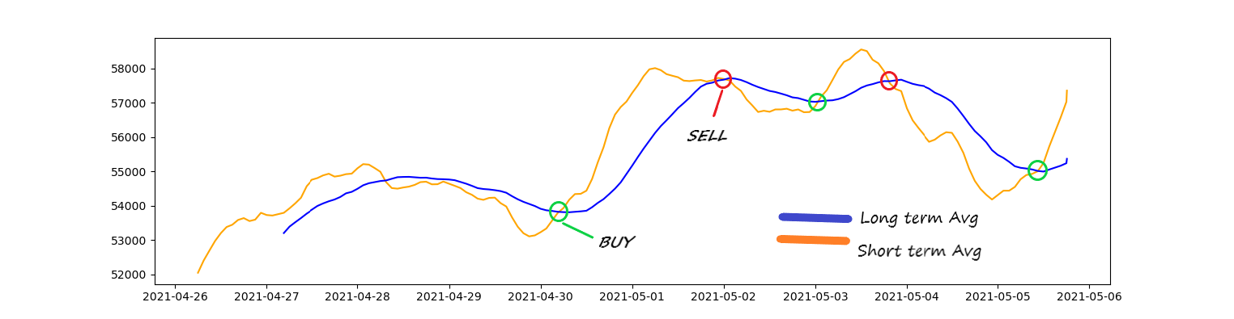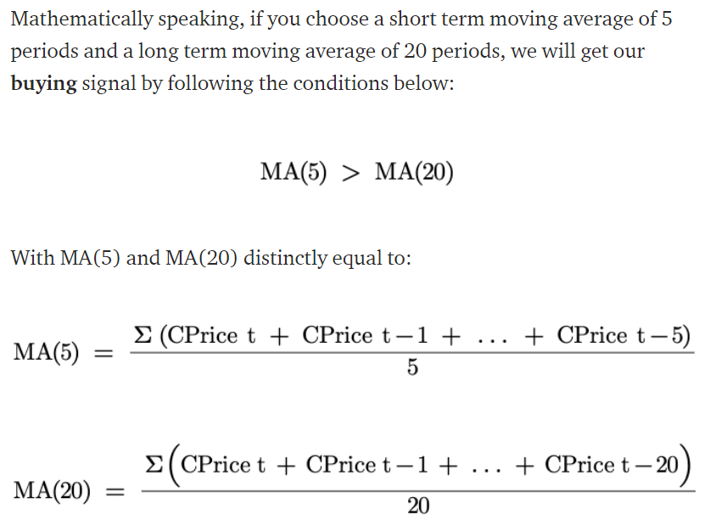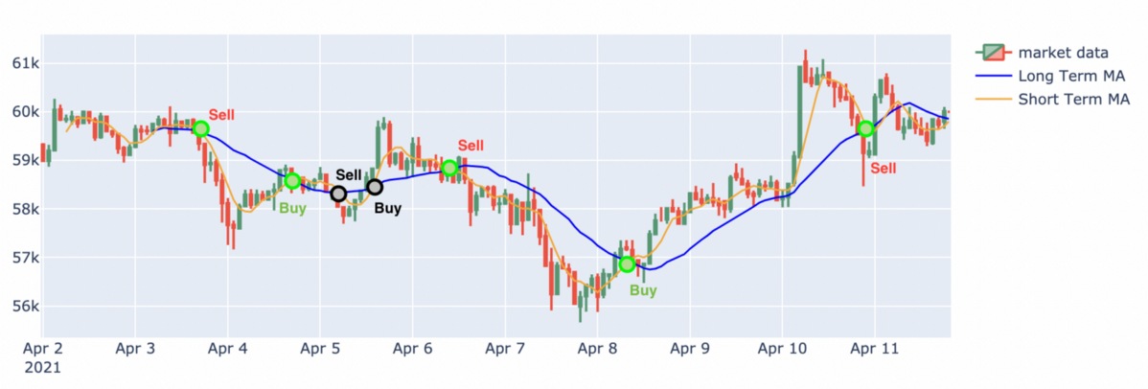-- Buying and Selling signals by comparing short and long term moving avgs