**GCC assignment**

1. Login into the Linux server with your login Ids:

1. Create a new directory called code_cov in your home directory <home>



1. Go inside the directory you have created in (2) /<home>/code_cov

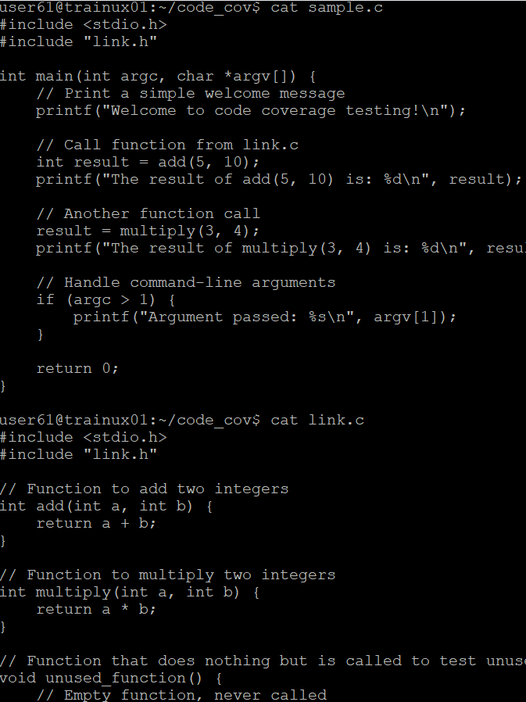

6. Compile the files sample.c and sample1.c and put the output in the executable file called output



7. Execute the file output

8. Now run gcov for each source file one by one

9.Run output again, this time with command line arguments:

>> vi sample.c.gcov

10. Now run gcov for sample.c again

