To enroll the device in Autopilot enrollment via Intune, we need to be added HWID in Intune.
And once its sync with profile.
HWID we can download from User device using PowerShell script.
So, we have below script, which is MS suggested.
In user Device search with PowerShell, and then click the Run as administrator.
Like below
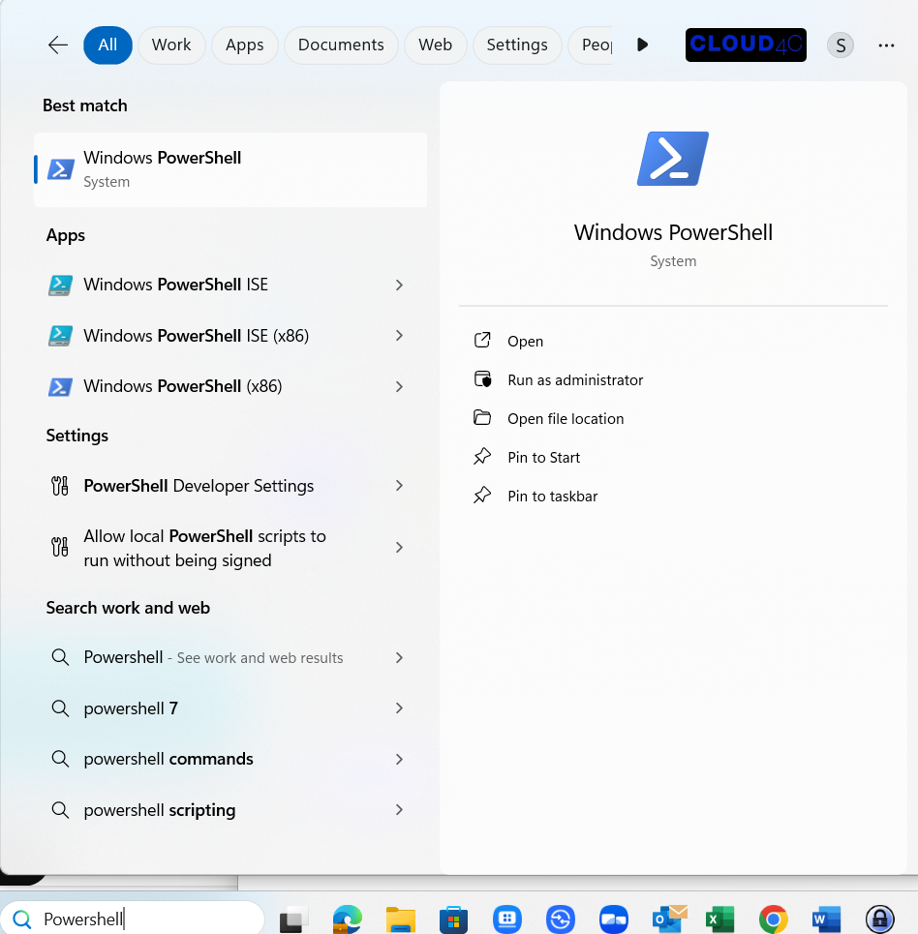
MAG
And then copy below script and then paste in PowerShell.
It will ask you with two options. “YES or NO”. Click on YES. It will download Meanwhile.

[Net.ServicePointManager]::SecurityProtocol = [Net.SecurityProtocolType]::Tls12
New-Item -Type Directory -Path "C:\HWID"
Set-Location -Path "C:\HWID"
$env:Path += ";C:\Program Files\WindowsPowerShell\Scripts"
Set-ExecutionPolicy -Scope Process -ExecutionPolicy RemoteSigned
Install-Script -Name Get-WindowsAutopilotInfo
Get-WindowsAutopilotInfo -OutputFile AutopilotHWID.csv

The hardware hash is saved locally on the device in the directory C:\HWID with the filename AutopilotHWID.csv. The CSV file can then be used to import the device into an MDM service such as Intune.

URL: Windows Autopilot devices - Microsoft Intune admin center
Please click above link and add HWID.CSV file. And then click on sync button.
It will add and sync with current policies.

