hybrid azure ad joined setup



Document control

Preparation
Draft | Author | Date
V 0.1 | Nitin Manvi | 12/30/2024

Classification | Storage Location
Confidential | Shared folder

Reviewer(s)
Draft | Reviewer | Date
V 0.1

Approver(s)
Draft | Approver | Date
V 0.1

Distribution List
Name | Designation | Department
 |  | Service Delivery

Change Control
Version | Change Reason | Effective Date
V 0.1

STATEMENT OF CONFIDENTIALITY
This document contains proprietary trade secrets and confidential information to be used solely for evaluating CtrlS & Cloud4C Datacentre Ltd. The information contained herein is to be considered confidential. Customer by receiving this document, the customer agrees that neither this document nor the information disclosed herein, nor any part thereof, shall be reproduced or transferred to other documents, or used or disclosed to others for any purpose except as specifically authorized in writing by Ctrl S Datacentre’s Ltd.

Contents
Document control 2
Preparation 2
Reviewer(s) 2
Approver(s) 2
Distribution List 2
Change Control 2
STATEMENT OF CONFIDENTIALITY 2
Contents 3
1. Introduction 4
2. Pre-requisites 4
2.1 Device enrollment prerequisites 4
2.2 Intune connector server prerequisites 4
3. Configure hybrid Azure AD join 5
3.1 Collect the hardware hash 10
3.2 Desktop hash export 11
3.3 Configure device settings 11
3.4 Add devices 12
3.5 Create a device group 13
3.6 BYO VPNs 15
3.7 Create and assign a Domain Join profile 16
3.8 Uninstall the ODJ Connector 17
4. Appendix 19

Introduction
This document describes the procedure for Hybrid Azure Active directory setup.

Pre-requisites
- Azure AD Connect version 1.1.819.0 or later.
  - Don't exclude the default device attributes from your Azure AD Connect sync configuration. To learn more about default device attributes synced to Azure AD, see Attributes synchronized by Azure AD Connect.
  - If the computer objects of the devices you want to be hybrid Azure AD joined belong to specific organizational units (OUs), configure the correct OUs to sync in Azure AD Connect. To learn more about how to sync computer objects by using Azure AD Connect, see Organizational unit–based filtering.
- Global Administrator credentials for your Azure AD tenant.
- Enterprise administrator credentials for each of the on-premises Active Directory Domain Services forests.
- (For federated domains) At least Windows Server 2012 R2 with Active Directory Federation Services installed.
- Users can register their devices with Azure AD. More information about this setting can be found under the heading Configure device settings, in the article, Configure device settings.

Device enrollment prerequisites
The device to be enrolled must follow these requirements:
- Use Windows 11 or Windows 10 version 1809 or later.
- Have access to the internet following Windows Autopilot network requirements.
- Have access to an Active Directory domain controller.
- Successfully ping the domain controller of the domain you're trying to join.
- If using Proxy, WPAD Proxy settings option must be enabled and configured.
- Undergo the out-of-box experience (OOBE).
- Use an authorization type that Azure Active Directory supports in OOBE.

Intune connector server prerequisites
- The Intune Connector for Active Directory must be installed on a computer that's running Windows Server 2016 or later with .NET Framework version 4.7.2 or later.
- The server hosting the Intune Connector must have access to the internet and your Active Directory.
- To increase scale and availability, you can install multiple connectors in your environment. We recommend installing the Connector on a server that's not running any other Intune connectors. Each connector must be able to create computer objects in any domain that you want to support.
- If your organization has multiple domains and you install multiple Intune Connectors, you must use a service account that can create computer objects in all domains, even if you plan to implement hybrid Azure AD join only for a specific domain. If these domains are untrusted domains, you must uninstall the connectors from domains in which you don't want to use Windows Autopilot. Otherwise, with multiple connectors across multiple domains, all connectors must be able to create computer objects in all domains.
This connector service account must have the following permissions:
  - Log on as a service
  - Must be part of the Domain user group
  - Must be a member of the local Administrators group on the Windows server that hosts the connector

Configure hybrid Azure AD join
- Start Azure AD Connect, and then select Configure.
- In Additional tasks, select Configure device options, and then select Next.
- In Overview, select Next.
- In Connect to Azure AD, enter the credentials of a Global Administrator for your Azure AD tenant.
- In Device options, select Configure Hybrid Azure AD join, and then select Next.
- In Device operating systems, select the operating systems that devices in your Active Directory environment use, and then select Next.
- In SCP configuration, for each forest where you want Azure AD Connect to configure the SCP, complete the following steps, and then select Next.
  - Select the Forest.
  - Select an Authentication Service.
  - Select Add to enter the enterprise administrator credentials.

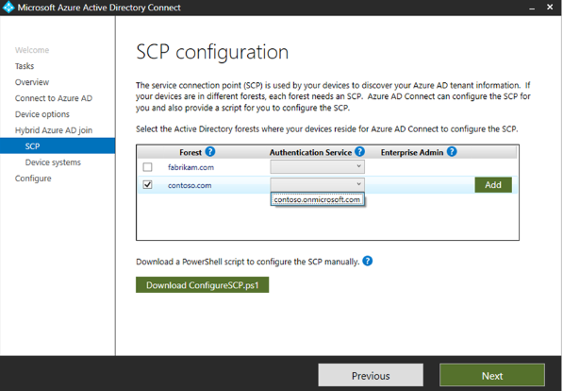
- In Ready to configure, select Configure.
- In Configuration complete, select Exit.
Set up Windows automatic MDM enrollment
- Sign in to Azure, in the left pane, select Azure Active Directory > Mobility (MDM and MAM) > Microsoft Intune.
- Make sure users who deploy Azure AD-joined devices by using Intune and Windows are members of a group included in MDM User scope.
- Use the default values in the MDM Terms of use URL, MDM Discovery URL, and MDM Compliance URL boxes, and then select Save.

Increase the computer account limit in the Organizational Unit
The Intune Connector for your Active Directory creates autopilot-enrolled computers in the on-premises Active Directory domain. The computer that hosts the Intune Connector must have the rights to create the computer objects within the domain.
In some domains, computers aren't granted the rights to create computers. Additionally, domains have a built-in limit (default of 10) that applies to all users and computers that aren't delegated rights to create computer objects. The rights must be delegated to computers that host the Intune Connector on the organizational unit where hybrid Azure AD-joined devices are created.
The organizational unit that's granted the rights to create computers must match:
- The organizational unit that's entered in the Domain Join profile.
- If no profile is selected, the computer's domain name for your domain.
- Open Active Directory Users and Computers (DSA.msc).
- Right-click the organizational unit to use to create hybrid Azure AD-joined computers > Delegate Control.
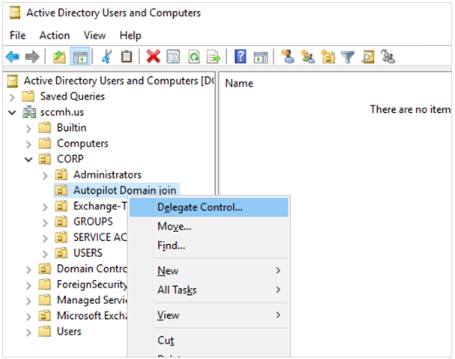
- In the Delegation of Control wizard, select Next > Add > Object Types.
- In the Object Types pane, select the Computers > OK
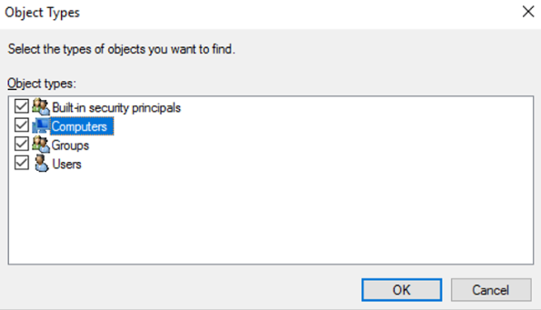
In the Select Users, Computers, or Groups pane, in the Enter the object names to select box, enter the name of the computer where the Connector is installed
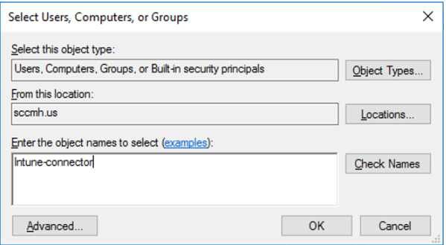
- Select Check Names to validate your entry > OK > Next.
- Select Create a custom task to delegate > Next.
- Select only the following objects in the folder > Computer objects.
- Select Create selected objects in this folder and Delete selected objects in this folder.
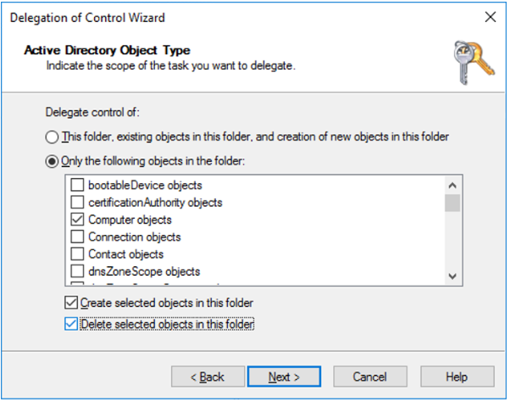
- Select Next.
- Under Permissions, select the Full Control check box. This action selects all the other options.
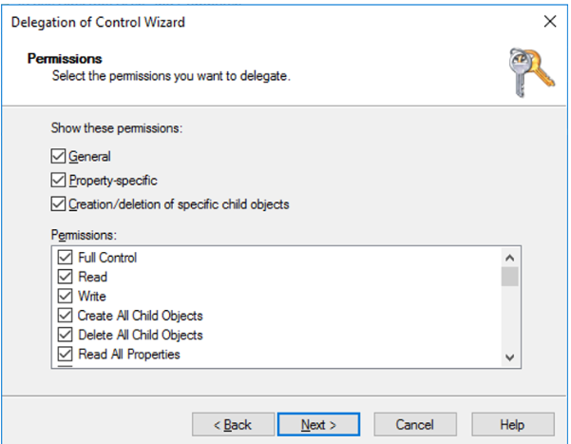
- Select Next > Finish.

Install the Intune Connector
Disable Internet Explorer Enhanced Security Configuration, which is enabled by default on Windows Server. If you encounter issues signing in to the Intune Connector for Active Directory, should consider deactivating Internet Explorer Enhanced Security Configuration specifically for the Administrator account. To accomplish this, follow the below given steps.

  - On the server where the Intune Connector will be installed, open Server Manager.
  - In the left pane of Server Manager, select Local Server.
  - In the right PROPERTIES pane of Server Manager, select the On or Off link next to IE Enhanced Security Configuration.
  - In the Internet Explorer Enhanced Security Configuration window, select Off under Administrators, and then select OK.
- In the Microsoft Intune admin center, select Devices > Windows > Windows enrollment > Intune Connector for Active Directory > Add.
- Follow the instructions to download the Connector.
- Open the downloaded Connector setup file, ODJConnectorBootstrapper.exe, to install the Connector.
- At the end of the setup, select Configure Now.
- Select Sign In.
- Enter the Global administrator or Intune administrator role credentials. The user account must have an assigned Intune license.
- Go to Devices > Windows > Windows enrollment > Intune Connector for Active Directory, and then confirm that the connection status is Active.
Note
- The Global administrator role is a temporary requirement at the time of installation.
- After you sign in to the Connector, it can take several minutes to appear in the Microsoft Intune admin center. It appears only if it can successfully communicate with the Intune service.
- Inactive Intune connectors still appear in the Intune Connectors blade and will automatically be cleaned up after 30 days.

Collect the hardware hash
The following methods are available to harvest a hardware hash from existing devices:
- Using Microsoft Configuration Manager
- Using Windows PowerShell
- During OOBE by using the Diagnostics Page (Windows 11 only)
- From the Desktop using Settings > Accounts
Configuration Manager
Microsoft Configuration Manager automatically collects the hardware hashes for existing Windows devices. For more information, see Gather information from Configuration Manager for Windows Autopilot. You can extract the hash information from Configuration Manager into a CSV file.
PowerShell
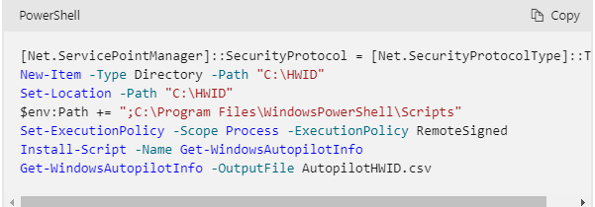

Desktop hash export
- From the Windows 10 or Windows 11 Start menu, right click and select Settings > Accounts > Access work or school.
- Export log files. The logs include a CSV file with the hardware hash.
  - Windows 11: In the Export your management log files tile, select Export.
  - Windows 10: Select the Export your management log files link.

Configure device settings
If you want to manage device identities by using the Azure portal, the devices need to be either registered or joined to Azure AD. As an administrator, you can control the process of registering and joining devices by configuring the following device settings.
You must be assigned one of the following roles to view device settings in the Azure portal:
- Global Administrator
- Global Reader
- Cloud Device Administrator
- Intune Administrator
- Windows 365 Administrator
- Directory Reviewer
You must be assigned one of the following roles to manage device settings in the Azure portal:
- Global Administrator
- Cloud Device Administrator

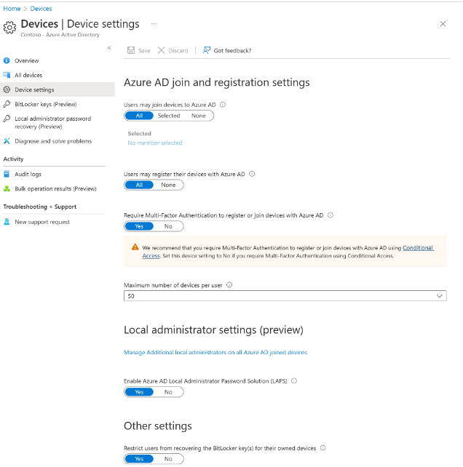

Users may join devices to Azure AD: This setting enables you to select the users who can register their devices as Azure AD joined devices. The default is All.

Add devices
In the Microsoft Intune admin center, select Devices > Windows > Windows enrollment > Devices (under Windows Autopilot Deployment Program) > Import
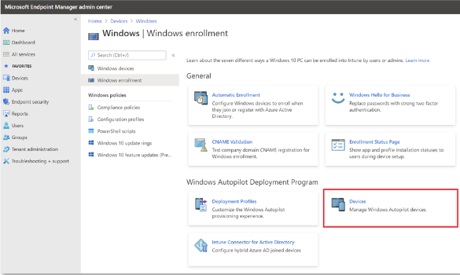
Under Add Windows Autopilot devices, browse to the CSV file that lists the devices that you want to add.
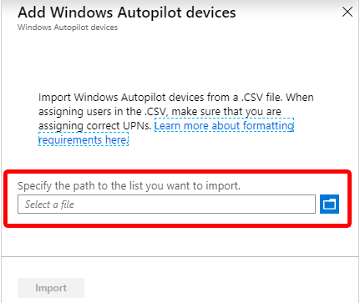
- Select Import to start importing the device information. Importing can take several minutes.
- After import is complete, select Devices > Windows > Windows enrollment > Devices (under Windows Autopilot Deployment Program) > Sync.
A message says that the synchronization is in progress. The process might take a few minutes to complete, depending on how many devices are being synchronized.
- Refresh the view to see the new devices.

Create a device group
- In the Microsoft Intune admin center, select Groups > New group.
- In the Group pane, choose the following options:
  - For Group type, select Security.
  - Enter a Group name and Group description.
  - Select a Membership type.
- If you selected Dynamic Devices for the membership type, in the Group pane, select Dynamic device members.
- Select Edit in the Rule syntax box and enter one of the following code lines:
  - To create a group that includes all your Autopilot devices, enter (device.devicePhysicalIDs -any _ -contains "[ZTDId]").
  - Intune's Group Tag field maps to the OrderID attribute on Azure AD devices. If you want to create a group that includes all of your Autopilot devices with a specific Group Tag (OrderID), type: (device.devicePhysicalIds -any _ -eq "[OrderID]:179887111881").
  - To create a group that includes all your Autopilot devices with a specific Purchase Order ID, enter (device.devicePhysicalIds -any _ -eq "[PurchaseOrderId]:76222342342").
- Select Save > Create.
Register Autopilot devices that are already enrolled
- Create an Autopilot deployment profile with the setting Convert all targeted devices to Autopilot set to Yes.
- Assign the profile to a group that contains the members that you want to automatically register with Autopilot.
Display registered Autopilot device
Before they're enrolled in Intune, registered Autopilot devices are displayed in three places (with names set to their serial numbers):
- The Autopilot Devices pane in the Intune in the Azure portal. Select Device enrollment > Windows enrollment > Devices.
- The Azure AD devices pane in the Intune in the Azure portal. Select Devices > Azure AD Devices.
- The Azure AD All Devices pane in Azure Active Directory in the Azure portal by selecting Devices > All Devices.
After your Autopilot devices are enrolled, they're displayed in four places:
- The Autopilot Devices pane in the Intune in the Azure portal. Select Device enrollment > Windows enrollment > Devices.
- The Azure AD devices pane in the Intune in the Azure portal. Select Devices > Azure AD Devices.
- The Azure AD All Devices pane in Azure Active Directory in the Azure portal. Select Devices > All Devices.
- The All Devices pane in the Intune in the Azure portal. Select Devices > All Devices.
After the Autopilot devices are enrolled, their names become the hostname of the device. By default, the hostname begins with DESKTOP-. A device object is pre-created in Azure AD once a device is registered in Autopilot. When a device goes through a hybrid Azure AD deployment, by design, another device object is created resulting in duplicate entries.

BYO VPNs
The following is a list of VPN clients that have been tested and validated:

VPN clients
- In-box Windows VPN client
- Cisco AnyConnect (Win32 client)
- Pulse Secure (Win32 client)
- GlobalProtect (Win32 client)
- Checkpoint (Win32 client)
- Citrix NetScaler (Win32 client)
- SonicWall (Win32 client)
- FortiClient VPN (Win32 client)
Not supported VPN clients
The following VPN solutions are known not to work with Autopilot and therefore aren't supported for use with Autopilot:

- UWP-based VPN plug-ins
- Anything that requires a user cert
- DirectAccess
Create and assign an Autopilot deployment profile
Autopilot deployment profiles are used to configure the Autopilot devices.
- In the Microsoft Intune admin center, select Devices > Windows > Windows enrollment > Deployment Profiles > Create Profile.
- On the Basics page, type a Name and optional Description.
- If you want all devices in the assigned groups to automatically register to Autopilot, set Convert all targeted devices to Autopilot to Yes. All corporate owned, non-Autopilot devices in assigned groups will register with the Autopilot deployment service. Personally owned devices won't be registered to Autopilot. Allow 48 hours for the registration to be processed. When the device is unenrolled and reset, Autopilot will enroll it. After a device is registered in this way, disabling this setting or removing the profile assignment won't remove the device from the Autopilot deployment service. You must instead remove the device directly.
- Select Next.
- On the Out-of-box experience (OOBE) page, for Deployment mode, select User-driven.
- In the Join to Azure AD as box, select Hybrid Azure AD joined.
- If you're deploying devices off of the organization's network using VPN support, set the Skip Domain Connectivity Check option to Yes. For more information, see User-driven mode for hybrid Azure Active Directory join with VPN support.
- Configure the remaining options on the Out-of-box experience (OOBE) page as needed.
- Select Next.
- On the Scope tags page, select scope tags for this profile.
- Select Next.
- On the Assignments page, select Select groups to include > search for and select the device group > Select.
- Select Next > Create.
Note: Intune will periodically check for new devices in the assigned groups, and then begin the process of assigning profiles to those devices. Due to several different factors involved in the process of Autopilot profile assignment, an estimated time for the assignment can vary from scenario to scenario. These factors can include AAD groups, membership rules, hash of a device, Intune and Autopilot service, and internet connection. The assignment time will vary depending on all the factors and variables involved in a specific scenario.
Turn on the enrollment status page(Optional)
- In the Microsoft Intune admin center, select Devices > Windows > Windows enrollment > Enrollment Status Page.
- In the Enrollment Status Page pane, select Default > Settings.
- In the Show app and profile installation progress box, select Yes.
- Configure the other options as needed.
- Select Save.

Create and assign a Domain Join profile
- In the Microsoft Intune admin center, select Devices > Configuration profiles > Create Profile.
- Enter the following properties:
  - Name: Enter a descriptive name for the new profile.
  - Description: Enter a description for the profile.
  - Platform: Select Windows 10 and later.
  - Profile type: Select Templates, choose the template name Domain Join, and select Create.
- Enter the Name and Description and select Next.
- Provide a Computer name prefix and Domain name.
- (Optional) Provide an Organizational unit (OU) in DN format. The options include:
  - Provide an OU in which you've delegated control to your Windows 2016 device that is running the Intune Connector.
  - Provide an OU in which you've delegated control to the root computers in your on-premises Active Directory.
  - If its left blank, the computer object will be created in the Active Directory default container (CN=Computers if you never changed it).
Here are some valid examples:
  - OU=SubOU,OU=TopLevelOU,DC=contoso,DC=com
  - OU=Mine,DC=contoso,DC=com
Here are some examples that aren't valid:
  - CN=Computers,DC=contoso,DC=com (you can't specify a container, instead leave the value blank to use the default for the domain)
  - OU=Mine (you must specify the domain via the DC= attributes)
- Select OK > Create. The profile is created and displayed in the list.
- Assign a device profile to the same group used at the step Create a device group. Different groups can be used if there's a need to join devices to different domains or OUs.

Uninstall the ODJ Connector
The OSD connector is installed locally on a computer via an executable file. If the ODJ connector needs to be uninstalled from a computer, it needs to also be done locally on the computer. The ODJ connector can't be removed through the Intune portal or through a graph API call.
The following steps uninstalls the ODJ Connector from the computer where it's installed:
- Sign into the computer hosting the ODJ connector.
- Right-click on the Start menu and select Settings.
- In the Windows Settings window, select Apps.
- Under Apps & features, find and select Intune Connector for Active Directory.
- Under Intune Connector for Active Directory, select the Uninstall button, and then select the Uninstall button again.
- The ODJ connector proceeds to uninstall.

Difference between Hybrid AAD, Azure AD, and AAD
Hybrid Azure AD Joined is for:
corporate owned and managed devices
Authenticated using a corporate user id that exists at local AD & on AAD.
Authentication can be done using both: On-Prem AD & Azure AD.
Azure AD Joined is for
Corporate owned and managed devices
Authenticated using a corporate id that exists on Azure AD
Authentication is only through AAD.
AAD Register Device is for
Personally owned corporate enabled
Authentication to the device is with a local id or personal cloud id
Authentication to corporate resources using a user id on AAD.

Appendix
Glossary of Terms
Terms | Abbreviation
AD | Active Directory
AAD | Azure Active Directory
CSV | Comma Separated Value
MAM | Mobile Application Management
MDM | Mobile Device Management
ODJ | Offline Domain Join
OOBE | Out of Box Experience
OSD
SCP | Service Connection Point
URL | Uniform Resource Locator
VPN | Virtual Private Network

