NAME: Bhanu Parchuri

UGID:21WU0101034

Section-A (C.S.E)

CODE:

1

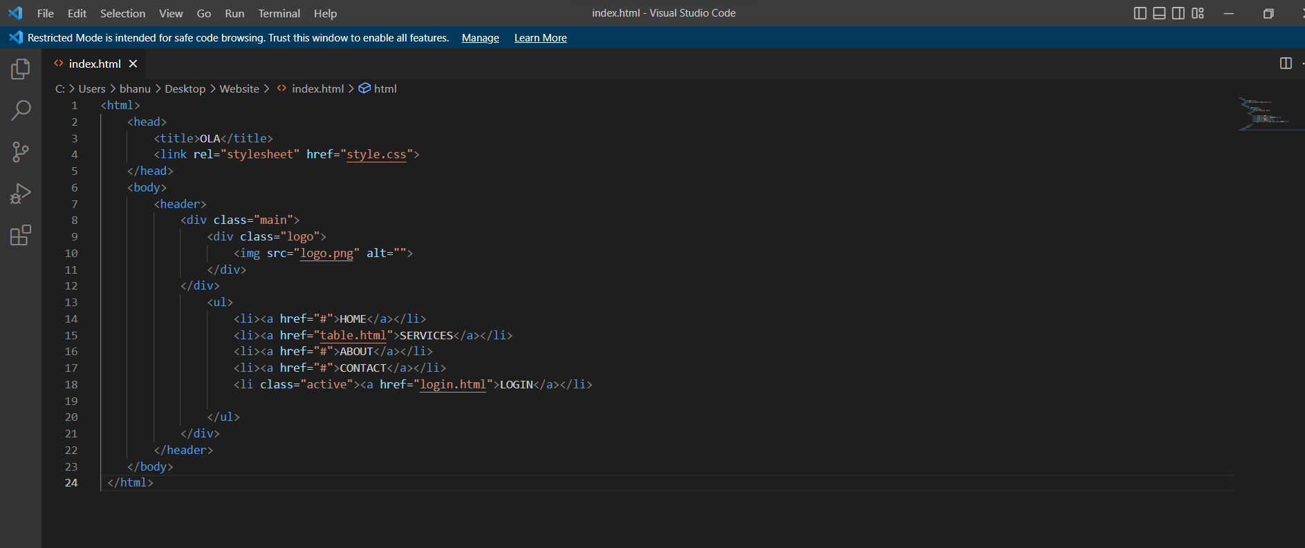

2

<!DOCTYPE html>

<html lang="en">

<head>

  <!-- Design by foolishdeveloper.com -->

    <title>Glassmorphism login Form Tutorial in html css</title>

    <link rel="preconnect" href="https://fonts.gstatic.com">

    <link rel="stylesheet" href="https://cdnjs.cloudflare.com/ajax/libs/font-awesome/5.15.4/css/all.min.css">

    <link href="https://fonts.googleapis.com/css2?family=Poppins:wght@300;500;600&display=swap" rel="stylesheet">

    <!--Stylesheet-->

    <style media="screen">

      \*,

\*:before,

\*:after{

    padding: 0;

    margin: 0;

    box-sizing: border-box;

}

body{

    background-color: #080710;

}

.background{

    width: 430px;

    height: 520px;

    position: absolute;

    transform: translate(-50%,-50%);

    left: 50%;

    top: 50%;

}

.background .shape{

    height: 200px;

    width: 200px;

    position: absolute;

    border-radius: 50%;

}

.shape:first-child{

    background: linear-gradient(

        #1845ad,

        #23a2f6

    );

    left: -80px;

    top: -80px;

}

.shape:last-child{

    background: linear-gradient(

        to right,

        #ff512f,

        #f09819

    );

    right: -30px;

    bottom: -80px;

}

form{

    height: 520px;

    width: 400px;

    background-color: rgba(255,255,255,0.13);

    position: absolute;

    transform: translate(-50%,-50%);

    top: 50%;

    left: 50%;

    border-radius: 10px;

    backdrop-filter: blur(10px);

    border: 2px solid rgba(255,255,255,0.1);

    box-shadow: 0 0 40px rgba(8,7,16,0.6);

    padding: 50px 35px;

}

form \*{

    font-family: 'Poppins',sans-serif;

    color: #ffffff;

    letter-spacing: 0.5px;

    outline: none;

    border: none;

}

form h3{

    font-size: 32px;

    font-weight: 500;

    line-height: 42px;

    text-align: center;

}

label{

    display: block;

    margin-top: 30px;

    font-size: 16px;

    font-weight: 500;

}

input{

    display: block;

    height: 50px;

    width: 100%;

    background-color: rgba(255,255,255,0.07);

    border-radius: 3px;

    padding: 0 10px;

    margin-top: 8px;

    font-size: 14px;

    font-weight: 300;

}

::placeholder{

    color: #e5e5e5;

}

button{

    margin-top: 50px;

    width: 100%;

    background-color: #ffffff;

    color: #080710;

    padding: 15px 0;

    font-size: 18px;

    font-weight: 600;

    border-radius: 5px;

    cursor: pointer;

}

.social{

  margin-top: 30px;

  display: flex;

}

.social div{

  background: red;

  width: 150px;

  border-radius: 3px;

  padding: 5px 10px 10px 5px;

  background-color: rgba(255,255,255,0.27);

  color: #eaf0fb;

  text-align: center;

}

.social div:hover{

  background-color: rgba(255,255,255,0.47);

}

.social .fb{

  margin-left: 25px;

}

.social i{

  margin-right: 4px;

}

    </style>

</head>

<body>

    <div class="background">

        <div class="shape"></div>

        <div class="shape"></div>

    </div>

    <form action="login.php" method="post">

        <h3>Login Here</h3>

        <label for="username">Username</label>

        <input name="username" type="text" placeholder="Email or Phone" id="username">

        <label for="password">Password</label>

        <input name="password" type="password" placeholder="Password" id="password">

        <button>Log In</button>

        <div class="social">

          <div class="go"><i class="fab fa-google"></i>  Google</div>

          <div class="fb"><i class="fab fa-facebook"></i>  Facebook</div>

        </div>

    </form>

</body>

</html>

OUTPUTS:

1

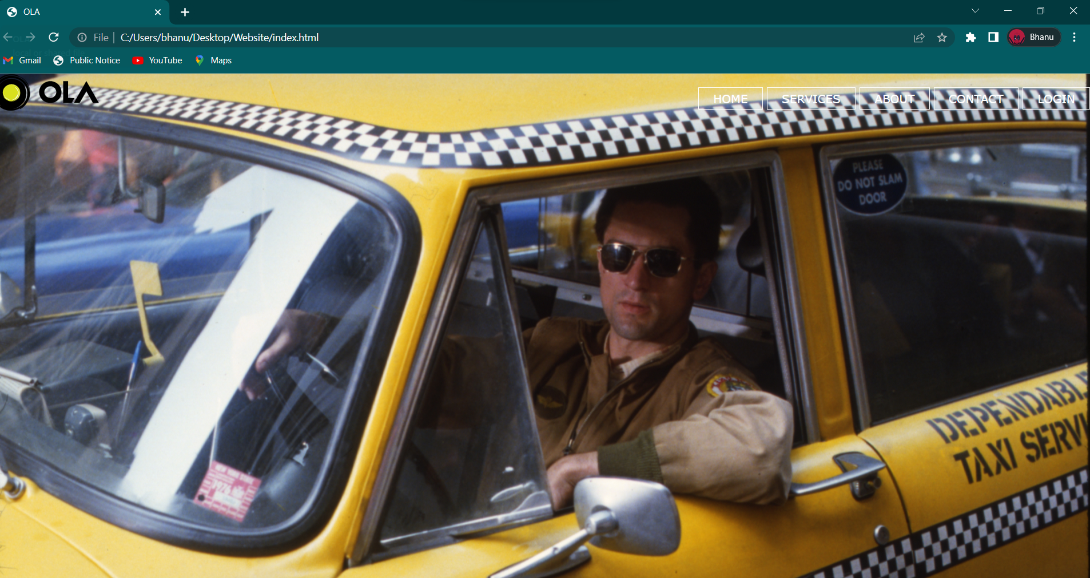

2

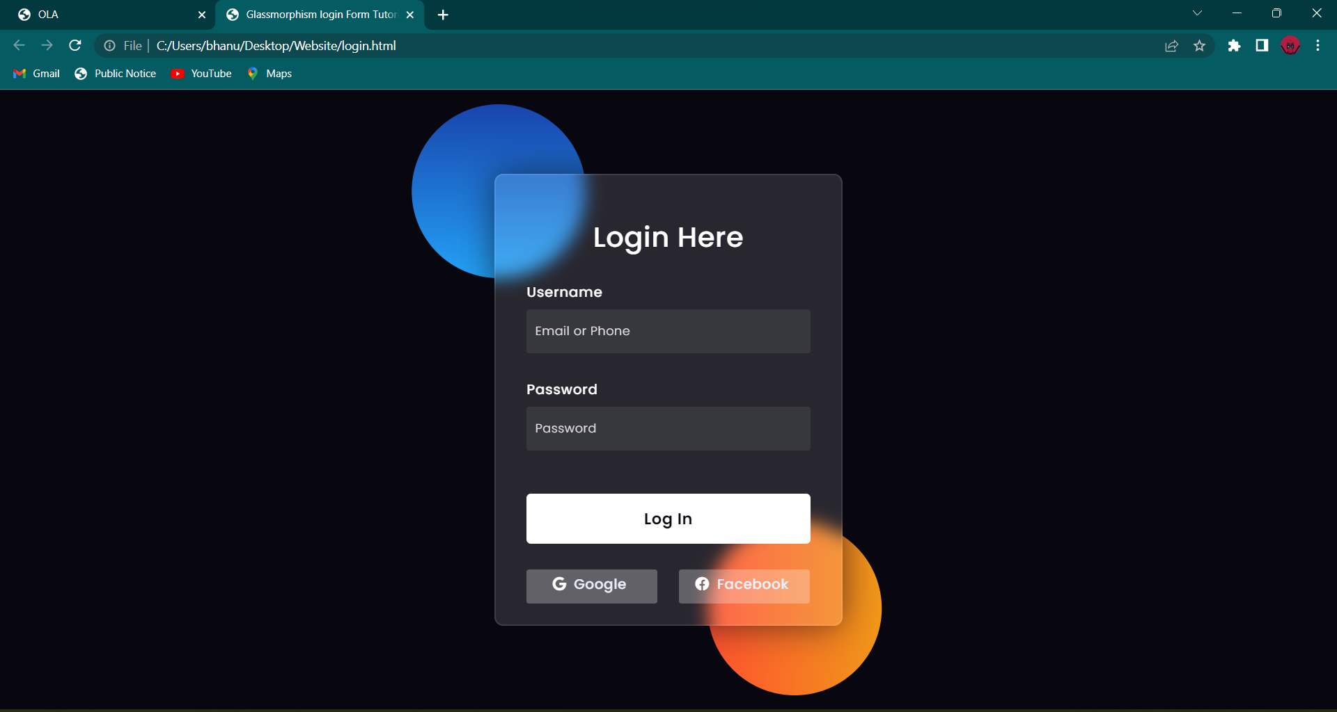

MINE MAP:

1

2

