DESIGN PROCESS

Block diagram: In this file I am mentioning two pictures related to my project.

This picture shows us how to led and make led matric here we are total use of 64 led for making

8\*8 led matrix.

After connecting the led we found 8 negative ends and 8 positive ends.

After we connect all negative and positive parts of Led's to atmega328 and simulate on simullide .

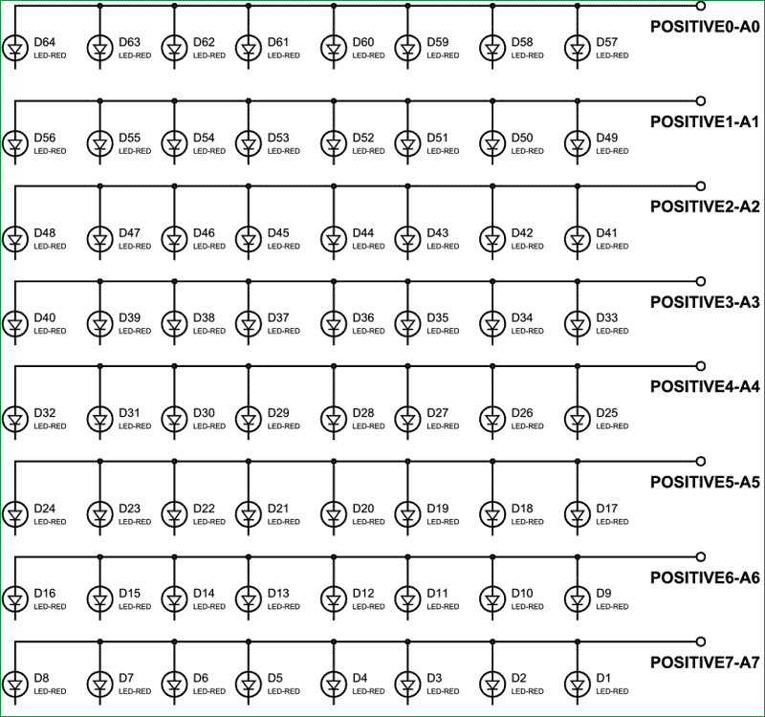

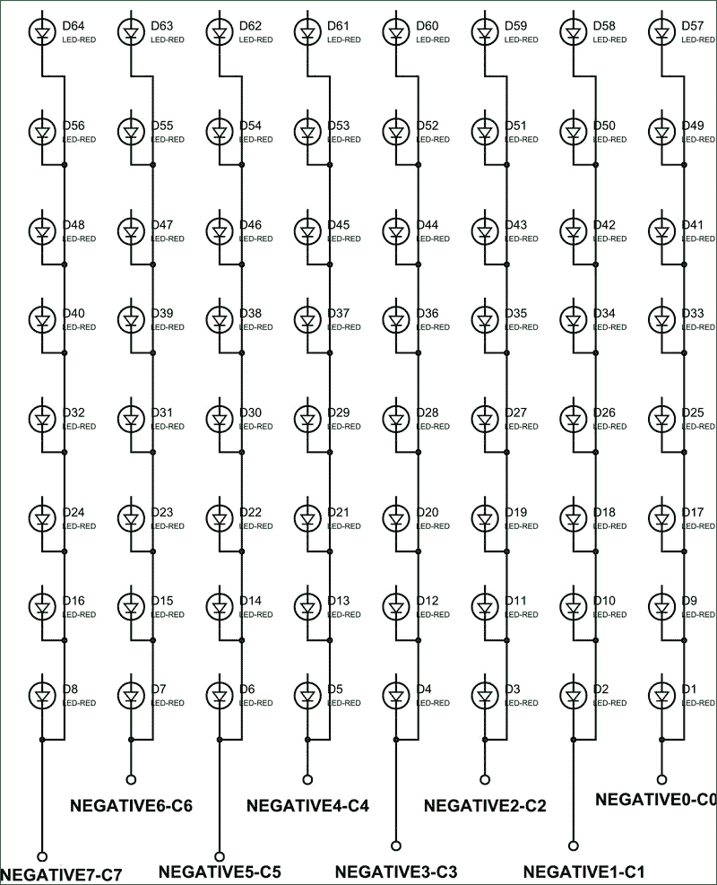

8\*8 Led matrix pin in and pin out diagram:

