**ASSIGNMENT 1**

Create your own profile/ resume in most creative or presentable form using anyone or both GIMP, Blender.

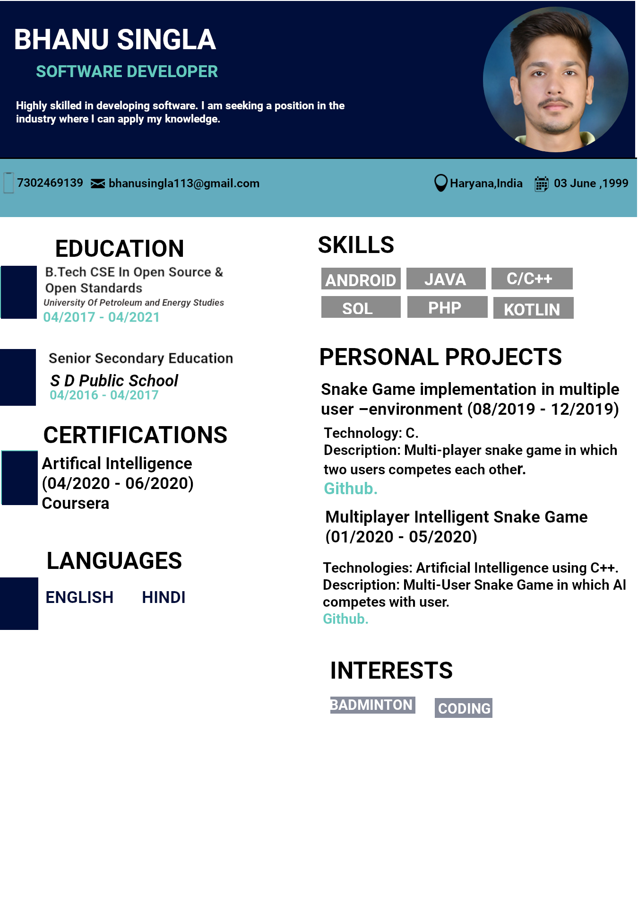

Drive Link : https://drive.google.com/drive/u/1/folders/1I7bSX5BGq0q5yyaipMp3eDOxv7QiRrM3