**University of Petroleum and Energy Studies**

School of Computer Science

Department of Cybernetics



**Graphics & Animation Tools**

**LAB FILE**

**(Session: 2020-2021)**

Course: B. Tech with Specialization in Open Source and Open Standards

Batch: 2017-2021

Semester: VIIth

**Submitted By: -**

Bhanu Singla

Roll No: R100217018

SAP ID: 500062436

**Submitted To: -**

Dr. Durgansh Sharma Assistant Professor

Department of Cybernetics

**Experiment - 5** Design of 3D Text using Blender.

**Step 1:**Shift A and Add text. Click**“**Shift + A**”**from the keyboard a list opens on the screen select “Text” option from there.

**Step 2:**After filling the required text in the area click TAB the text mode changes to object mode.

**Step 3:**Select text and click “Tab” to get text mode on.

**Step 4:**3D text excludes can be done in as shown below.

**Step 5: Rotate Text**

Till now our text was flat with on the grid now let’s make the text visible from the front view (let’s wake it up).

Go to rotate options and on X-axis give the value as 90 degrees. The text changes its orientation as shown.

**Step 6:**Go to the Fronts layer in the left panel for all text-related attributions on the pane.Front -> click on Load a file (Folder symbol)

**Step 7:**After applying appropriate front to the text then on left pane we have 2 options Level and Bevel. Both help in shaping the corners of the text if there are too sharp at corners.

**Step 8:**It’s easy to add texture to the text Click on Lambert Symbol on the left pane.

**Step 9:**Click on render option on the top right corner of the application screen to have a rendered view of the text.

**OUTPUT:**

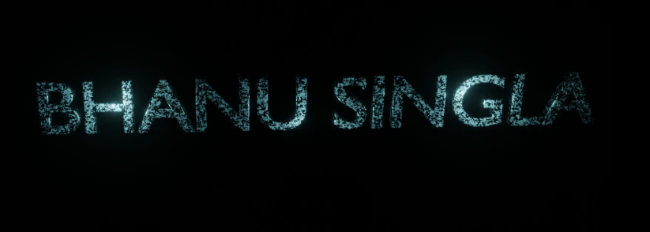

Drive link : <https://drive.google.com/drive/u/1/folders/1ESqx44wn8XgU78eufakQ2KliIe8QBz65>

Video Animation of Text is uploaded on google drive.