**University of Petroleum and Energy Studies**

School of Computer Science

Department of Cybernetics



**Graphics & Animation Tools**

**LAB FILE**

**(Session: 2020-2021)**

Course: B. Tech with Specialization in Open Source and Open Standards

Batch: 2017-2021

Semester: VIIth

**Submitted By: -**

Bhanu Singla

Roll No: R100217018

SAP ID: 500062436

**Submitted To: -**

Dr. Durgansh Sharma Assistant Professor

Department of Cybernetics

**Experiment - 6** Design of 3D Text using Blender

Step: 1 Open Blender

Step: 2 Go to object mode-> add -> mesh -> cylinder

Step: 3 Go to Edit mode -> press 2 -> and straight required side of cylinder

Step: 4 Select straight side of cylinder -> press face -> insert face -> move it to set hut gate -> delete selected to open the gate of face.

Step: 5 Select vertex of cylinder -> press E to extrude -> press S to scale extrude part

Step: 6 By extrude and scale complete building hut cone.

Step: 7 Press Ctrl+R to add loop in hut.

Step: 8 Save it.

**OUTPUT:**

S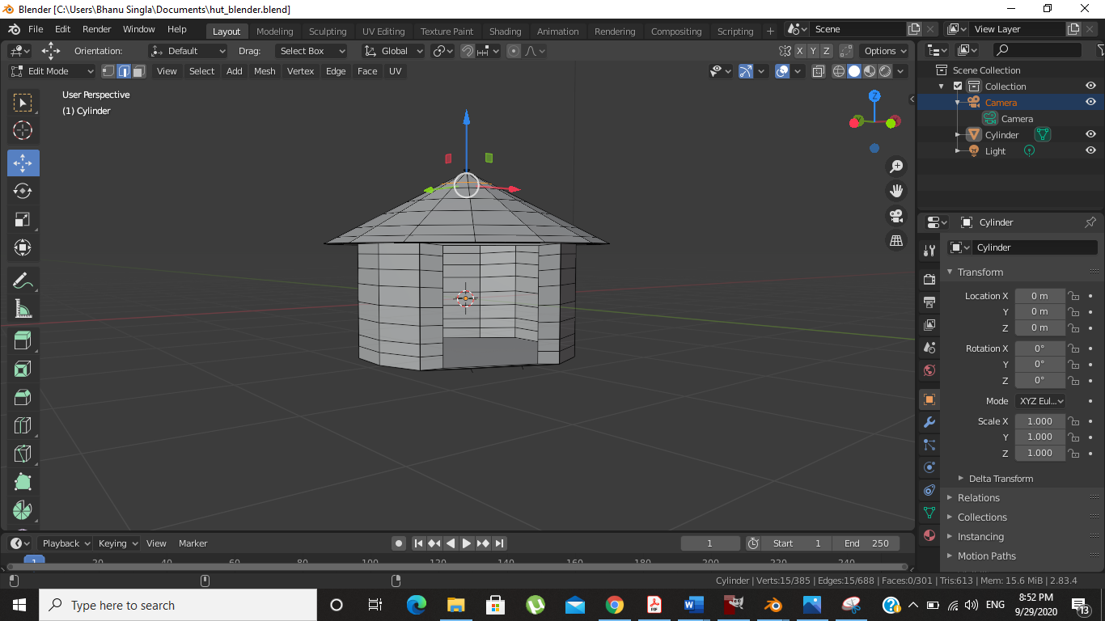

Drive Link : <https://drive.google.com/drive/u/1/folders/1hdJHNwxPIU2hQBdzNZaGai5Ub6Ptvx51>