**University of Petroleum and Energy Studies**

School of Computer Science

Department of Cybernetics



**Graphics & Animation Tools**

**LAB FILE**

**(Session: 2020-2021)**

Course: B. Tech with Specialization in Open Source and Open Standards

Batch: 2017-2021

Semester: VIIth

**Submitted By: -**

Bhanu Singla

Roll No: R100217018

SAP ID: 500062436

**Submitted To: -**

Dr. Durgansh Sharma Assistant Professor

Department of Cybernetics

**Experiment – 7** Design of 3D Rocket using Blender.

Step: 1 Open Blender

Step: 2 Go to object mode-> add -> mesh -> cylinder

Step: 3 Go to Edit mode -> press Ctrl+R to loop cut.

Step: 4 Give shape like structure by loop cut with the help of move option.

Step: 5 Go to object mode -> add -> mesh -> rectangle.

Step: 6 use key Ctrl + R to loop cut of rectangle.

Step: 7 Shape rectangle like a stand to remain rocket vertical.

Step: 8 Go to Shading to colour the rocket.

Step: 9 save it.

**OUTPUT:**

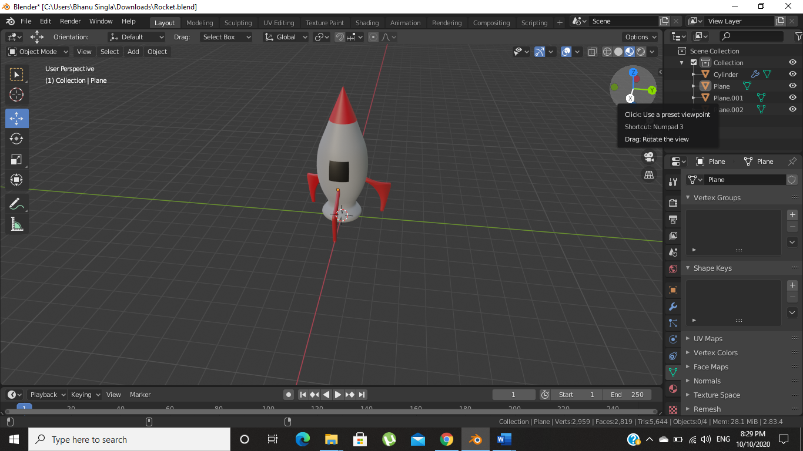

Drive link: https://drive.google.com/drive/u/1/folders/1SaCZwOQDtFidZOmwnrAJQfW4RltJLLbK