Assignment – 1

Programs:

1. **Write a java program to find the area of rectangle**

**Sol:**

import java.util.Scanner;

public class AreaofRectangle

{

public static void main(String[] args)

{

int a,b;

int area;

Scanner sc=new Scanner(System.in);

a=sc.nextInt();

b=sc.nextInt();

System.out.println("Length of Rectangle is"+" "+a);

System.out.println("Breadth of Rectangle is"+" "+b);

area=a*b;

System.out.println("Area of Rectangle is"+" "+area);

}

}

**Expected Output:**

Length of Rectangle is 14

Breadth of Rectangle is 5

Area of Rectangle is 70

**Output:**

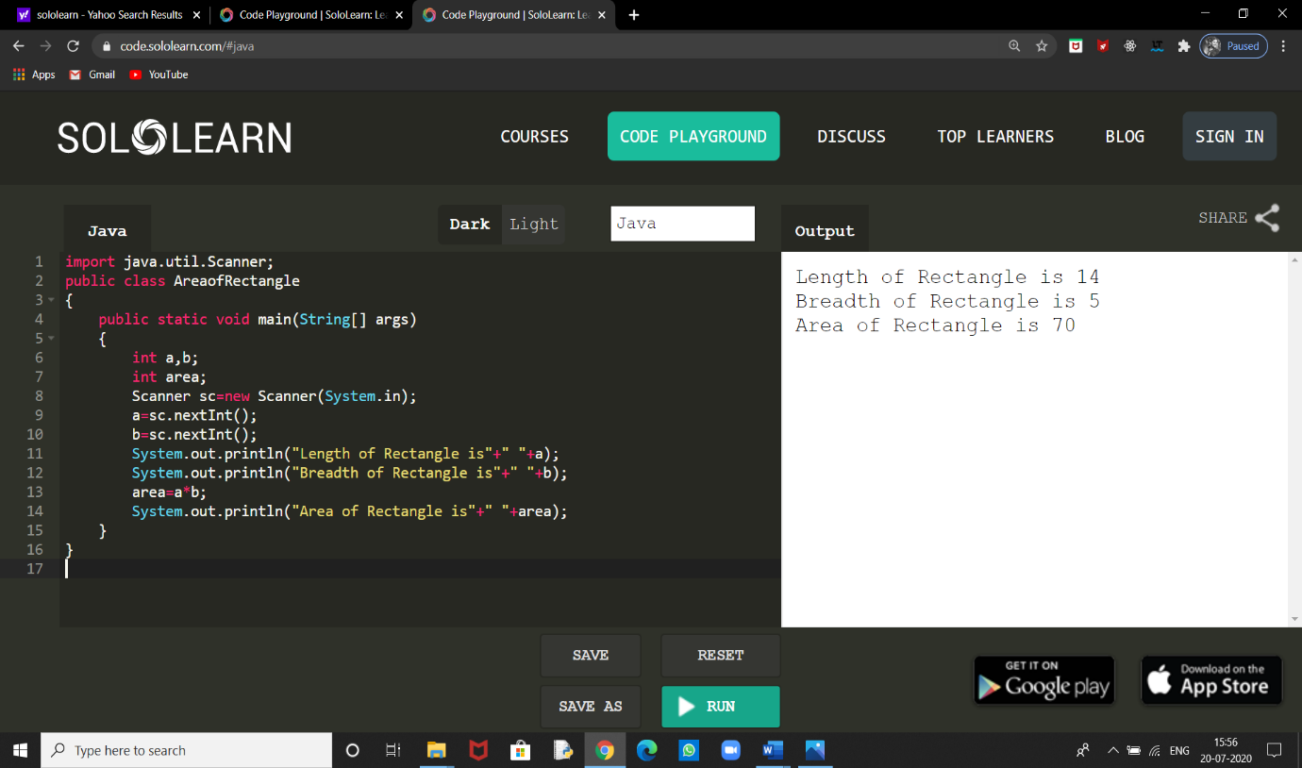

1. **Write a java program to check the given no is Armstrong or not(153 is Armstrong no 1*1*1+5*5*5+3*3*3=153)**

**Sol:**

import java.util.Scanner;

public class Armstrong

{

public static void main(String[] args)

{

int c=0,r,temp,n;

Scanner sc=new Scanner(System.in);

n=sc.nextInt();

System.out.println("Number is"+" "+n);

temp=n;

while(n>0)

{

r=n%10;

n=n/10;

c=c+(r*r*r);

}

if(temp==c)

System.out.println(temp+" "+"is Armstrong Number");

else

System.out.println(temp+" "+" is not Armstrong Number");

}

}

**Expected Output:**

Number is 153

153 is Armstrong Number

**Output:**

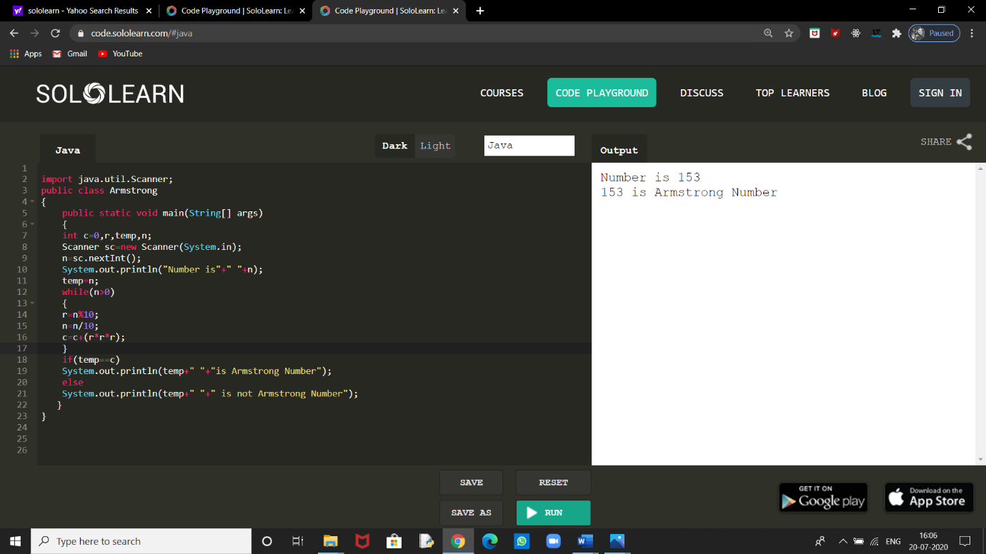

**3.Write a java program to check the given no is palindrome or not**

**Sol:**

import java.util.Scanner;

public class Pallindrome

{

public static void main(String[] args)

{

int r,sum=0,temp,n;

Scanner sc=new Scanner(System.in);

n=sc.nextInt();

System.out.println("Number is "+" "+n);

temp=n;

while(n>0)

{

r=n%10;

sum=(sum*10)+r;

n=n/10;

}

if(temp==sum)

System.out.println(temp+" "+"is a Palindrome Number ");

else

System.out.println(temp+" "+"is not a Palindrome Number");

}

}

**Expected Output:**

Number is 141

141 is a Palindrome Number

**Output:**

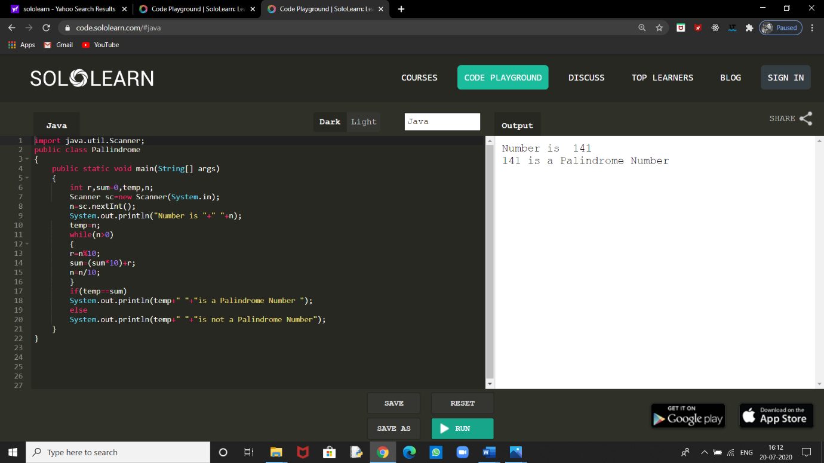

1. **Write a java program to generate first N prime numbers**

**Sol:**

import java.util.Scanner;

class Primenumberrange

{

public static void main(String[] args)

{

int n,flag=0,i,j;

Scanner g=new Scanner(System.in);

n=g.nextInt();

System.out.println("Number is"+" "+n);

System.out.println("The prime numbers upto"+" "+n+" are**:**");

for(i=1;i<=n;i++)

{

flag=0;

for(j=1;j<=n;j++)

{

if(i%j==0)

flag++;

}

if(flag==2)

{

System.out.print(i+" ");

}

}

}

}

**Expected Output:**

Number is 23

The prime numbers upto 23 are :

2 3 5 7 11 13 17 19 23

**Output:**

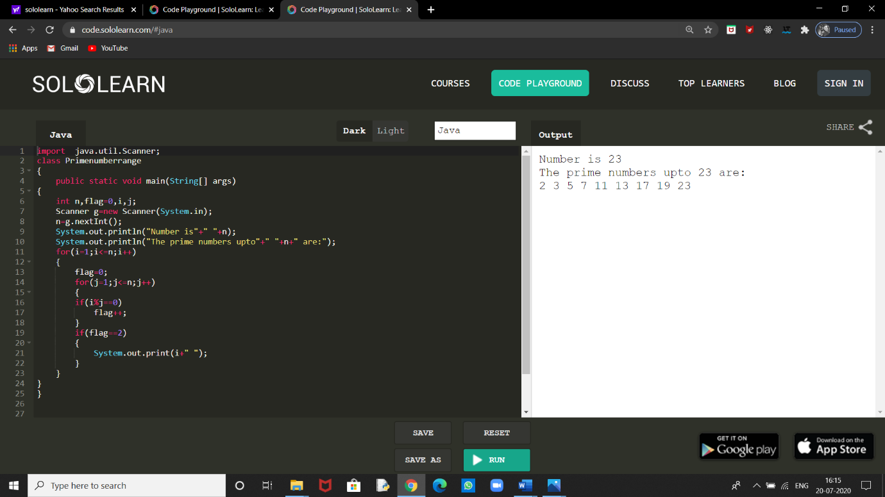

1. **Write a java program to print even numbers in between given two numbers.**

**Sol:**

import java.util.Scanner;

public class EvenRange

{

public static void main(String[] args)

{

int n1,n2,i,k=1;

Scanner sc=new Scanner(System.in);

n1=sc.nextInt();

n2=sc.nextInt();

System.out.println("Even numbers in between"+" "+n1+" "+"and"+" "+n2+" "+"are**:**");

for(i=n1;i<=n2/2;i++)

{

k=2*i;

System.out.print(k+" ");

}

}

}

**Expected Output:**

Even numbers in between 1 and 10 are:

2 4 6 8 10

**Output:**

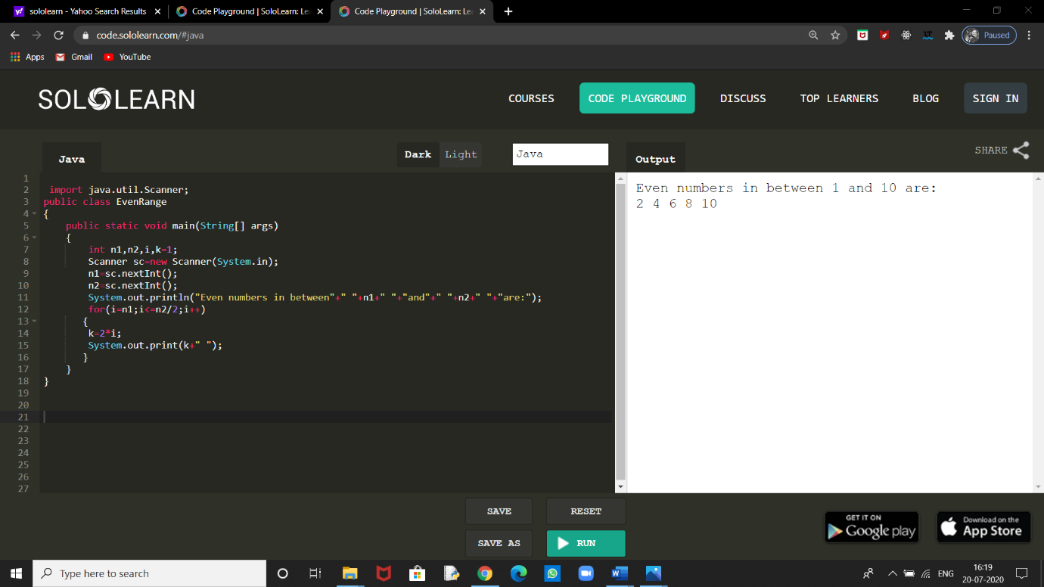

**Question no**.**1: What is Abstraction?**

**Ans:** Abstraction is a process of hiding the implementation details and showing only functionality to the user. It shows only essential things to the user and hides the internal details. In Java, abstraction is achieved using abstract classes and interfaces.

**Question no.2: What is Encapsulation?**

**Ans:** Encapsulation is a process of wrapping code and data together into a single unit. We can create a fully encapsulated class in Java by making all the data members of the class private.

**Question no.3: What is JDK?**

**Ans:** The Java Development Kit (JDK) is a software development environment used for developing Java applications and applets. It includes the Java Runtime Environment (JRE), an interpreter (java), a compiler (javac), a documentation generator (javadoc) and other tools needed in Java development.

**Question no.4: What is JVM?**

**Ans:** JVM - Java Virtual Machine. JVM is an abstract computing machine, or virtual machine. It is a platform-independent execution environment that converts Java byte code into machine language and executes it

**Question no.5: Define Inheritance.**

**Ans:** Inheritance is the process wherein characteristics are inherited from ancestors. Similarly, in Java, a subclass inherits the characteristics (properties and methods) of its super class (ancestor).

**Question no.6: How java achieved platform independence?**

**Ans:** Since every Java program runs on Java virtual machine, same byte code can be run on any platform. Byte code which is generated is not machine instruction, they are platform independent instruction to JVM. Hence combination of byte code and JVM makes Java program platform independent

**Question no**.**7: Write the syntax of main function.**

**Ans:** public static void main(String[] args){}

**Question no.8: What is conditional operator?**

**Ans:** The conditional operator is also known as the ternary operator. This operator consists of three operands and is used to evaluate Boolean expressions. The goal of the operator is to decide which value should be assigned to the variable. The operator general syntax is written as**:**

variable x = (expression)? value if true**:** value if false

**Question no.9: How many data types in java?**

**Ans:** Data types specify the different sizes and values that can be stored in the variable. There are two types of data types in Java.

Primitive data types**:** The primitive data types include boolean, char, byte, short, int, long, float and double.

Non-primitive data types**:** The non-primitive data types include Classes, Interfaces, and Arrays.

**Question no.10: What is constant? How it is declared?**

**Ans:** A constant is a variable whose value cannot change once it has been assigned. Java doesn't have built-in support for constants, but the variable modifiers static and final can be used to effectively create one. General Syntax is:

static final datatype identifier_name = constant;