Spam or Ham
Text Message Spam Detection
Project Report
Prepared using: Python, Scikit-learn, TensorFlow/Keras, NLTK, Streamlit
Dataset: SMS Spam Collection (spam.csv)

Arava Bhanusri

1. What Is This Project About?
This project builds a system that reads a text message and decides whether it is 'spam' (an unwanted, junk, or scam message) or 'ham' (a normal, genuine message). This is something you already see in real life — your phone or email automatically moves suspicious messages to a spam folder.
This is a Binary Classification problem, which means the computer only has to choose between two options: spam (1) or ham (0). We tried two different approaches to solve it — classic Machine Learning models and a Deep Learning model — and compared them to pick the best one.

2. Dataset Used
We used the well-known SMS Spam Collection dataset. It contains real text messages, each labelled as spam or ham.
- Total messages (before cleaning): 5,572
- Columns: Category (spam/ham) and Message (the actual text)
- Class split: about 87% ham and 13% spam — so the dataset is imbalanced (many more normal messages than spam ones).
Because spam messages are the minority, we had to be careful during model building and testing — a model could get high accuracy just by always guessing 'ham', so we also checked precision, recall, and F1-score, not just accuracy.

3. Cleaning the Data
Real-world data is rarely perfect, so we first checked and fixed a few issues:
- Missing values: none found — every row had both a Category and a Message.
- Duplicate rows: found 415 duplicate messages and removed them, leaving 5,157 unique messages.
- Converted the Category column into numbers: ham = 0, spam = 1, since models need numeric labels.
After cleaning, the dataset had 4,516 ham messages and 641 spam messages.

4. Creating Extra Clues (Feature Engineering)
Besides the words in a message, we noticed that spam messages often 'look' different too — for example, they may be longer, use more numbers, or use more capital letters (like 'WINNER!!'). So we created five extra number-based clues for every message:
Feature | What It Counts
char_count | Total number of characters in the message
word_count | Total number of words
digit_count | How many digits (0-9) appear
upper_count | How many uppercase letters appear
special_count | How many special symbols appear (!, £, $, etc.)

A quick comparison confirmed our idea — spam messages are very different from ham messages on these clues:
Feature | Ham (average) | Spam (average)
Characters | 70.95 | 137.54
Words | 14.24 | 23.66
Digits | 0.30 | 15.33
Uppercase letters | 4.02 | 15.55
Special symbols | 3.87 | 6.04

Spam messages are roughly twice as long as ham messages, and contain far more digits (like phone numbers or prize codes) and capital letters (used to grab attention).

5. Exploring the Data (Visualizations)
Before building any model, we looked at the data visually to understand it better.
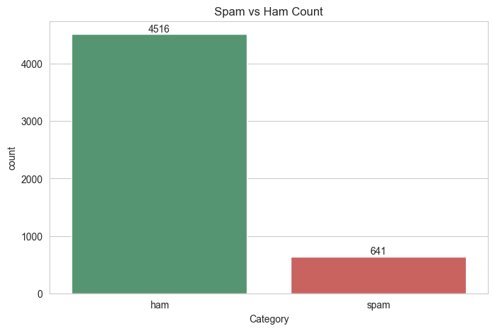
Figure 1: Number of ham vs spam messages — the dataset is clearly imbalanced
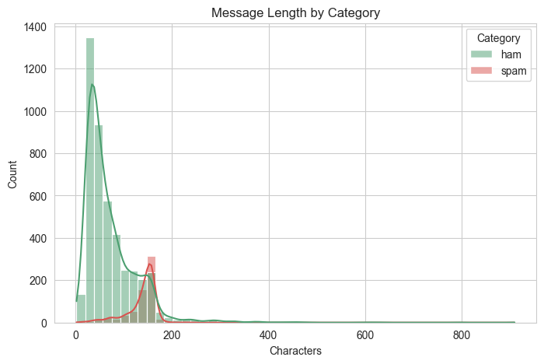
Figure 2: Message length — spam messages (right side) tend to be longer than ham
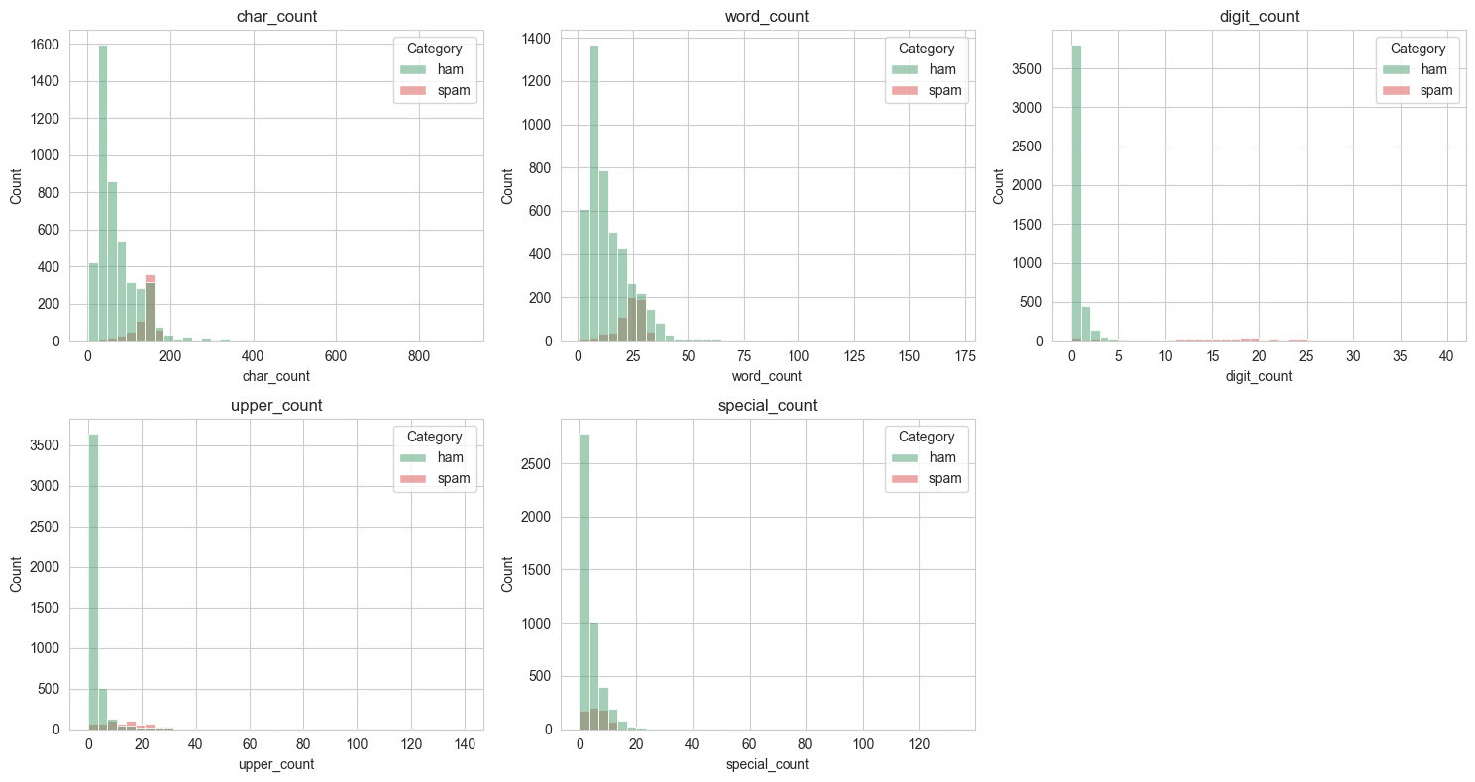
Figure 3: Distribution of all five extra clues, split by spam vs ham
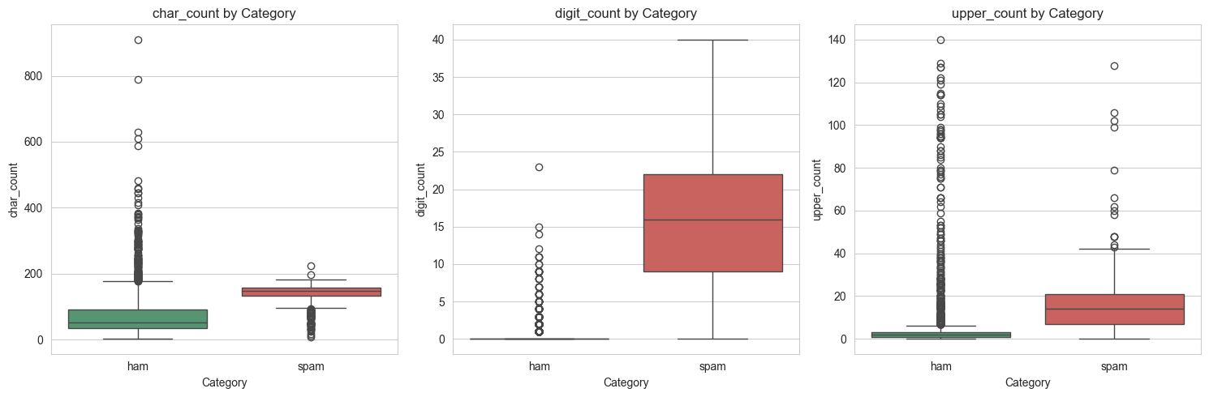
Figure 4: Boxplots showing spam messages have higher character, digit, and uppercase counts
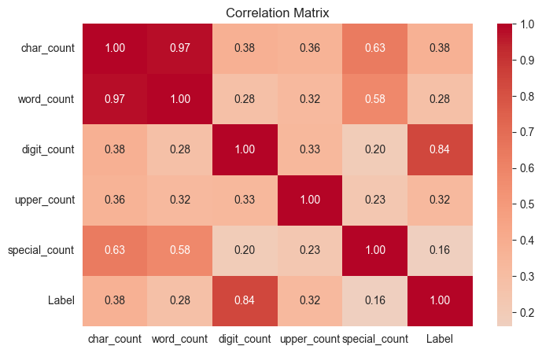
Figure 5: Correlation heatmap — character count and word count move together, as expected
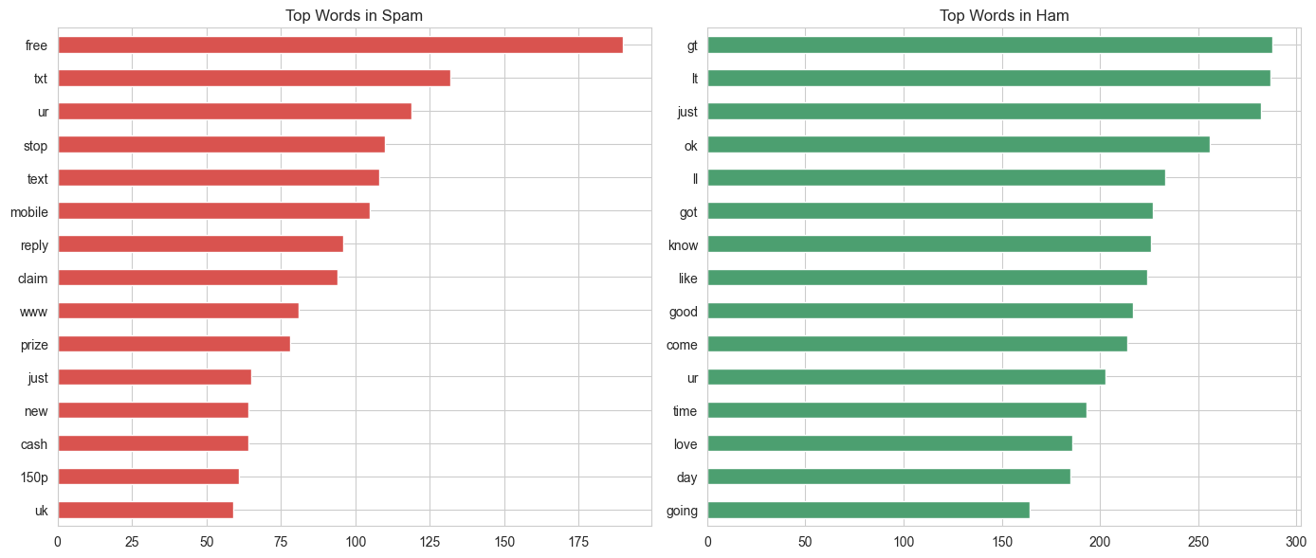
Figure 6: Most common words in spam messages vs ham messages
The word analysis was very telling: spam vocabulary is promotional and pushy (words like 'free', 'call', 'claim', 'prize', 'win'), while ham vocabulary is casual and conversational, matching everyday texting.

6. Preparing the Text for the Model
Computers cannot understand raw sentences, so every message was cleaned and converted into a standard format:
- Lowercased all text, so 'FREE' and 'free' are treated the same.
- Removed everything that wasn't a plain letter (numbers, punctuation, symbols).
- Removed common 'stopwords' (like 'the', 'is', 'and') that don't carry much meaning.
- Applied stemming (using the Porter Stemmer), which trims words down to their root form — e.g. 'calling', 'called', and 'calls' all become 'call'. This helps the model treat similar words the same way.

7. Splitting the Data and Turning Text into Numbers
We split the data into a training set (80%) and a test set (20%), making sure both sets kept the same spam/ham ratio (about 12% spam in each), so the test results are fair and representative.
- Training set: 4,125 messages
- Test set: 1,032 messages
To turn cleaned text into numbers, we used a technique called TF-IDF (Term Frequency – Inverse Document Frequency). In simple terms, TF-IDF gives higher importance to words that are common in one message but rare across all messages — these words are usually the most meaningful ones. We kept the top 5,000 most useful words and word-pairs.
We then combined the TF-IDF numbers with our five extra clues (char_count, word_count, etc.), after scaling those clues to a similar range using MinMaxScaler, so no single feature would dominate just because of its size.

8. Building and Comparing Machine Learning Models
We trained four different classic machine learning models on the same data, so we could compare them fairly and pick the best one:
- Naive Bayes — a simple, fast model that works well for text.
- Logistic Regression — a widely-used model for yes/no type problems.
- Linear SVM (Support Vector Machine) — draws the best possible boundary line between spam and ham.
- Random Forest — combines many decision trees to make a final decision.
Because spam is the minority class, we also told the models to pay extra attention to spam (using 'balanced' class weights), so they wouldn't just get lazy and predict 'ham' every time.

8.1 Model Comparison Results
Model | Accuracy | Precision | Recall | F1-Score
Linear SVM | 98.74% | 96.75% | 92.97% | 0.948
Logistic Regression | 98.45% | 97.46% | 89.84% | 0.935
Random Forest | 98.06% | 100% | 84.38% | 0.915
Naive Bayes | 97.48% | 100% | 79.69% | 0.887

Precision tells us: 'Of all the messages the model called spam, how many really were spam?' Recall tells us: 'Of all the actual spam messages, how many did the model catch?' F1-score is a balanced combination of both. Since missing real spam (low recall) is worse than occasionally flagging a normal message, F1-score and recall matter more here than plain accuracy.
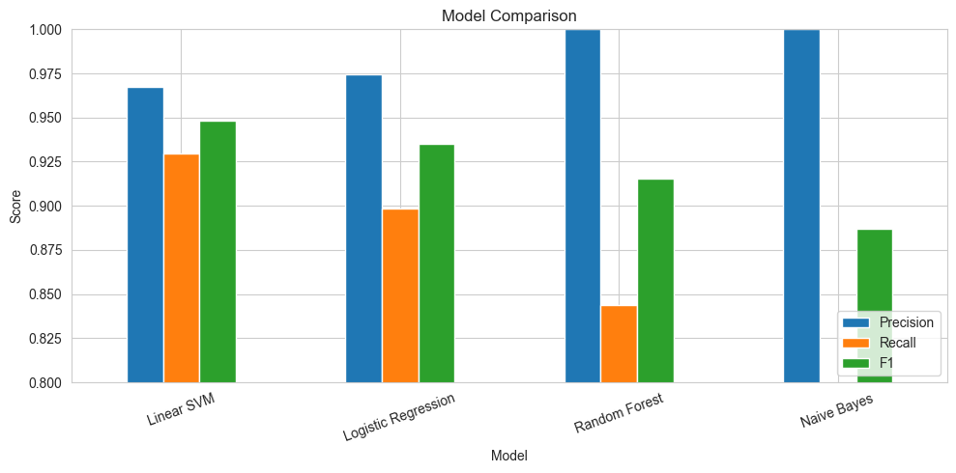
Figure 7: Precision, Recall, and F1-score compared across all four models
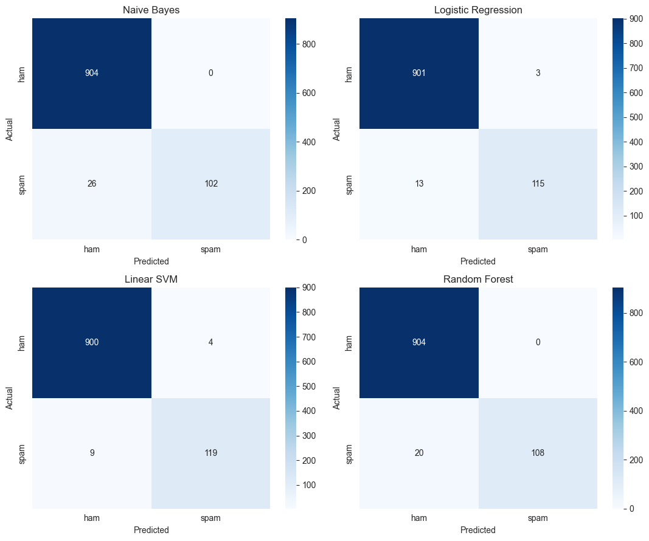
Figure 8: Confusion matrices — each shows exactly how many messages were correctly and incorrectly classified

8.2 Best Model: Linear SVM
Linear SVM came out on top, with the best F1-score (0.948) and the best recall (92.97%) — meaning it correctly caught the most spam messages while still keeping a very high precision (96.75%).
Naive Bayes and Random Forest had perfect precision (100%) — every message they called spam really was spam — but they missed a lot of actual spam (recall only 80% and 84%), which is risky in a real spam filter. Linear SVM struck the best balance, so it was saved as the final model (model.pkl).

9. Trying a Deep Learning Approach (Bonus)
To go a step further, we also tried a Deep Learning model using a Bidirectional LSTM (BiLSTM) — a type of neural network that reads a sentence both forwards and backwards to understand context better, commonly used in NLP tasks.
The model was built with these layers:
- Embedding layer — turns each word into a list of 64 numbers representing its meaning.
- Bidirectional LSTM (32 units) — reads the message in both directions to capture context.
- Dropout — randomly switches off some connections to avoid memorizing the training data.
- Dense layers — make the final spam/ham decision using a sigmoid output (a probability between 0 and 1).
Total parameters: about 345,889. Training used Early Stopping so it would stop automatically once it stopped improving (it stopped after 7 rounds).
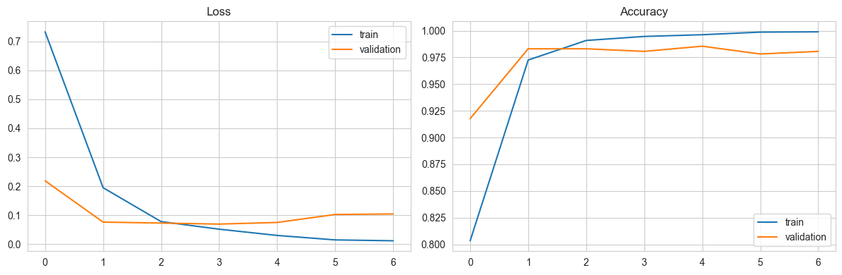
Figure 9: BiLSTM training loss and accuracy curves
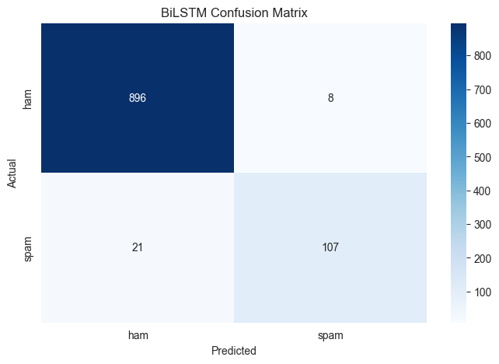
Figure 10: BiLSTM confusion matrix on the test set

9.1 Deep Learning vs Classic Machine Learning
Model | Accuracy | Precision | Recall | F1-Score
Linear SVM (best classic model) | 98.74% | 96.75% | 92.97% | 0.948
BiLSTM (deep learning) | 97.19% | 93.04% | 83.59% | 0.881

Interestingly, the deep learning model did not beat the simpler Linear SVM. This is a useful and realistic finding: deep learning models usually need a lot of data to show their strength, and this dataset is fairly small (about 5,000 messages). The Linear SVM also had an advantage — it used our five extra number-based clues (like digit_count and upper_count), while the BiLSTM only looked at the raw words. This shows that a simpler model, with good handcrafted features, can beat a more complex model on a small dataset.

10. Turning It Into a Real App
A model is only useful if people can actually use it. So the final Linear SVM model, along with the TF-IDF converter and the number-scaler, were saved as files (model.pkl, tfidf.pkl, scaler.pkl) and loaded into a simple web app built with Streamlit.
How the app works:
- The user types or pastes a text message into a box.
- The app cleans the text the exact same way as during training (lowercase, remove symbols, remove stopwords, stem words).
- It calculates the same five number-based clues from the message.
- It combines both pieces of information and feeds them to the saved Linear SVM model.
- The app displays the result clearly: a red 'SPAM' warning or a green 'HAM (not spam)' message, along with a confidence score.
This means anyone can open the app, paste in any message, and instantly find out whether it looks like spam — without needing to know anything about the code behind it.

11. Conclusion
We built a complete spam detection system, starting from raw text messages and ending with a working app. Along the way, we cleaned the data, engineered useful extra features, explored the data visually, converted text into numbers using TF-IDF, and trained and compared five different models (four classic ones plus a deep learning model).
The final choice — Linear SVM — correctly identifies spam messages about 93% of the time while almost never wrongly flagging a normal message, making it both accurate and trustworthy for real use.

11.1 Limitations and Future Improvements
- The dataset is relatively small and slightly old; testing on newer, more varied spam styles could reveal new patterns.
- The BiLSTM model could likely improve if it also used the five numeric clues, not just the raw text.
- Trying other models like XGBoost or a Transformer-based model (like BERT) could be explored for comparison.
- Collecting more spam examples would help balance the dataset and could improve recall further.

12. Tools and Skills Used
- Python programming
- Pandas and NumPy for data handling
- Matplotlib and Seaborn for visualizations
- NLTK for text cleaning, stopword removal, and stemming
- Scikit-learn for TF-IDF, scaling, and classic machine learning models
- TensorFlow/Keras for the deep learning (BiLSTM) model
- Streamlit for building the final web app
- Core ML concepts: classification, class imbalance, precision/recall/F1, overfitting, model comparison

