ASSIGNMENT-3

NAME:-Bhanu chand Garikapati

Student#:-700748274

Github id:-<https://github.com/Bhanu5423/neural_assignments>

Program-1:-

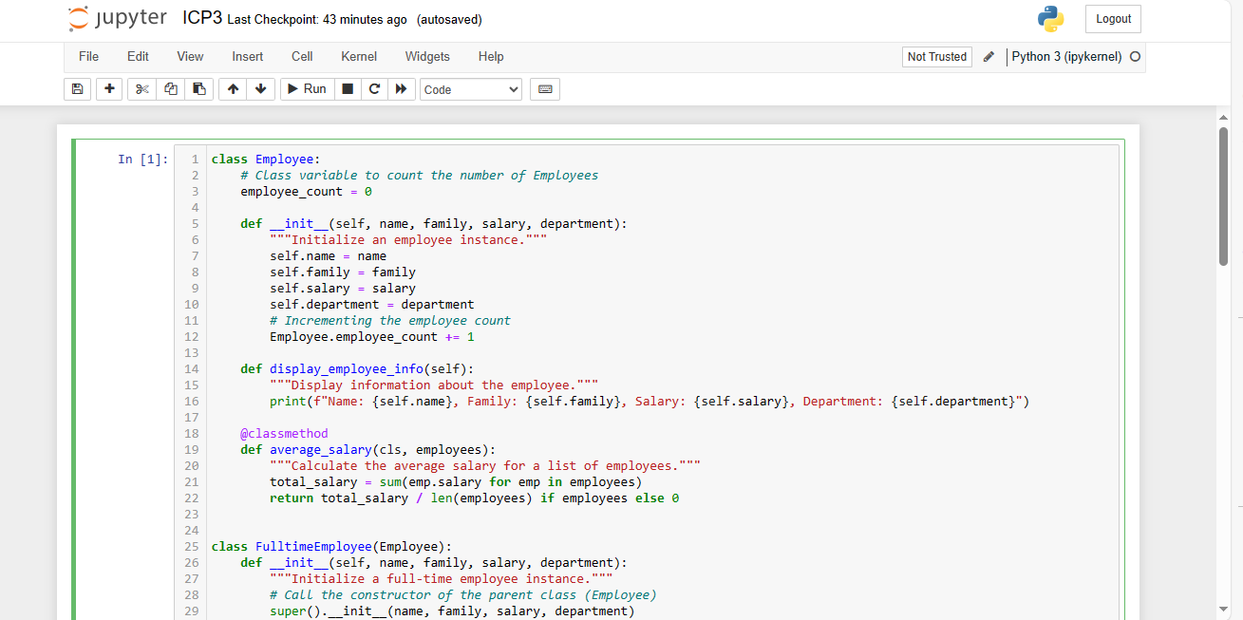

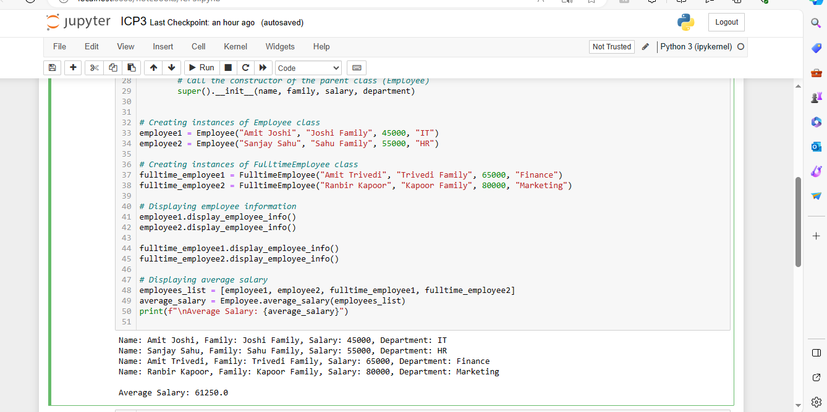

Program-2:-

