# DEEP LEARNING AND NEURAL NETWORK

ASSIGNMENT -1

NAME :- BHANU CHAND GARIKAPATI

STUDENT#:- 700748274

GITHUB LINK:-

Program-1:-

Program-2:-

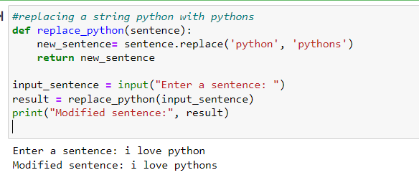

Program 3:-

