IMPROVEMENT IN ROAD SIGNAGES ON NATIONAL HIGHWAY IN INDIA USING ARTIFICIAL INTELLIGENCE (AI) BASED SURVEYS

Name of the stretch -
Six lane road from mohali to patiala via isbt - 43 singhu border
Unique Project Code (UPC) -N/09001/01002/PB
State -Punjab
Regional Office (RO) -Punjab
Project Implementation Unit (PIU) -Amritsar

Executive Summary
National Highways Authority of India (NHAI), under Ministry of Road Transport and Highways (MoRTH), Government of India has signed a Memorandum of Understanding (MoU) with Indraprastha Institute of Information Technology, Delhi (IIITD) to utilize AI based solutions for carrying out Gap Study w.r.t availability and broad condition of road sign on around 25,000 km of selected National Highways (provided by NHAI). The gap study shall be carried out by assessing the difference between the AI based survey findings and the road signage inventory as per NHAI record. The other part of the gap study shall cover the additional requirement of road signages as per the recommendations of certified Road Safety Auditor (RSA) based on latest codal provisions relevant to high-speed corridors.
The MoU was signed on 30-10-2025 and project completion period was kept as twelve (12) months. The date of commencement of this project was 30-10-2026.
This report summarizes the findings of a gap study conducted on National Highway project Six Laning of Jalandhar - Amritsar Section of NH-1 from Km 387.100 to Km 407.100 (Bidhipur Dhilwan).The linear length of project stretch is 20 km and it includes “Six Lane with divided carriageway with Service Road” configuration and the type of pavement is Flexible/Rigid. The construction work of the project was completed on/ date of COD was value . The project is currently under DLP/O&M stage.
The survey on this project stretch was carried out on 3/10/2025 by the team of IIIT Delhi. As per survey findings which is based on Artificial Intelligence (AI), there are 303 nos. of roads signs including Chevron, Hazard, Cautionary Warning, Prohibitory Mandatory & Informatory Signs, on this project. However, as per NHAI record/ approved Road Signage Plan of Contract Agreement, the number of road signages on this project are 242 nos. (data as provided by NHAI). Therefore, a gap of -61 nos. sign boards have been observed vis-à-vis NHAI record. This variance in the count of signages in the contract document and existing signages taken out by AI survey report is not available in NHAI record. This finding will help NHAI in better inventorisation of the existing Road Signage on this project.
Secondly, this project has also carried out gap study based on the recommendation of certified road safety auditor (RSA). As per RSA recommendation, the number of Total road signs required on this project are {road_signs_required} nos. Accordingly, there is an additional requirement of {road_signs_rsa_gap} of signages over and above {road_signs_rsa} nos. as observed during the survey.
The following table presents the summary of Gap study report :
Category of Signages | Nos. of Signages As per NHAI record | Nos. of Signages Based on the AI Survey | Total signages required including Existing and RSA recommendation (AI + Δ RSA) | Gap Based on NHAI record , (-) represents excess signs boards w.r.t NHAI record | Gap Based on RSA recommendation
Chevron | 0 | 0 | 0 | 0 | 0
Cautionary Warning Signs | 0 | 10 | 23 | -10 | 13
Hazard | 0 | 243 | 260 | -243 | 17
Prohibitory Mandatory Signs | 0 | 45 | 61 | -45 | 16
Informatory Signs | 0 | 60 | 63 | -60 | 3
Total | 0 | 358 | 407 | -358 | 49

1. Introduction

1.1.Brief description about the MoU
A Memorandum of Understanding (MoU) has been signed between the National Highways Authority of India (NHAI) and Indraprastha Institute of Information Technology, Delhi (IIIT Delhi) for carrying out Gap Study w.r.t availability and broad condition of road sign on around 25,000 km National Highways in India.
The project duration as per the MoU is twelve (12) months and the date of commencement of work is 27.09.2024. The tentative length of roads to be covered under the aforementioned study shall be 25,000 km. The list of stretches included in the project are from different states which is divided into 05 zones (Zone A to E).
Zone | States
Zone A | Jammu & Kashmir, Punjab, Himachal Pradesh, Uttarakhand , Haryana , Chandigarh and Delhi
Zone B | Gujrat and Rajasthan
Zone C | Maharashtra and Madhya Pradesh
Zone D | Andhra Pradesh , Tamil Nadu , Telangana , Karnataka , Kerala , Chhattisgarh
Zone E | Assam , Bihar , Meghalaya , Jharkhand , Odisha , Uttar Pradesh and West Bengal
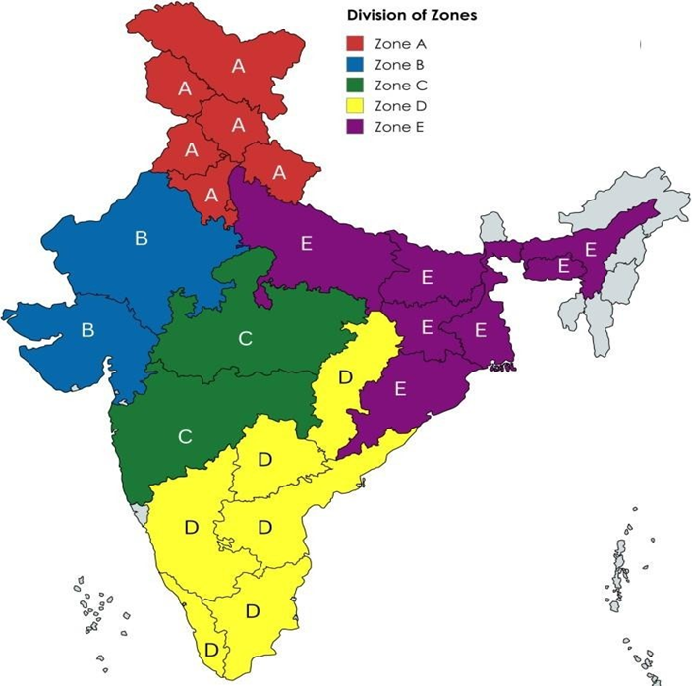

1.2 Objectives of Gap Study
Adequate availability of the road signs on the roads plays a significant role in the road safety. NHAI intends to enhance the road safety for all road users by embracing innovation and adopting advanced technologies.
Artificial Intelligence (Al) has emerged as a powerful tool for automating tasks and improving data analysis capabilities. By harnessing the potential of Al and Geographic Information Systems (GIS), NHAI can revolutionize its approach w.r.t road signs inspection.
Therefore, NHAI in collaboration with IIIT Delhi intends to utilize Al based solutions for Improvement in the availability of road signs on National Highways in India.

1.3 Scope of services
The scope of work is to carry out Gap studies w.r.t the availability and broad condition of road signs on around 25,000 km of National Highways in India. The services includes following:
i. The gap study shall be carried out by assessing the difference between the survey findings and the requirements of road signs as per signage plan of the respective Contract Agreement.
ii. Gap study based on updated / latest Codal provisions relevant to high-speed corridors to cater for enhanced safety requirements. For this purpose, IIITD shall engage a certified Road Safety Auditor (RSA) for assisting in the gap study and preparation of report.
iii. IIITD shall carry out the surveys for collecting imagery and other ancillary data related to availability and condition of road signages on selected National Highways stretches in India as provided by NHAI.
iv. The data collected through surveys shall be processed through deployment of adequately capable Artificial Intelligence (AI) for accurate identification and classification of road sign types.

1.4 Salient features of the instant National Highway Project
i. The salient features of the instant National Highway Project are mentioned as under:
Description/ Particular | Details
Name of the project Highway
Unique Project Code (UPC)
NHAI Regional Office
NHAI Project Implementation Unit (PIU)
Details of Project Construction;
(a) Date of Completion/ COD
(b) DLP Completion Date
Details of O&M Agency (if any);
(a) O&M Contract Duration
ii. Key Features of the Project:
Description/ Particular | Details
Pavement Type &amp; Lane Configuration
Length of Main Carriageway
Length of Service/ Slip Roads
Major Junctions
Minor Junctions
Bridges (Major/Minor)
ROB/RUB/Flyovers
Underpasses (VUP/PUP/CUP)
Culverts
Toll Plaza
iii. Index map:
Index map showing the start point and end point of the said project.
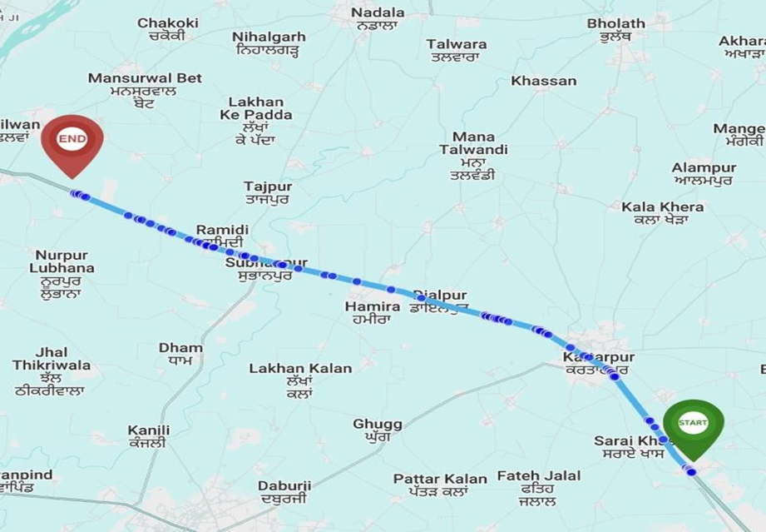
iv. Total Road segments in this project:
Main Carraige Way LHS Surveyed -56
Main Carraige Way RHS Surveyed -56
Total Service Roads Surveyed -56
Total Intersections Surveyed -10

2. Methodology

2.1. Data Collection
The research methodology used is a combination of data collection and processing the same through Artificial Intelligence (AI) based solutions. The data collection involves the use of technology like integrated device which is mounted on the vehicle and the survey is done with expert and driver in the vehicle. The start point is marked and the Main Carriageway (MCW) is covered on both LHS & RHS. The survey further includes covering all the service roads and intersections of the same stretch on vehicles to collect data remotely. The data which is collected is uploaded for the further processing through AI models.

2.2. Broad Methodology- Artificial Intelligence based solution
AI models are employed to process the collected data, identify patterns, and generate insights into road signages as seen in the video captured. The chainage, name of the road, latitude & longitude are marked simultaneously.

3. Inventory of Road Signs

3.1.Road Signage Inventory (provided by NHAI)
The inventory of road signs as provided by NHAI with broad categorisation is presented in the table below. The detailed inventory is placed at Annexure A.
Category of Signages | Nos. of Signages As per NHAI record
Chevron | 0
Cautionary Warning Signs | 0
Hazard | 0
Prohibitory Mandatory Signs | 0
Informatory Signs | 0
Total | 0

3.2.Road Signage Inventory based on Survey Data (conducted by IIIT)
The inventory of road signs based on AI Survey Data with broad categorisation is presented in the table below. The detailed inventory is placed at Annexure B.
Category of Signages | Nos. of Signages Based on the AI Survey
Chevron | 0
Cautionary Warning Signs | 10
Hazard | 243
Prohibitory Mandatory Signs | 45
Informatory Signs | 60
Total | 358

3.3.Road signage Requirement as per Road Safety Audit
The inventory of road signs as per Road Safety Auditor recommendation is presented in the table below. The detailed inventory is placed at Annexure C.

4. Results of Gap study

4.1.Gap study based on NHAI data
Following table represents the gap analysis of road signs between NHAI record and AI survey data-
Category of Signages | Nos. of Signages As per NHAI record | Nos. of Signages Based on the AI Survey | Gap Analysis
Chevron | 0 | 0 | 0
Cautionary Warning Signs | 0 | 10 | -10
Hazard | 0 | 243 | -243
Prohibitory Mandatory Signs | 0 | 45 | -45
Informatory Signs | 0 | 60 | -60
Total | 0 | 358 | -358
Following graph shows the difference between NHAI record and AI based survey in a bar chart-
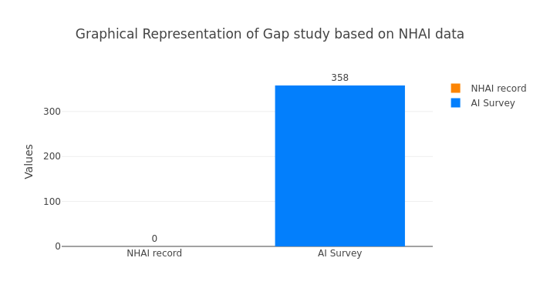

4.2.Gap study based on Rad safety audit
Following table represents the gap analysis of road signs between NHAI record , AI survey data and Road safety auditor recommendation with different category of signage. The detailed inventory is placed at Annexure D.
Category of Signages | Nos. of Signages As per NHAI record | Nos. of Signages Based on the AI Survey | Total signages required including Existing and RSA recommendation (AI + Δ RSA) | Gap Based on NHAI record , (-) represents excess signs boards w.r.t NHAI record | Gap Based on RSA recommendation
Chevron | 0 | 0 | 0 | 0 | 0
Cautionary Warning Signs | 0 | 10 | 23 | -10 | 13
Hazard | 0 | 243 | 260 | -243 | 17
Prohibitory Mandatory Signs | 0 | 45 | 61 | -45 | 16
Informatory Signs | 0 | 60 | 63 | -60 | 3
Total | 0 | 358 | 407 | -358 | 49
Following graph shows the difference between NHAI record , AI based survey and Road safety auditor recommendation in a bar chart format,lk-
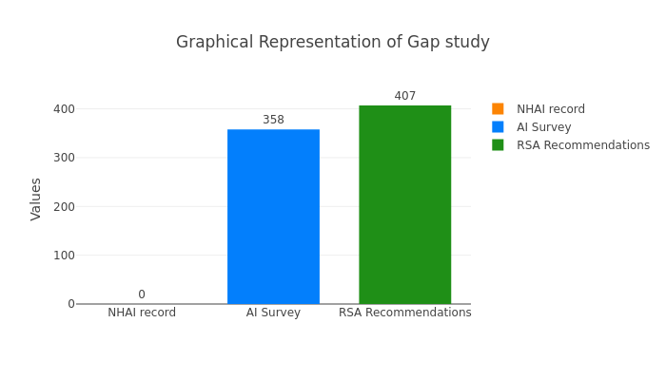

Road Signage Inventory (as provided by NHAI)
Category of Signages | Nos. of Signages As per NHAI record
Chevron | 0
Cautionary Warning Signs | 0
Hazard | 0
Prohibitory Mandatory Signs | 0
Informatory Signs | 0
Total | 0

Road Signage Inventory based on AI Survey Data (conducted by IIITD)
Category of Signages | Nos. of Signages Based on the AI Survey
Chevron | 0
Cautionary Warning Signs | 10
Hazard | 243
Prohibitory Mandatory Signs | 45
Informatory Signs | 60
Total | 358

Gap study based on NHAI data
Category of Signages | Nos. of Signages As per NHAI record | Nos. of Signages Based on the AI Survey | Gap Analysis
Chevron | 0 | 0 | 0
Cautionary Warning Signs | 0 | 10 | -10
Hazard | 0 | 243 | -243
Prohibitory Mandatory Signs | 0 | 45 | -45
Informatory Signs | 0 | 60 | -60
Total | 0 | 358 | -358




Chainage Wise Gap Analysis
Chainage: All
Gap Analysis:
Category of Signages | Nos. of Signages As per NHAI record | Nos. of Signages Based on the AI Survey | Total signages required including Existing and RSA recommendation (AI + Δ RSA) | Gap Based on NHAI record , (-) represents excess signs boards w.r.t NHAI record | Gap Based on RSA recommendation
Chevron | 0 | 0 | 0 | 0 | 0
Cautionary Warning Signs | 0 | 10 | 23 | -10 | 13
Hazard | 0 | 243 | 260 | -243 | 17
Prohibitory Mandatory Signs | 0 | 45 | 61 | -45 | 16
Informatory Signs | 0 | 60 | 63 | -60 | 3
Total | 0 | 358 | 407 | -358 | 49
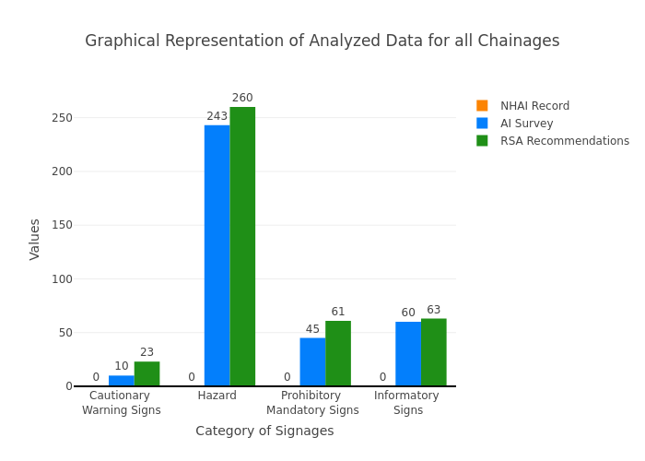
Chainage: 0-500
Gap Analysis:
Category of Signages | Nos. of Signages As per NHAI record | Nos. of Signages Based on the AI Survey | Total signages required including Existing and RSA recommendation (AI + Δ RSA) | Gap Based on NHAI record , (-) represents excess signs boards w.r.t NHAI record | Gap Based on RSA recommendation
Chevron | 0 | 0 | 0 | 0 | 0
Cautionary Warning Signs | 0 | 3 | 8 | -3 | 5
Hazard | 0 | 18 | 20 | -18 | 2
Prohibitory Mandatory Signs | 0 | 14 | 17 | -14 | 3
Informatory Signs | 0 | 2 | 2 | -2 | 0
Total | 0 | 37 | 47 | -37 | 10
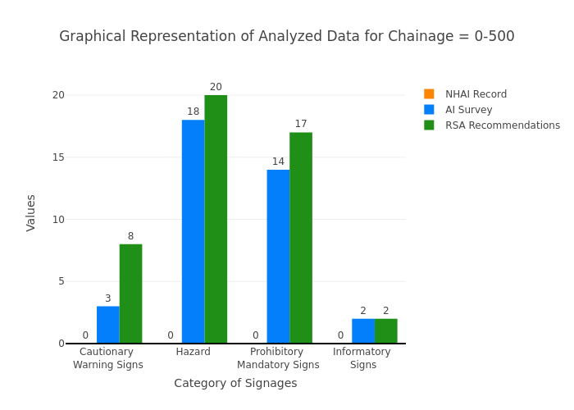

Chainage: 1000-500
Gap Analysis:
Category of Signages | Nos. of Signages As per NHAI record | Nos. of Signages Based on the AI Survey | Total signages required including Existing and RSA recommendation (AI + Δ RSA) | Gap Based on NHAI record , (-) represents excess signs boards w.r.t NHAI record | Gap Based on RSA recommendation
Chevron | 0 | 0 | 0 | 0 | 0
Cautionary Warning Signs | 0 | 0 | 0 | 0 | 0
Hazard | 0 | 0 | 1 | 0 | 1
Prohibitory Mandatory Signs | 0 | 2 | 4 | -2 | 2
Informatory Signs | 0 | 12 | 12 | -12 | 0
Total | 0 | 14 | 17 | -14 | 3
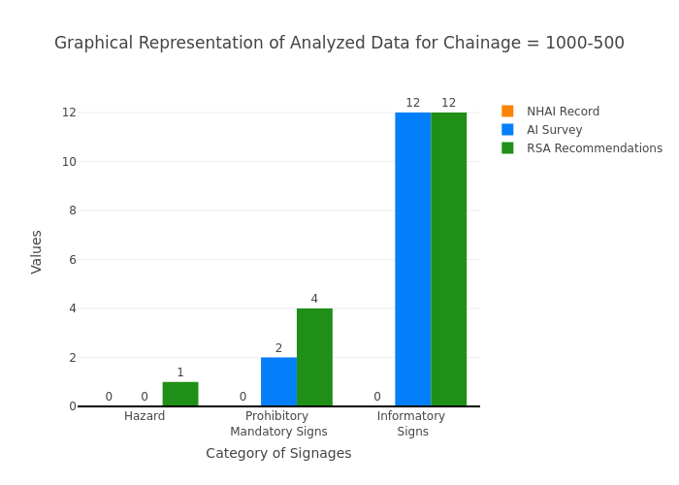

Chainage: 1000-1500
Gap Analysis:
Category of Signages | Nos. of Signages As per NHAI record | Nos. of Signages Based on the AI Survey | Total signages required including Existing and RSA recommendation (AI + Δ RSA) | Gap Based on NHAI record , (-) represents excess signs boards w.r.t NHAI record | Gap Based on RSA recommendation
Chevron | 0 | 0 | 0 | 0 | 0
Cautionary Warning Signs | 0 | 0 | 0 | 0 | 0
Hazard | 0 | 3 | 4 | -3 | 1
Prohibitory Mandatory Signs | 0 | 0 | 0 | 0 | 0
Informatory Signs | 0 | 2 | 2 | -2 | 0
Total | 0 | 5 | 6 | -5 | 1
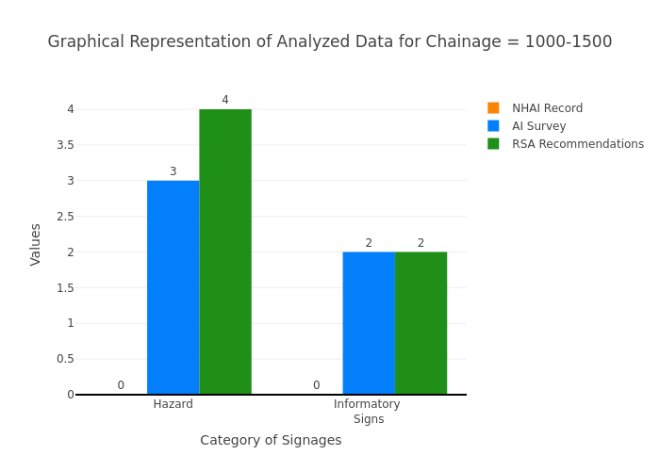

Chainage: 1500-2000
Gap Analysis:
Category of Signages | Nos. of Signages As per NHAI record | Nos. of Signages Based on the AI Survey | Total signages required including Existing and RSA recommendation (AI + Δ RSA) | Gap Based on NHAI record , (-) represents excess signs boards w.r.t NHAI record | Gap Based on RSA recommendation
Chevron | 0 | 0 | 0 | 0 | 0
Cautionary Warning Signs | 0 | 0 | 0 | 0 | 0
Hazard | 0 | 3 | 3 | -3 | 0
Prohibitory Mandatory Signs | 0 | 0 | 0 | 0 | 0
Informatory Signs | 0 | 2 | 2 | -2 | 0
Total | 0 | 5 | 5 | -5 | 0
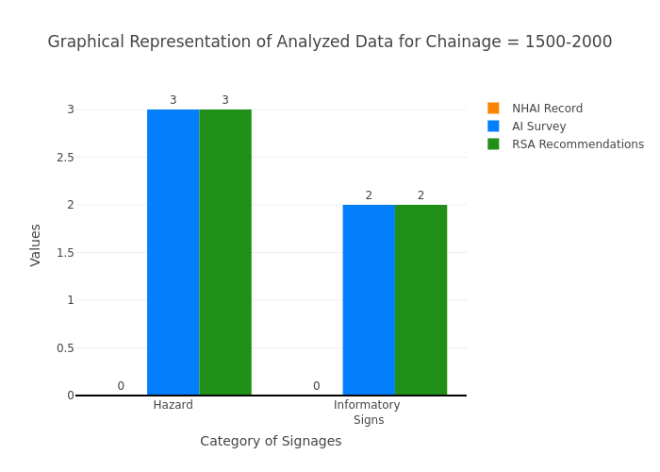

Chainage: 2000-2500
Gap Analysis:
Category of Signages | Nos. of Signages As per NHAI record | Nos. of Signages Based on the AI Survey | Total signages required including Existing and RSA recommendation (AI + Δ RSA) | Gap Based on NHAI record , (-) represents excess signs boards w.r.t NHAI record | Gap Based on RSA recommendation
Chevron | 0 | 0 | 0 | 0 | 0
Cautionary Warning Signs | 0 | 0 | 0 | 0 | 0
Hazard | 0 | 3 | 3 | -3 | 0
Prohibitory Mandatory Signs | 0 | 0 | 1 | 0 | 1
Informatory Signs | 0 | 1 | 1 | -1 | 0
Total | 0 | 4 | 5 | -4 | 1
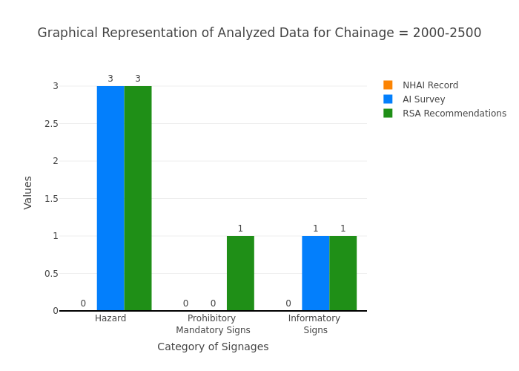

Chainage: 2500-3000
Gap Analysis:
Category of Signages | Nos. of Signages As per NHAI record | Nos. of Signages Based on the AI Survey | Total signages required including Existing and RSA recommendation (AI + Δ RSA) | Gap Based on NHAI record , (-) represents excess signs boards w.r.t NHAI record | Gap Based on RSA recommendation
Chevron | 0 | 0 | 0 | 0 | 0
Cautionary Warning Signs | 0 | 1 | 3 | -1 | 2
Hazard | 0 | 6 | 7 | -6 | 1
Prohibitory Mandatory Signs | 0 | 5 | 9 | -5 | 4
Informatory Signs | 0 | 3 | 3 | -3 | 0
Total | 0 | 15 | 22 | -15 | 7
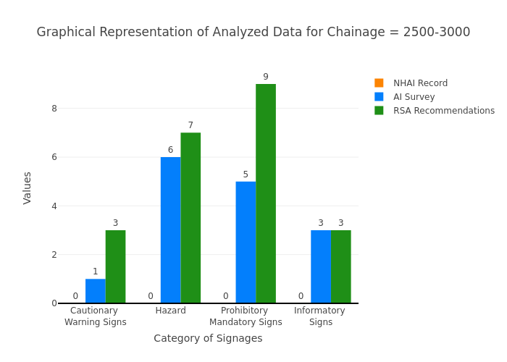

Chainage: 3000-3500
Gap Analysis:
Category of Signages | Nos. of Signages As per NHAI record | Nos. of Signages Based on the AI Survey | Total signages required including Existing and RSA recommendation (AI + Δ RSA) | Gap Based on NHAI record , (-) represents excess signs boards w.r.t NHAI record | Gap Based on RSA recommendation
Chevron | 0 | 0 | 0 | 0 | 0
Cautionary Warning Signs | 0 | 0 | 3 | 0 | 3
Hazard | 0 | 7 | 8 | -7 | 1
Prohibitory Mandatory Signs | 0 | 0 | 5 | 0 | 5
Informatory Signs | 0 | 3 | 3 | -3 | 0
Total | 0 | 10 | 19 | -10 | 9
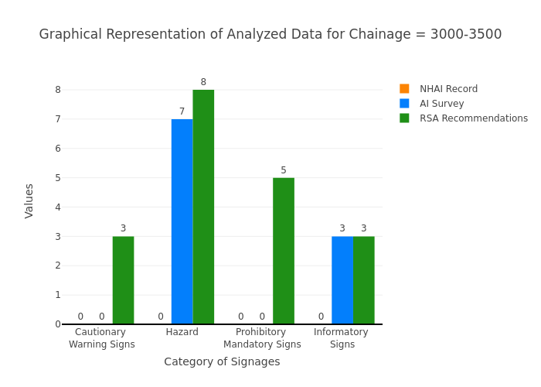

Chainage: 3500-4000
Gap Analysis:
Category of Signages | Nos. of Signages As per NHAI record | Nos. of Signages Based on the AI Survey | Total signages required including Existing and RSA recommendation (AI + Δ RSA) | Gap Based on NHAI record , (-) represents excess signs boards w.r.t NHAI record | Gap Based on RSA recommendation
Chevron | 0 | 0 | 0 | 0 | 0
Cautionary Warning Signs | 0 | 0 | 0 | 0 | 0
Hazard | 0 | 7 | 7 | -7 | 0
Prohibitory Mandatory Signs | 0 | 0 | 1 | 0 | 1
Informatory Signs | 0 | 2 | 2 | -2 | 0
Total | 0 | 9 | 10 | -9 | 1
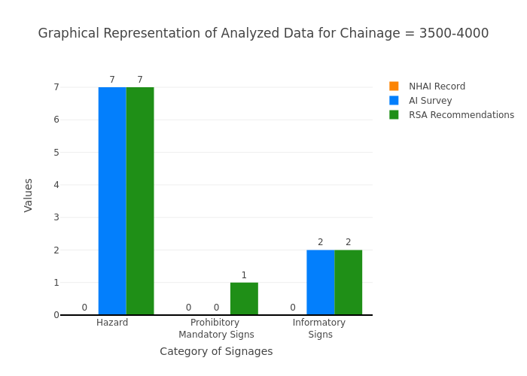

Chainage: 4000-4500
Gap Analysis:
Category of Signages | Nos. of Signages As per NHAI record | Nos. of Signages Based on the AI Survey | Total signages required including Existing and RSA recommendation (AI + Δ RSA) | Gap Based on NHAI record , (-) represents excess signs boards w.r.t NHAI record | Gap Based on RSA recommendation
Chevron | 0 | 0 | 0 | 0 | 0
Cautionary Warning Signs | 0 | 0 | 0 | 0 | 0
Hazard | 0 | 8 | 8 | -8 | 0
Prohibitory Mandatory Signs | 0 | 1 | 1 | -1 | 0
Informatory Signs | 0 | 1 | 1 | -1 | 0
Total | 0 | 10 | 10 | -10 | 0
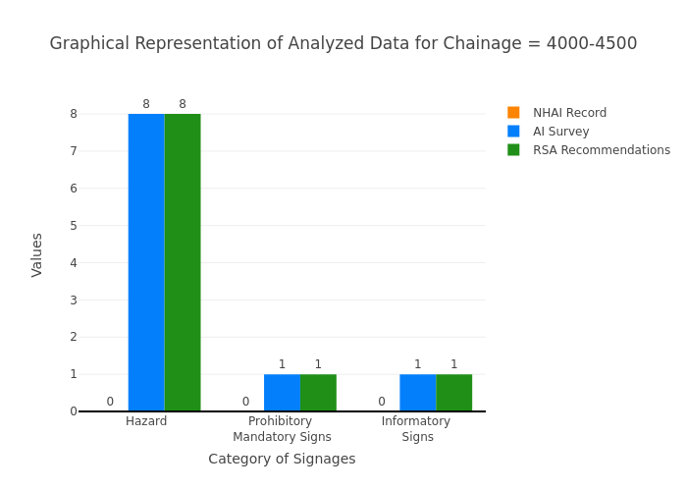

Chainage: 4500-5000
Gap Analysis:
Category of Signages | Nos. of Signages As per NHAI record | Nos. of Signages Based on the AI Survey | Total signages required including Existing and RSA recommendation (AI + Δ RSA) | Gap Based on NHAI record , (-) represents excess signs boards w.r.t NHAI record | Gap Based on RSA recommendation
Chevron | 0 | 0 | 0 | 0 | 0
Cautionary Warning Signs | 0 | 0 | 0 | 0 | 0
Hazard | 0 | 3 | 3 | -3 | 0
Prohibitory Mandatory Signs | 0 | 0 | 0 | 0 | 0
Informatory Signs | 0 | 0 | 0 | 0 | 0
Total | 0 | 3 | 3 | -3 | 0
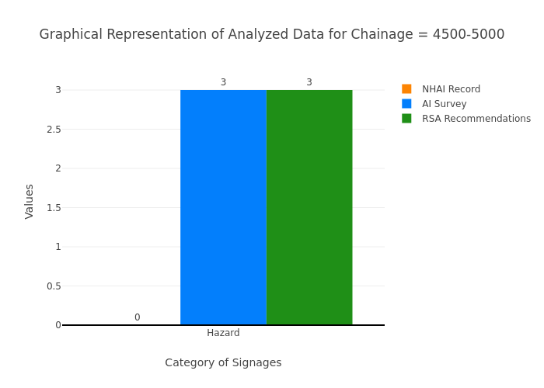

Chainage: 5000-5500
Gap Analysis:
Category of Signages | Nos. of Signages As per NHAI record | Nos. of Signages Based on the AI Survey | Total signages required including Existing and RSA recommendation (AI + Δ RSA) | Gap Based on NHAI record , (-) represents excess signs boards w.r.t NHAI record | Gap Based on RSA recommendation
Chevron | 0 | 0 | 0 | 0 | 0
Cautionary Warning Signs | 0 | 0 | 1 | 0 | 1
Hazard | 0 | 4 | 4 | -4 | 0
Prohibitory Mandatory Signs | 0 | 0 | 0 | 0 | 0
Informatory Signs | 0 | 1 | 1 | -1 | 0
Total | 0 | 5 | 6 | -5 | 1
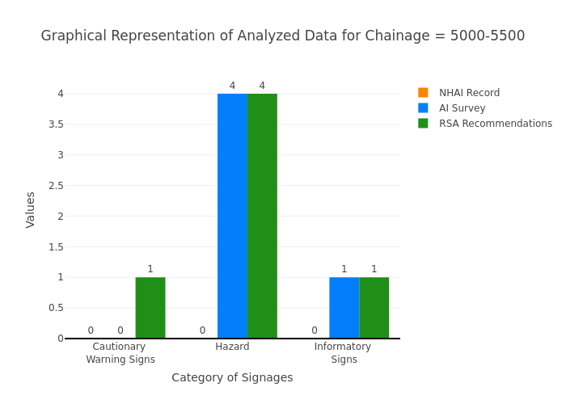

Chainage: 5500-6000
Gap Analysis:
Category of Signages | Nos. of Signages As per NHAI record | Nos. of Signages Based on the AI Survey | Total signages required including Existing and RSA recommendation (AI + Δ RSA) | Gap Based on NHAI record , (-) represents excess signs boards w.r.t NHAI record | Gap Based on RSA recommendation
Chevron | 0 | 0 | 0 | 0 | 0
Cautionary Warning Signs | 0 | 1 | 1 | -1 | 0
Hazard | 0 | 8 | 8 | -8 | 0
Prohibitory Mandatory Signs | 0 | 0 | 0 | 0 | 0
Informatory Signs | 0 | 2 | 2 | -2 | 0
Total | 0 | 11 | 11 | -11 | 0
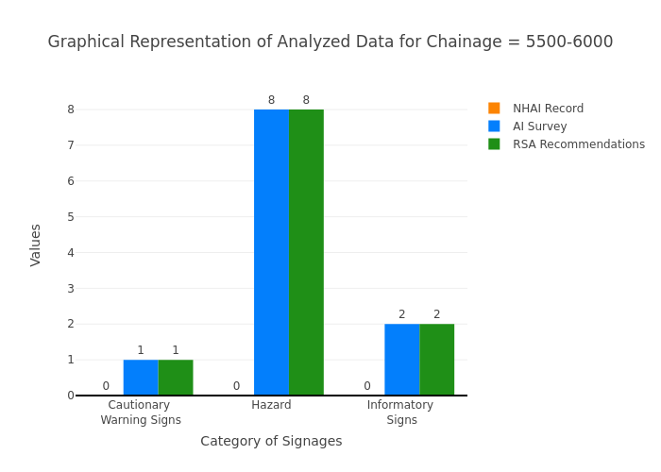

Chainage: 6000-6500
Gap Analysis:
Category of Signages | Nos. of Signages As per NHAI record | Nos. of Signages Based on the AI Survey | Total signages required including Existing and RSA recommendation (AI + Δ RSA) | Gap Based on NHAI record , (-) represents excess signs boards w.r.t NHAI record | Gap Based on RSA recommendation
Chevron | 0 | 0 | 0 | 0 | 0
Cautionary Warning Signs | 0 | 1 | 1 | -1 | 0
Hazard | 0 | 0 | 0 | 0 | 0
Prohibitory Mandatory Signs | 0 | 1 | 1 | -1 | 0
Informatory Signs | 0 | 0 | 0 | 0 | 0
Total | 0 | 2 | 2 | -2 | 0
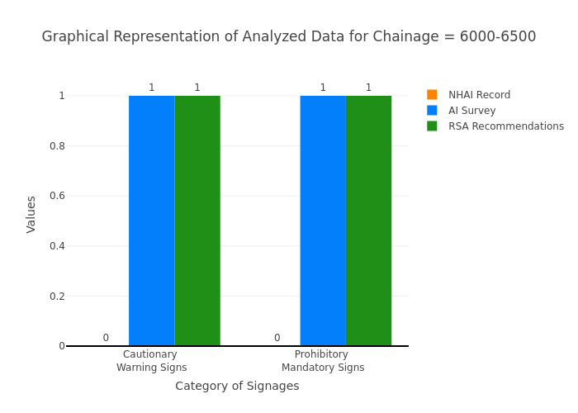

Chainage: 6500-7000
Gap Analysis:
Category of Signages | Nos. of Signages As per NHAI record | Nos. of Signages Based on the AI Survey | Total signages required including Existing and RSA recommendation (AI + Δ RSA) | Gap Based on NHAI record , (-) represents excess signs boards w.r.t NHAI record | Gap Based on RSA recommendation
Chevron | 0 | 0 | 0 | 0 | 0
Cautionary Warning Signs | 0 | 0 | 0 | 0 | 0
Hazard | 0 | 11 | 11 | -11 | 0
Prohibitory Mandatory Signs | 0 | 1 | 1 | -1 | 0
Informatory Signs | 0 | 1 | 1 | -1 | 0
Total | 0 | 13 | 13 | -13 | 0
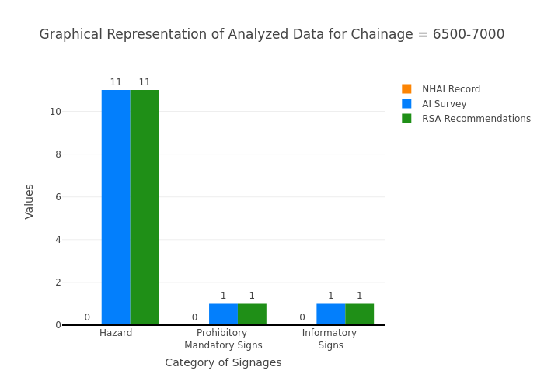

Chainage: 7000-7500
Gap Analysis:
Category of Signages | Nos. of Signages As per NHAI record | Nos. of Signages Based on the AI Survey | Total signages required including Existing and RSA recommendation (AI + Δ RSA) | Gap Based on NHAI record , (-) represents excess signs boards w.r.t NHAI record | Gap Based on RSA recommendation
Chevron | 0 | 0 | 0 | 0 | 0
Cautionary Warning Signs | 0 | 0 | 0 | 0 | 0
Hazard | 0 | 0 | 0 | 0 | 0
Prohibitory Mandatory Signs | 0 | 0 | 0 | 0 | 0
Informatory Signs | 0 | 0 | 0 | 0 | 0
Total | 0 | 0 | 0 | 0 | 0
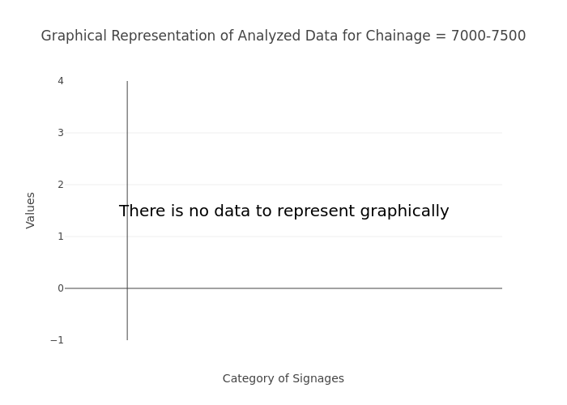

Chainage: 7500-8000
Gap Analysis:
Category of Signages | Nos. of Signages As per NHAI record | Nos. of Signages Based on the AI Survey | Total signages required including Existing and RSA recommendation (AI + Δ RSA) | Gap Based on NHAI record , (-) represents excess signs boards w.r.t NHAI record | Gap Based on RSA recommendation
Chevron | 0 | 0 | 0 | 0 | 0
Cautionary Warning Signs | 0 | 0 | 0 | 0 | 0
Hazard | 0 | 3 | 3 | -3 | 0
Prohibitory Mandatory Signs | 0 | 0 | 0 | 0 | 0
Informatory Signs | 0 | 0 | 0 | 0 | 0
Total | 0 | 3 | 3 | -3 | 0
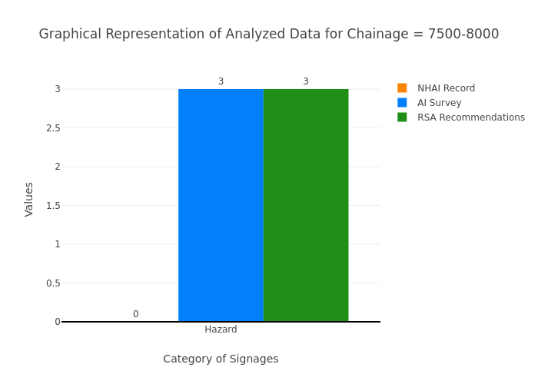

Chainage: 8000-8500
Gap Analysis:
Category of Signages | Nos. of Signages As per NHAI record | Nos. of Signages Based on the AI Survey | Total signages required including Existing and RSA recommendation (AI + Δ RSA) | Gap Based on NHAI record , (-) represents excess signs boards w.r.t NHAI record | Gap Based on RSA recommendation
Chevron | 0 | 0 | 0 | 0 | 0
Cautionary Warning Signs | 0 | 0 | 0 | 0 | 0
Hazard | 0 | 5 | 5 | -5 | 0
Prohibitory Mandatory Signs | 0 | 2 | 2 | -2 | 0
Informatory Signs | 0 | 0 | 0 | 0 | 0
Total | 0 | 7 | 7 | -7 | 0
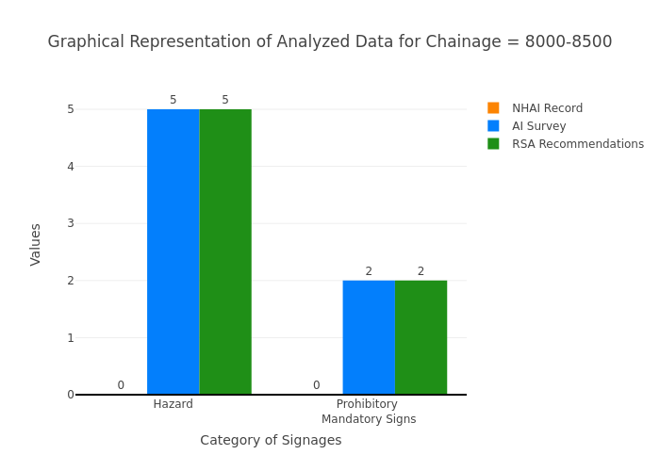

Chainage: 8500-9000
Gap Analysis:
Category of Signages | Nos. of Signages As per NHAI record | Nos. of Signages Based on the AI Survey | Total signages required including Existing and RSA recommendation (AI + Δ RSA) | Gap Based on NHAI record , (-) represents excess signs boards w.r.t NHAI record | Gap Based on RSA recommendation
Chevron | 0 | 0 | 0 | 0 | 0
Cautionary Warning Signs | 0 | 0 | 0 | 0 | 0
Hazard | 0 | 1 | 1 | -1 | 0
Prohibitory Mandatory Signs | 0 | 1 | 1 | -1 | 0
Informatory Signs | 0 | 1 | 1 | -1 | 0
Total | 0 | 3 | 3 | -3 | 0
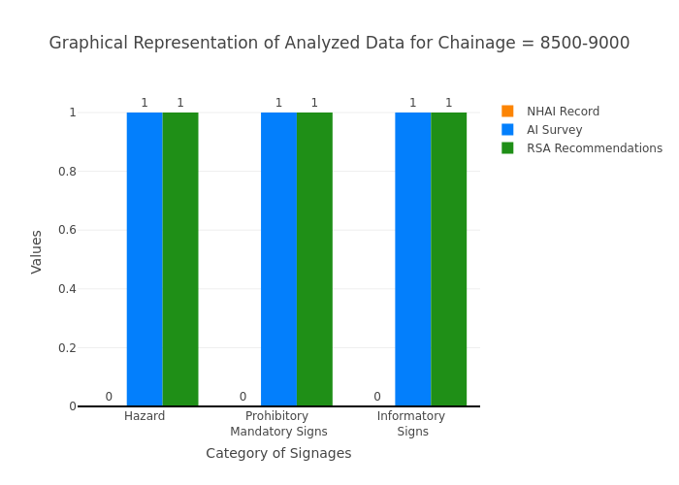

Chainage: 9000-9500
Gap Analysis:
Category of Signages | Nos. of Signages As per NHAI record | Nos. of Signages Based on the AI Survey | Total signages required including Existing and RSA recommendation (AI + Δ RSA) | Gap Based on NHAI record , (-) represents excess signs boards w.r.t NHAI record | Gap Based on RSA recommendation
Chevron | 0 | 0 | 0 | 0 | 0
Cautionary Warning Signs | 0 | 0 | 0 | 0 | 0
Hazard | 0 | 1 | 2 | -1 | 1
Prohibitory Mandatory Signs | 0 | 0 | 0 | 0 | 0
Informatory Signs | 0 | 4 | 4 | -4 | 0
Total | 0 | 5 | 6 | -5 | 1
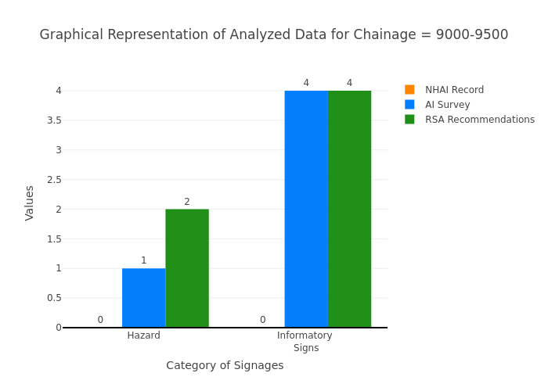

Chainage: 10000-9500
Gap Analysis:
Category of Signages | Nos. of Signages As per NHAI record | Nos. of Signages Based on the AI Survey | Total signages required including Existing and RSA recommendation (AI + Δ RSA) | Gap Based on NHAI record , (-) represents excess signs boards w.r.t NHAI record | Gap Based on RSA recommendation
Chevron | 0 | 0 | 0 | 0 | 0
Cautionary Warning Signs | 0 | 0 | 0 | 0 | 0
Hazard | 0 | 3 | 4 | -3 | 1
Prohibitory Mandatory Signs | 0 | 0 | 0 | 0 | 0
Informatory Signs | 0 | 1 | 1 | -1 | 0
Total | 0 | 4 | 5 | -4 | 1
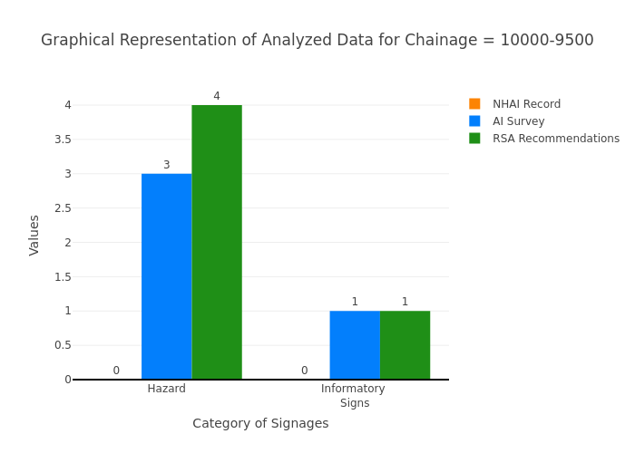

Chainage: 10000-10500
Gap Analysis:
Category of Signages | Nos. of Signages As per NHAI record | Nos. of Signages Based on the AI Survey | Total signages required including Existing and RSA recommendation (AI + Δ RSA) | Gap Based on NHAI record , (-) represents excess signs boards w.r.t NHAI record | Gap Based on RSA recommendation
Chevron | 0 | 0 | 0 | 0 | 0
Cautionary Warning Signs | 0 | 0 | 0 | 0 | 0
Hazard | 0 | 3 | 3 | -3 | 0
Prohibitory Mandatory Signs | 0 | 1 | 1 | -1 | 0
Informatory Signs | 0 | 0 | 0 | 0 | 0
Total | 0 | 4 | 4 | -4 | 0
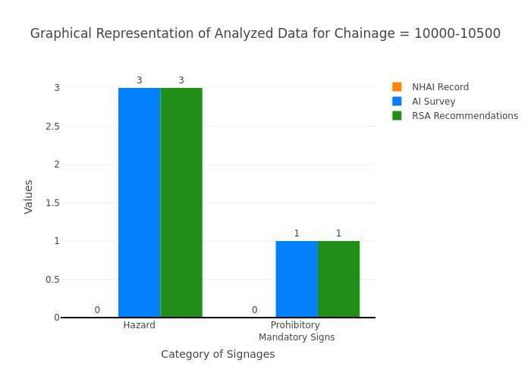

Chainage: 10500-11000
Gap Analysis:
Category of Signages | Nos. of Signages As per NHAI record | Nos. of Signages Based on the AI Survey | Total signages required including Existing and RSA recommendation (AI + Δ RSA) | Gap Based on NHAI record , (-) represents excess signs boards w.r.t NHAI record | Gap Based on RSA recommendation
Chevron | 0 | 0 | 0 | 0 | 0
Cautionary Warning Signs | 0 | 0 | 0 | 0 | 0
Hazard | 0 | 9 | 9 | -9 | 0
Prohibitory Mandatory Signs | 0 | 1 | 1 | -1 | 0
Informatory Signs | 0 | 6 | 6 | -6 | 0
Total | 0 | 16 | 16 | -16 | 0
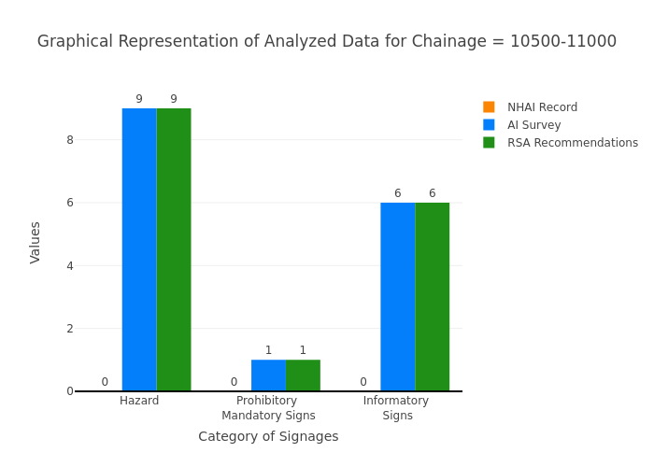

Chainage: 11000-11500
Gap Analysis:
Category of Signages | Nos. of Signages As per NHAI record | Nos. of Signages Based on the AI Survey | Total signages required including Existing and RSA recommendation (AI + Δ RSA) | Gap Based on NHAI record , (-) represents excess signs boards w.r.t NHAI record | Gap Based on RSA recommendation
Chevron | 0 | 0 | 0 | 0 | 0
Cautionary Warning Signs | 0 | 0 | 0 | 0 | 0
Hazard | 0 | 4 | 4 | -4 | 0
Prohibitory Mandatory Signs | 0 | 0 | 0 | 0 | 0
Informatory Signs | 0 | 2 | 3 | -2 | 1
Total | 0 | 6 | 7 | -6 | 1
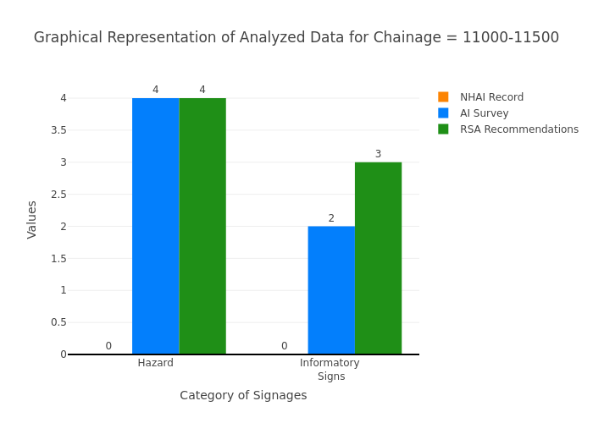

Chainage: 11500-12000
Gap Analysis:
Category of Signages | Nos. of Signages As per NHAI record | Nos. of Signages Based on the AI Survey | Total signages required including Existing and RSA recommendation (AI + Δ RSA) | Gap Based on NHAI record , (-) represents excess signs boards w.r.t NHAI record | Gap Based on RSA recommendation
Chevron | 0 | 0 | 0 | 0 | 0
Cautionary Warning Signs | 0 | 0 | 0 | 0 | 0
Hazard | 0 | 3 | 4 | -3 | 1
Prohibitory Mandatory Signs | 0 | 0 | 0 | 0 | 0
Informatory Signs | 0 | 2 | 2 | -2 | 0
Total | 0 | 5 | 6 | -5 | 1
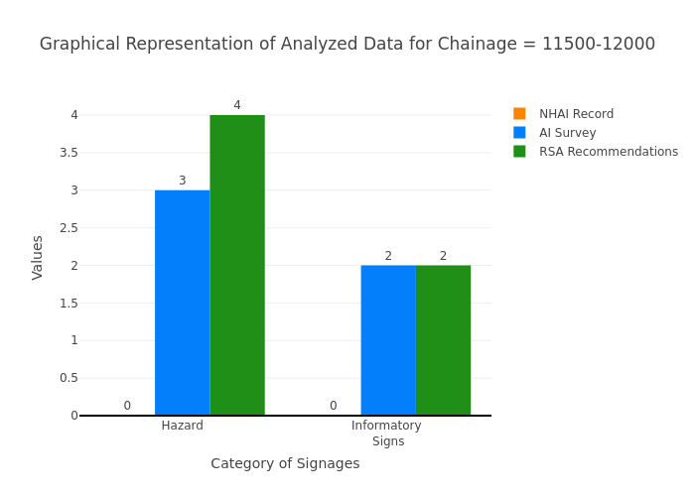

Chainage: 12000-12500
Gap Analysis:
Category of Signages | Nos. of Signages As per NHAI record | Nos. of Signages Based on the AI Survey | Total signages required including Existing and RSA recommendation (AI + Δ RSA) | Gap Based on NHAI record , (-) represents excess signs boards w.r.t NHAI record | Gap Based on RSA recommendation
Chevron | 0 | 0 | 0 | 0 | 0
Cautionary Warning Signs | 0 | 0 | 2 | 0 | 2
Hazard | 0 | 2 | 5 | -2 | 3
Prohibitory Mandatory Signs | 0 | 0 | 0 | 0 | 0
Informatory Signs | 0 | 0 | 2 | 0 | 2
Total | 0 | 2 | 9 | -2 | 7
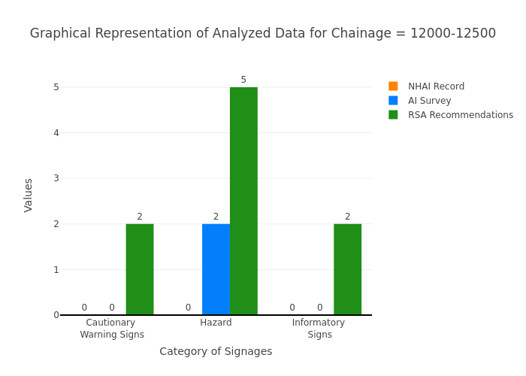

Chainage: 12500-13000
Gap Analysis:
Category of Signages | Nos. of Signages As per NHAI record | Nos. of Signages Based on the AI Survey | Total signages required including Existing and RSA recommendation (AI + Δ RSA) | Gap Based on NHAI record , (-) represents excess signs boards w.r.t NHAI record | Gap Based on RSA recommendation
Chevron | 0 | 0 | 0 | 0 | 0
Cautionary Warning Signs | 0 | 0 | 0 | 0 | 0
Hazard | 0 | 2 | 2 | -2 | 0
Prohibitory Mandatory Signs | 0 | 1 | 1 | -1 | 0
Informatory Signs | 0 | 0 | 0 | 0 | 0
Total | 0 | 3 | 3 | -3 | 0
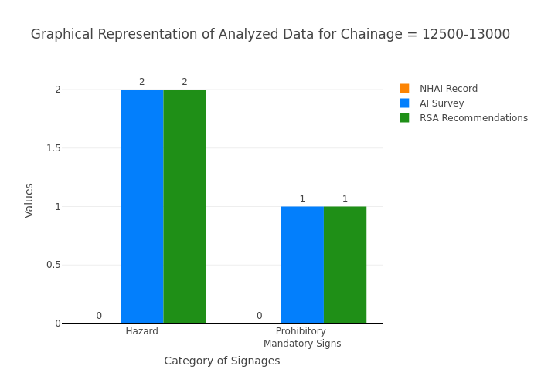

Chainage: 13000-13500
Gap Analysis:
Category of Signages | Nos. of Signages As per NHAI record | Nos. of Signages Based on the AI Survey | Total signages required including Existing and RSA recommendation (AI + Δ RSA) | Gap Based on NHAI record , (-) represents excess signs boards w.r.t NHAI record | Gap Based on RSA recommendation
Chevron | 0 | 0 | 0 | 0 | 0
Cautionary Warning Signs | 0 | 0 | 0 | 0 | 0
Hazard | 0 | 1 | 1 | -1 | 0
Prohibitory Mandatory Signs | 0 | 0 | 0 | 0 | 0
Informatory Signs | 0 | 1 | 1 | -1 | 0
Total | 0 | 2 | 2 | -2 | 0
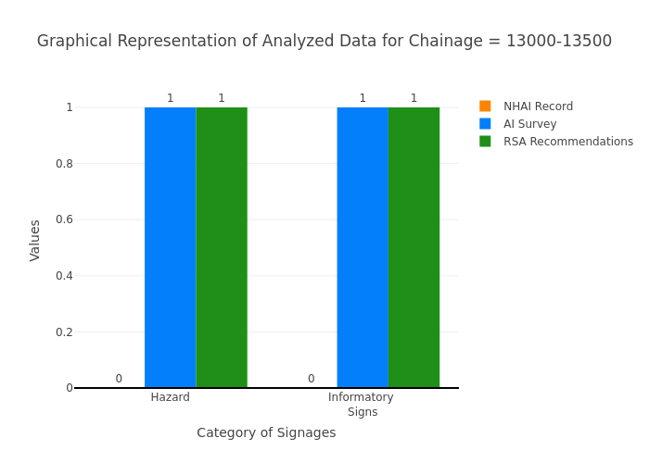

Chainage: 13500-14000
Gap Analysis:
Category of Signages | Nos. of Signages As per NHAI record | Nos. of Signages Based on the AI Survey | Total signages required including Existing and RSA recommendation (AI + Δ RSA) | Gap Based on NHAI record , (-) represents excess signs boards w.r.t NHAI record | Gap Based on RSA recommendation
Chevron | 0 | 0 | 0 | 0 | 0
Cautionary Warning Signs | 0 | 0 | 0 | 0 | 0
Hazard | 0 | 2 | 3 | -2 | 1
Prohibitory Mandatory Signs | 0 | 0 | 0 | 0 | 0
Informatory Signs | 0 | 0 | 0 | 0 | 0
Total | 0 | 2 | 3 | -2 | 1
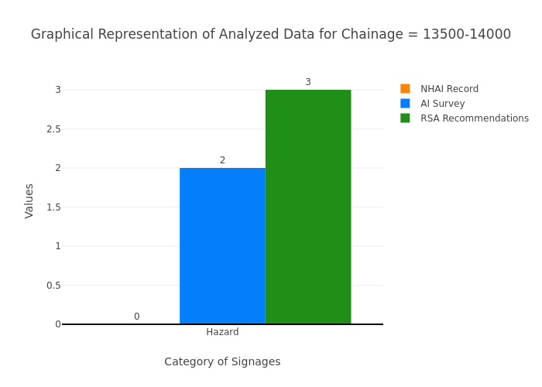

Chainage: 14000-14500
Gap Analysis:
Category of Signages | Nos. of Signages As per NHAI record | Nos. of Signages Based on the AI Survey | Total signages required including Existing and RSA recommendation (AI + Δ RSA) | Gap Based on NHAI record , (-) represents excess signs boards w.r.t NHAI record | Gap Based on RSA recommendation
Chevron | 0 | 0 | 0 | 0 | 0
Cautionary Warning Signs | 0 | 0 | 0 | 0 | 0
Hazard | 0 | 3 | 3 | -3 | 0
Prohibitory Mandatory Signs | 0 | 1 | 1 | -1 | 0
Informatory Signs | 0 | 1 | 1 | -1 | 0
Total | 0 | 5 | 5 | -5 | 0
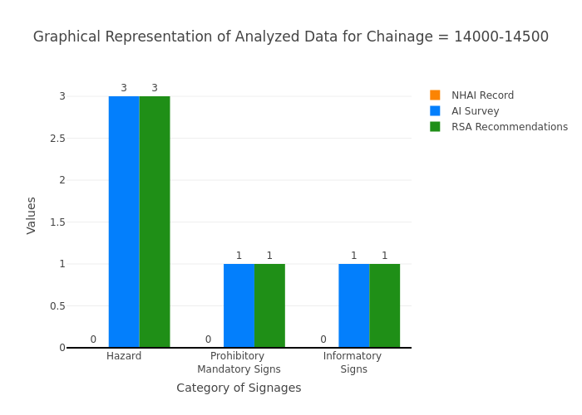

Chainage: 14500-15000
Gap Analysis:
Category of Signages | Nos. of Signages As per NHAI record | Nos. of Signages Based on the AI Survey | Total signages required including Existing and RSA recommendation (AI + Δ RSA) | Gap Based on NHAI record , (-) represents excess signs boards w.r.t NHAI record | Gap Based on RSA recommendation
Chevron | 0 | 0 | 0 | 0 | 0
Cautionary Warning Signs | 0 | 0 | 0 | 0 | 0
Hazard | 0 | 4 | 4 | -4 | 0
Prohibitory Mandatory Signs | 0 | 1 | 1 | -1 | 0
Informatory Signs | 0 | 0 | 0 | 0 | 0
Total | 0 | 5 | 5 | -5 | 0
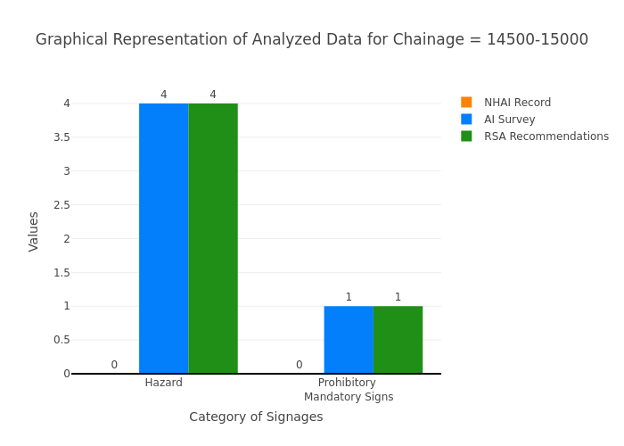

Chainage: 15000-15500
Gap Analysis:
Category of Signages | Nos. of Signages As per NHAI record | Nos. of Signages Based on the AI Survey | Total signages required including Existing and RSA recommendation (AI + Δ RSA) | Gap Based on NHAI record , (-) represents excess signs boards w.r.t NHAI record | Gap Based on RSA recommendation
Chevron | 0 | 0 | 0 | 0 | 0
Cautionary Warning Signs | 0 | 0 | 0 | 0 | 0
Hazard | 0 | 3 | 3 | -3 | 0
Prohibitory Mandatory Signs | 0 | 0 | 0 | 0 | 0
Informatory Signs | 0 | 0 | 0 | 0 | 0
Total | 0 | 3 | 3 | -3 | 0
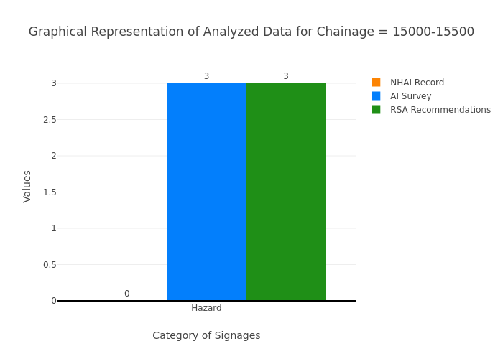

Chainage: 15500-16000
Gap Analysis:
Category of Signages | Nos. of Signages As per NHAI record | Nos. of Signages Based on the AI Survey | Total signages required including Existing and RSA recommendation (AI + Δ RSA) | Gap Based on NHAI record , (-) represents excess signs boards w.r.t NHAI record | Gap Based on RSA recommendation
Chevron | 0 | 0 | 0 | 0 | 0
Cautionary Warning Signs | 0 | 0 | 0 | 0 | 0
Hazard | 0 | 7 | 7 | -7 | 0
Prohibitory Mandatory Signs | 0 | 0 | 0 | 0 | 0
Informatory Signs | 0 | 3 | 3 | -3 | 0
Total | 0 | 10 | 10 | -10 | 0
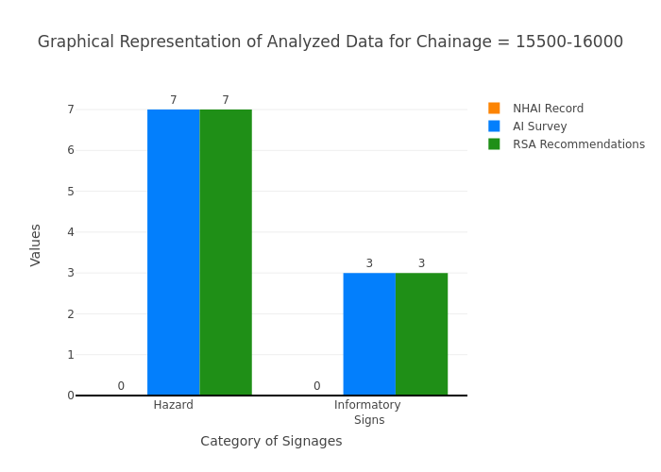

Chainage: 16000-16500
Gap Analysis:
Category of Signages | Nos. of Signages As per NHAI record | Nos. of Signages Based on the AI Survey | Total signages required including Existing and RSA recommendation (AI + Δ RSA) | Gap Based on NHAI record , (-) represents excess signs boards w.r.t NHAI record | Gap Based on RSA recommendation
Chevron | 0 | 0 | 0 | 0 | 0
Cautionary Warning Signs | 0 | 0 | 0 | 0 | 0
Hazard | 0 | 1 | 1 | -1 | 0
Prohibitory Mandatory Signs | 0 | 1 | 1 | -1 | 0
Informatory Signs | 0 | 0 | 0 | 0 | 0
Total | 0 | 2 | 2 | -2 | 0
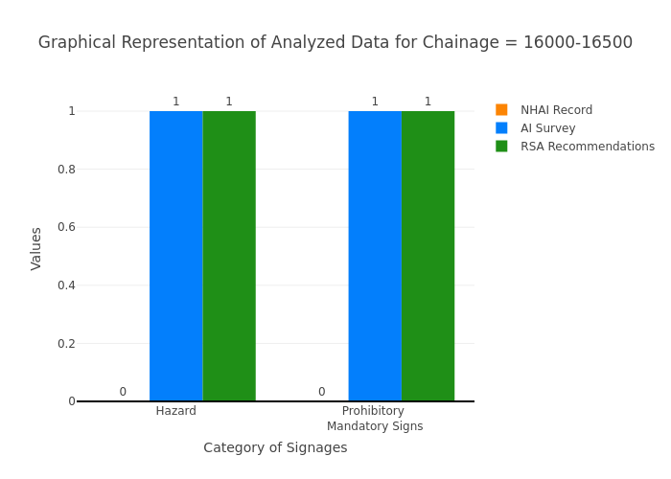

Chainage: 16500-17000
Gap Analysis:
Category of Signages | Nos. of Signages As per NHAI record | Nos. of Signages Based on the AI Survey | Total signages required including Existing and RSA recommendation (AI + Δ RSA) | Gap Based on NHAI record , (-) represents excess signs boards w.r.t NHAI record | Gap Based on RSA recommendation
Chevron | 0 | 0 | 0 | 0 | 0
Cautionary Warning Signs | 0 | 0 | 0 | 0 | 0
Hazard | 0 | 2 | 2 | -2 | 0
Prohibitory Mandatory Signs | 0 | 0 | 0 | 0 | 0
Informatory Signs | 0 | 0 | 0 | 0 | 0
Total | 0 | 2 | 2 | -2 | 0
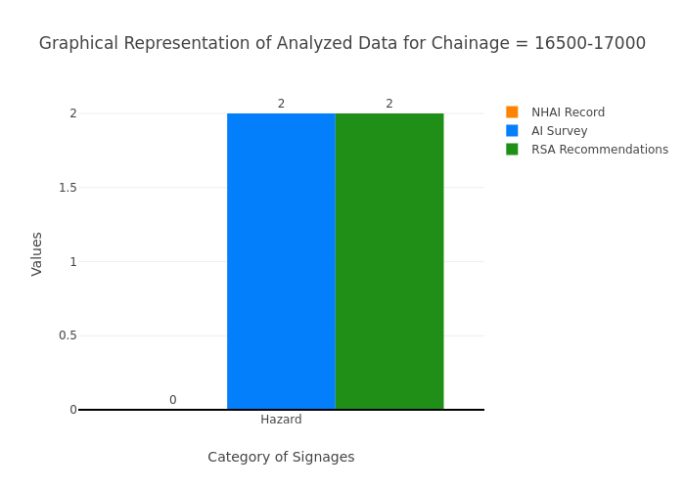

Chainage: 17000-17500
Gap Analysis:
Category of Signages | Nos. of Signages As per NHAI record | Nos. of Signages Based on the AI Survey | Total signages required including Existing and RSA recommendation (AI + Δ RSA) | Gap Based on NHAI record , (-) represents excess signs boards w.r.t NHAI record | Gap Based on RSA recommendation
Chevron | 0 | 0 | 0 | 0 | 0
Cautionary Warning Signs | 0 | 0 | 0 | 0 | 0
Hazard | 0 | 1 | 1 | -1 | 0
Prohibitory Mandatory Signs | 0 | 0 | 0 | 0 | 0
Informatory Signs | 0 | 0 | 0 | 0 | 0
Total | 0 | 1 | 1 | -1 | 0
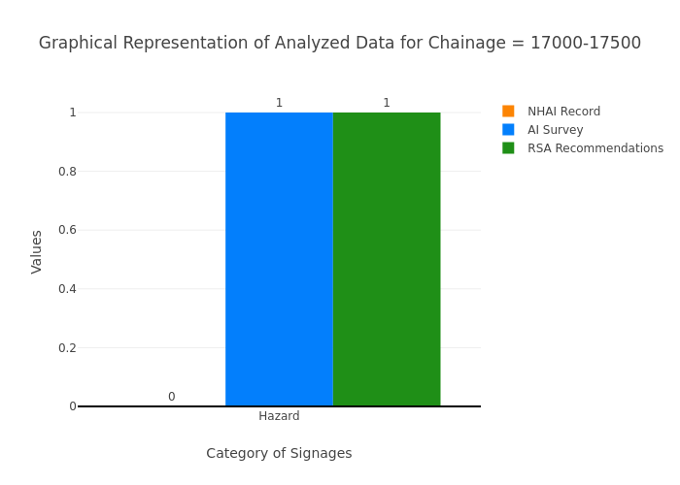

Chainage: 17500-18000
Gap Analysis:
Category of Signages | Nos. of Signages As per NHAI record | Nos. of Signages Based on the AI Survey | Total signages required including Existing and RSA recommendation (AI + Δ RSA) | Gap Based on NHAI record , (-) represents excess signs boards w.r.t NHAI record | Gap Based on RSA recommendation
Chevron | 0 | 0 | 0 | 0 | 0
Cautionary Warning Signs | 0 | 0 | 0 | 0 | 0
Hazard | 0 | 7 | 7 | -7 | 0
Prohibitory Mandatory Signs | 0 | 0 | 0 | 0 | 0
Informatory Signs | 0 | 0 | 0 | 0 | 0
Total | 0 | 7 | 7 | -7 | 0
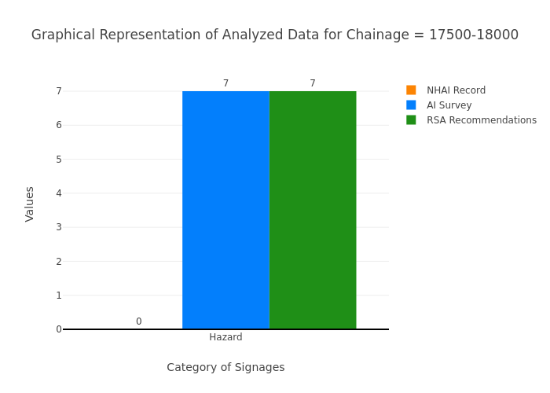

Chainage: 18000-18500
Gap Analysis:
Category of Signages | Nos. of Signages As per NHAI record | Nos. of Signages Based on the AI Survey | Total signages required including Existing and RSA recommendation (AI + Δ RSA) | Gap Based on NHAI record , (-) represents excess signs boards w.r.t NHAI record | Gap Based on RSA recommendation
Chevron | 0 | 0 | 0 | 0 | 0
Cautionary Warning Signs | 0 | 1 | 1 | -1 | 0
Hazard | 0 | 4 | 4 | -4 | 0
Prohibitory Mandatory Signs | 0 | 1 | 1 | -1 | 0
Informatory Signs | 0 | 0 | 0 | 0 | 0
Total | 0 | 6 | 6 | -6 | 0
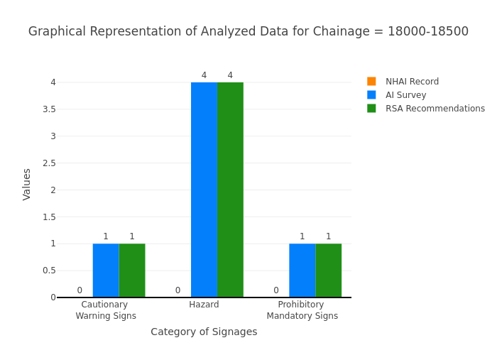

Chainage: 18500-19000
Gap Analysis:
Category of Signages | Nos. of Signages As per NHAI record | Nos. of Signages Based on the AI Survey | Total signages required including Existing and RSA recommendation (AI + Δ RSA) | Gap Based on NHAI record , (-) represents excess signs boards w.r.t NHAI record | Gap Based on RSA recommendation
Chevron | 0 | 0 | 0 | 0 | 0
Cautionary Warning Signs | 0 | 1 | 1 | -1 | 0
Hazard | 0 | 3 | 3 | -3 | 0
Prohibitory Mandatory Signs | 0 | 1 | 1 | -1 | 0
Informatory Signs | 0 | 0 | 0 | 0 | 0
Total | 0 | 5 | 5 | -5 | 0
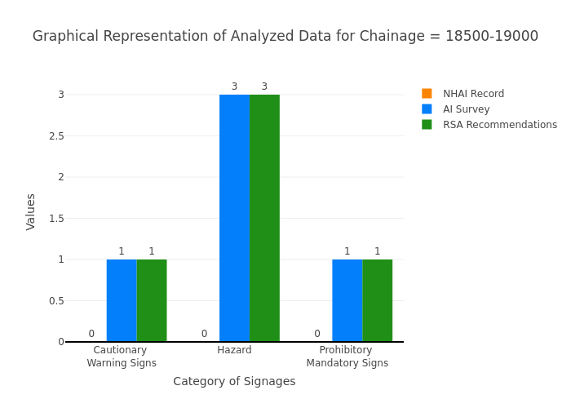

Chainage: 19000-19500
Gap Analysis:
Category of Signages | Nos. of Signages As per NHAI record | Nos. of Signages Based on the AI Survey | Total signages required including Existing and RSA recommendation (AI + Δ RSA) | Gap Based on NHAI record , (-) represents excess signs boards w.r.t NHAI record | Gap Based on RSA recommendation
Chevron | 0 | 0 | 0 | 0 | 0
Cautionary Warning Signs | 0 | 0 | 0 | 0 | 0
Hazard | 0 | 0 | 1 | 0 | 1
Prohibitory Mandatory Signs | 0 | 0 | 0 | 0 | 0
Informatory Signs | 0 | 5 | 5 | -5 | 0
Total | 0 | 5 | 6 | -5 | 1
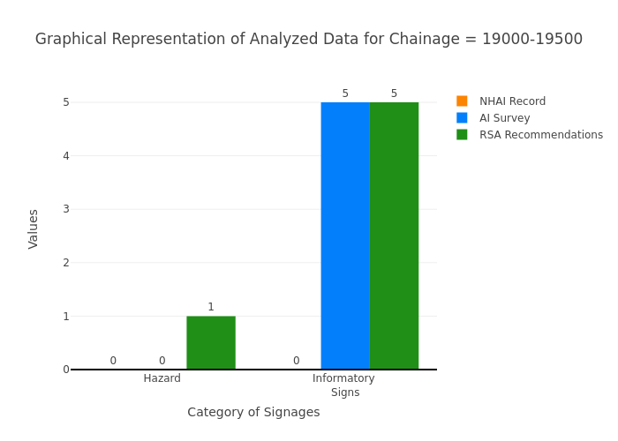

Chainage: 19500-20000
Gap Analysis:
Category of Signages | Nos. of Signages As per NHAI record | Nos. of Signages Based on the AI Survey | Total signages required including Existing and RSA recommendation (AI + Δ RSA) | Gap Based on NHAI record , (-) represents excess signs boards w.r.t NHAI record | Gap Based on RSA recommendation
Chevron | 0 | 0 | 0 | 0 | 0
Cautionary Warning Signs | 0 | 0 | 0 | 0 | 0
Hazard | 0 | 2 | 3 | -2 | 1
Prohibitory Mandatory Signs | 0 | 0 | 0 | 0 | 0
Informatory Signs | 0 | 0 | 0 | 0 | 0
Total | 0 | 2 | 3 | -2 | 1
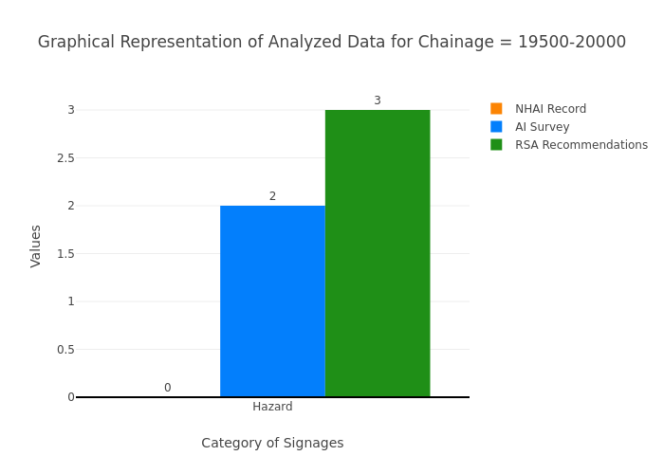

Chainage: 20000-20500
Gap Analysis:
Category of Signages | Nos. of Signages As per NHAI record | Nos. of Signages Based on the AI Survey | Total signages required including Existing and RSA recommendation (AI + Δ RSA) | Gap Based on NHAI record , (-) represents excess signs boards w.r.t NHAI record | Gap Based on RSA recommendation
Chevron | 0 | 0 | 0 | 0 | 0
Cautionary Warning Signs | 0 | 0 | 0 | 0 | 0
Hazard | 0 | 4 | 4 | -4 | 0
Prohibitory Mandatory Signs | 0 | 0 | 0 | 0 | 0
Informatory Signs | 0 | 1 | 1 | -1 | 0
Total | 0 | 5 | 5 | -5 | 0
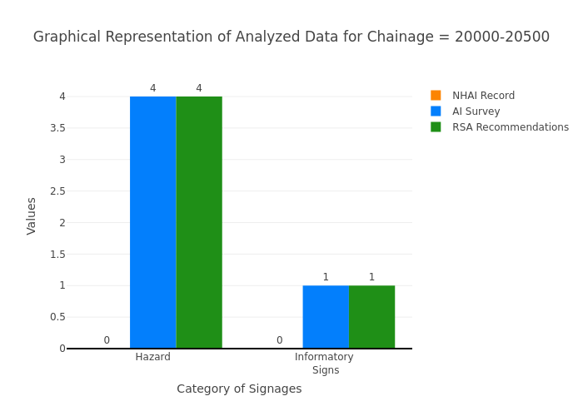

Chainage: 20500-21000
Gap Analysis:
Category of Signages | Nos. of Signages As per NHAI record | Nos. of Signages Based on the AI Survey | Total signages required including Existing and RSA recommendation (AI + Δ RSA) | Gap Based on NHAI record , (-) represents excess signs boards w.r.t NHAI record | Gap Based on RSA recommendation
Chevron | 0 | 0 | 0 | 0 | 0
Cautionary Warning Signs | 0 | 0 | 0 | 0 | 0
Hazard | 0 | 8 | 8 | -8 | 0
Prohibitory Mandatory Signs | 0 | 1 | 1 | -1 | 0
Informatory Signs | 0 | 0 | 0 | 0 | 0
Total | 0 | 9 | 9 | -9 | 0
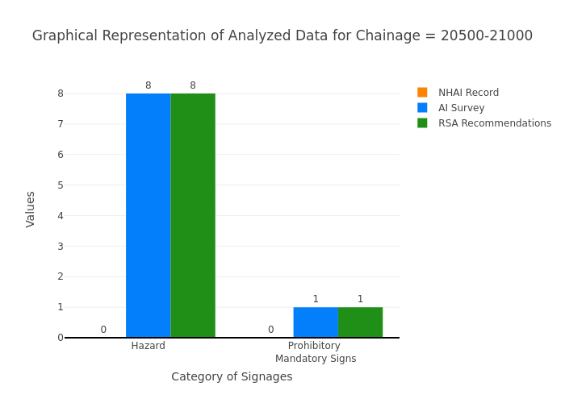

Chainage: 21000-21500
Gap Analysis:
Category of Signages | Nos. of Signages As per NHAI record | Nos. of Signages Based on the AI Survey | Total signages required including Existing and RSA recommendation (AI + Δ RSA) | Gap Based on NHAI record , (-) represents excess signs boards w.r.t NHAI record | Gap Based on RSA recommendation
Chevron | 0 | 0 | 0 | 0 | 0
Cautionary Warning Signs | 0 | 0 | 0 | 0 | 0
Hazard | 0 | 4 | 4 | -4 | 0
Prohibitory Mandatory Signs | 0 | 0 | 0 | 0 | 0
Informatory Signs | 0 | 0 | 0 | 0 | 0
Total | 0 | 4 | 4 | -4 | 0
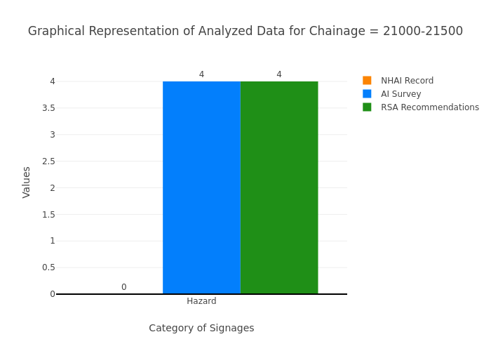

Chainage: 21500-22000
Gap Analysis:
Category of Signages | Nos. of Signages As per NHAI record | Nos. of Signages Based on the AI Survey | Total signages required including Existing and RSA recommendation (AI + Δ RSA) | Gap Based on NHAI record , (-) represents excess signs boards w.r.t NHAI record | Gap Based on RSA recommendation
Chevron | 0 | 0 | 0 | 0 | 0
Cautionary Warning Signs | 0 | 0 | 0 | 0 | 0
Hazard | 0 | 4 | 4 | -4 | 0
Prohibitory Mandatory Signs | 0 | 0 | 0 | 0 | 0
Informatory Signs | 0 | 0 | 0 | 0 | 0
Total | 0 | 4 | 4 | -4 | 0
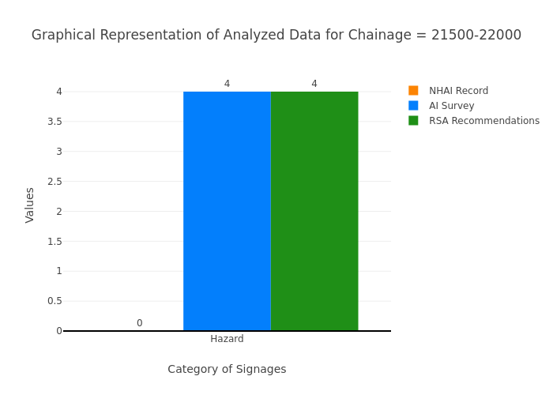

Chainage: 22000-22500
Gap Analysis:
Category of Signages | Nos. of Signages As per NHAI record | Nos. of Signages Based on the AI Survey | Total signages required including Existing and RSA recommendation (AI + Δ RSA) | Gap Based on NHAI record , (-) represents excess signs boards w.r.t NHAI record | Gap Based on RSA recommendation
Chevron | 0 | 0 | 0 | 0 | 0
Cautionary Warning Signs | 0 | 0 | 0 | 0 | 0
Hazard | 0 | 5 | 5 | -5 | 0
Prohibitory Mandatory Signs | 0 | 0 | 0 | 0 | 0
Informatory Signs | 0 | 0 | 0 | 0 | 0
Total | 0 | 5 | 5 | -5 | 0
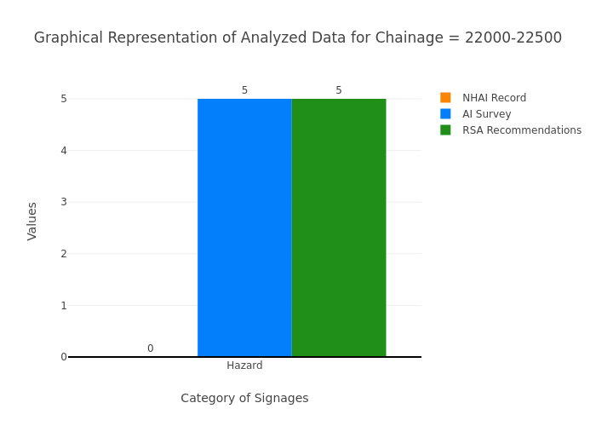

Chainage: 22500-23000
Gap Analysis:
Category of Signages | Nos. of Signages As per NHAI record | Nos. of Signages Based on the AI Survey | Total signages required including Existing and RSA recommendation (AI + Δ RSA) | Gap Based on NHAI record , (-) represents excess signs boards w.r.t NHAI record | Gap Based on RSA recommendation
Chevron | 0 | 0 | 0 | 0 | 0
Cautionary Warning Signs | 0 | 0 | 0 | 0 | 0
Hazard | 0 | 4 | 5 | -4 | 1
Prohibitory Mandatory Signs | 0 | 1 | 1 | -1 | 0
Informatory Signs | 0 | 0 | 0 | 0 | 0
Total | 0 | 5 | 6 | -5 | 1
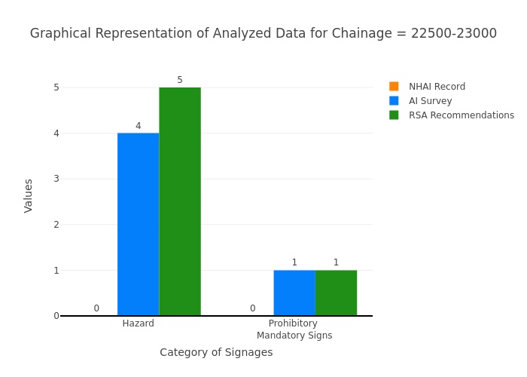

Chainage: 23000-23500
Gap Analysis:
Category of Signages | Nos. of Signages As per NHAI record | Nos. of Signages Based on the AI Survey | Total signages required including Existing and RSA recommendation (AI + Δ RSA) | Gap Based on NHAI record , (-) represents excess signs boards w.r.t NHAI record | Gap Based on RSA recommendation
Chevron | 0 | 0 | 0 | 0 | 0
Cautionary Warning Signs | 0 | 0 | 0 | 0 | 0
Hazard | 0 | 2 | 2 | -2 | 0
Prohibitory Mandatory Signs | 0 | 0 | 0 | 0 | 0
Informatory Signs | 0 | 0 | 0 | 0 | 0
Total | 0 | 2 | 2 | -2 | 0
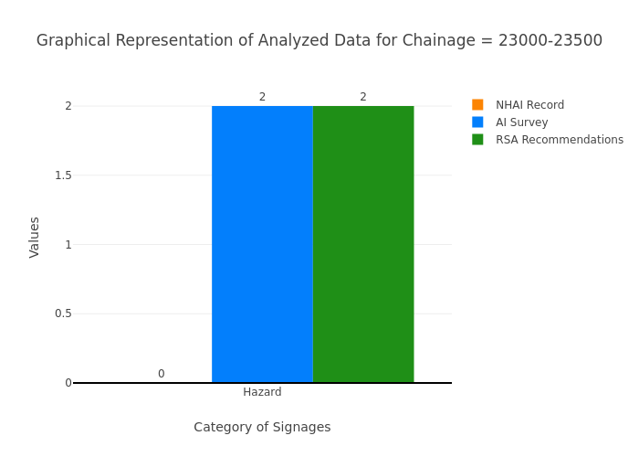

Chainage: 23500-24000
Gap Analysis:
Category of Signages | Nos. of Signages As per NHAI record | Nos. of Signages Based on the AI Survey | Total signages required including Existing and RSA recommendation (AI + Δ RSA) | Gap Based on NHAI record , (-) represents excess signs boards w.r.t NHAI record | Gap Based on RSA recommendation
Chevron | 0 | 0 | 0 | 0 | 0
Cautionary Warning Signs | 0 | 0 | 0 | 0 | 0
Hazard | 0 | 8 | 8 | -8 | 0
Prohibitory Mandatory Signs | 0 | 0 | 0 | 0 | 0
Informatory Signs | 0 | 0 | 0 | 0 | 0
Total | 0 | 8 | 8 | -8 | 0
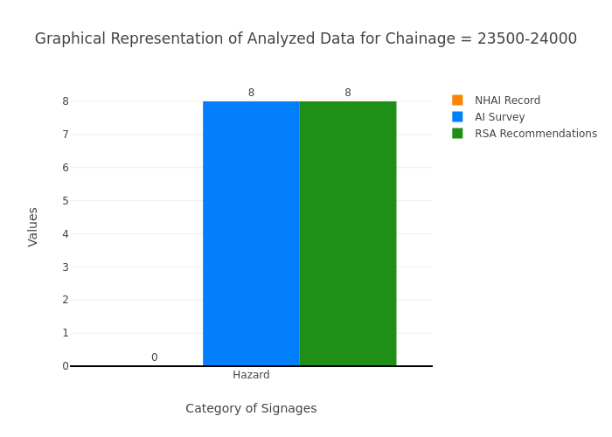

Chainage: 24000-24500
Gap Analysis:
Category of Signages | Nos. of Signages As per NHAI record | Nos. of Signages Based on the AI Survey | Total signages required including Existing and RSA recommendation (AI + Δ RSA) | Gap Based on NHAI record , (-) represents excess signs boards w.r.t NHAI record | Gap Based on RSA recommendation
Chevron | 0 | 0 | 0 | 0 | 0
Cautionary Warning Signs | 0 | 1 | 1 | -1 | 0
Hazard | 0 | 3 | 3 | -3 | 0
Prohibitory Mandatory Signs | 0 | 5 | 5 | -5 | 0
Informatory Signs | 0 | 0 | 0 | 0 | 0
Total | 0 | 9 | 9 | -9 | 0
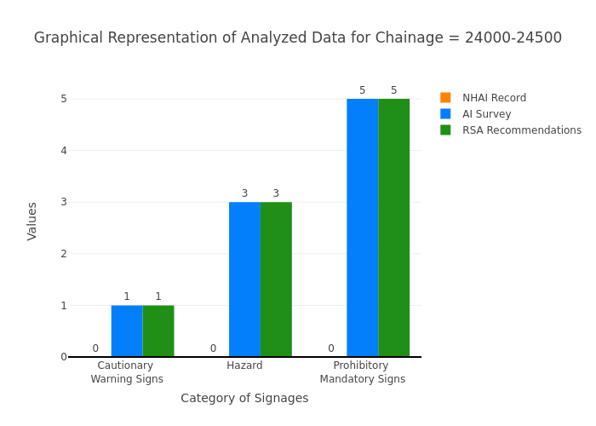

Chainage: 24500-25000
Gap Analysis:
Category of Signages | Nos. of Signages As per NHAI record | Nos. of Signages Based on the AI Survey | Total signages required including Existing and RSA recommendation (AI + Δ RSA) | Gap Based on NHAI record , (-) represents excess signs boards w.r.t NHAI record | Gap Based on RSA recommendation
Chevron | 0 | 0 | 0 | 0 | 0
Cautionary Warning Signs | 0 | 1 | 1 | -1 | 0
Hazard | 0 | 5 | 5 | -5 | 0
Prohibitory Mandatory Signs | 0 | 0 | 0 | 0 | 0
Informatory Signs | 0 | 1 | 1 | -1 | 0
Total | 0 | 7 | 7 | -7 | 0
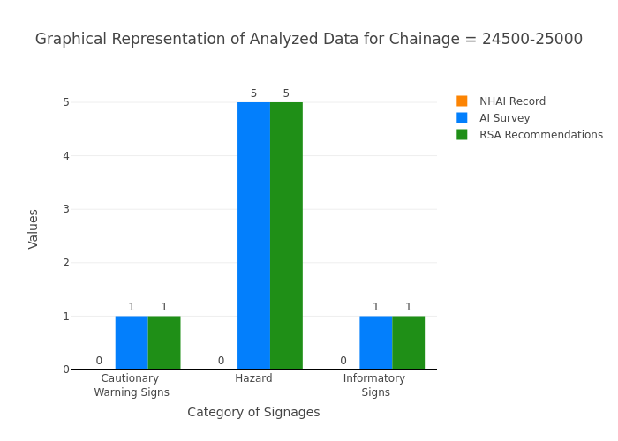

Chainage: 25000-25500
Gap Analysis:
Category of Signages | Nos. of Signages As per NHAI record | Nos. of Signages Based on the AI Survey | Total signages required including Existing and RSA recommendation (AI + Δ RSA) | Gap Based on NHAI record , (-) represents excess signs boards w.r.t NHAI record | Gap Based on RSA recommendation
Chevron | 0 | 0 | 0 | 0 | 0
Cautionary Warning Signs | 0 | 0 | 0 | 0 | 0
Hazard | 0 | 4 | 4 | -4 | 0
Prohibitory Mandatory Signs | 0 | 0 | 0 | 0 | 0
Informatory Signs | 0 | 0 | 0 | 0 | 0
Total | 0 | 4 | 4 | -4 | 0
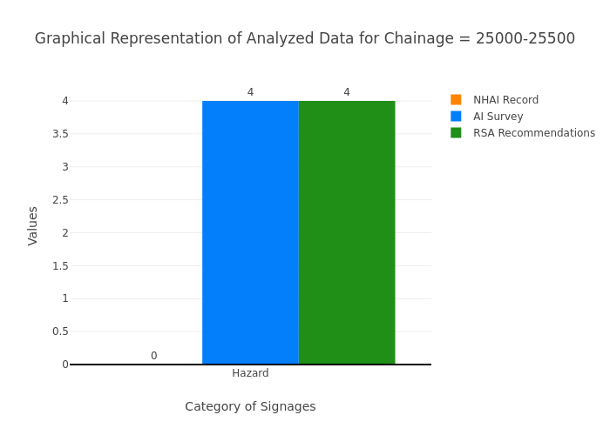

Chainage: 25500-26000
Gap Analysis:
Category of Signages | Nos. of Signages As per NHAI record | Nos. of Signages Based on the AI Survey | Total signages required including Existing and RSA recommendation (AI + Δ RSA) | Gap Based on NHAI record , (-) represents excess signs boards w.r.t NHAI record | Gap Based on RSA recommendation
Chevron | 0 | 0 | 0 | 0 | 0
Cautionary Warning Signs | 0 | 0 | 0 | 0 | 0
Hazard | 0 | 8 | 8 | -8 | 0
Prohibitory Mandatory Signs | 0 | 0 | 0 | 0 | 0
Informatory Signs | 0 | 0 | 0 | 0 | 0
Total | 0 | 8 | 8 | -8 | 0
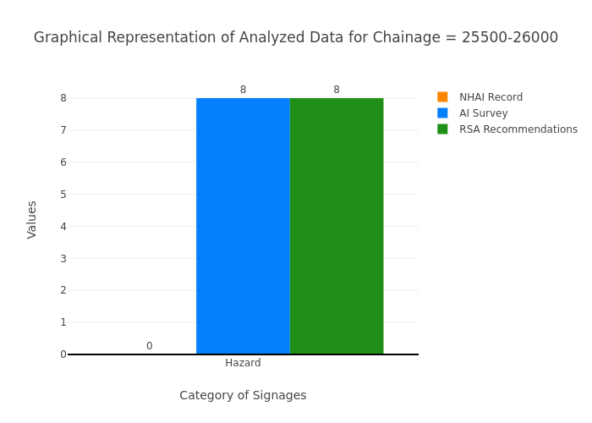

Chainage: 26000-26500
Gap Analysis:
Category of Signages | Nos. of Signages As per NHAI record | Nos. of Signages Based on the AI Survey | Total signages required including Existing and RSA recommendation (AI + Δ RSA) | Gap Based on NHAI record , (-) represents excess signs boards w.r.t NHAI record | Gap Based on RSA recommendation
Chevron | 0 | 0 | 0 | 0 | 0
Cautionary Warning Signs | 0 | 0 | 0 | 0 | 0
Hazard | 0 | 5 | 5 | -5 | 0
Prohibitory Mandatory Signs | 0 | 0 | 0 | 0 | 0
Informatory Signs | 0 | 0 | 0 | 0 | 0
Total | 0 | 5 | 5 | -5 | 0
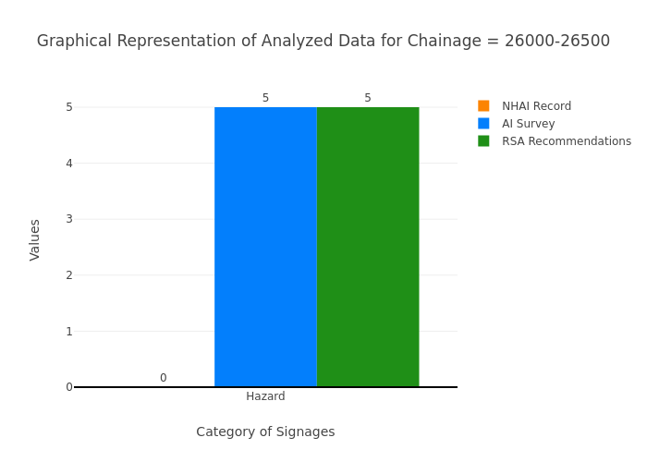

Chainage: 26500-27000
Gap Analysis:
Category of Signages | Nos. of Signages As per NHAI record | Nos. of Signages Based on the AI Survey | Total signages required including Existing and RSA recommendation (AI + Δ RSA) | Gap Based on NHAI record , (-) represents excess signs boards w.r.t NHAI record | Gap Based on RSA recommendation
Chevron | 0 | 0 | 0 | 0 | 0
Cautionary Warning Signs | 0 | 0 | 0 | 0 | 0
Hazard | 0 | 4 | 4 | -4 | 0
Prohibitory Mandatory Signs | 0 | 1 | 1 | -1 | 0
Informatory Signs | 0 | 0 | 0 | 0 | 0
Total | 0 | 5 | 5 | -5 | 0
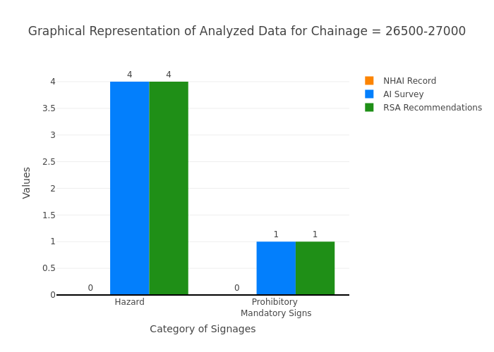

Chainage: 27000-27500
Gap Analysis:
Category of Signages | Nos. of Signages As per NHAI record | Nos. of Signages Based on the AI Survey | Total signages required including Existing and RSA recommendation (AI + Δ RSA) | Gap Based on NHAI record , (-) represents excess signs boards w.r.t NHAI record | Gap Based on RSA recommendation
Chevron | 0 | 0 | 0 | 0 | 0
Cautionary Warning Signs | 0 | 0 | 0 | 0 | 0
Hazard | 0 | 4 | 4 | -4 | 0
Prohibitory Mandatory Signs | 0 | 0 | 0 | 0 | 0
Informatory Signs | 0 | 0 | 0 | 0 | 0
Total | 0 | 4 | 4 | -4 | 0
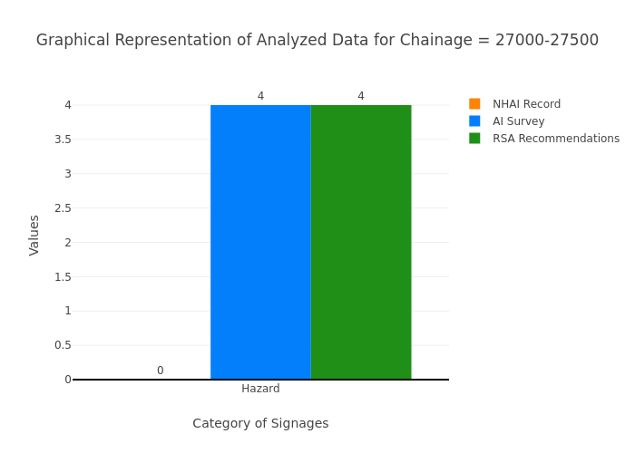

Chainage: 27500-28000
Gap Analysis:
Category of Signages | Nos. of Signages As per NHAI record | Nos. of Signages Based on the AI Survey | Total signages required including Existing and RSA recommendation (AI + Δ RSA) | Gap Based on NHAI record , (-) represents excess signs boards w.r.t NHAI record | Gap Based on RSA recommendation
Chevron | 0 | 0 | 0 | 0 | 0
Cautionary Warning Signs | 0 | 0 | 0 | 0 | 0
Hazard | 0 | 5 | 5 | -5 | 0
Prohibitory Mandatory Signs | 0 | 0 | 0 | 0 | 0
Informatory Signs | 0 | 0 | 0 | 0 | 0
Total | 0 | 5 | 5 | -5 | 0
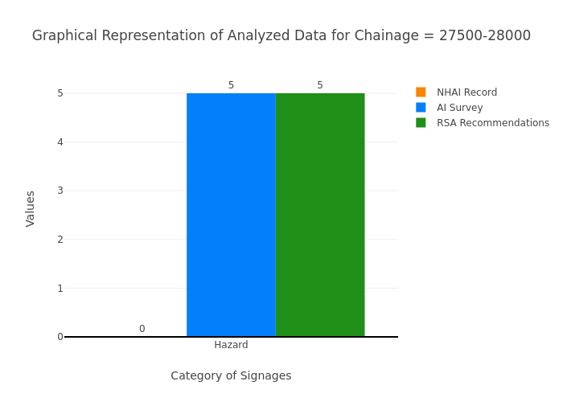

Chainage: 28000-28500
Gap Analysis:
Category of Signages | Nos. of Signages As per NHAI record | Nos. of Signages Based on the AI Survey | Total signages required including Existing and RSA recommendation (AI + Δ RSA) | Gap Based on NHAI record , (-) represents excess signs boards w.r.t NHAI record | Gap Based on RSA recommendation
Chevron | 0 | 0 | 0 | 0 | 0
Cautionary Warning Signs | 0 | 0 | 0 | 0 | 0
Hazard | 0 | 5 | 6 | -5 | 1
Prohibitory Mandatory Signs | 0 | 0 | 0 | 0 | 0
Informatory Signs | 0 | 0 | 0 | 0 | 0
Total | 0 | 5 | 6 | -5 | 1
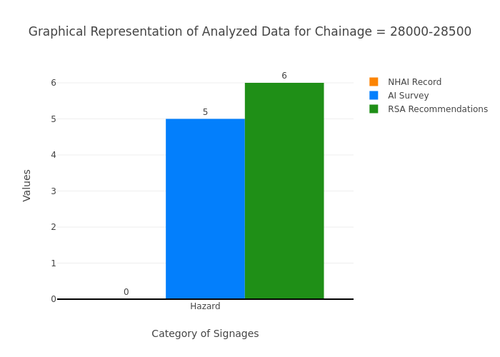

Chainage: 28500-28700
Gap Analysis:
Category of Signages | Nos. of Signages As per NHAI record | Nos. of Signages Based on the AI Survey | Total signages required including Existing and RSA recommendation (AI + Δ RSA) | Gap Based on NHAI record , (-) represents excess signs boards w.r.t NHAI record | Gap Based on RSA recommendation
Chevron | 0 | 0 | 0 | 0 | 0
Cautionary Warning Signs | 0 | 0 | 0 | 0 | 0
Hazard | 0 | 4 | 4 | -4 | 0
Prohibitory Mandatory Signs | 0 | 2 | 2 | -2 | 0
Informatory Signs | 0 | 0 | 0 | 0 | 0
Total | 0 | 6 | 6 | -6 | 0
