IMPROVEMENT IN ROAD SIGNAGES ON NATIONAL HIGHWAY IN INDIA USING ARTIFICIAL INTELLIGENCE (AI) BASED SURVEYS



Name of the stretch -

Unique Project Code (UPC) -
State -
Regional Office (RO) -
Project Implementation Unit (PIU) -

Table of Contents
Executive Summary 3
1. Introduction 5
1.1. Brief description about the MoU 5
1.2. Objectives of Gap Study 6
1.3. Scope of Services 6
1.4. Salient features of the instant National Highway Project 7
2. Methodology 9
2.1. Data Collection 9
2.2. Broad Methodology- Artificial Intelligence based solution 9
3. Inventory of Road signs 10
3.1. Road Signage Inventory (as provided by NHAI) 10
3.2. Road Signage Inventory based on AI Survey Data (conducted by IIITD) 10
3.3. Road signage requirement as per Road Safety Auditor recommendation 10
4. Results of Gap study 13
4.1. Gap study based on NHAI data 13
4.2. Gap study based on Road safety auditor recommendation 14
Annexure A 16
Annexure B 18
Annexure C 61
Annexure D 124

Executive Summary

National Highways Authority of India (NHAI), under Ministry of Road Transport and Highways (MoRTH), Government of India has signed a Memorandum of Understanding (MoU) with Indraprastha Institute of Information Technology, Delhi (IIITD) to utilize AI based solutions for carrying out Gap Study w.r.t availability and broad condition of road sign on around 25,000 km of selected National Highways (provided by NHAI). The gap study shall be carried out by assessing the difference between the AI based survey findings and the road signage inventory as per NHAI record. The other part of the gap study shall cover the additional requirement of road signages as per the recommendations of certified Road Safety Auditor (RSA) based on latest codal provisions relevant to high-speed corridors.

The MoU was signed on 19-07-2024 and project completion period was kept as twelve (12) months. The date of commencement of this project was 15-10-2024.

This report summarizes the findings of a gap study conducted on National Highway project .The linear length of project stretch is Km and it includes “Lane with divided carriageway with Service Road” configuration and the type of pavement is . The construction work of the project was completed on/ date of COD was_. The project is currently under the stage.

The survey on this project stretch was carried out on by the team of IIIT Delhi. As per survey findings which is based on Artificial Intelligence (AI), there are 534 nos. of roads signs including Chevron, Hazard, Cautionary Warning, Prohibitory Mandatory & Informatory Signs, on this project. However, as per NHAI record/ Approved Road Signage Plan of Contract Agreement, the number of road signages on this project are 0 nos. (data as provided by NHAI). Therefore, an excess of 534 nos. sign boards have been observed vis-à-vis NHAI record. This variance in the count of signages in the contract document and existing signages taken out by AI survey report is not available in NHAI record. This finding will help NHAI in better inventorisation of the existing Road Signage on this project.

Secondly, this project has also carried out gap study based on the recommendation of certified road safety auditor (RSA). As per RSA recommendation, the number of Total road signs required on this project are 681 nos. Accordingly, there is an additional requirement of 147 nos. of signages over and above 534 nos. as observed during the survey.

The following table presents the summary of Gap study report:

### INSERT_EXECUTIVE_SUMMARY_TABLE ###

Introduction

Brief description about the MoU
A Memorandum of Understanding (MoU) has been signed between the National Highways Authority of India (NHAI) and Indraprastha Institute of Information Technology, Delhi (IIIT Delhi) for carrying out Gap Study w.r.t availability and broad condition of road sign on around 25,000 km National Highways in India.

The project duration as per the MoU is twelve (12) months and the date of commencement of work is 27.09.2024. The tentative length of roads to be covered under the aforementioned study shall be 25,000 km. The list of stretches included in the project are from different states which is divided into 05 zones (Zone A to E).

Zone | States
Zone A | Jammu & Kashmir, Punjab, Himachal Pradesh, Uttarakhand , Haryana , Chandigarh and Delhi
Zone B | Gujrat and Rajasthan
Zone C | Maharashtra and Madhya Pradesh
Zone D | Andhra Pradesh , Tamil Nadu , Telangana , Karnataka , Kerala , Chhattisgarh
Zone E | Assam , Bihar , Meghalaya , Jharkhand , Odisha , Uttar Pradesh and West Bengal

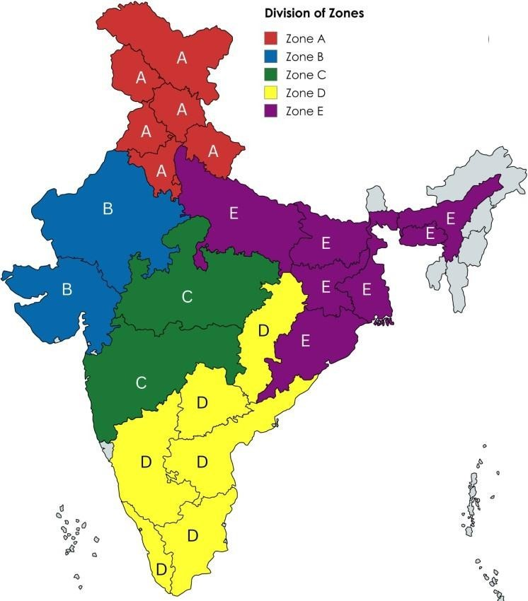

Objectives of Gap Study
Adequate availability of the road signs on the roads plays a significant role in the road safety. NHAI intends to enhance the road safety for all road users by embracing innovation and adopting advanced technologies.

Artificial Intelligence (Al) has emerged as a powerful tool for automating tasks and improving data analysis capabilities. By harnessing the potential of Al and Geographic Information Systems (GIS), NHAI can revolutionize its approach w.r.t road signs inspection.

Therefore, NHAI in collaboration with IIIT Delhi intends to utilize Al based solutions for Improvement in the availability of road signs on National Highways in India.

Scope of Services
The scope of work is to carry out Gap studies w.r.t the availability and broad condition of road signs on around 25,000 km of National Highways in India. The services includes following:

- The gap study shall be carried out by assessing the difference between the survey findings and the requirements of road signs as per signage plan of the respective Contract Agreement.

- Gap study based on updated / latest Codal provisions relevant to high-speed corridors to cater for enhanced safety requirements. For this purpose, IIITD shall engage a certified Road Safety Auditor (RSA) for assisting in the gap study and preparation of report.

- IIITD shall carry out the surveys for collecting imagery and other ancillary data related to availability and condition of road signages on selected National Highways stretches in India as provided by NHAI.

- The data collected through surveys shall be processed through deployment of adequately capable Artificial Intelligence (AI) for accurate identification and classification of road sign types.

Salient features of the instant National Highway Project

- The salient features of the instant National Highway Project are mentioned as under:
S. No. | Description/ Particular | Details
1 | Name of the project Highway
2 | Unique Project Code (UPC)
3 | NHAI Regional Office
4 | NHAI Project Implementation Unit (PIU)
5 | Details of Project Construction;
 | (a) Date of Completion/ COD
 | (b) DLP Completion Date
6 | Details of O&M Agency (if any);
 | (a) O&M Contract Duration

- Key Features of the Project:

S. No. | Description/ Particular | Details
1 | Pavement Type & Lane Configuration
2 | Length of Main Carriageway
3 | Length of Service/ Slip Roads
4 | Major Junctions
5 | Minor Junctions
6 | Bridges (Major/Minor)
7 | ROB/RUB/Flyovers
8 | Underpasses (VUP/PUP/CUP)
9 | Culverts
10 | Toll Plaza
–

- Index map:

Index map showing the start point and end point of the said project.
None

- Total Road segments in this project
Main Carraige Way LHS Surveyed - 1
Main Carraige Way RHS Surveyed - 1

### INSERT_ROAD_TABLE ###

Methodology

Data Collection
The research methodology used is a combination of data collection and processing the same through Artificial Intelligence (AI) based solutions. The data collection involves the use of technology like integrated device which is mounted on the vehicle and the survey is done with expert and driver in the vehicle. The start point is marked and the Main Carriageway (MCW) is covered on both LHS & RHS. The survey further includes covering all the service roads and intersections of the same stretch on vehicles to collect data remotely. The data which is collected is uploaded for the further processing through AI models.

The information from respective PIUs were captured through an automated form to make the process of Data collection Streamline.

Broad Methodology- Artificial Intelligence based solution
AI models are employed to process the collected data, identify patterns, and generate insights into road signages as seen in the video captured. The chainage, name of the road, latitude & longitude are marked simultaneously.

Inventory of Road signs

Road Signage Inventory (as provided by NHAI)
The inventory of road signs as provided by NHAI with broad categorisation is presented in the table below. The detailed inventory is placed at Annexure A.
### INSERT_INVENTORY_SECTION_ONE ###

Road Signage Inventory based on AI Survey Data (conducted by IIITD)
The inventory of road signs based on AI Survey Data with broad categorisation is presented in the table below. The detailed inventory is placed at Annexure B.

### INSERT_INVENTORY_SECTION_TWO ###

Road signage requirement as per Road Safety Auditor recommendation
The inventory of road signs as per Road Safety Auditor recommendation is presented in the table below. The detailed inventory is placed at Annexure C.

### RSA_SUMMARY ###

Results of Gap study

Gap study based on NHAI data
### RESULT_GAP_STUDY_ONE ###

Gap study based on Road safety auditor recommendation
Following table represents the gap analysis of road signs between NHAI record , AI survey data and Road safety auditor recommendation with different category of signage. The detailed inventory is placed at Annexure D.

### RESULT_GAP_STUDY_TWO_TABLE ###

Following graph shows the difference between NHAI record , AI based survey and Road safety auditor recommendation with different category of signage in a bar chart .
### RESULT_GAP_STUDY_TWO_GRAPH_ONE ###

Following graph shows the difference between NHAI record , AI based survey and Road safety auditor recommendationin a bar chart format

### RESULT_GAP_STUDY_TWO_GRAPH_TWO ###

Annexure A

### ANX_A ###

Annexure B

### ANX_B ###

Annexure C

### ANX_C ###

Annexure D

Chainage Wise Gap Analysis

### ANX_D ###

