# **Requirements**

* Operating system (any)
* GCC compiler
* VS code
* Make

**Introduction**

Tic-Tac-Toe also known as noughts and crosses is a game played by two persons who alternately place X's and O's upon a 3x3 playing field. The players first decide who will mark his moves with an X and who will go first. Play proceeds with the opponents alternately placing their marks in any unoccupied cell. The object of the game is to be the first player with 3 marks in a row, where a row can be either vertical, horizontal, or diagonal.

# **4W's and 1'H**

### Who:

* There is no age restriction. People of any age can play this game.
* This a 2-player game.

### What:

* This game is played on a 3 x 3 grid of available cells, and the goal of the game is to match three of your tokens (X or O) on the board in a row, column or diagonally.

## **When:**

* When you feel the necessity to sharpen your strategic skills.

## **Where:**

* This game needs to be installed on computer.
* This game can be played anywhere and is supported by most of the platforms without the use of internet.

## **How:**

* The game is played between two players where one player makes the move by 'X' and another by '0'
* To win, a player must place three of their marks in a horizontal, vertical, or diagonal row.

**SWOT Analysis**

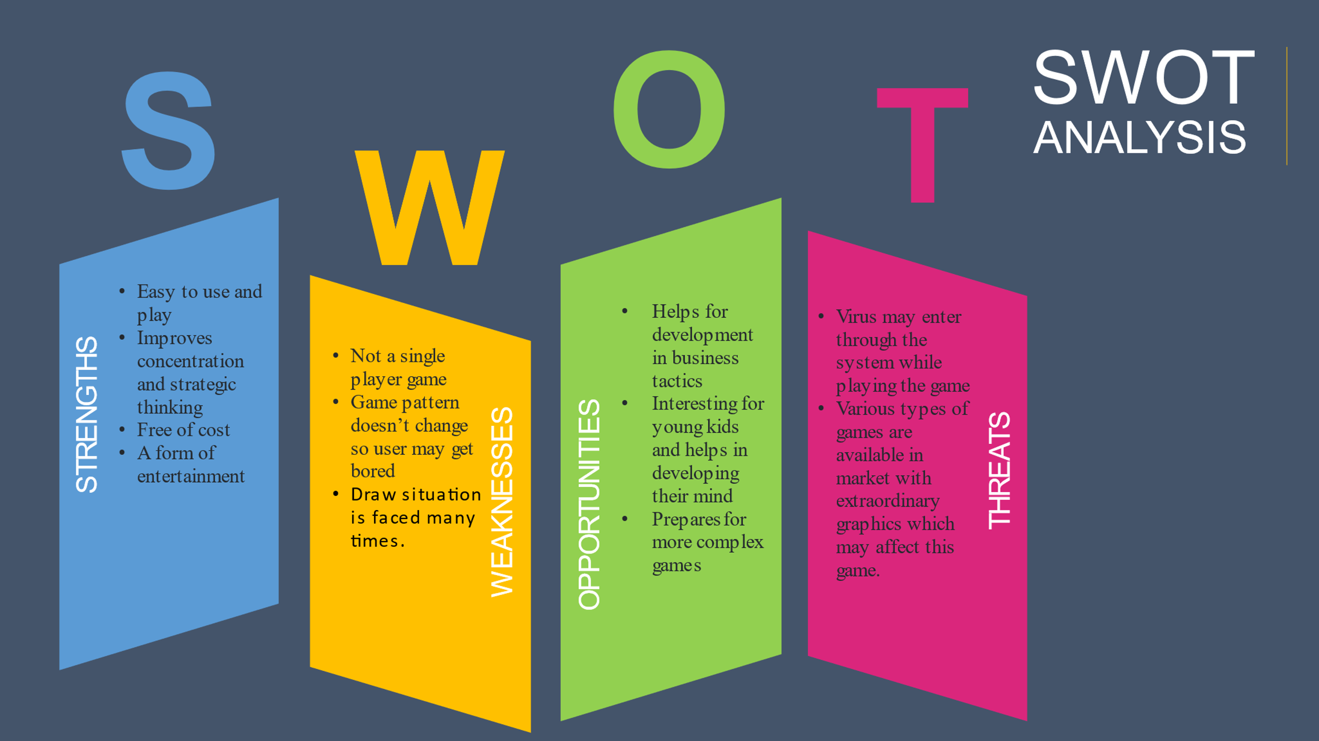

# **Detailed Requirements**

## **High Level Requirements**

|  |  |  |  |
| --- | --- | --- | --- |
| **ID** | **Description** | **Category** | **Status** |
| HL01 | Player should see a 3*3 grid to play the game | Technical | Implemented |
| HL02 | Player should be able to choose square of his choice to put the mark | Technical | Implemented |
| HL03 | Player should be declared as winner if he is able to match his mark diagonal, vertical or horizontal | Technical | Implemented |

## **Low Level Requirements**

|  |  |  |  |
| --- | --- | --- | --- |
| **ID** | **Description** | **Category** | **Status** |
| LL01 | If player selects a square no which is already chose by another player display "Invalid move" | Technical | Implemented |
| LL02 | If there is no outcome after specified moves then display "Game draw" | Technical | Implemented |

|  |  |  |  |
| --- | --- | --- | --- |