Java Test

Objective: 10 Name : GuduruBhanu
Subjective: 10
Programs: 2

Objective:
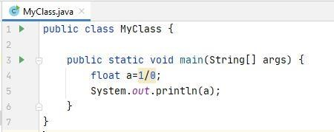
- What is the output of following program?

  - Infinity
  - ArithmeticException
  - Zero
  - 1

1.Correct Ans : B (ArithmeticException)

- What is the output of following program?
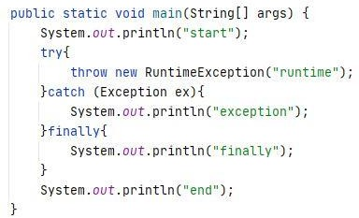
  - start runtime finally
  - start exception finally end
  - start finally end
  - start exception end

2.Correct Ans : B (start exception finally end)

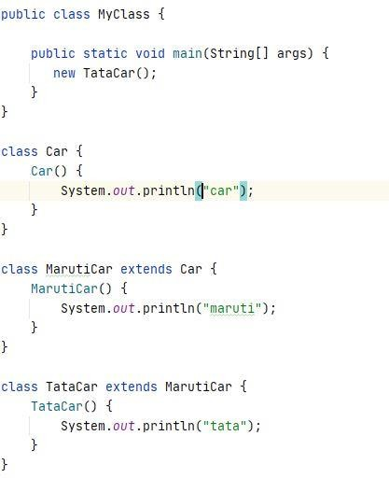
- What is the output of following program?
  - car maruti tata
  - tata maruti car
  - tata maruti
  - maruti tata

3.Correct Ans : A (car maruti tata)

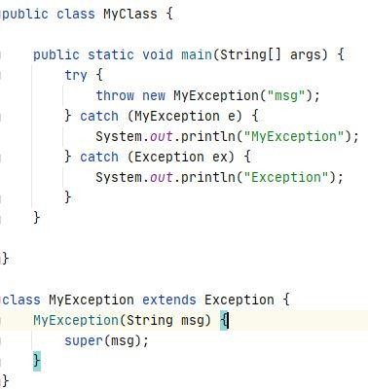
- What is the output of following program?
  - MyException
  - Exception
  - msg MyException
  - msg Exception

4.Correct Ans : A (MyException)

- Identify logic to create instance of Child Class?
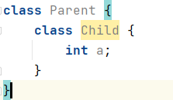

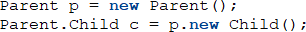
A.

B. 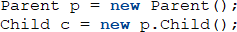

C. 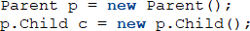

D. Cannot Create instance of Child Class

5.Correct Ans : A (Parent p = new Parent();
Parent.Child c = p.new Child();)

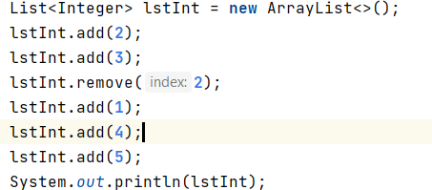
- What is the output of following program?
  - Compilation error
  - Runtime error
C. 3 1 4 5
D. 2 3 4 5

6.Correct Ans : A(Compilation error)

- Identify the component type for the following html element?



  - limit
  - progress
  - slidebar
  - Range

7.Correct Ans: D(Range)

- how can we get the following styling?
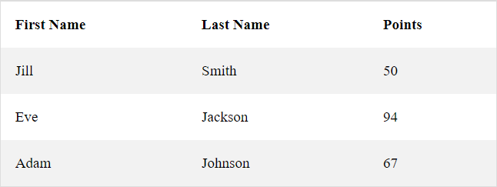

A.
tr:nth-child(even) { background-color: #f2f2f2;
}
B.
tr:nth-child(odd) { background-color: #f2f2f2;
}

C.
tr:nth-child(2) {
background-color: #f2f2f2;
}

D.
tr:nth-child(1) {
background-color: #f2f2f2;
}

8.Correct Ans: A(tr:nth-child(even) { background-color: #f2f2f2;
}

- Identify life cycle methods in jsp
  - jspinit, jspservice,jspdestroy
  - init, service, destroy
  - init, doGet,doPost,destroy
  - _init,_construct,_destroy

9.Correct Ans: B(init, service, destroy)

- Which event is used to capture cursor placed on div component
  - focus
  - hover
  - mouseover
  - click

10.Correct Ans: B(hover)

Subjective:
- what is the difference between arraylist and linkedlist, provide the scenarios for each one’s usage?
Ans) Both ArrayList and LinkedList are the part of Collections frame and ArrayList and LinkedList are identically same.
Differences
Array List | Linked List
Dynamic array to store elements | Doubly Linked List to store elements
Manipulation is slow because of shifting operation | Manipulation is faster because there is no shifting operation
Acts only as list because it implements only list interface | Acts as list and queue because it implements List and dequeue interface
Better for storing and accessing | Better for Manipulation

import java.util.ArrayList;
import java.util.List;

public class ArrLList {
public static void main(String[] args) {
List<String> Ll=new ArrayList<String>();
Ll.add("Bhanu");
Ll.add("Ravi");
Ll.add("Varun");
Ll.add("Akhil");
System.out.println("arraylist: "+Ll);

}
}
import java.util.LinkedList;
import java.util.List;

public class LnkList {
public static void main(String[] args) {
List<String> L2=new LinkedList<String>();
L2.add("Bhanu");
L2.add("Suresh");
L2.add("Mahesh");
L2.add("Naresh");
System.out.println("linkedlist: "+L2);

}
}
- what is error page, how to create one in JSP?
Ans) Error page means ,When we see a "404 error" or "page not found" on a page ,where we wrote a program for the appearence of webpage on the back.The page says that the user reached the domain requested, but the URL provided with no information.If we want to create an error page ,we have to set page directive attribute isErrorPage value to true.
<html>
<body>
<%@ page isErrorPage="true" %>
error:
<%= exception %>
</body>
</html>

- what are different type of tags available in JSP?
- Expression tags
- Scriptlet tags
- Declaration tags
- Directive tags

- why html is stateless?
HTTP is called as a stateless protocol because each request is executed independently, without any knowledge of the requests that were executed before it, which means once the transaction ends the connection between the browser and the server is also lost.

- what are the ways to iterate over list? what is fail fast case in collections? how to overcome the same?
Ans)The Fail Fast iterators immediately throw ConcurrentModificationException in case of structural modification of the collection. Structural modification means adding, removing, updating the value of an element in a data collection while another thread is iterating over that collection.
OverCome:-
The Fail Safe iterators are just opposite to Fail Fast iterators; unlike them, A fail-safe iterator does not throw any exceptions unless it can handle if the collection is modified during the iteration process. This can be done because they operate on the copy of the collection object instead of the original object. The structural changes performed on the original collection ignored by them and affect the copied collection,
- what is the difference between HttpSession’s getSession(), getSession(true) and getSession(false) methods which one is preferred
Ans:
- getSession() : Returns the current session associated with this request, or if the request does not have a session, creates one.
- getSession(true) : Returns the current HttpSession associated with this request, if there is no current session, returns a new session
- getSession(false) : Returns the current HttpSession associated with this request, if there is no current session, returns null.
- getSession() is preferable because it checks and creates the new one.

- what is memory leakage? How to prevent the same?

Ans) Java memory leak happens when an application unintentionally (due to logical errors in code) holds on to object references that are no longer required. These unintentional object references prevent the built-in Java garbage collection mechanism from freeing up the memory consumed by these objects.
We can prevent memory leaks by
- Release the session when it is no longer needed. Use the HttpSession.invalidate() to do this.
- Store only the necessary data in your HttpSession.
- When using JDBC code, avoid using “*” when you write your query. Try to use the corresponding column name instead.
- If you are going to use stmt = con.prepareStatement(sql query) within a loop, then be sure to close it inside that particular loop.
- Be sure to close the Statement and ResultSet when you need to reuse these.
- Close the ResultSet, Connection, PreparedStatement and Statement in the final block.

- can we declare class as final?
- Yes, we can declare a class as final.
- Final is a non-access modifier.
- when we declare a class as a final it is known as final class.
- the final class can’t be inherited.
- There are two uses of the final class

- How can we ensure that a resource is not used by the multiple threads simultaneously in multi-threading?
Ans) In multi-threading, access to the resources which are shared among multiple threads can be controlled by using the concept of synchronization. Using synchronized keyword, we can ensure that only one thread can use shared resource at a time and others can get control of the resource only once it has become free from the other one using it.
- what is cloning where is the cloning used?
- Clone in Java refers to the creation of an Exact copy of an object. It creates a new instance of the class of the Existing object and initializes all its attributes with exact Values of the corresponding attributes of this object. there is no operator to create a copy of an object.we have a method to create the clone of the object called Clone() method.
- The java.lang.Cloneable interface must be implemented by the class whose object is going to create .if we don’t implement the cloneable interface it generates an exception “CloneNotsupportedException”.
- If We use Clone() method it saves the extra processing task for creating the exact copy of an object.if we use new keyword for creating object it takes a lot of processing time that’s why we use object cloning method.

Program 1

import java.util.Scanner;

public class Prgms1 {
public static void main(String[] args) {
Scanner sc = new Scanner(System.in);
int count=0;
System.out.println("enter String1");
String str1=sc.next();
System.out.println("enter String2");
String str2=sc.next();
boolean result=str1.contains(str2);
if(result){
System.out.println("true"+ " "+ "(string1 contain string2)");
}
else{
System.out.println("false"+ " "+ "(string1 not contain string2)");
}

}
}

Program 2
import java.util.Scanner;
import java.util.Arrays;
public class Prgms2 {
public static void main(String args[]){
Scanner sc = new Scanner(System.in);
int count=0;
System.out.println("Enter the size of an array to be created: ");
int size = sc.nextInt();
int[] myArray = new int[size];
System.out.println("Enter the elements of the array: ");
for(int i=0; i<size; i++){
myArray[i] = sc.nextInt();
}
System.out.println("Enter the number: ");
int num = sc.nextInt();
System.out.println("Array created is: "+Arrays.toString(myArray));
System.out.println("indices of the elements whose sum is: "+num);
for(int i=0; i<myArray.length; i++){
for (int j=i+1; j<myArray.length; j++){
if((myArray[i]+myArray[j])== num){
count++;
System.out.println(myArray[i]+","+myArray[j]);
System.out.println(myArray[j]+","+myArray[i]);
}
}

}
if(count==0){
System.out.println("cannot get value of given sum");
}
}
}

