**Stock Market Analysis:**

Stock markets exist to serve the wider economy. It helps individuals earn a profit on their income when they invest in the stock market and allows firms to spread their risks and receive large rewards. It also enables the government to increase spending through the tax revenue they earn from corporations that trade on the stock exchange. The government uses the revenue to increase re-investment and employment capacity.

The stock market plays an important role in the economy of a country in terms of spending and investment. Without stock markets, many countries would not be as developed as they are. Alongside this, it has helped individuals become wealthy and increases the overall standard of living in many economies.

We have analyzed a few stocks and predicted the trends in the High value and Net value of stocks selected in the IT category.

Data Source:

<https://finance.yahoo.com/>

The Datasets used can be downloaded from Yahoo finance using the above link.

Steps to download the datasets:

* Open Yahoo Finance using <https://finance.yahoo.com/>
* Search for the specific stock you want to download
* Select historical data tab and choose the time for 5 years using the options provided
* Preview using the Apply button present and download the data

The stocks used in this project are for Apple, Microsoft, Google, Netflix, WaltDisney, Spotify, Bank of America Corporation, Visa, Mastercard, Volkswagen, Ford, Tesla, Costco, Walmart, BestBuy, Facebook, Twitter, and Snapchat.

Tools required:

MongoDb, JupyterNotebook, Spark

Setting Up the Environment:

1. Connect to MongoDB, create a database and load the data from csv files into it.
2. Using PyMongo driver connect Python with MongoDb in Jupyter Notebook to load data and transform it accordingly.

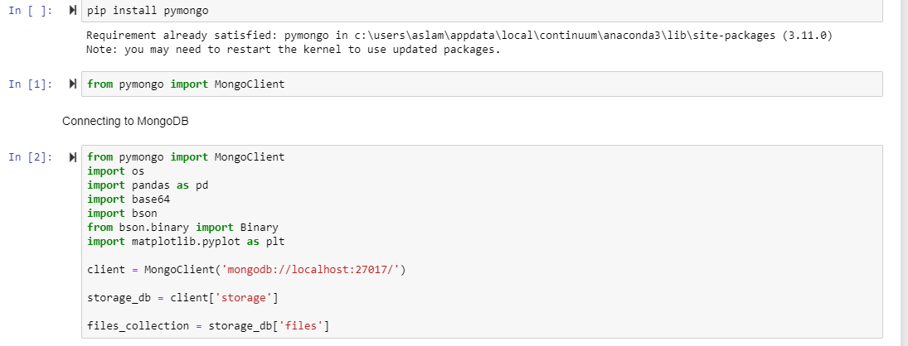

1. Fetch data from the database and perform analysis using visualization tools such as Plotly and Matplotlib. Plotly is a python library for interactive visualizations. We can install it using pip install plotly.

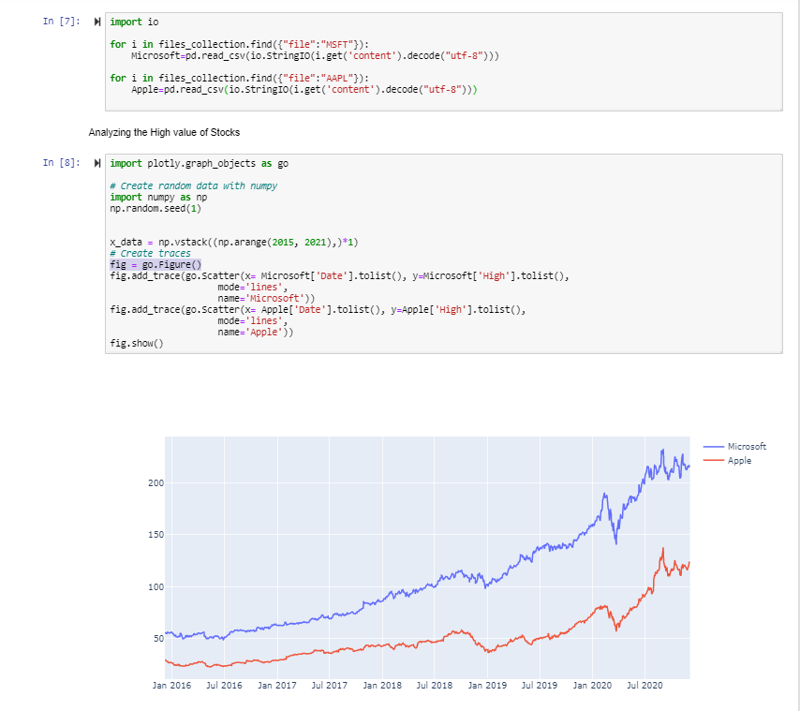

1. Created functions to compare High Value and Net Value of the stocks using visualizations

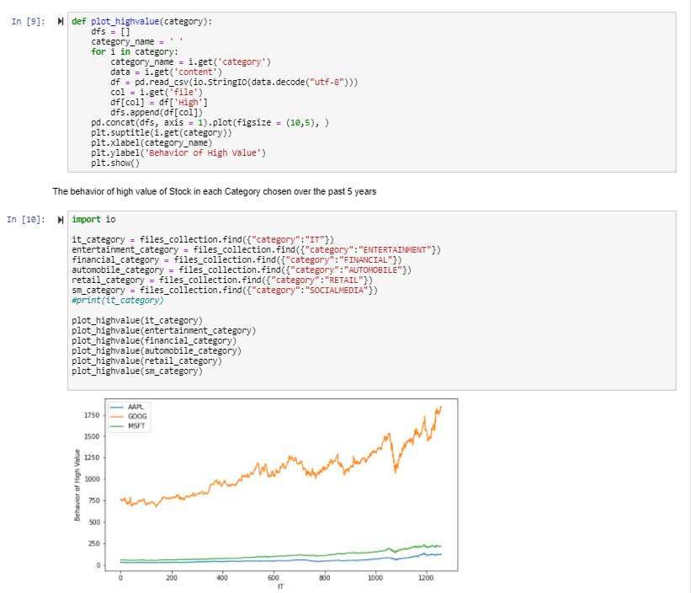

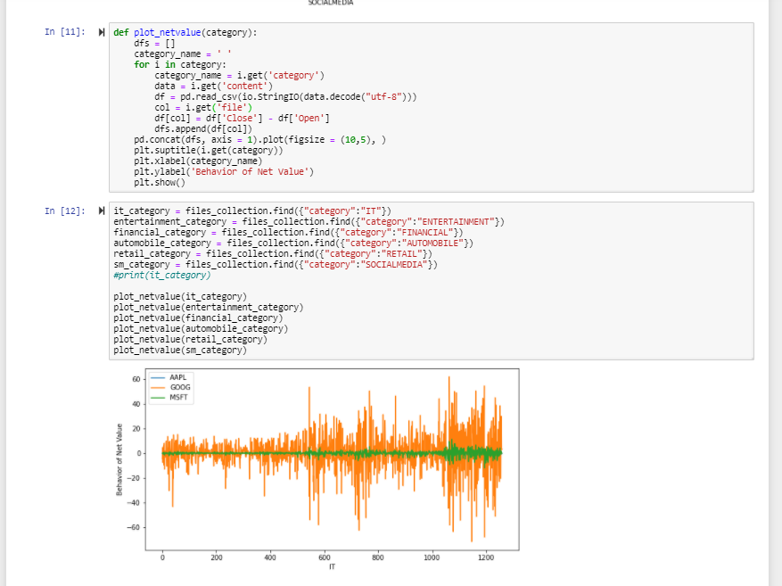

1. Imported pyspark. PySpark needs to be installed before importing it
2. Loaded the data from MongoDb and stored them as a Spark Data frame

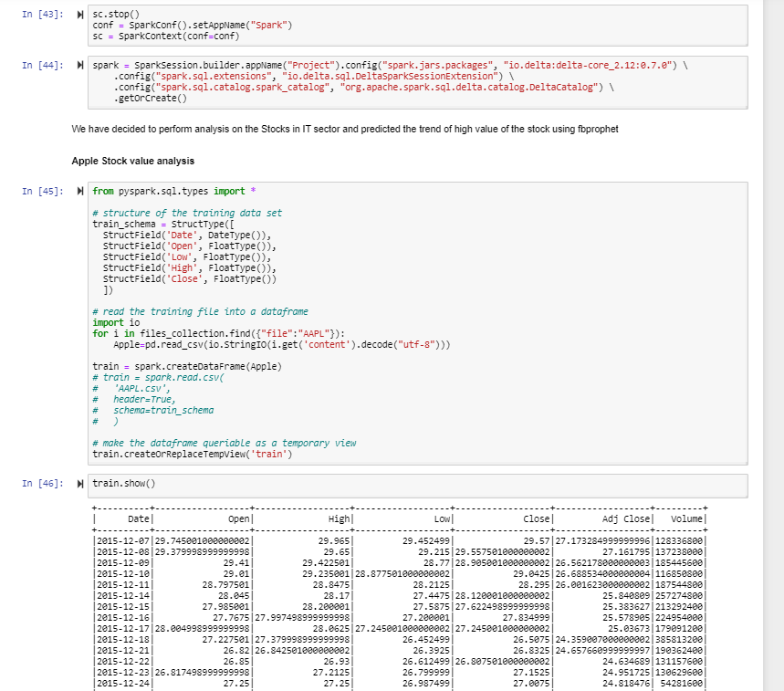

1. Converted the data frame into the required format for feeding it to fbprophet for forecasting the trends. Prophet is a procedure used for forecasting the time series data based on an additive model where non linear trends are fit with yearly, weekly and daily seasonality. Fbprophet can be installed using pip install fbprophet after installing pystan using pip intall pystan. For fbprophet another dependency needed to be installed is PyArrow.
2. Forecasting the trends for high value and net value of the stocks in IT category

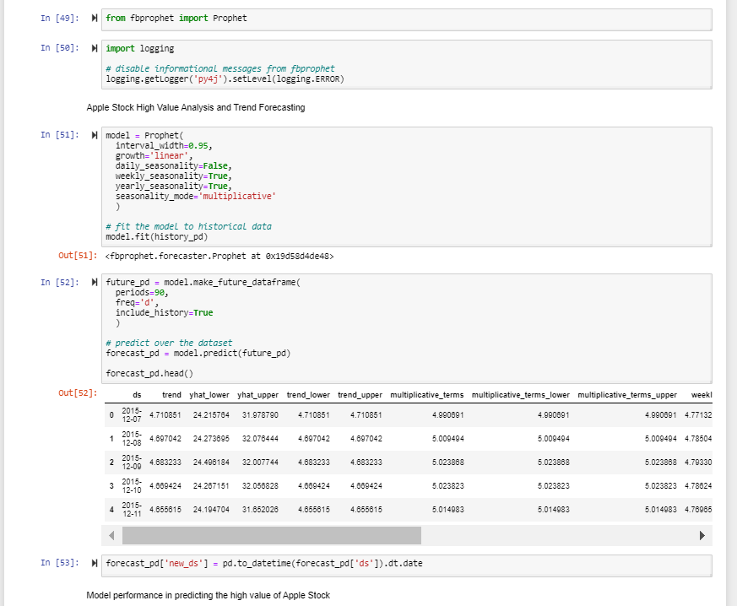

1. Visualizing the findings

