- Use Figma to create an interactive diagram illustrating the components of a basic cellular system.
AIM:
To create an interactive diagram illustrating the components of a basic cellular system

Output:

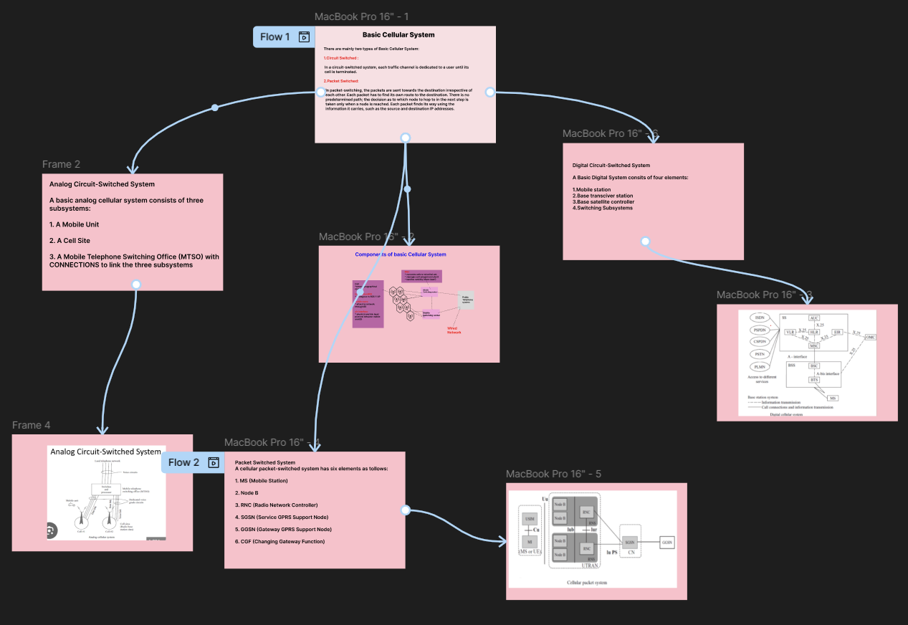

Result: Hence an interactive diagram illustrating the components of a basic cellular system using Figma is created and executed successfully

