LogiPlex Connector

LogiPlex is a SailPoint IdentityIQ connector that combines the behavior of:
- Logical Connector
- Multiplex Application
Its purpose is to create multiple logical applications (sub-applications) from a single source application while still using the same target system for aggregation and provisioning.

Why Do We Need LogiPlex?
Imagine an LDAP or Active Directory contains groups for many business applications:
Active Directory
|
+-- WebApp Groups
+-- ExpenseApp Groups
+-- HRApp Groups
Normally all groups are aggregated into one application.
With LogiPlex, SailPoint can separate them into:
Active Directory
|
+-- WebApplication
+-- ExpenseApplication
+-- HRApplication
This makes:
- Certifications easier
- Access requests easier
- Reporting easier
- Governance cleaner

Real Example
Suppose an AD account has these groups:
CN=WEBAPP_USERS
CN=WEBAPP_ADMIN
CN=EXPENSE_USERS
LogiPlex Split Rule can create:
Sub Application 1:
WebApplication
- WEBAPP_USERS
- WEBAPP_ADMIN

Sub Application 2:
ExpenseApplication
- EXPENSE_USERS
One AD account becomes multiple logical application accounts.

How Many Modes Are Available?
There are 2 Modes:
- Classic Mode
- Adapter Mode

Mode 1: Classic Mode
Architecture
Master Application
(Active Directory)
|
V
LogiPlex Main Application
|
V
Generated Sub Applications
What We Create?
Step 1
Create normal AD application.
Active Directory
This is called the Master Application.
Step 2
Create another application.
Type = LogiPlex Connector
This is called the Main Application.
Step 3
Configure Split Rule.
Step 4
Run Aggregation.
Sub Applications are created automatically.

Functionality of Classic Mode
Aggregation
AD
|
Read Account
|
Split Rule
|
+----> WebApplication
|
+----> ExpenseApplication
Provisioning
Access Request
|
Sub Application
|
LogiPlex
|
Master Application
|
AD

Advantages
- Easy UI configuration
- Less XML work
Disadvantages
- Two application definitions
- Duplicate configuration
- Provisioning policies copied manually
- Poor delta aggregation support

Mode 2: Adapter Mode (Recommended)
Architecture
Active Directory
|
+---- LogiPlex Adapter
|
Generated Sub Applications
Master and Main Application become a single application.

What We Do?
Instead of creating a second application:
Modify existing application XML.
Before
connector="sailpoint.connector.ADLDAPConnector"
After
connector="sailpoint.services.standard.connector.LogiPlexConnector"
Store original connector:
<entry key="logiPlexMasterConnector"
value="sailpoint.connector.ADLDAPConnector"/>

Functionality of Adapter Mode
Aggregation
AD Account
|
V
LogiPlex Split Rule
|
+--> WebApplication
|
+--> ExpenseApplication
|
+--> HRApplication
Provisioning
Request Access
|
V
Sub Application
|
V
LogiPlex Merge Rule
|
V
Original AD Connector
|
V
Active Directory

Advantages
Better Performance
No duplicate application processing.
Better Delta Aggregation
Works correctly with:
- LDAP
- Active Directory
- Other connectors storing delta information
Easier Maintenance
Only one application definition.

Important Components
1. Master Application
Real target system.
Examples:
- AD
- LDAP
- JDBC
- Oracle
Purpose:
Actual Aggregation
Actual Provisioning

2. Main Application
LogiPlex application.
Purpose:
Controls split logic
Controls provisioning logic
(Only exists separately in Classic Mode.)

3. Sub Application
Generated automatically.
Examples:
WebApplication
ExpenseApplication
HRApplication
Purpose:
Show only relevant entitlements.

Core Functionality 1: Split Rule
Most important part of LogiPlex.
Purpose:
Determine which entitlement belongs to which application.
Example:
CN=WEBAPP_USERS
Returns:
WebApplication
Example:
CN=EXPENSE_USERS
Returns:
ExpenseApplication
During aggregation LogiPlex uses this rule to create sub-applications.

Core Functionality 2: Provisioning Rule
Purpose:
When access is requested on a sub-application, merge the request back to the real application.
Example:
User requests:
ExpenseApplication
LogiPlex converts request into:
Active Directory Group Add
and provisions through AD.

Complete Flow
Active Directory
|
V
Aggregation
|
V
Split Rule
|
+---- WebApplication
|
+---- ExpenseApplication
|
+---- HRApplication

User Requests Access
|
V
ExpenseApplication
|
V
Provisioning Rule
|
V
Active Directory
|
V
Group Membership Updated

LogiPlex Connector Implementation – Our Requirement
Our requirement was to manage multiple application-specific groups that exist within a single Active Directory application. When aggregated into SailPoint, all these groups were initially coming under one application. To achieve proper access governance, we needed to split the groups into separate logical applications based on business application ownership.
To meet this requirement, we implemented the LogiPlex Connector in Adapter Mode.
Why Adapter Mode?
Adapter Mode is well suited for our use case because it allows a single Active Directory application to be logically divided into multiple applications based on group membership criteria defined in a Custom Object and Split Rule.
Implemented Functionality
- Active Directory groups are aggregated through a single source application.
- The LogiPlex Split Rule evaluates the groups and categorizes them into the appropriate logical applications based on the Custom Object configuration.
- Separate application definitions are automatically created for the identified applications.
- Entitlements (groups) are displayed under their respective applications in the Entitlement Catalog.
- During access requests, users can search for an application and view only the groups associated with that specific application.
- Provisioning requests are processed through the LogiPlex Provisioning Rule, ensuring access changes are correctly applied back to Active Directory.
Why We Did Not Use Classic Mode
Classic Mode was not suitable for our implementation due to the following limitations:
- The provisioning rule was not executed as required for our use case.
- Entitlements were not properly displayed under their respective applications in the Access Request Center.
- The user experience for requesting application-specific access was not aligned with the business requirement.
- Adapter Mode provided better support for entitlement visibility, access requests, and provisioning operations.
Result
By implementing LogiPlex in Adapter Mode, we successfully separated application-specific groups from a single Active Directory source into multiple logical applications, enabling clear entitlement visibility, simplified access requests, and accurate provisioning.

Implementation overview

3.1 Custom Object Creation

- Create a Custom Object to map AD groups to their respective applications
- Define group mappings in the Custom Object to enable splitting of sub-applications based on group naming.
- If new AD groups are introduced, they can either be mapped to an existing application or used to create a new application. In both cases, only the Custom Object needs to be updated accordingly.

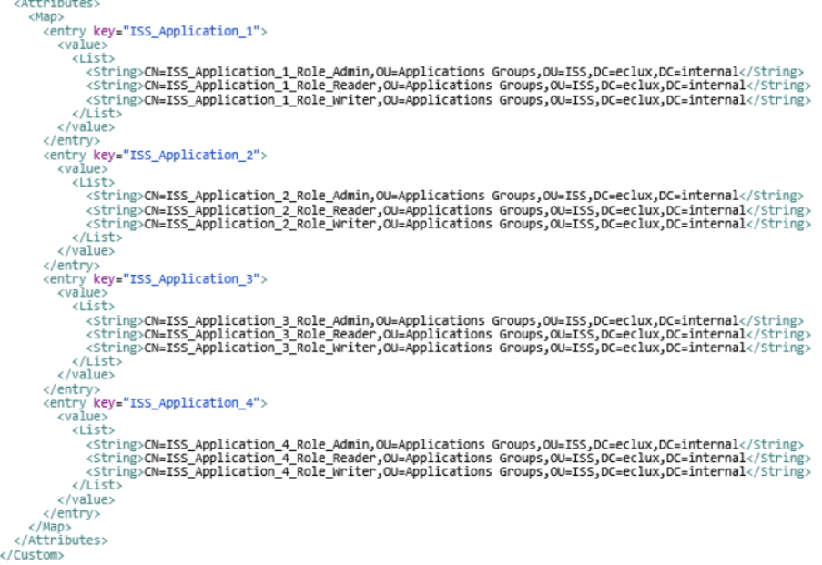

3.2 Application Configuration Changes

- Modify the AD target application (real application) via XML configuration
- Replace the existing connector class with the Logiplex connector class.
- Add the required attributes in the Application XML:
- Split Rule Name
- Provisioning Rule Name
- Prefix
- Connector Class (real connector)
- Save the updated application configuration
- Run Account Aggregation for the target application

