Logiplex Connector deployment document:-

Requirement Description :-
Currently, several applications are managed through Active Directory (AD) groups using standard AD connectors (e.g., ActiveDirectorySERVITIA, ISBL). Access is granted via Business Roles that assign AD groups.
For example, in the Alexandria application, AD groups follow the naming convention Ag_ALXN*. While this setup works technically, it lacks clarity from a governance and audit perspective.
Clients and auditors find it difficult to understand which accesses belong to which applications, as everything is indirectly represented through AD group names.
To address this, we are evaluating the use of an AD Logiplex connector to:
- Better organize and identify application-specific access
- Provide a clearer view of entitlements per application
- Improve readability and audit transparency of access rights

Implementation Overview :-
3.1 Custom Object Creation

- Create a Custom Object to map AD groups to their respective applications
- Define group mappings in the Custom Object to enable splitting of sub-applications based on group naming.
- If new AD groups are introduced, they can either be mapped to an existing application or used to create a new application. In both cases, only the Custom Object needs to be updated accordingly.

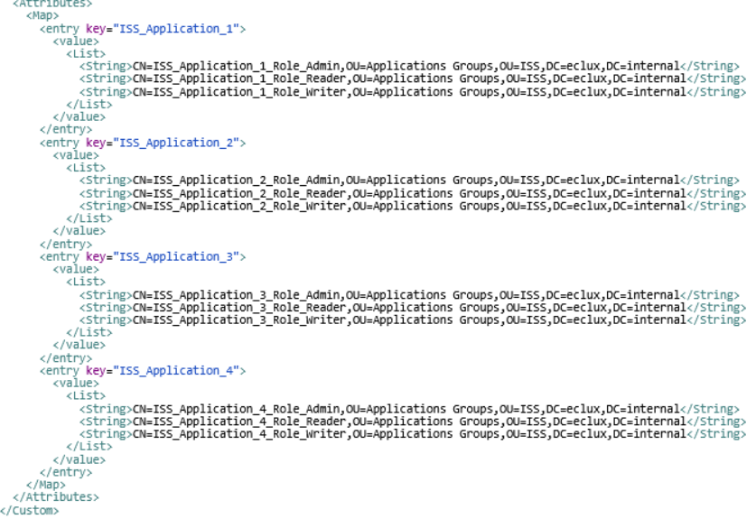

3.2 Application Configuration Changes

- Modify the AD target application (real application) via XML configuration
- Replace the existing connector class with the Logiplex connector class.
- Add the required attributes in the Application XML:
  - Split Rule Name
  - Provisioning Rule Name
  - Prefix
  - Connector Class (real connector)
- Save the updated application configuration
- Run Account Aggregation for the target application

Pre-Deployment :-
- Identify and map AD groups to applications based on naming conventions
- Create the Custom Object with group-to-application mappings
- Prepare and test Split and Provisioning Rules in lower environments
- Update and validate Application XML configuration
- Perform testing (aggregation, access request, provisioning)
- Take backup of Application before deployment

Backup files:-
- ActiveDirectory-Eclux Application

Modified files:-
- ActiveDirectory-Eclux Application (updated configuration)

Deployment in Production:-
- Import Split Rule and Provisioning Rule from Test to Production
  - Split rule: ISS_Logiplex_Split_Rule
  - Provisioning rule: ISS Logiplex Provisioning Rule
- Update the Application XML using Debug pages
- Save and validate the configuration

Post Deployment :-
- Verify that the application is functioning correctly
- Validate all operations, including:
  - Account aggregation
  - Access requests
  - Provisioning and de-provisioning

Rollback :-
- Revert the application to the previously backed-up configuration
- Restore original connector settings and XML configuration

