**Assignment – 5**

Submission by : Bhanu Prakash Samoju

**Assignment - 1: Creating a Kubernetes Pod and Deployment**

1. Set Up Your Kubernetes Environment:

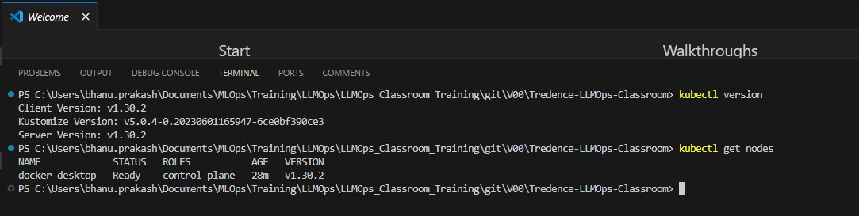

2. Create a Pod Using the Imperative Method:



3. Access the Pod:

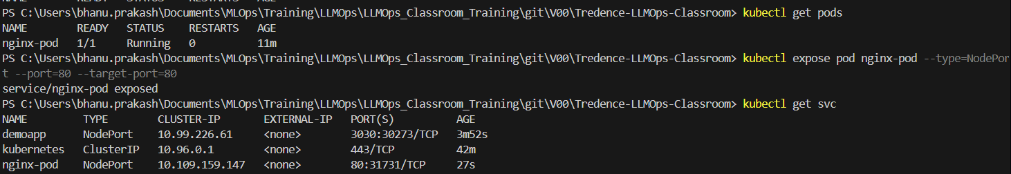

4. Create a Deployment Using the Declarative Method:

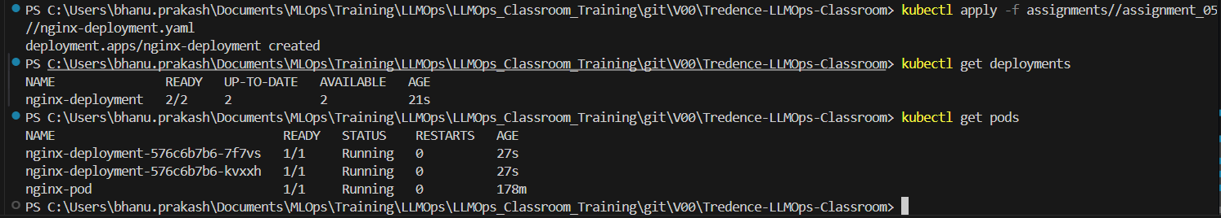

5. Scaling the Deployment:

6. Clean Up Resources:

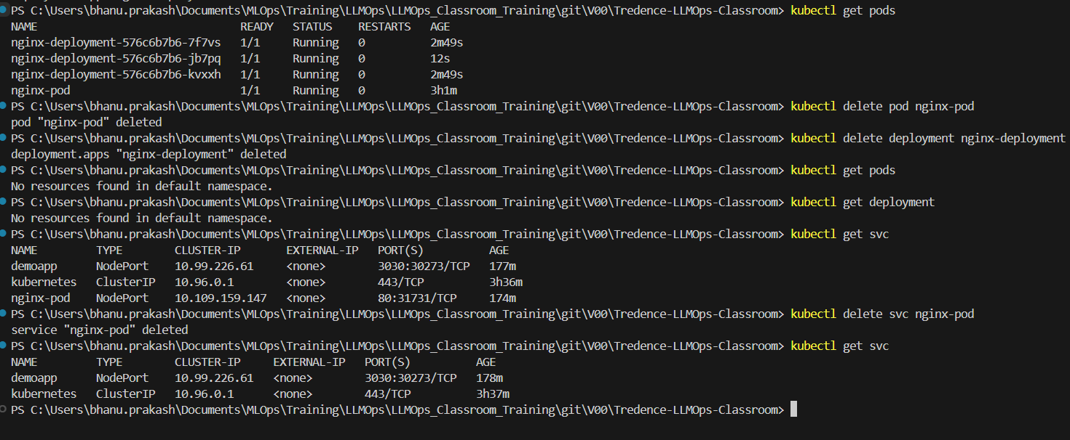

**Assignment – 2: Advanced Kubernetes Concepts – Persistent Volumes and Secrets**

1. Create a Secret:

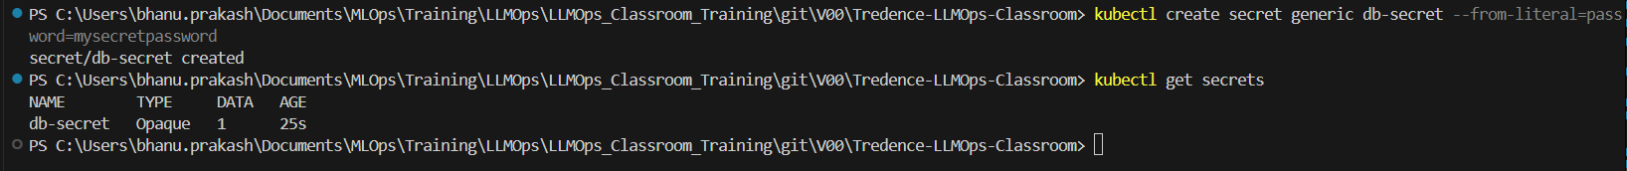

2. Create a Persistent Volume and Persistent Volume Claim:

3. Create a Deployment Using the PVC and Secret:

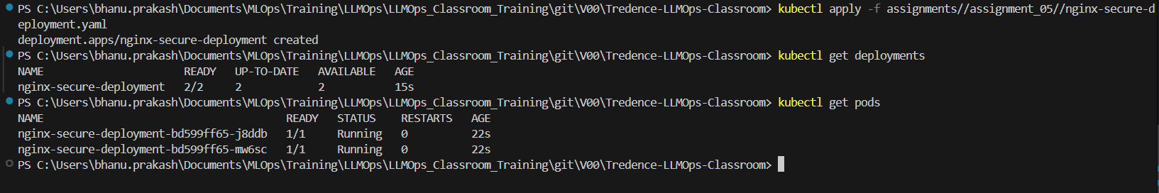

4. Access the Pods to Verify Configuration:

1. Use `kubectl exec` to enter one of the running Pods and check the content of `/usr/share/nginx/html`.

**Observation**: Mounted paths are created but no content can be found in both the pods under /usr/share/nginx/html directory

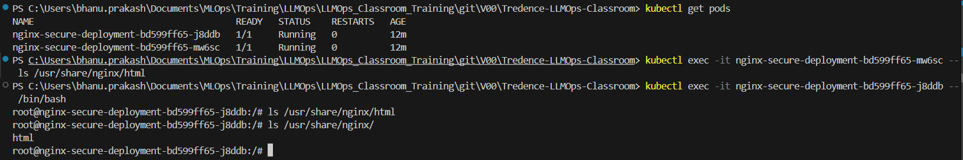

2. Check if the `DB_PASSWORD` environment variable is set correctly within the Pod by running `echo $DB_PASSWORD` inside the Pod.

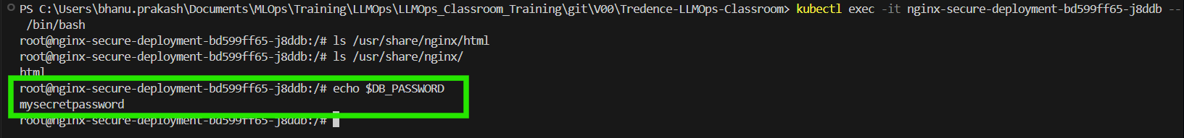

5. Clean Up Resources:

