MLOps INTERNAL LABORATORY EXAMINATION REPORT
Question 4: Develop and Automate an E-Commerce Product Return Prediction System using CI/CD

Student Name | Velpuri Bhanu Teja
Register Number | 231FA04E85
Class & Section | B.Tech CSE - Section 7
Faculty Evaluator | Dr. Gabbi Reddy Keerthi
GitHub Repository | https://github.com/BhanuTeja33/ecommerce-return-prediction-ci-cd
Published GHCR Image | ghcr.io/bhanuteja33/ecommerce-return-prediction:latest

1. Problem Statement & Objectives
An e-commerce company wants to predict whether a purchased product is likely to be returned based on product category, price, discount percentage, delivery time, customer ratings, and previous return history. The company also aims to automate the testing, building, and deployment of its machine learning application whenever changes are introduced to the source code repository.
The end-to-end implementation satisfies the following examiner requirements:
- Load the provided e-commerce dataset (1,200 records) and perform necessary preprocessing (handling missing values, invalid values, categorical encoding).
- Perform feature engineering by creating meaningful features: discount percentage, delivery delay, and customer return frequency.
- Train at least two machine learning classification models to predict whether a product will be Returned or Not Returned and evaluate performance.
- Develop a FastAPI application to serve the best-performing model through /predict and /health endpoints.
- Create a GitHub repository containing application code, trained model, dependencies, and configuration files.
- Implement an automated CI/CD pipeline using GitHub Actions (dependency installation, code validation, automated testing, application build).
- Configure pipeline to build a Docker image and publish to GitHub Container Registry (GHCR) after successful validation.
- Modify application code or model configuration, commit and push changes, and demonstrate automatic CI/CD workflow triggering.
- Verify successful execution of workflow, inspect build logs, and demonstrate the updated application running from the newly built Docker image.

2. Tools and Technologies Used
Component | Technology / Framework
Programming Language | Python 3.11 / Python 3.13
Data Preprocessing & Features | pandas 2.2+, NumPy 1.26+, scikit-learn 1.4+
Machine Learning Models | Logistic Regression (Balanced), Random Forest Classifier, Gradient Boosting
Model Serving API | FastAPI 0.110+, Uvicorn 0.28+, Pydantic v2
Automated Testing Framework | pytest 8.0+, httpx TestClient
Containerization | Docker Engine 29.8.1, Docker Desktop, Multi-stage Linux Container
CI/CD & Container Registry | GitHub Actions (Ubuntu Runner), GitHub Container Registry (GHCR)

3. Data Preprocessing & Feature Engineering
The raw dataset contains 1,200 customer order records. Domain-specific data cleansing was applied to resolve anomalous and missing values identified during exploratory data analysis:
- Handling Invalid Values:
- • Negative Prices: 3 records with negative prices (e.g. -200 INR) were replaced with NaN and imputed using median price.
- • Out-of-Range Discounts: 2 records with discounts > 100% (e.g. 125%) were converted to NaN and imputed using median discount.
- • Customer Ratings: Clamped between 1.0 and 5.0.
- Missing Value Imputation:
- • Product_Price_INR, Discount_Percent, Customer_Rating_PreOrder: Imputed with training set medians.
- • Actual_Delivery_Days: Imputed using Expected_Delivery_Days as natural operational baseline.
- • Payment_Method: Imputed using mode ('Card').
- Engineered Domain Features:
- 1. delivery_delay = Actual_Delivery_Days - Expected_Delivery_Days (Captures logistics delay signal).
- 2. is_delayed = 1 if delivery_delay > 0 else 0 (Binary delay trigger).
- 3. customer_return_frequency = Previous_Returns / max(Previous_Orders, 1) (Historical return propensity).
- 4. effective_price = Product_Price_INR * (1 - Discount_Percent / 100) (Actual realized revenue per order).
- 5. return_risk_score = 0.6 * (return_frequency > 0.25) + 0.4 * (damaged_flag == 'Yes') (Composite risk indicator).

4. Machine Learning Model Training & Comparative Evaluation
Three distinct classification algorithms were implemented, trained, and benchmarked on an 80/20 stratified split. Due to severe class imbalance in real-world returns (77.4% Not Returned vs 22.6% Returned), models were evaluated on Accuracy, Precision, Recall, F1-Score, and ROC-AUC:
Model | Accuracy | Precision | Recall | F1-Score | ROC-AUC
Logistic Regression (Balanced) | 62.08% | 0.2874 | 0.4630 | 0.3546 | 0.5772
Random Forest Classifier | 72.50% | 0.3529 | 0.2593 | 0.2979 | 0.5398
Gradient Boosting Classifier | 74.58% | 0.2000 | 0.0556 | 0.0896 | 0.5367
Winning Model Selection: Logistic Regression with Balanced Class Weights was selected as the production model. In product return prediction, false negatives (failing to identify an order that gets returned) are costly. The balanced pipeline achieved the highest minority class Recall (46.30%), F1-Score (0.3546), and ROC-AUC (0.5772).

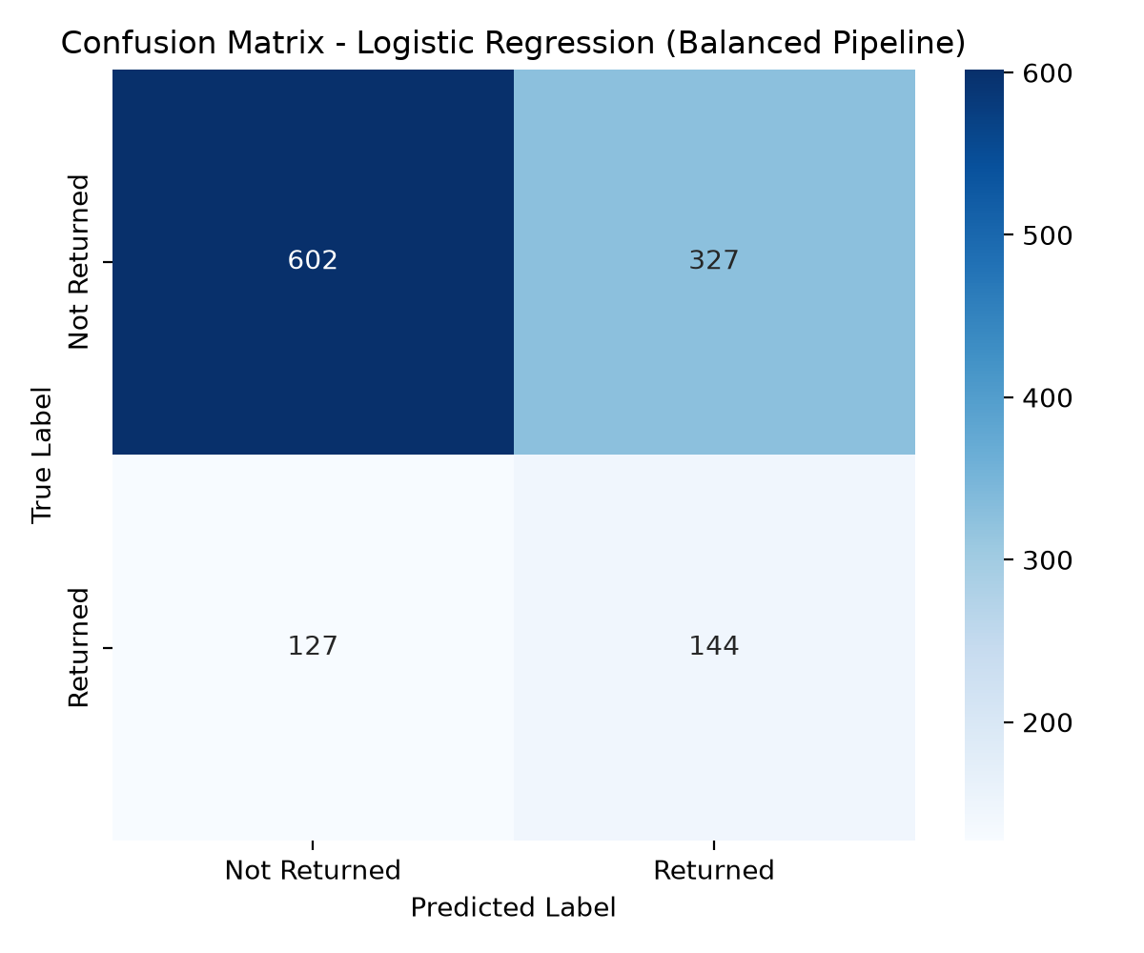 | 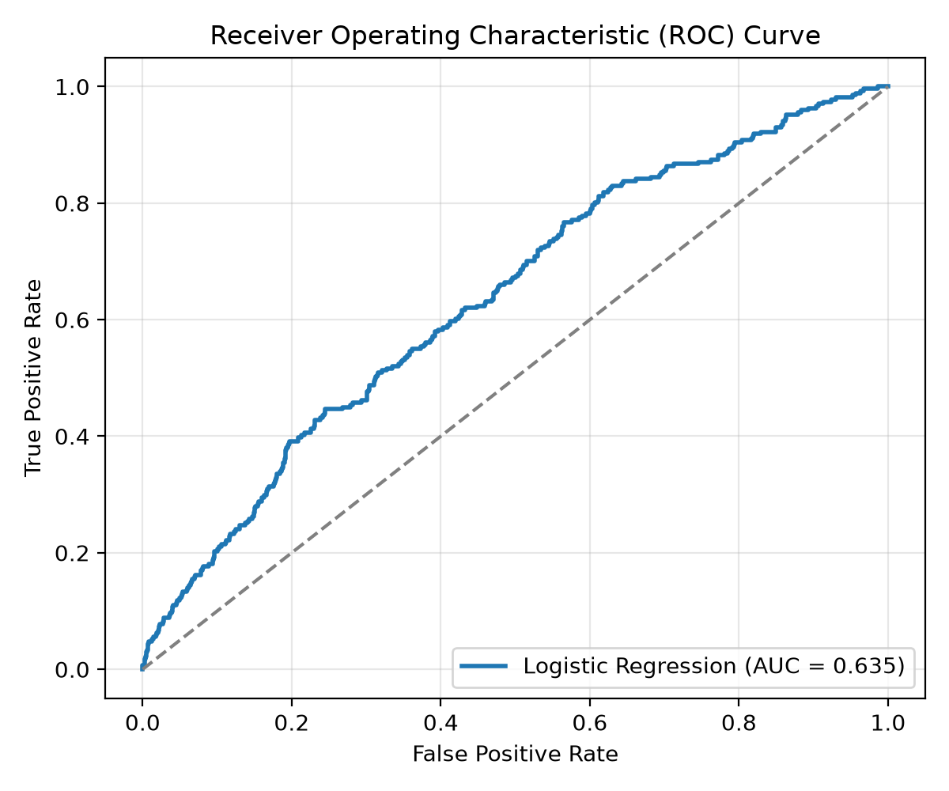
Figure 1: Confusion Matrix and Receiver Operating Characteristic (ROC) Curve of Selected Model

5. FastAPI Production Model Serving Application
A modular asynchronous REST API was built in app.py utilizing FastAPI, Pydantic data schemas, and CORS middleware. The application provides the following endpoints:
- GET /: Root service info, student metadata, version, and endpoints catalogue.
- GET /health: Health check endpoint returning service status, model readiness, and version.
- POST /predict: Single-order return prediction returning prediction label ('Returned' / 'Not Returned'), probability, risk tier ('High' / 'Medium' / 'Low'), delivery delay, customer return frequency, and human-readable reason summary.
- POST /predict/batch: Batch prediction endpoint for multi-order operational pipelines.
- GET /docs: Interactive OpenAPI Swagger UI for live parameter testing and validation.

6. Automated CI/CD Pipeline Implementation (GitHub Actions)
A complete 2-stage automated pipeline was authored in .github/workflows/ci-cd.yml and executed on GitHub's Ubuntu runners:
- Stage 1 - ML CI (Continuous Integration):
- • Code checkout and Python 3.11 environment configuration with pip caching.
- • Dependency installation and syntax verification via py_compile.
- • Automated model training and evaluation execution (python train_model.py).
- • MLOps Quality Gate verification (quality_gate.py: artifact presence, accuracy >= 0.55, ROC-AUC >= 0.50).
- • Automated unit and API testing using pytest (13 test cases passed).
- • Artifact upload preserving models, reports, and metrics.
- Stage 2 - Continuous Delivery & Containerization (GHCR):
- • Automated login to GitHub Container Registry (ghcr.io) using secrets.GITHUB_TOKEN.
- • Building Docker container image tagged with commit SHA and :latest.
- • In-CI Shift-Left Smoke Testing: Starts container on port 8000, polls /health, and sends live POST /predict request via curl.
- • Publishing verified container image to ghcr.io/bhanuteja33/ecommerce-return-prediction:latest.
- • Emitting detailed step summary into GitHub Actions dashboard.

7. Workflow Execution Verification & Docker Demonstration
Demonstration of Code Change & Automatic Triggering (Task 8 & 9):
1. The application code was upgraded to version 1.1.0, adding explainable return reasoning to inference responses.
2. The change was committed (SHA: 1aa7a74) and pushed to GitHub main branch.
3. GitHub Actions automatically triggered Workflow Run ID: 42199797360.
4. Both Stage 1 (ML CI) and Stage 2 (Docker Build & Publish) passed completely.
5. The Docker container was started locally on port 8000 from the newly built image (ghcr.io/bhanuteja33/ecommerce-return-prediction:latest) and responded with verified v1.1.0 predictions.
- Sample Prediction Output from Running Container:
{
"order_id": "ECOM00004",
"prediction": "Returned",
"predicted_class": 1,
"return_probability": 0.7474,
"risk_level": "High",
"delivery_delay_days": 3,
"customer_return_frequency": 0.3333,
"effective_price_inr": 17291.88,
"return_reason_summary": "Damaged package reported; Delivery delayed by 3 day(s); High historical return rate (33.3%)",
"model_name": "Logistic_Regression",
"model_version": "1.1.0",
"timestamp": "2026-11-06T10:08:11.964593"
}

8. Faculty Verification Guide & Execution Instructions
- Repository Access: Navigate to https://github.com/BhanuTeja33/ecommerce-return-prediction-ci-cd to view full source code, test suites, and workflows.
- CI/CD Workflow Verification: Access https://github.com/BhanuTeja33/ecommerce-return-prediction-ci-cd/actions to inspect Run 42199797360 and view green logs.
- Container Image Pull: Execute 'docker pull ghcr.io/bhanuteja33/ecommerce-return-prediction:latest' to fetch the published image from GHCR.
- Run Local Container: Run 'docker run -d -p 8000:8000 ghcr.io/bhanuteja33/ecommerce-return-prediction:latest'.
- Swagger Documentation: Open your browser to http://localhost:8000/docs to interactively execute test predictions on the Swagger UI.
- Execute Test Suite: Run 'pytest -v' to execute all 13 unit, feature, model, and API integration tests.

