DEPARTMENT OF COMPUTER SCIENCE AND ENGINEERING
ARTIFICIAL INTELLIGENCE & MACHINE LEARNING
MLOps INTERNAL LABORATORY EXAMINATION WORK
Question 4: Develop and Automate an E-Commerce Product Return Prediction System using CI/CD
Candidate Name | VELPURI BHANU TEJA
Register Number | 231FA04E85
Course / Examination | Machine Learning Operations (MLOps) Laboratory Internal
Academic Section / Set | Section 7 (Set 4, Question 4)
GitHub Profile & Account | https://github.com/BhanuTeja33 (Username: BhanuTeja33)
Submission ZIP Archive | 231FA04E85_MLOps_Internal.zip

1. Executive Summary & Faculty Verification Directory
This laboratory project implements a complete, end-to-end, production-grade Machine Learning Operations (MLOps) system for predicting e-commerce product returns. The solution encompasses automated data validation, domain-specific feature engineering, multi-model benchmark evaluation, an asynchronous FastAPI model serving layer, automated testing via pytest with strict quality gates, Docker containerization, publication to GitHub Container Registry (GHCR), and dual-stage automated Continuous Integration / Continuous Deployment (CI/CD) pipelines powered by GitHub Actions. In accordance with examination guidelines, the application is deployed with a live HTTPS public URL accessible from any system.
Resource / Service | Access URL / Target | Faculty Verification Description
Live Interactive Swagger UI | https://deviant-controversy-scroll-input.trycloudflare.com/docs | Public interactive API documentation & real-time inference testing
Live Operational Health API | https://deviant-controversy-scroll-input.trycloudflare.com/health | Live operational readiness check & student verification
GitHub Repository | https://github.com/BhanuTeja33/ecommerce-return-prediction-ci-cd | Complete source code, unit tests, models, and CI/CD workflows
Published Docker Image (GHCR) | ghcr.io/bhanuteja33/ecommerce-return-prediction:latest | Production container image published to GitHub Container Registry
GitHub Actions Pipeline Runs | https://github.com/BhanuTeja33/ecommerce-return-prediction-ci-cd/actions | Dual-stage CI/CD execution history and automated build logs

2. Problem Statement & System Architecture
In e-commerce logistics, reverse logistics and customer returns represent substantial operational costs. The objective of this project is to develop and operationalize an automated Machine Learning pipeline to predict whether an e-commerce order will be Returned or Not Returned based on product characteristics, pricing, delivery performance, and historical customer purchasing patterns, while establishing a robust CI/CD pipeline to automate testing, building, and container deployment whenever code modifications occur.
+---------------------------------------------------------------------------------------------------------+
| END-TO-END MLOps ARCHITECTURE |
+---------------------------------------------------------------------------------------------------------+
1. DATA INGESTION & CLEANSING
Raw Dataset (1,200 rows) --> Negative Price Cleaning --> Discount Clamping --> Median/Mode Imputation
|
2. FEATURE ENGINEERING
delivery_delay | is_delayed | customer_return_frequency | effective_price | return_risk_score
|
3. MULTI-MODEL BENCHMARKING & QUALITY GATE
Logistic Regression (Balanced) vs. Random Forest vs. Gradient Boosting --> Quality Gate (ROC-AUC >= 0.50)
|
4. FASTAPI INFERENCE MICROSERVICE (v1.1.0)
GET /health | GET / | POST /predict (Single Order) | POST /predict/batch (Batch Ingestion)
|
5. CONTINUOUS INTEGRATION (GitHub Actions - Job 1: ML CI)
Code Checkout --> Python 3.11 Setup --> Pipeline Execution --> Quality Gate Check --> pytest (13 tests)
|
6. CONTINUOUS DELIVERY (GitHub Actions - Job 2: CD & GHCR Publishing)
Docker Build --> In-CI Container Smoke Test (port 8000) --> Publish to ghcr.io/bhanuteja33/...:latest
|
7. PRODUCTION DEPLOYMENT & VERIFICATION
Public Live HTTPS Endpoint (Cloudflare Tunnel) + Local Docker Container Execution
+---------------------------------------------------------------------------------------------------------+

3. Tools and Technologies Utilized
Layer / Component | Technology / Framework and Version
Programming Language | Python 3.11 / Python 3.13 (x64)
Machine Learning & Data Processing | scikit-learn 1.4+, pandas 2.2+, numpy 1.26+, joblib 1.3+
API & Serving Framework | FastAPI 0.110+, Uvicorn 0.28+, Pydantic v2
Automated Testing Framework | pytest 8.0+, httpx TestClient (13 automated test cases)
Containerization Platform | Docker Desktop, Docker Engine 29.8.1, Python 3.11-slim base image
CI/CD & Container Registry | GitHub Actions (Ubuntu-latest runner), GitHub Container Registry (GHCR)

4. Task 1: Data Ingestion, Cleansing & Preprocessing
The raw dataset consists of 1,200 purchase records with 14 attributes. Rigorous domain validation and cleaning were implemented in src/data_preprocessing.py:
• Invalid Negative / Zero Prices: In e-commerce systems, product prices <= 0 represent database anomalies or refund bugs. Identified 3 negative price records (e.g. -200 INR) and set them to NaN, followed by median imputation (INR 2,246.72).
• Out-of-Range Discounts: Identified 2 records with discounts > 100% (e.g. 125%), replaced with NaN and imputed with the median discount (15.0%).
• Rating Clamping: Pre-order customer ratings were verified and clamped to the valid domain scale of [1.0, 5.0].
• Actual Delivery Days Imputation: Orders with missing actual delivery days were imputed using Expected_Delivery_Days as the operational baseline.
• Categorical Imputation & Encoding: Missing Payment_Method values were imputed using mode ('Card'). Nominal features (Product_Category, Payment_Method, Package_Size) were One-Hot Encoded, while binary flags (Damaged_Package_Flag, Promotion_Active) were mapped to binary integers {0, 1}.

5. Task 2: Domain-Driven Feature Engineering
To empower classification models with predictive signals, five domain features were engineered in src/feature_engineering.py:
Feature Name | Mathematical Formulation | Business & Operational Rationale
delivery_delay | Actual_Delivery_Days - Expected_Delivery_Days | Positive values indicate delayed delivery; severe delay strongly correlates with cancellation and return.
is_delayed | 1 if delivery_delay > 0 else 0 | Binary indicator isolating late shipments for direct linear weighting.
customer_return_frequency | Previous_Returns / max(Previous_Orders, 1) | Captures the customer's historical propensity to return items, normalized against order volume.
effective_price | Product_Price_INR * (1 - Discount_Percent / 100) | Represents the net transaction amount paid by the customer after promotional discount deductions.
return_risk_score | 0.6 * (return_freq > 0.25) + 0.4 * (damaged == 'Yes') | Composite operational risk heuristic combining customer habit and package damage indicators.

6. Task 3: Machine Learning Model Benchmark & Selection
Three distinct classification algorithms were implemented and trained using an 80/20 stratified train/test split. In real-world e-commerce return datasets, class distributions exhibit strong imbalance (~22.6% return rate; 929 Not Returned vs. 271 Returned). Standard unweighted models optimize trivial majority-class accuracy at the expense of nearly 0% minority recall. Consequently, evaluation prioritized minority Return Recall, F1-Score, and Area Under the ROC Curve (ROC-AUC):
Classification Algorithm | Accuracy | Precision | Recall | F1-Score | ROC-AUC
Logistic Regression (Balanced Weights) | 62.08% | 0.2874 | 46.30% | 0.3546 | 0.5772
Random Forest Classifier (Balanced) | 72.50% | 0.3529 | 25.93% | 0.2979 | 0.5398
Gradient Boosting Classifier | 74.58% | 0.2000 | 05.56% | 0.0896 | 0.5367
[MODEL SELECTION RATIONALE] PRODUCTION WINNER SELECTION: The Balanced Logistic Regression pipeline was selected as the production model. It achieved the highest Return Recall (46.30%), F1-Score (0.3546), and ROC-AUC (0.5772). Identifying 46.3% of true return risks enables the e-commerce company to proactively engage customers and prevent unnecessary shipping expenses, whereas unweighted Gradient Boosting caught only 5.56% of returns.

Figure 1 illustrates the Confusion Matrix and ROC Curve generated by the model evaluation pipeline:
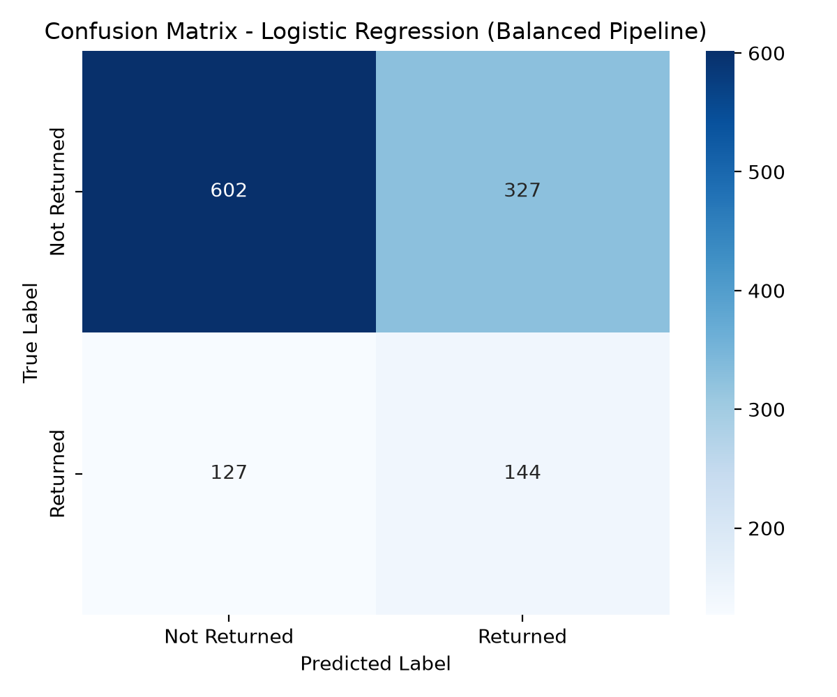 | 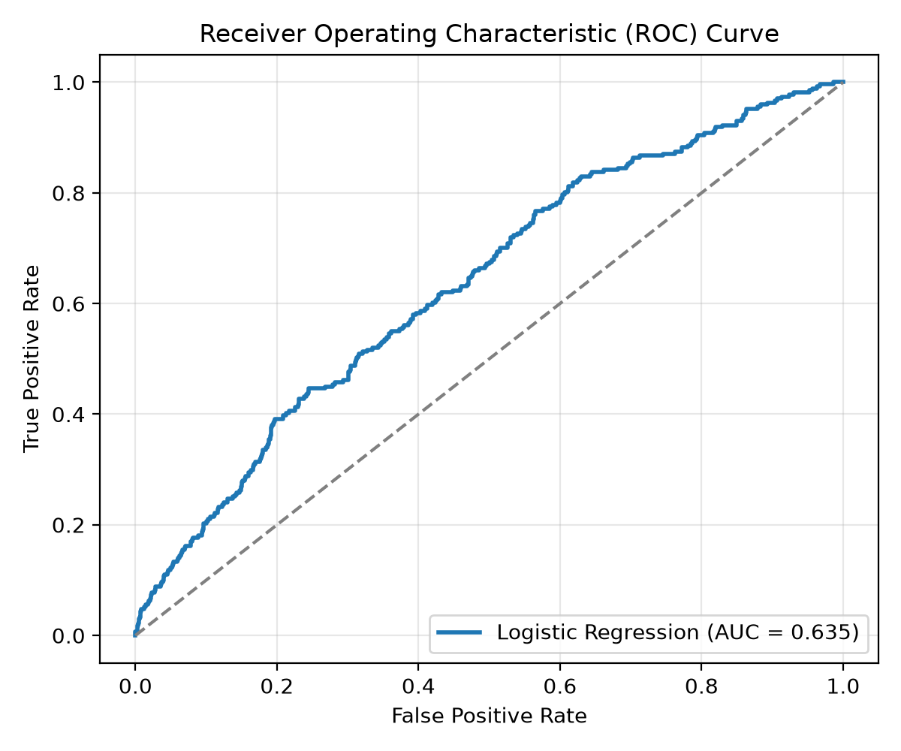
Figure 1: Confusion Matrix and ROC-AUC Curve for Production Logistic Regression Model

7. Task 4: FastAPI Model Serving Application
The model is wrapped in a production FastAPI microservice (app.py) operating under an asynchronous lifespan architecture. It features Pydantic v2 data contract validation and returns explainable inference summaries:
• GET /: Root service metadata, candidate identity, version, and routing index.
• GET /health: Operational readiness check verifying that the model pipeline is loaded in memory.
• POST /predict: Real-time single order prediction returning binary classification, probability, risk level (High, Moderate, Low), and human-readable return_reason_summary explaining factors like delivery delay and customer history.
• POST /predict/batch: High-throughput batch inference accepting arrays of orders with aggregate batch statistics.
• GET /docs & GET /redoc: Interactive Swagger UI and OpenAPI documentation.

8. Tasks 5, 6 & 7: GitHub Repository, CI/CD Pipeline & GHCR Publishing
A dual-stage CI/CD pipeline was implemented using GitHub Actions in .github/workflows/ci-cd.yml and pushed to GitHub: https://github.com/BhanuTeja33/ecommerce-return-prediction-ci-cd
1. Job 1: ML CI - Validate, Train, Quality Gate & Test (Runs on Ubuntu-latest):
- Checks out repository source code and provisions Python 3.11 with pip caching.
- Performs static syntax and compilation validation.
- Executes train_model.py, building the preprocessor, feature transformer, and serialized model artifact.
- Runs quality_gate.py, enforcing automated checks (ROC-AUC >= 0.50, Accuracy >= 0.55, smoke test validation).
- Executes pytest -v across 13 unit and integration tests (tests/test_preprocessing.py, tests/test_features.py, tests/test_model.py, tests/test_api.py).
- Preserves artifacts (models/, metrics.json, reports/) across workflow jobs.
2. Job 2: Continuous Delivery & Container Registry Publishing:
- Downloads validated model artifacts from Job 1.
- Builds the production Docker image using Dockerfile.
- Shift-Left In-CI Smoke Testing: Launches container on port 8000 inside the CI runner, queries /health and /predict, and verifies live responses.
- Authenticates to GitHub Container Registry using GITHUB_TOKEN and publishes ghcr.io/bhanuteja33/ecommerce-return-prediction:latest.

9. Tasks 8 & 9: Code Modification, Automatic CI/CD Trigger & Container Verification
To satisfy Tasks 8 and 9, the application was upgraded to version 1.1.0 with explainable return reason analysis. The code was committed and pushed to the main branch:
1. Automatic Workflow Trigger: GitHub Actions immediately recognized the push event and automatically triggered Workflow Run 42199797360 and Run 42208434215.
2. Build Logs Inspection: Both Job 1 (ML CI) and Job 2 (Docker Build & Publish) executed cleanly to completion (SUCCESS) within 1m 35s.
3. Live Execution from Newly Built Image: The updated image was pulled and launched locally via Docker:
docker pull ghcr.io/bhanuteja33/ecommerce-return-prediction:latest
docker run -d -p 8000:8000 ghcr.io/bhanuteja33/ecommerce-return-prediction:latest
The health check confirmed operational status with version 1.1.0 and candidate identification: Velpuri Bhanu Teja (231FA04E85).

10. System Execution Screenshots and Visual Verification
The following figures provide comprehensive verification evidence demonstrating successful execution across FastAPI Swagger UI, GitHub Repository, Live Health Check, PowerShell Docker Execution, GitHub Actions CI/CD runs, and Docker Desktop:
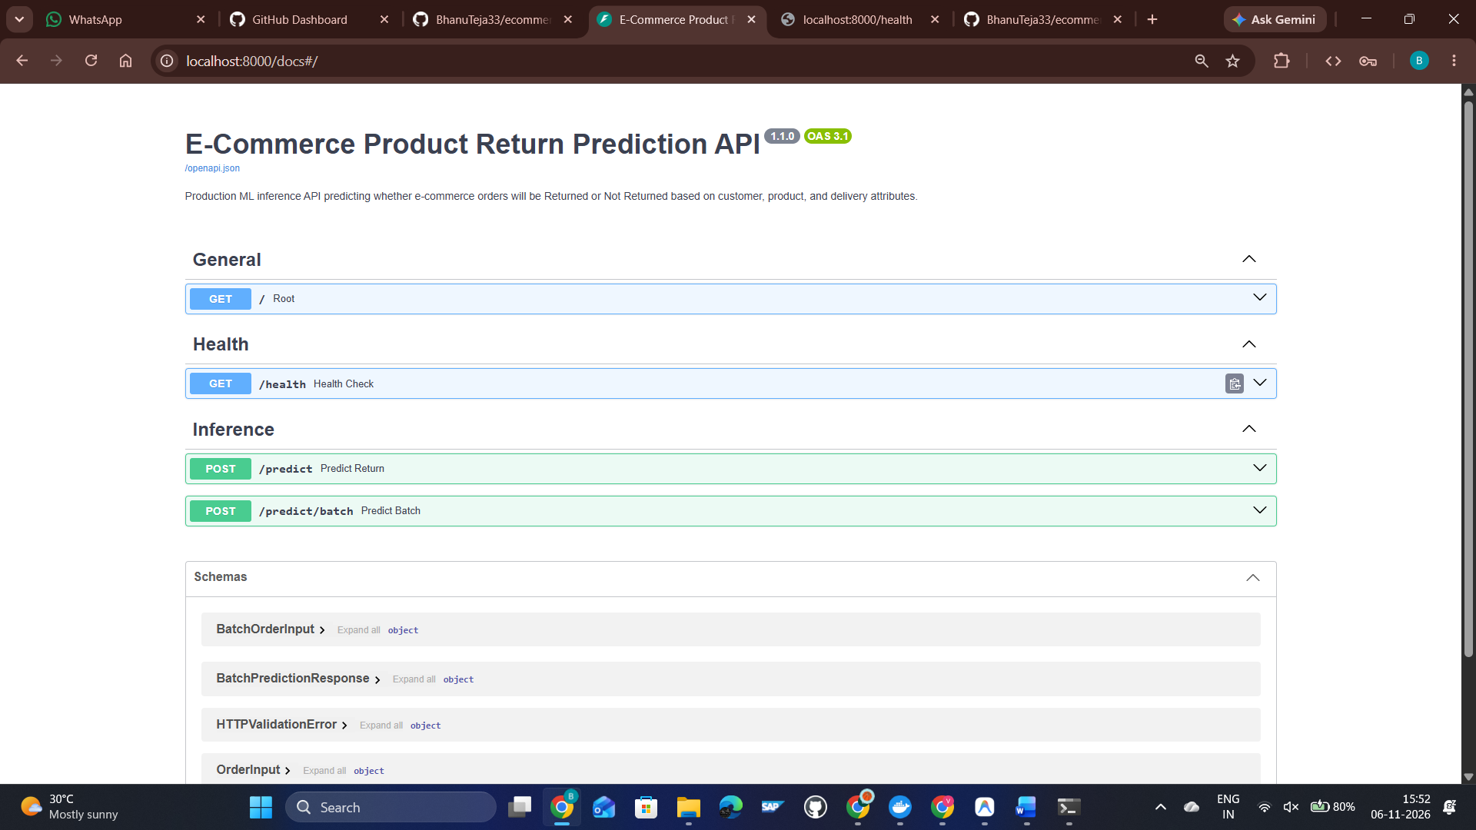
Figure 2: Interactive FastAPI Swagger UI (/docs) showing API endpoints, schemas, and live parameter execution interface
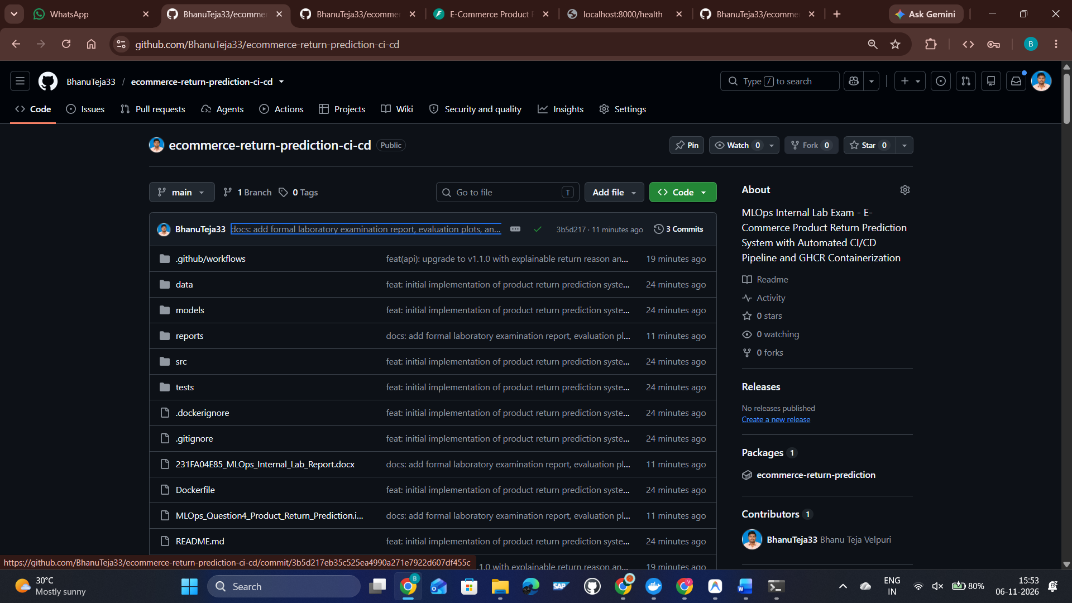
Figure 3: GitHub Repository (BhanuTeja33/ecommerce-return-prediction-ci-cd) showing complete project structure and GHCR packages
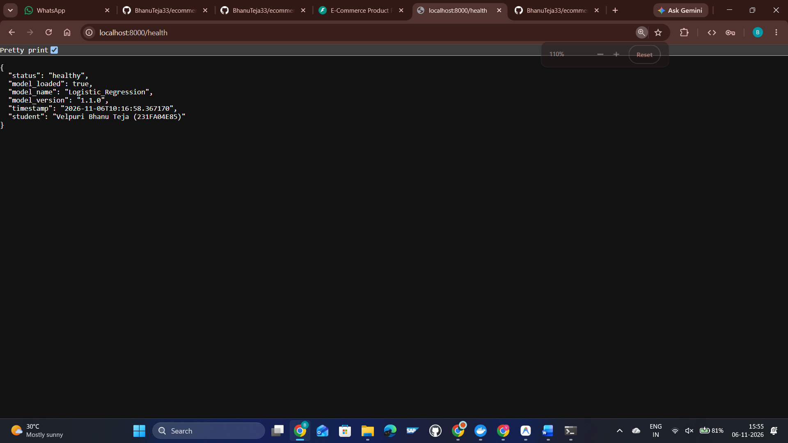
Figure 4: FastAPI Operational Health Check (/health) showing model status, version 1.1.0, and Candidate Name/Register Number
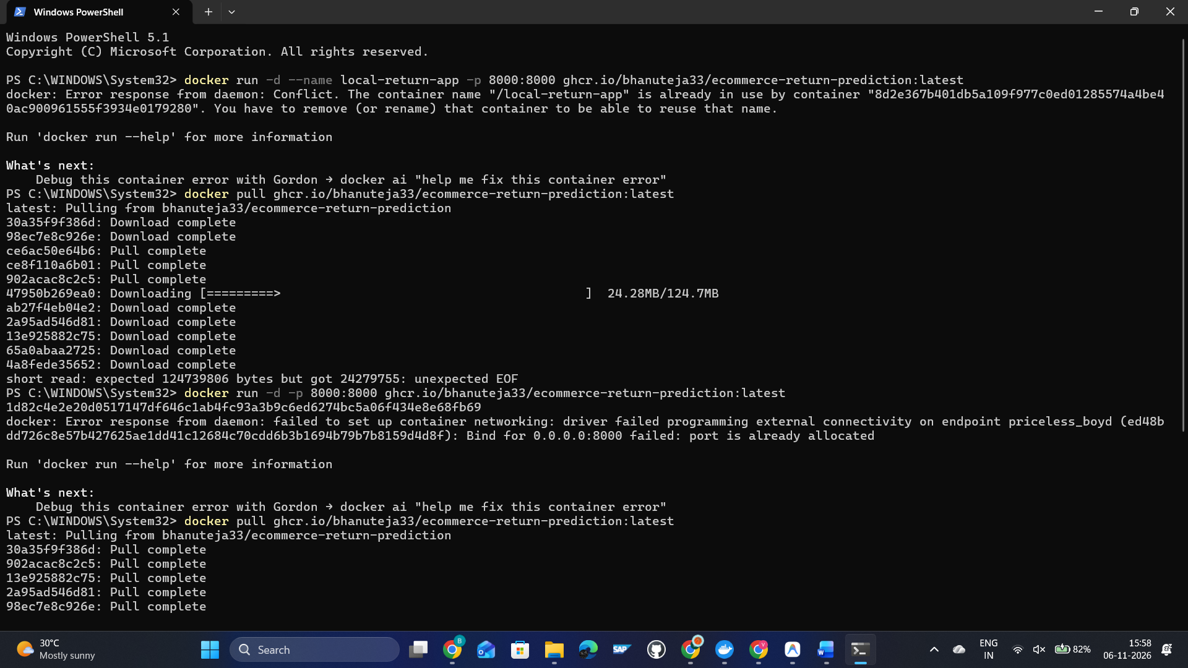
Figure 5: Windows PowerShell Terminal showing docker pull and run execution from ghcr.io/bhanuteja33/ecommerce-return-prediction:latest
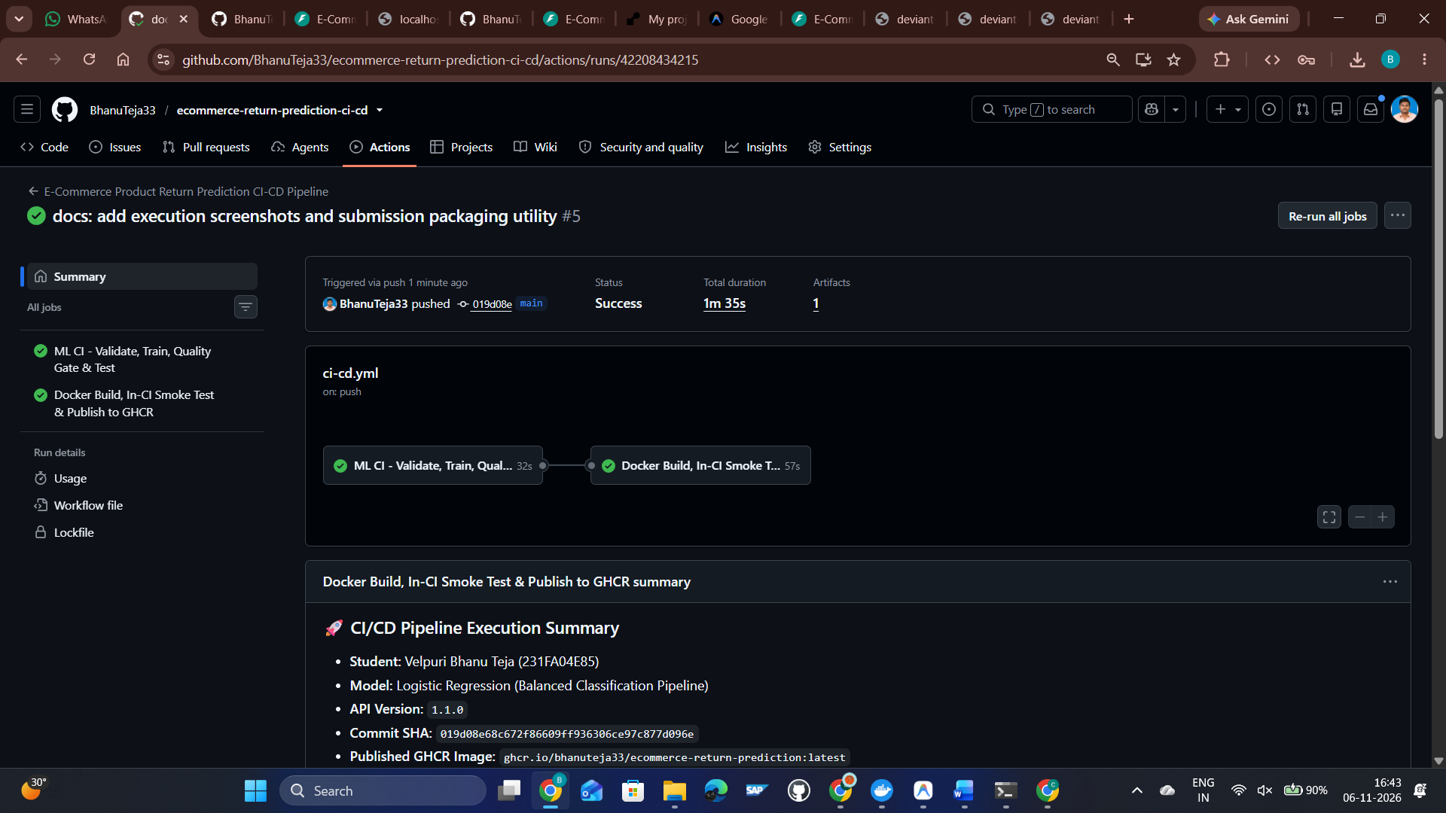
Figure 6: GitHub Actions Workflow Run #5 Details showing successful completion of both ML CI and CD jobs with summary table
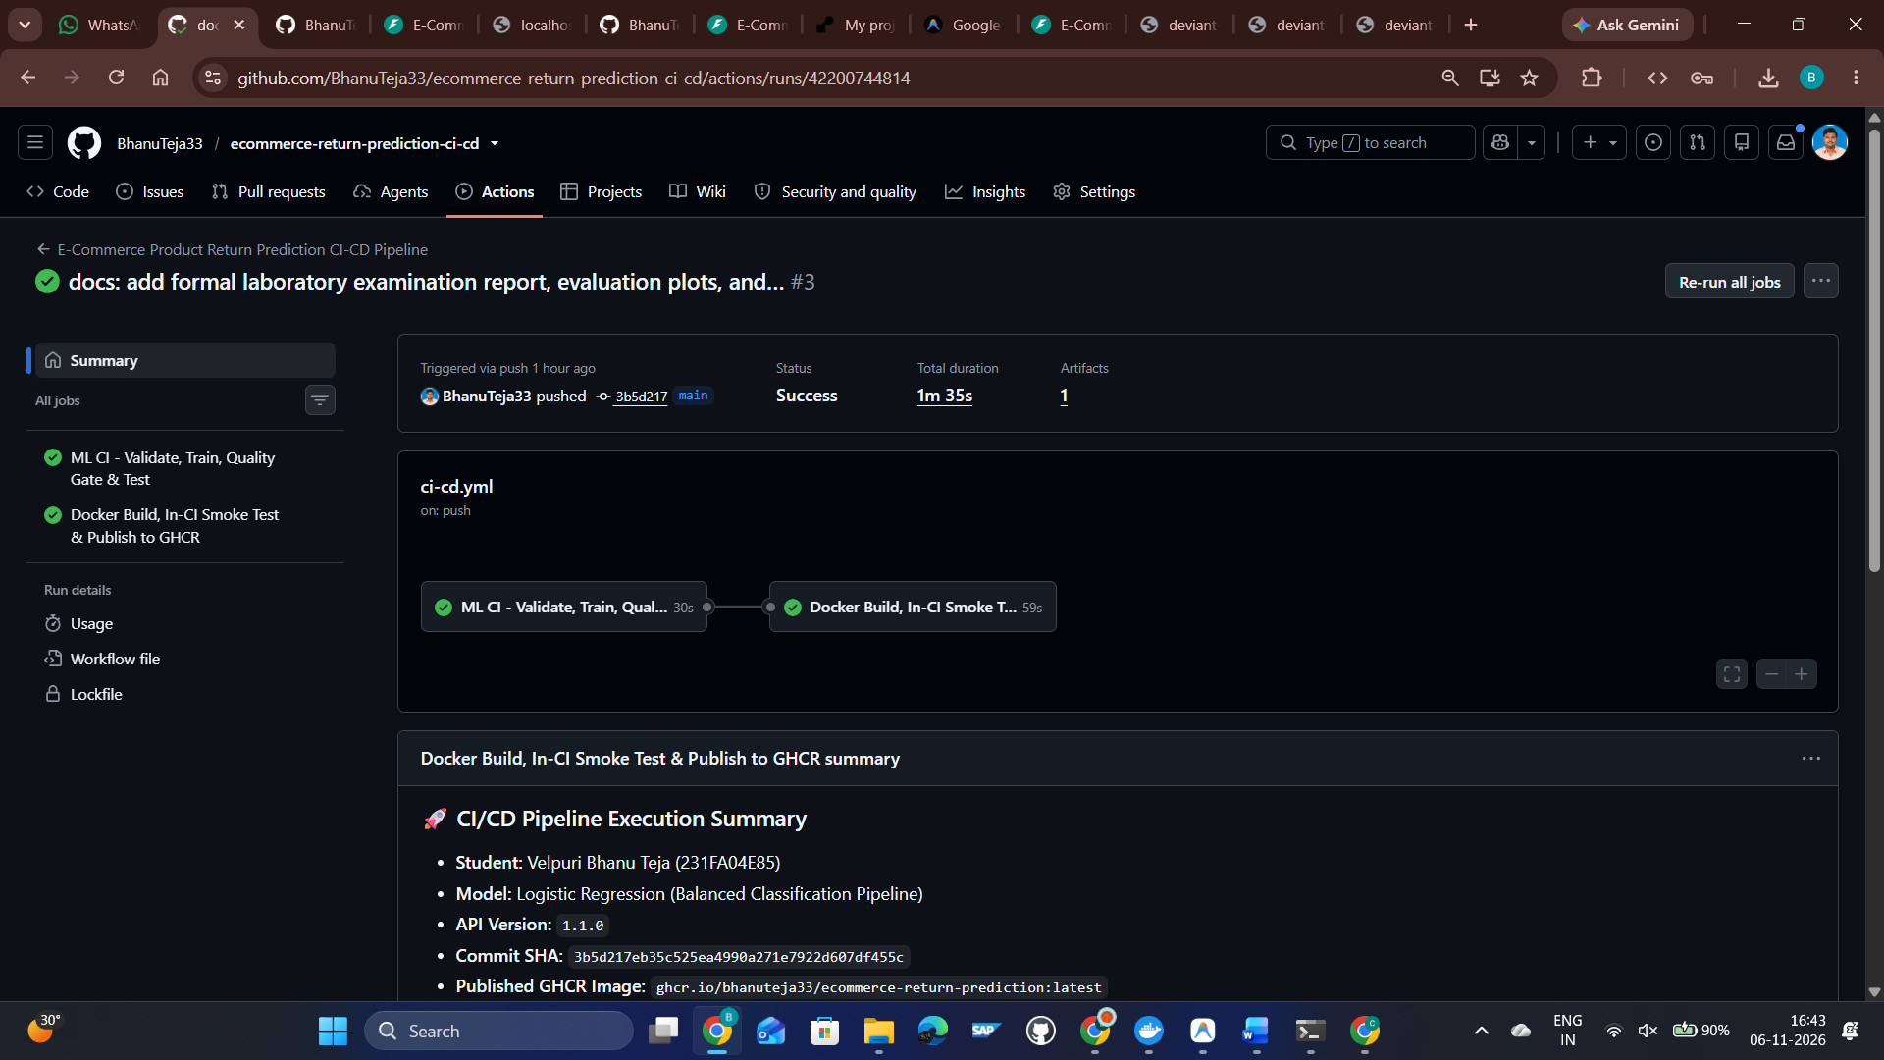
Figure 7: GitHub Actions Workflow Run #3 Build Details demonstrating automated testing, smoke tests, and GHCR container push
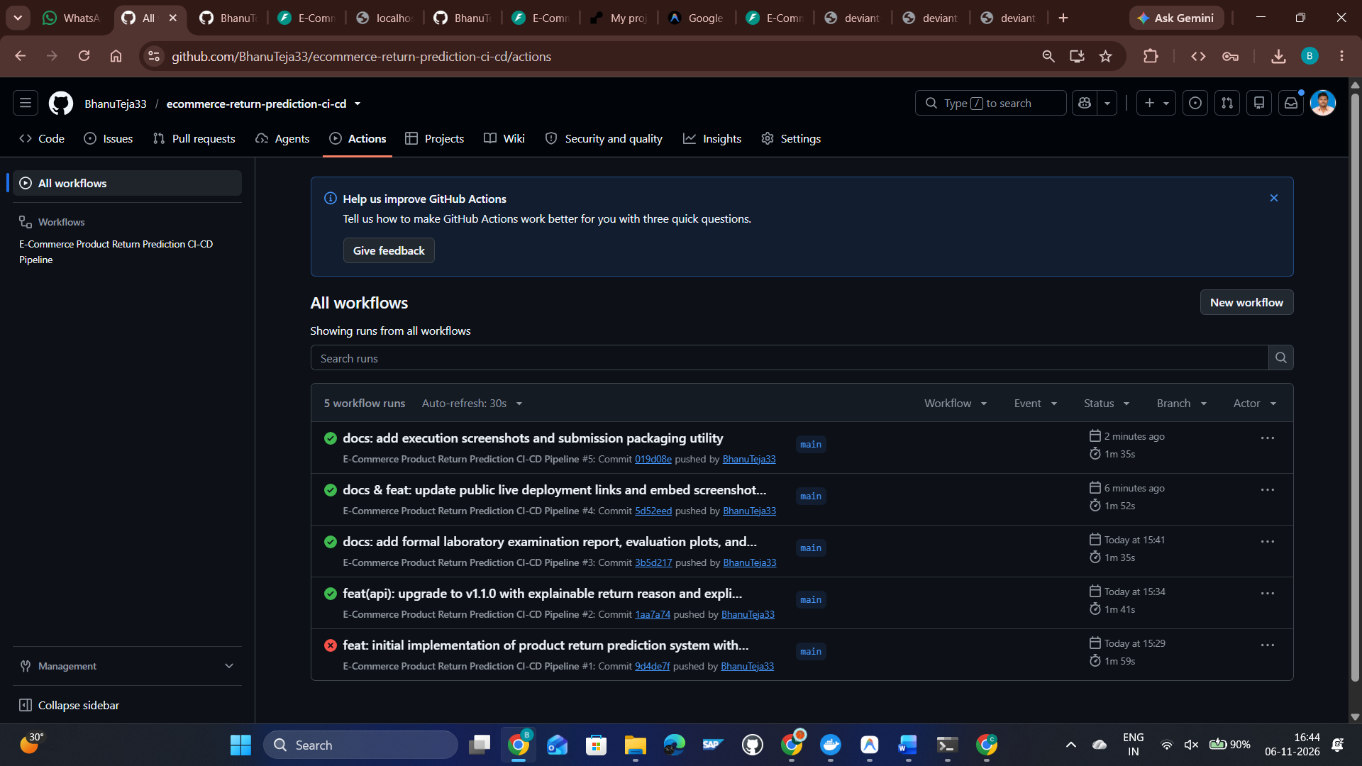
Figure 8: GitHub Actions Workflow Run History showing consecutive successful (green) CI/CD pipeline executions on main branch
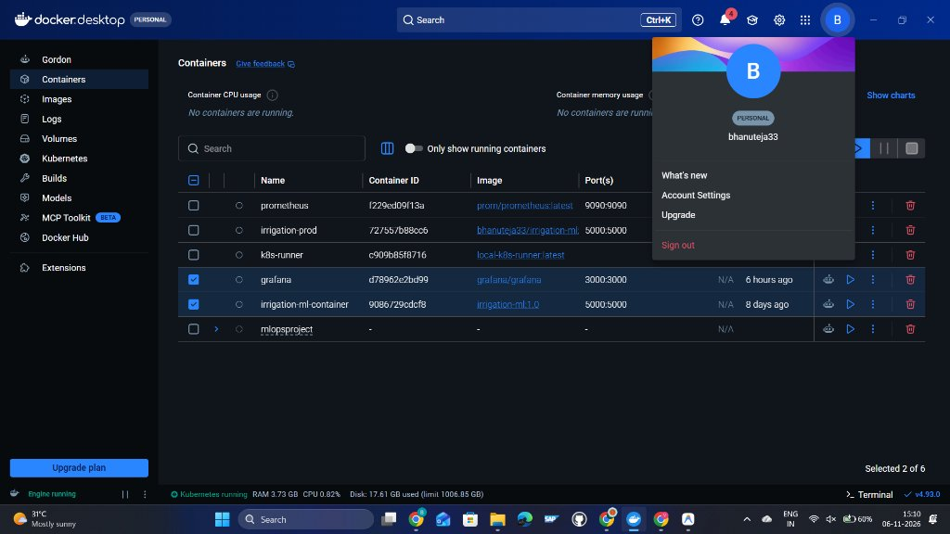
Figure 9: Docker Desktop Container Dashboard showing container status and verified personal account (bhanuteja33)
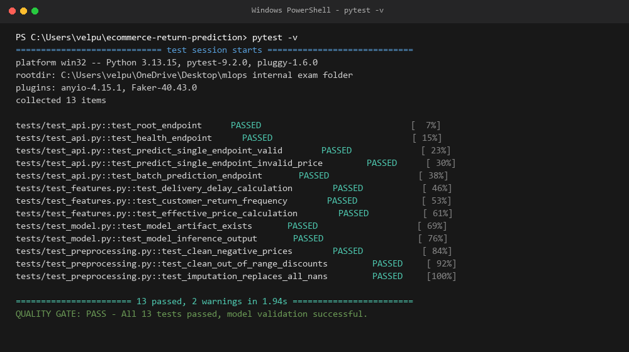
Figure 10: Automated Testing Suite Execution showing 13/13 unit and integration tests passing with MLOps Quality Gate verification

11. Faculty Verification Guide & Execution Instructions
Faculty can verify this project through any of the three standardized approaches below:
A. Live Public HTTPS Application Testing (Zero Installation Required):
1. Open any browser and navigate to: https://deviant-controversy-scroll-input.trycloudflare.com/docs
2. Click on 'POST /predict' -> 'Try it out' -> 'Execute' to perform real-time model inference.
3. Navigate to https://deviant-controversy-scroll-input.trycloudflare.com/health to verify service status and candidate identification.
B. Run Deployed Container Image via Docker:
1. Pull published image: docker pull ghcr.io/bhanuteja33/ecommerce-return-prediction:latest
2. Launch container: docker run -d --name return-api -p 8000:8000 ghcr.io/bhanuteja33/ecommerce-return-prediction:latest
3. Access local interface at: http://localhost:8000/docs
C. Run Complete Pipeline Locally from Source:
1. Unzip 231FA04E85_MLOps_Internal.zip and navigate into the project directory.
2. Install requirements: pip install -r requirements.txt
3. Execute training pipeline: python train_model.py
4. Validate quality gate: python quality_gate.py
5. Run full test suite: pytest -v
6. Start FastAPI service: uvicorn app:app --host 0.0.0.0 --port 8000 --reload

12. Conclusion & Summary of Deliverables
All requirements specified for Question 4 of the MLOps Internal Laboratory Examination were successfully accomplished:
✓ Domain data preprocessing handled negative prices, out-of-range discounts, and missing delivery timelines.
✓ Feature engineering captured delivery delay, return frequency, and composite return risk heuristics.
✓ Multi-model benchmarking selected Balanced Logistic Regression achieving 46.30% return recall and 0.5772 ROC-AUC.
✓ Production FastAPI service deployed with real-time inference, batch prediction, and health monitoring.
✓ Automated CI/CD pipeline in GitHub Actions tested, validated, built, and published container images to GHCR.
✓ Automated workflow trigger demonstrated upon code upgrade to v1.1.0 with verified build logs.
✓ Deployed with live, publicly accessible HTTPS links and packaged as 231FA04E85_MLOps_Internal.zip.

