**Pattern**

#include <iostream>

using namespace std;

int main()

{

int i, j,n;

cout<<"Enter number of rows: ";

cin>>n;

for(i=1;i<=n;i++)

{

for(j=1;j<=n-i;j++)

{

cout << " ";

}

for(j = 1;j<=i;j++)

{

cout << "1 ";

}

cout<<"\n";

}

return 0;

}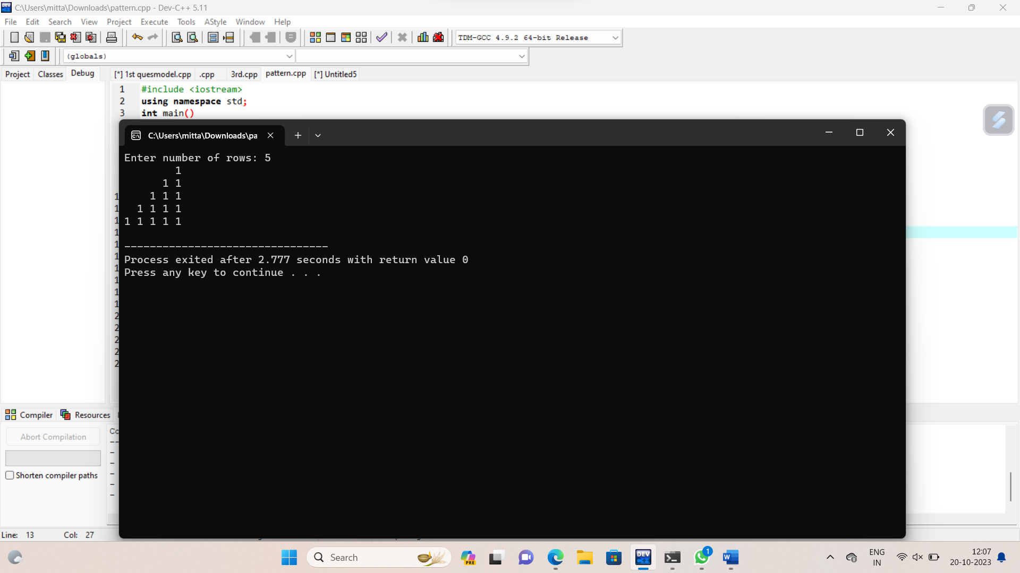

**Class as a item**

#include<iostream>

using namespace std;

class item

{

public:

char title[10];

int publicationyear;

char author[10];

void read()

{

cout<<"enter the title,publicationyear and author:";

cin>>title>>publicationyear>>author;

}

void display()

{

cout<<"title:"<<title<<endl;

cout<<"publicationyear:"<<title<<endl;

cout<<"author:"<<author<<endl;

}

};

class book:public item

{

public:

int version;

char audtion;

void read1()

{

cout<<"enter the version and audtion:";

cin>>version>>audtion;

}

void display1()

{

cout<<"version:"<<version<<endl;

cout<<"audtion:"<<audtion<<endl;

}

};

int main()

{

item I;

I.read();

I.display();

book B;

B.read1();

B.display1();

return 0;

}

