Q1.

Code:
package Q_01;

import javax.swing.*;

public class Q_01{
public static void main(String[] args){

JFrame newWindow;
newWindow = new JFrame();
newWindow.setSize(800 , 600);
newWindow.setTitle("Welcome to Java");
newWindow.setVisible(true);

}
}

Output:

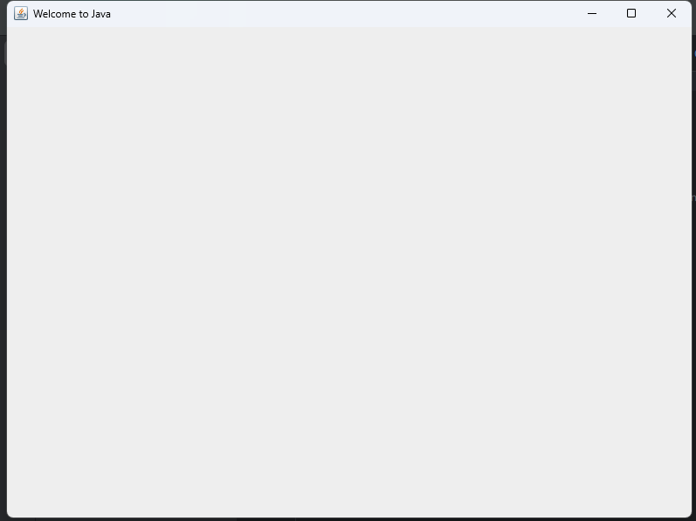

Q2.

Code:
package Q_02;

import javax.swing.*;
import java.util.*;

public class Q_02{
public static void main(String[] args) {

Scanner Name1;
Name1 = new Scanner(System.in);
String firstName;
System.out.print("Enter your first name : ");
firstName = Name1.next();

String secondName;
System.out.print("Enter your second name : ");
secondName = Name1.next();

//System.out.println("Full name is "+ firstName + secondName);

JFrame newWindow;
newWindow = new JFrame();
newWindow.setSize(800 , 600);
newWindow.setTitle(firstName + ' ' + secondName);
newWindow.setVisible(true);

}
}

Output:

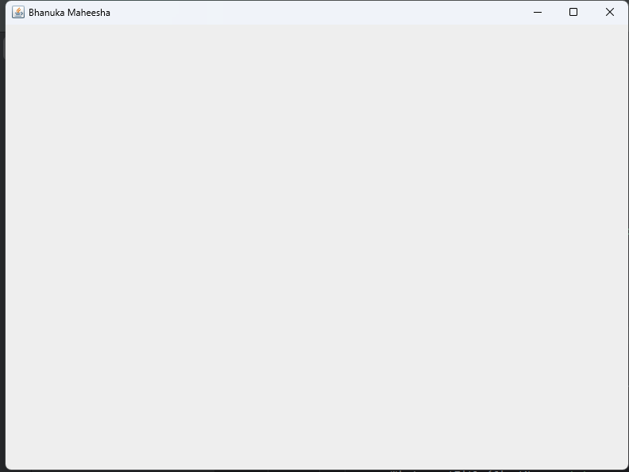

Q3.

Code:
package Q_03;

import java.util.Scanner;

public class Q_03 {
public static void main(String[] args){

Scanner name1;
name1 = new Scanner(System.in);
String fName;
System.out.print("Enter your first name : ");
fName = name1.next();

String sName;
System.out.print("Enter your middle name : ");
sName = name1.next();

String lName;
System.out.print("Enter your surname : ");
lName = name1.next();

System.out.println(fName + ' ' + (sName.charAt(0)) + '.' + lName);

}
}

Output:

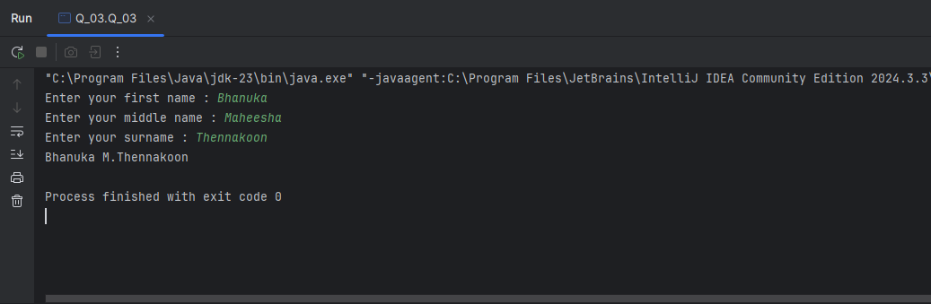
Q4.

Code:
package Q_04;

import java.text.SimpleDateFormat;
import java.util.Date;

public class Q_04{
public static void main(String[] args){

Date today;
SimpleDateFormat sdf;
today = new Date( );
sdf = new SimpleDateFormat("d MMMMMMM yyyy");
System.out.println(sdf.format(today));
}
}

Output:

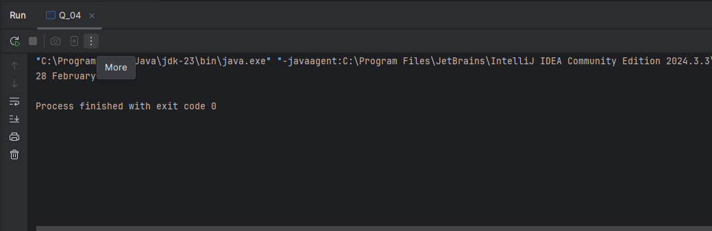

Q5.

Code:
package Q_05;

import java.text.SimpleDateFormat;
import java.util.Date;

public class Q_05{
public static void main(String[] args){

Date today;
SimpleDateFormat sdf;
today = new Date( );
sdf = new SimpleDateFormat("EEEEEEEEE, MMMMMMM d yyyy");
System.out.println(sdf.format(today));
}
}

Output:

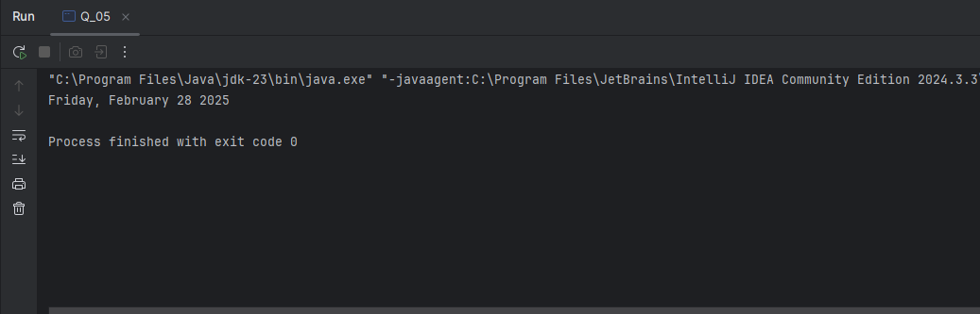

Q6.

Code:
package Q_06;

import javax.swing.*;
import java.util.*;

public class Q_06{
public static void main(String[] args){

Scanner data;
data = new Scanner(System.in);
int W;
System.out.print("Enter width of frame : ");
W = Integer.parseInt(data.next());

int H;
System.out.print("Enter height of frame : ");
H = Integer.parseInt(data.next());

String title;
System.out.print("Enter title : ");
title = data.next();

JFrame newWindow;
newWindow = new JFrame();
newWindow.setSize(W , H);
newWindow.setTitle(title);
newWindow.setVisible(true);

}
}

Output:

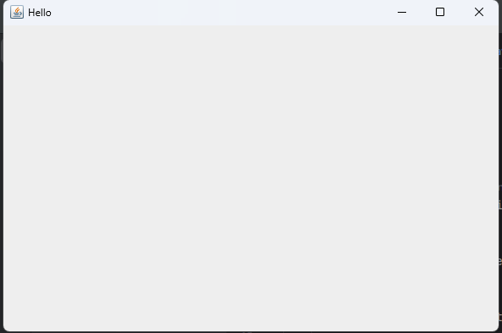

Q7.

Code:
package Q_07;

import java.time.LocalTime;
import javax.swing.*;
import java.time.format.DateTimeFormatter;

public class Q_07{
public static void main(String[] args){

LocalTime now = LocalTime.now();
DateTimeFormatter dtf = DateTimeFormatter.ofPattern("hh:mm:ss a");
String formated = now.format(dtf);

JFrame window;
window = new JFrame();
window.setSize(600 , 400);
window.setTitle(formated);
window.setVisible(true);

}
}

Output:

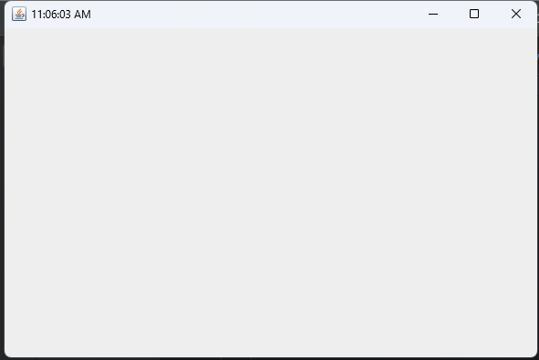

Q8.

Code:
package Q_08;

import java.util.*;

public class Q_08{
public static void main(String[] args){

Scanner line;
line = new Scanner(System.in);
System.out.print("Enter your String : ");
String line1 = line.nextLine();

String[] lineArray = line1.split("!");

for (String st : lineArray) {
System.out.println(st);
}

}
}

Output:
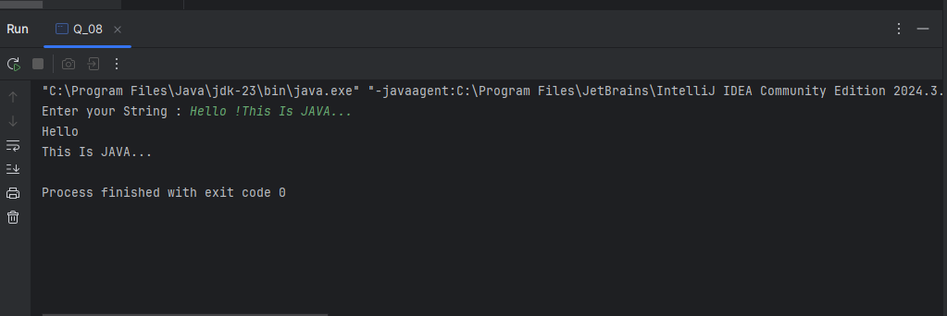

Q9.

Code:
package Q_09;

import java.util.*;

public class Q_09{
public static void main(String[] args){

Scanner str;
str = new Scanner(System.in);
System.out.print("Enter your String : ");
String str1 = str.nextLine();

System.out.println(str1.length());

System.out.println(str1.charAt(0));

System.out.println(str1.charAt(str1.length() - 1));

}
}

Output:
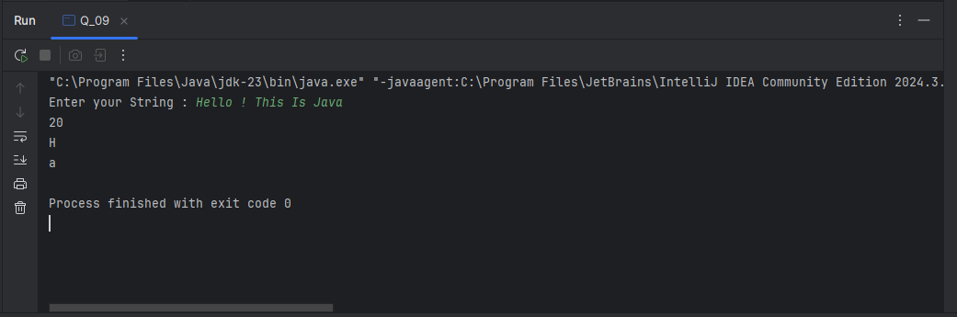

Q10.

Code:
package Q_10;

import java.util.*;

public class Q_10{
public static void main(String[] args){

Scanner str;
str = new Scanner(System.in);
System.out.print("Enter your String : ");
String str1 = str.next();

int num = (str1.length() / 2);

System.out.println(str1.charAt(num));

}
}

Output:
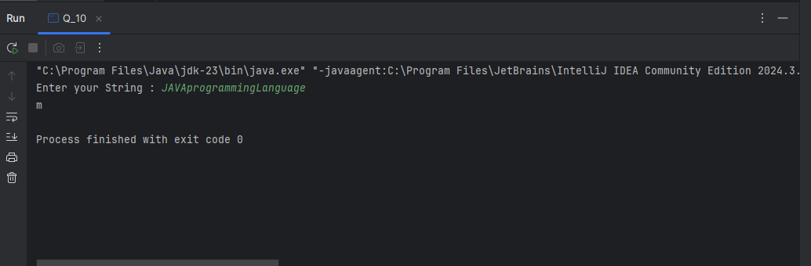

Q11.

Code:
package Q_11;

import java.util.*;

public class Q_11 {
public static void main(String[] args) {

Scanner name = new Scanner(System.in);
System.out.print("Enter your full name (first middle last) : ");
String fullName = name.nextLine();

String[] fname = fullName.split(" ");

String firstName = fname[0];
String middleName = fname[1];
String lastName = fname[2];

System.out.println(lastName + ',' + firstName + ' ' + middleName.charAt(0) + '.');

}
}

Output:
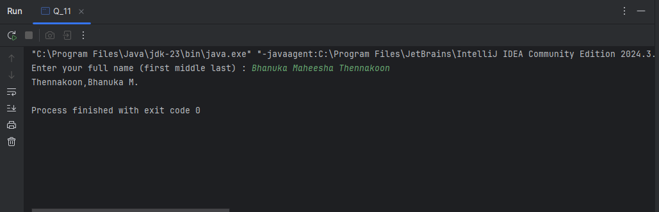

Q12.

Code:
package Q_12;

import javax.swing.*;

public class Q_12 {
public static void main(String[] args) {

JFrame newWindow = new JFrame();
newWindow.setSize(300,200);
newWindow.setTitle("My First Frame");
newWindow.setVisible(true);
newWindow.setLocation(50,100);

}
}

Output:
