Q1.

Code:

|  |
| --- |
| ***package Q_01;***  ***import javax.swing.*;***  ***public class Q_01{***  ***public static void main(String[] args){***  ***JFrame newWindow;***  ***newWindow = new JFrame();***  ***newWindow.setSize(800 , 600);***  ***newWindow.setTitle("Welcome to Java");***  ***newWindow.setVisible(true);***  ***}***  ***}*** |

Output:

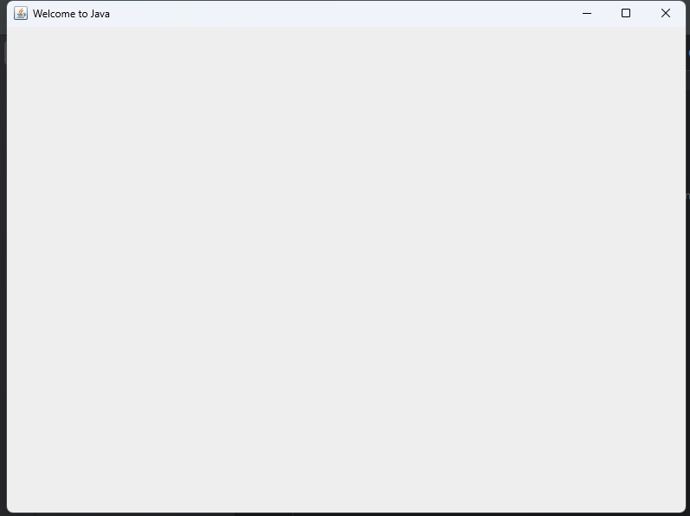

Q2.

Code:

|  |
| --- |
| ***package Q_02;***  ***import javax.swing.*;***  ***import java.util.*;***  ***public class Q_02{***  ***public static void main(String[] args) {***  ***Scanner Name1;***  ***Name1 = new Scanner(System.in);***  ***String firstName;***  ***System.out.print("Enter your first name : ");***  ***firstName = Name1.next();***  ***String secondName;***  ***System.out.print("Enter your second name : ");***  ***secondName = Name1.next();***  ***//System.out.println("Full name is "+ firstName + secondName);***  ***JFrame newWindow;***  ***newWindow = new JFrame();***  ***newWindow.setSize(800 , 600);***  ***newWindow.setTitle(firstName + ' ' + secondName);***  ***newWindow.setVisible(true);***  ***}***  ***}*** |

Output:

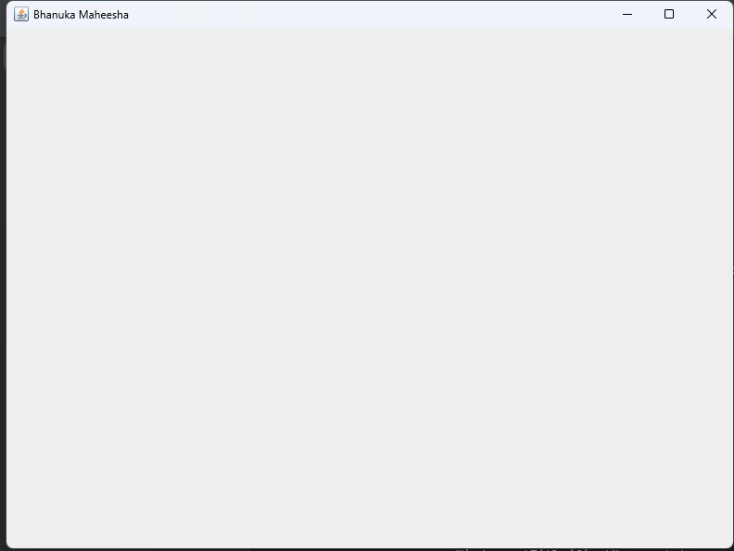

Q3.

Code:

|  |
| --- |
| ***package Q_03;***  ***import java.util.Scanner;***  ***public class Q_03 {***  ***public static void main(String[] args){***  ***Scanner name1;***  ***name1 = new Scanner(System.in);***  ***String fName;***  ***System.out.print("Enter your first name : ");***  ***fName = name1.next();***  ***String sName;***  ***System.out.print("Enter your middle name : ");***  ***sName = name1.next();***  ***String lName;***  ***System.out.print("Enter your surname : ");***  ***lName = name1.next();***  ***System.out.println(fName + ' ' + (sName.charAt(0)) + '.' + lName);***  ***}***  ***}*** |

Output:

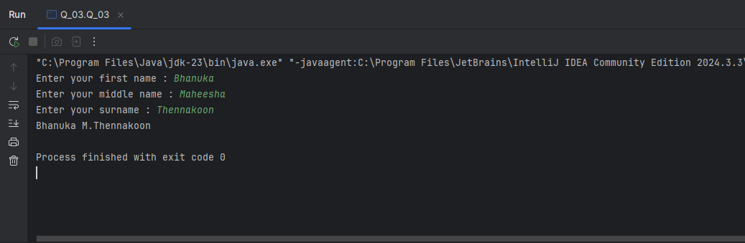

 Q4.

Code:

|  |
| --- |
| ***package Q_04;***  ***import java.text.SimpleDateFormat;***  ***import java.util.Date;***  ***public class Q_04{***  ***public static void main(String[] args){***  ***Date today;***  ***SimpleDateFormat sdf;***  ***today = new Date( );***  ***sdf = new SimpleDateFormat("d MMMMMMM yyyy");***  ***System.out.println(sdf.format(today));***  ***}***  ***}*** |

Output:

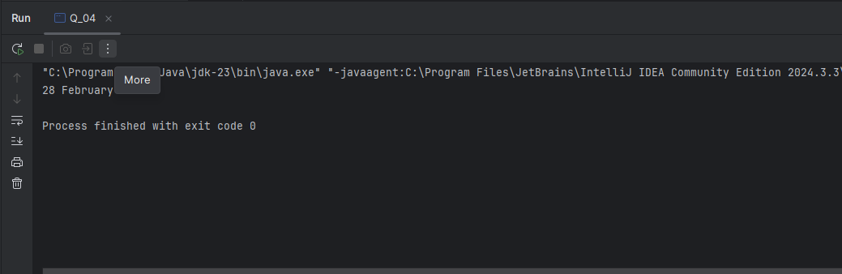

 Q5.

Code:

|  |
| --- |
| ***package Q_05;***  ***import java.text.SimpleDateFormat;***  ***import java.util.Date;***  ***public class Q_05{***  ***public static void main(String[] args){***  ***Date today;***  ***SimpleDateFormat sdf;***  ***today = new Date( );***  ***sdf = new SimpleDateFormat("EEEEEEEEE, MMMMMMM d yyyy");***  ***System.out.println(sdf.format(today));***  ***}***  ***}*** |

Output:

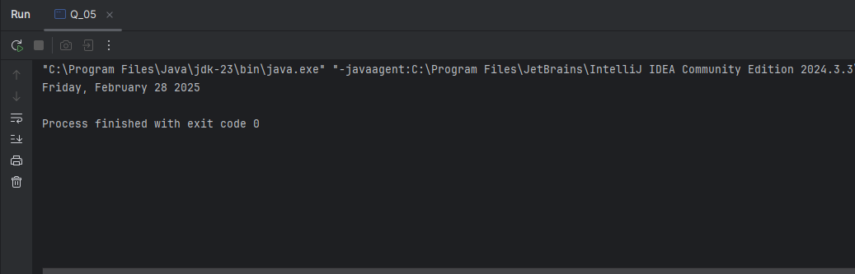

 Q6.

Code:

|  |
| --- |
| ***package Q_06;***  ***import javax.swing.*;***  ***import java.util.*;***  ***public class Q_06{***  ***public static void main(String[] args){***  ***Scanner data;***  ***data = new Scanner(System.in);***  ***int W;***  ***System.out.print("Enter width of frame : ");***  ***W = Integer.parseInt(data.next());***  ***int H;***  ***System.out.print("Enter height of frame : ");***  ***H = Integer.parseInt(data.next());***  ***String title;***  ***System.out.print("Enter title : ");***  ***title = data.next();***  ***JFrame newWindow;***  ***newWindow = new JFrame();***  ***newWindow.setSize(W , H);***  ***newWindow.setTitle(title);***  ***newWindow.setVisible(true);***  ***}***  ***}*** |

Output:

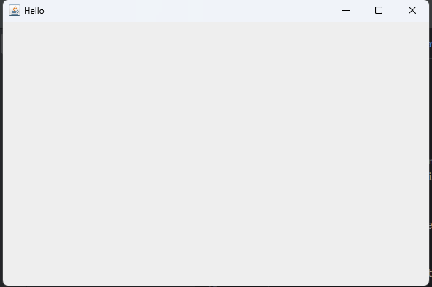

 Q7.

Code:

|  |
| --- |
| ***package Q_07;***  ***import java.time.LocalTime;***  ***import javax.swing.*;***  ***import java.time.format.DateTimeFormatter;***  ***public class Q_07{***  ***public static void main(String[] args){***  ***LocalTime now = LocalTime.now();***  ***DateTimeFormatter dtf = DateTimeFormatter.ofPattern("hh:mm:ss a");***  ***String formated = now.format(dtf);***  ***JFrame window;***  ***window = new JFrame();***  ***window.setSize(600 , 400);***  ***window.setTitle(formated);***  ***window.setVisible(true);***    ***}***  ***}*** |

Output:

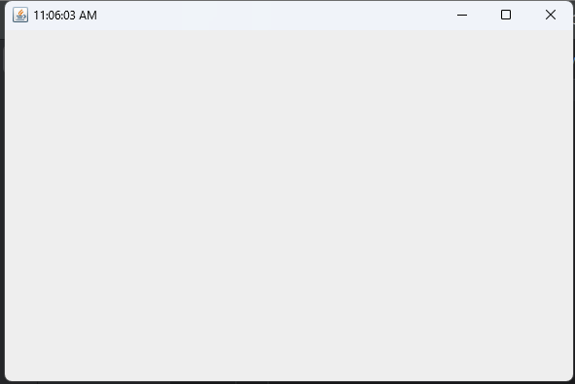

 Q8.

Code:

|  |
| --- |
| ***package Q_08;***  ***import java.util.*;***  ***public class Q_08{***  ***public static void main(String[] args){***  ***Scanner line;***  ***line = new Scanner(System.in);***  ***System.out.print("Enter your String : ");***  ***String line1 = line.nextLine();***  ***String[] lineArray = line1.split("!");***  ***for (String st : lineArray) {***  ***System.out.println(st);***  ***}***  ***}***  ***}*** |

Output:

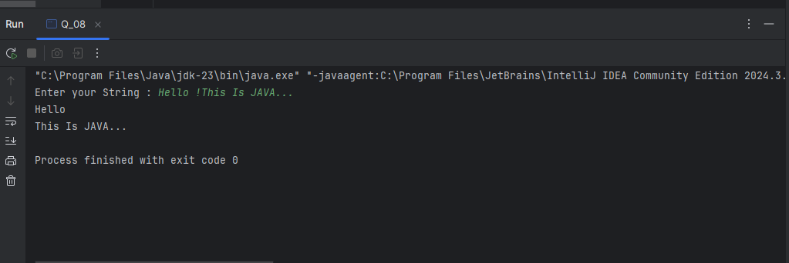

Q9.

Code:

|  |
| --- |
| ***package Q_09;***  ***import java.util.*;***  ***public class Q_09{***  ***public static void main(String[] args){***  ***Scanner str;***  ***str = new Scanner(System.in);***  ***System.out.print("Enter your String : ");***  ***String str1 = str.nextLine();***  ***System.out.println(str1.length());***  ***System.out.println(str1.charAt(0));***  ***System.out.println(str1.charAt(str1.length() - 1));***  ***}***  ***}*** |

Output:

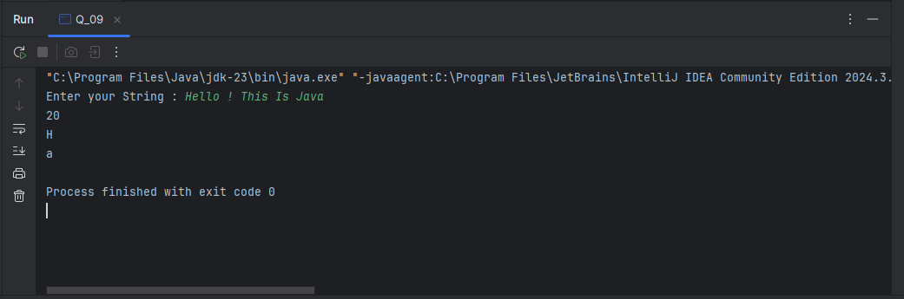

Q10.

Code:

|  |
| --- |
| ***package Q_10;***  ***import java.util.*;***  ***public class Q_10{***  ***public static void main(String[] args){***  ***Scanner str;***  ***str = new Scanner(System.in);***  ***System.out.print("Enter your String : ");***  ***String str1 = str.next();***  ***int num = (str1.length() / 2);***  ***System.out.println(str1.charAt(num));***  ***}***  ***}*** |

Output:

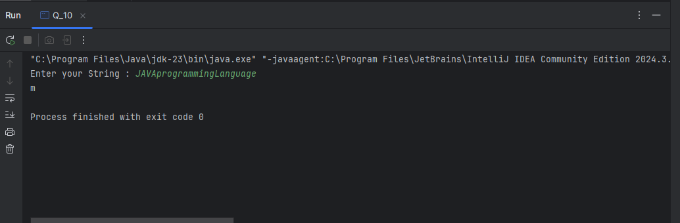

Q11.

Code:

|  |
| --- |
| ***package Q_11;***  ***import java.util.*;***  ***public class Q_11 {***  ***public static void main(String[] args) {***  ***Scanner name = new Scanner(System.in);***  ***System.out.print("Enter your full name (first middle last) : ");***  ***String fullName = name.nextLine();***  ***String[] fname = fullName.split(" ");***  ***String firstName = fname[0];***  ***String middleName = fname[1];***  ***String lastName = fname[2];***  ***System.out.println(lastName + ',' + firstName + ' ' + middleName.charAt(0) + '.');***  ***}***  ***}*** |

Output:

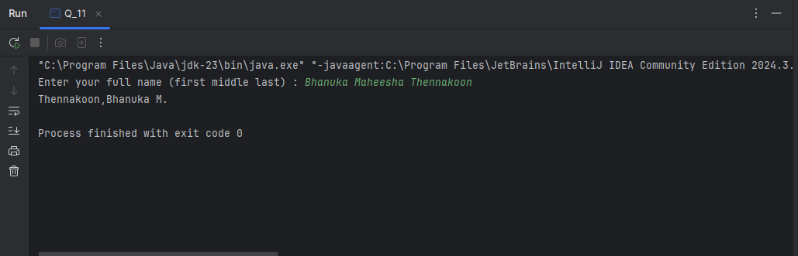

Q12.

Code:

|  |
| --- |
| ***package Q_12;***  ***import javax.swing.*;***  ***public class Q_12 {***  ***public static void main(String[] args) {***  ***JFrame newWindow = new JFrame();***  ***newWindow.setSize(300,200);***  ***newWindow.setTitle("My First Frame");***  ***newWindow.setVisible(true);***  ***newWindow.setLocation(50,100);***  ***}***  ***}*** |

Output:

