Q1.a.

Code:

|  |
| --- |
| ***package LW_02.src.Q_01;***  ***public class Q_01_a {***  ***public static void main(String[] args) {***  ***//a***  ***double B = 10, A = 20 , C = 15;***  ***System.out.println(Math.sqrt(( B * B) + (4 * A *C )));***  ***}***  ***}*** |

Output:

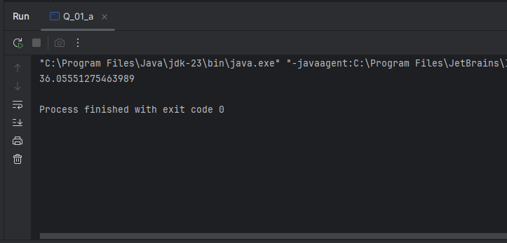

Q1.b.

Code:

|  |
| --- |
| ***package LW_02.src.Q_01;***  ***public class Q_01_b {***  ***public static void main(String[] args) {***  ***//b***  ***double X = 20 , Y = 10;***  ***System.out.println(Math.sqrt(X + (4 * Y * Y * Y)));***  ***}***  ***}*** |

Output:

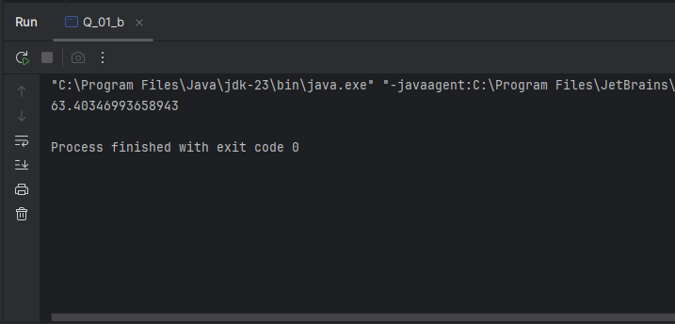

Q1.c.

Code:

|  |
| --- |
| ***package LW_02.src.Q_01;***  ***public class Q_01_c {***  ***public static void main(String[] args) {***  ***//c***  ***double X = 20 , Y = 10;***  ***System.out.println(Math.cbrt(X * Y));***  ***}***  ***}*** |

Output:

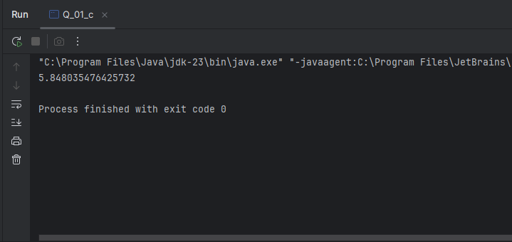

Q1.d.

Code:

|  |
| --- |
| ***package LW_02.src.Q_01;***  ***public class Q_01_d {***  ***public static void main(String[] args) {***  ***//d***  ***final double pi = 3.14;***  ***double r = 15;***  ***System.out.println( pi * r * r + " cm^2");***  ***}***  ***}*** |

Output:

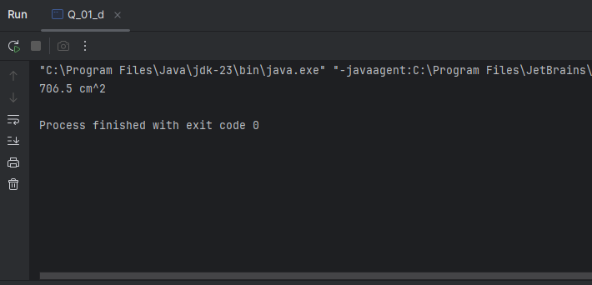

Q2.

Code:

|  |
| --- |
| ***package LW_02.src.Q_02;***  ***import java.util.Scanner;***  ***public class Q_02 {***  ***public static void main(String[] args) {***  ***Scanner l = new Scanner(System.in);***  ***double cm;***  ***System.out.print("Enter long in Centimeters : ");***  ***cm = l.nextDouble();***  ***//Inches convert***  ***System.out.println(cm * (1/2.54)+ " Inches");***  ***System.out.println((cm * (1/2.54)) / 12 + " feet");***  ***}***  ***}*** |

Output:

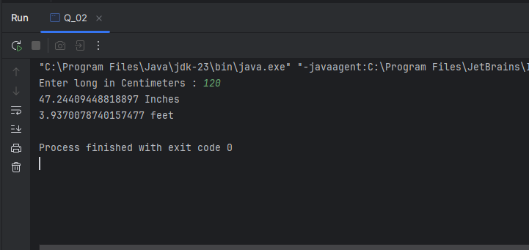

Q3.

Code:

|  |
| --- |
| ***package LW_02.src.Q_03;***  ***import java.util.Scanner;***  ***public class Q_03 {***  ***public static void main(String[] args) {***  ***Scanner temp = new Scanner(System.in);***  ***double cel;***  ***System.out.print("Enter temperature in Celsius : ");***  ***cel = temp.nextDouble();***  ***System.out.println((1.8 * cel) + 32 +" F");***  ***}***  ***}*** |

Output:

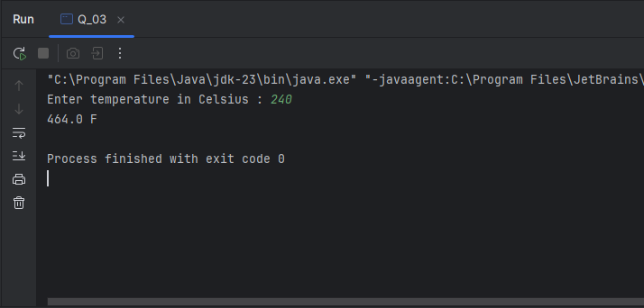

Q4.

Code:

|  |
| --- |
| ***package LW_02.src.Q_04;***  ***import java.util.Scanner;***  ***public class Q_04 {***  ***public static void main(String[] args) {***  ***Scanner weight = new Scanner(System.in);***  ***double w;***  ***System.out.print("Enter Weight in pound : ");***  ***w = weight.nextDouble();***  ***System.out.println("You need " + (w * 19) +" calories per day");***  ***}***  ***}*** |

Output:

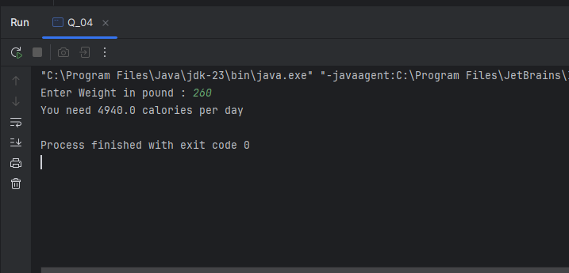

 Q5.

Code:

|  |
| --- |
| ***package LW_02.src.Q_05;***  ***import java.util.Scanner;***  ***public class Q_05 {***  ***public static void main(String[] args) {***  ***Scanner temp = new Scanner(System.in);***  ***double F;***  ***System.out.print("Enter temperature in Fahrenheit : ");***  ***F = temp.nextDouble();***  ***double c = (F - 32) * 5 / 9;***  ***System.out.println(c + " c");***  ***}***  ***}*** |

Output:

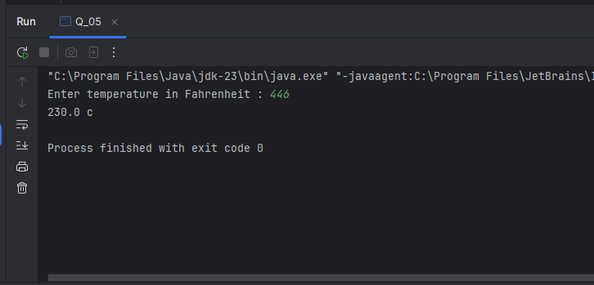

Q6.

Code:

|  |
| --- |
| ***package LW_02.src.Q_06;***  ***import java.text.SimpleDateFormat;***  ***import java.util.Date;***  ***import java.util.Scanner;***  ***public class Q_06 {***  ***public static void main(String[] args) {***  ***Scanner year = new Scanner(System.in);***  ***int byear;***  ***System.out.print("Enter your birth year : ");***  ***byear = year.nextInt();***  ***Date today;***  ***SimpleDateFormat sdf;***  ***today = new Date( );***  ***sdf = new SimpleDateFormat("yyyy");***  ***int cyear = Integer.parseInt(sdf.format(today));***  ***System.out.println("You were born in " + byear + " and will be (are) " + (cyear - byear) + " this year.");***  ***}***  ***}*** |

Output:

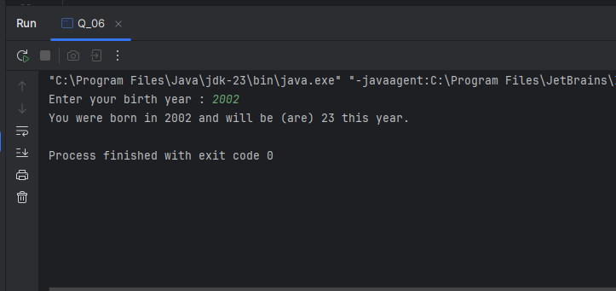

 Q7.

Code:

|  |
| --- |
| ***package LW_02.src.Q_07;***  ***import java.util.Scanner;***  ***import static java.lang.Math.pow;***  ***public class Q_07 {***  ***public static void main(String[] args) {***  ***Scanner bmi = new Scanner(System.in);***  ***double w;***  ***System.out.print("Enter your weight in Kg : ");***  ***w = bmi.nextDouble();***  ***double h;***  ***System.out.print("Enter your height in cm : ");***  ***h = bmi.nextDouble();***  ***double BMI = w / pow((h/100), 2);***  ***System.out.println("Your BMI value is " + BMI);***  ***}***  ***}*** |

Output:

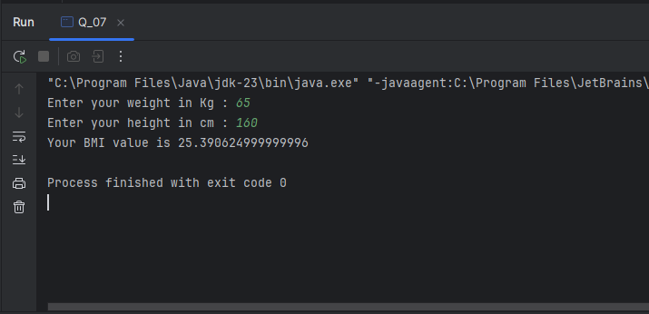

Q8.

Code:

|  |
| --- |
| ***package LW_02.src.Q_08;***  ***import static java.lang.Math.pow;***  ***public class Q_08 {***  ***public static void main(String[] args) {***  ***final double PI = 3.14;***  ***double r = 10;***  ***double V = ((double) 4 /3) * (PI * pow(r,3));***  ***System.out.println("Volume is " + V );***  ***}***  ***}*** |

Output:

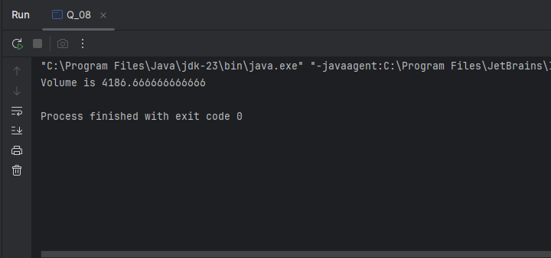

Q9.

Code:

|  |
| --- |
| ***package LW_02.src.Q_09;***  ***import java.util.Scanner;***  ***import static java.lang.Math.pow;***  ***public class Q_09 {***  ***public static void main(String[] args) {***  ***Scanner inv = new Scanner(System.in);***  ***double P;***  ***System.out.print("Enter invested amount : ");***  ***P = inv.nextDouble();***  ***double R;***  ***System.out.print("Enter interest rate : ");***  ***R = inv.nextDouble();***  ***int N;***  ***System.out.print("Enter number of years : ");***  ***N = inv.nextInt();***  ***double grow =P * pow((1+(R/100)),N);***  ***System.out.println(grow);***  ***}***  ***}*** |

Output:

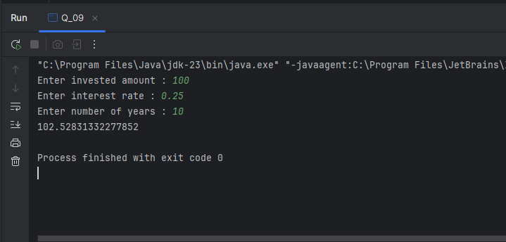

Q10.

Code:

|  |
| --- |
| ***package LW_02.src.Q_10;***  ***import java.util.Scanner;***  ***import static java.lang.Math.pow;***  ***public class Q_10 {***  ***public static void main(String[] args) {***  ***Scanner loan = new Scanner(System.in);***  ***double loanAmount;***  ***System.out.print("Enter loan amount : ");***  ***loanAmount = loan.nextDouble();***  ***double annualInterestRate;***  ***System.out.print("Enter annual interest rate : ");***  ***annualInterestRate = loan.nextDouble();***  ***double loanPeriod;***  ***System.out.print("Enter loan period : ");***  ***loanPeriod = loan.nextDouble();***  ***final int Month_In_Year = 12;***  ***double monthlyInterestRate = annualInterestRate /100.0 /Month_In_Year;***  ***double numberOfPayments = loanPeriod * Month_In_Year;***  ***double monthlyPayment = (loanAmount * monthlyInterestRate) / (1 - pow(1/(1+monthlyInterestRate),numberOfPayments));***  ***double totalPayment = monthlyPayment * numberOfPayments;***  ***System.out.println("Monthly interest rate is "+ monthlyInterestRate);***  ***System.out.println("Number of payments is "+ numberOfPayments);***  ***System.out.println("Monthly payment is "+ monthlyPayment);***  ***System.out.println("Total payment is "+ totalPayment);***  ***}***  ***}*** |

Output:

