Q1.

Code:

|  |
| --- |
| ***package LW_04;  import java.util.Scanner;  public class Q01 {  public static void main(String[] args) {  Scanner scanner = new Scanner(System.in);  System.out.print("Enter First Number: ");  int num1 = scanner.nextInt();  System.out.print("Enter Second Number: ");  int num2 = scanner.nextInt();  System.out.print("Enter Third Number: ");  int num3 = scanner.nextInt();   if(num1 == num2 && num1 == num3 && num2 == num3){  System.out.println("Numbers are equal");   }  else if (num1 < num2){  if(num1 < num3){  System.out.println("The smallest number is "+num1);  }  else {  System.out.println("The smallest number is "+num3);  }   }  else {  System.out.println("The smallest number is "+num2);  }  } }*** |

Output:

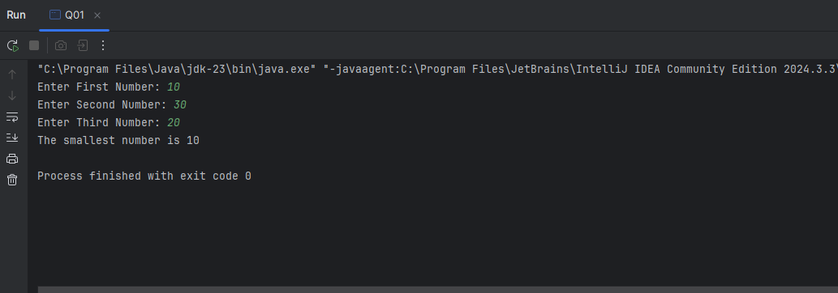

Q2.

Code:

|  |
| --- |
| ***package LW_04;  import java.util.Scanner;  public class Q02 {  public static void main(String[] args) {  Scanner scanner = new Scanner(System.in);  System.out.println("0.Magenta");  System.out.println("1.Cyan");  System.out.println("2.Red");  System.out.println("3.Blue");  System.out.println("4.Green");  System.out.println("Select one color from the above list:");   int selection = scanner.nextInt();    switch (selection){  case 0:  System.out.println("You selected Magenta");  break;   case 1:  System.out.println("You selected Cyan");  break;   case 2:  System.out.println("You selected Red");  break;   case 3:  System.out.println("You selected Blue");  break;   case 4:  System.out.println("You selected Green");  break;   default:  System.out.println("Invalid selection");  break;  }  } }*** |

Output:

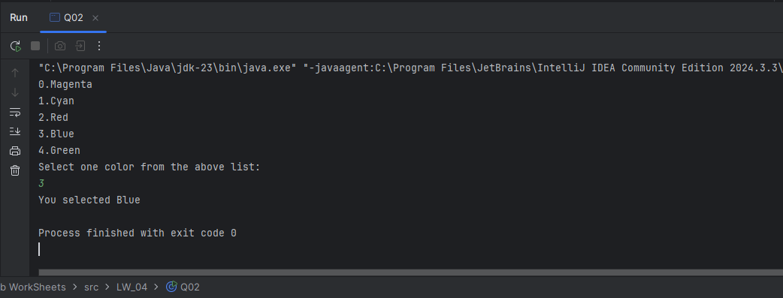

Q3.

Code:

|  |
| --- |
| ***package LW_04;  import java.util.HashMap; import java.util.Scanner;  public class Q03 {  public static void main(String[] args) {   HashMap<Integer,String> PowerTen = new HashMap<>();  PowerTen.put(6, "Million");  PowerTen.put(9, "Billion");  PowerTen.put(12, "Trillion");  PowerTen.put(15, "Quadrillion");  PowerTen.put(18, "Quintillion");  PowerTen.put(21, "Sextillion");  PowerTen.put(30, "Nonillion");  PowerTen.put(100, "Googol");   Scanner scanner = new Scanner(System.in);   System.out.print("Enter the power of 10: ");  int power = scanner.nextInt();    switch (power){   case 6:  System.out.println("Power is "+PowerTen.get(6));  break;   case 9:  System.out.println("Power is "+PowerTen.get(9));  break;   case 12:  System.out.println("Power is "+PowerTen.get(12));  break;   case 15:  System.out.println("Power is "+PowerTen.get(15));  break;   case 18:  System.out.println("Power is "+PowerTen.get(18));  break;   case 21:  System.out.println("Power is "+PowerTen.get(21));  break;   case 30:  System.out.println("Power is "+PowerTen.get(30));  break;   case 100:  System.out.println("Power is "+PowerTen.get(100));  break;   default:  System.out.println("Unrecognized power!!");  break;  }  } }*** |

Output:

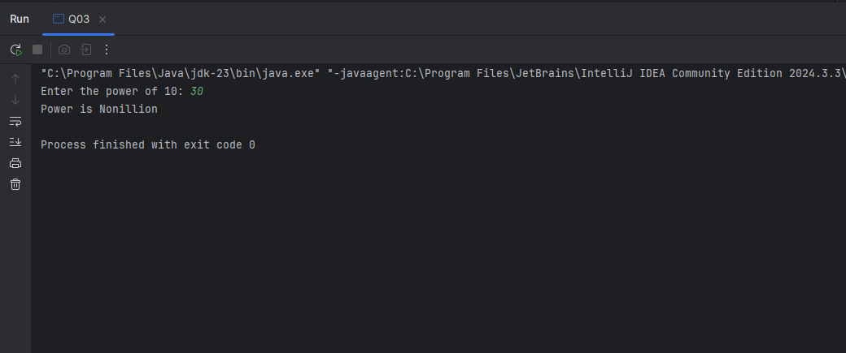

Q4.

Code:

|  |
| --- |
| ***package LW_04;  import java.util.Scanner;  public class Q04 {  public static void main(String[] args) {   Scanner scanner = new Scanner(System.in);   System.out.print("Enter Year: ");  int year = scanner.nextInt();   if(year%4 ==0){  if (year%100 == 0){  if (year%400 ==0){  System.out.println(year +" is a leap year");   }  else {  System.out.println(year +" is not a leap year");  }   }  else {  System.out.println(year +" is a leap year");  }  }  else {  System.out.println(year +" is not a leap year");  }  } }*** |

Output:

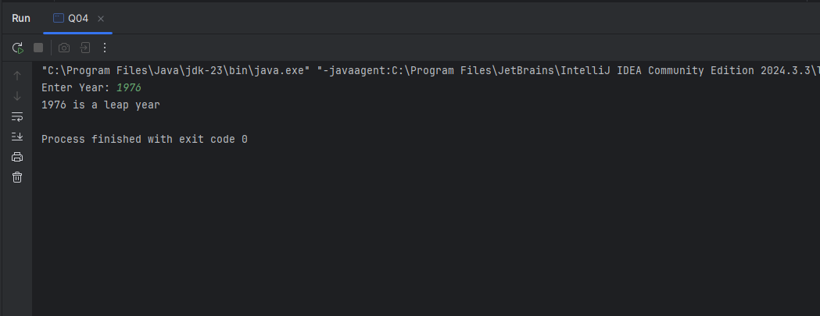

Q5.

Code:

|  |
| --- |
| ***package LW_04;  import java.util.HashMap; import java.util.Scanner;  public class Q05 {  public static void main(String[] args) {    HashMap<String,Double> EntreeList = new HashMap<>();  EntreeList.put("01.Tofu Burger", 3.49);  EntreeList.put("02.Cajun Chicken", 4.59);  EntreeList.put("03.Buffalo Wings", 3.99);  EntreeList.put("04.Rainbow Fillet", 2.99);   HashMap<String,Double> SideDishList = new HashMap<>();  SideDishList.put("01.Rice Cracker", 0.79);  SideDishList.put("02.No-Salt Fries", 0.69);  SideDishList.put("03.Zucchini", 1.09);  SideDishList.put("04.Brown Rice", 0.59);   HashMap<String,Double> DrinkList =new HashMap<>();  DrinkList.put("01.Cafe Mocha", 1.99);  DrinkList.put("02.Cafe Latte", 1.90);  DrinkList.put("03.Espresso", 2.49);  DrinkList.put("04.Oolong Tea", 0.99);        System.out.println("01.Entree");  System.out.println("02.Side Dish");  System.out.println("03.Drink");   Scanner scanner = new Scanner(System.in);   System.out.println();  System.out.print("Enter Categories number: ");  int Categories = scanner.nextInt();    switch (Categories){  case 01:  System.out.println("01.Tofu Burger");  System.out.println("02.Cajun Chicken");  System.out.println("03.Buffalo Wings");  System.out.println("04.Rainbow Fillet");   System.out.println();  System.out.print("Enter Entree number: ");  int entree = scanner.nextInt();   switch (entree){  case 01:  System.out.println("Tofu Burger's price is "+EntreeList.get("01.Tofu Burger"));  break;   case 02:  System.out.println("Cajun Chicken's price is "+EntreeList.get("02.Cajun Chicken"));  break;   case 03:  System.out.println("03.Buffalo Wing's price is "+EntreeList.get("03.Buffalo Wings"));  break;   case 04:  System.out.println("Rainbow Fillet's price is "+EntreeList.get("04.Rainbow Fillet"));  break;   default:  System.out.println("Invalid number");  break;  }   break;   case 02:  System.out.println("01.Rice Cracker");  System.out.println("02.No-Salt Fries");  System.out.println("03.Zucchini");  System.out.println("04.Brown Rice");   System.out.println();  System.out.print("Enter Side Dish number: ");  int sideDish = scanner.nextInt();   switch (sideDish){  case 01:  System.out.println("Rice Cracker's price is "+SideDishList.get("01.Rice Cracker"));  break;   case 02:  System.out.println("No-Salt Fries's price is "+SideDishList.get("02.No-Salt Fries"));  break;   case 03:  System.out.println("Zucchini's price is "+SideDishList.get("03.Zucchini"));  break;   case 04:  System.out.println("Brown Rice's price is "+SideDishList.get("04.Brown Rice"));  break;   default:  System.out.println("Invalid number");  break;  }   break;      case 03:  System.out.println("01.Cafe Mocha");  System.out.println("02.Cafe Latte");  System.out.println("03.Espresso");  System.out.println("04.Oolong Tea");   System.out.println();  System.out.print("Enter Drink number: ");  int drink = scanner.nextInt();   switch (drink){  case 01:  System.out.println("Cafe Mocha's price is "+DrinkList.get("01.Cafe Mocha"));  break;   case 02:  System.out.println("Cafe Latte's price is "+DrinkList.get("02.Cafe Latte"));  break;   case 03:  System.out.println("Espresso's price is "+DrinkList.get("03.Espresso"));  break;   case 04:  System.out.println("Oolong Tea's price is "+DrinkList.get("04.Oolong Tea"));  break;   default:  System.out.println("Invalid number");  break;  }    break;    default:  System.out.println("Invalid number");  break;   }  } }*** |

Output:

