Q1.

Code:

|  |
| --- |
| ***package LW_05;  public class Q01 {  public static void main(String[] args) {  int num = 10;  int count = 0;   while (num<= 49){  System.out.print( num+ " " );  count = count + 1;  if(count == 10){  System.out.println();  count = 0;  }  num = num +1;  }   } }*** |

Output:

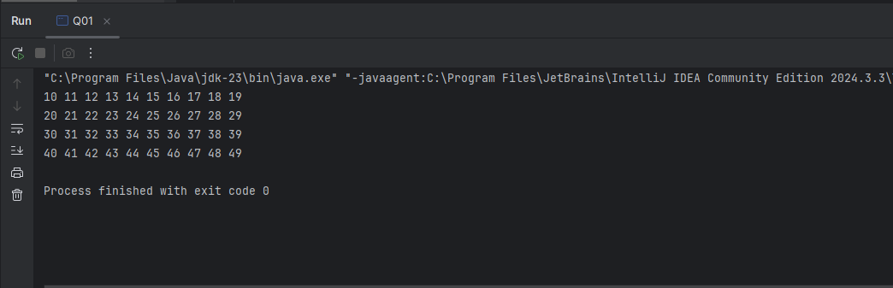

Q2.

Code:

|  |
| --- |
| ***package LW_05;   import java.util.Scanner;  public class Q02 {   public static int countDig(int num){   int count = 0;    while (num > 0){  num= num / 10;  count = count + 1;  }  return count;   }     public static void main(String[] args) {   int number = 0;   while (number > -1 ){  Scanner scanner = new Scanner(System.in);  System.out.print("Enter Num : ");  number = scanner.nextInt();  System.out.println(countDig(number));   }    }   }*** |

Output:

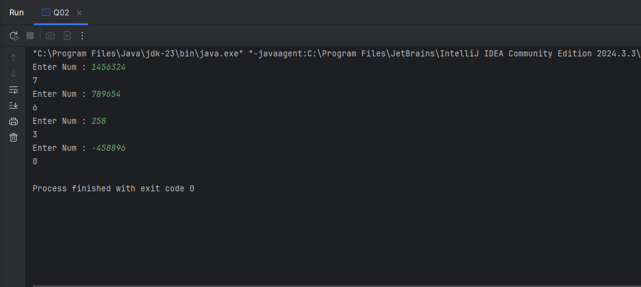

Q3.

Code:

|  |
| --- |
| ***package LW_05;  import java.util.Scanner;  public class Q03 {  public static void main(String[] args) {  Scanner scanner = new Scanner(System.in);  System.out.print("Enter Number : ");  int num = scanner.nextInt();   int mul = 1;   while (mul < 11){  System.out.println(num + " * " + mul + " = " + (num*mul));  mul++;  }   }   }*** |

Output:

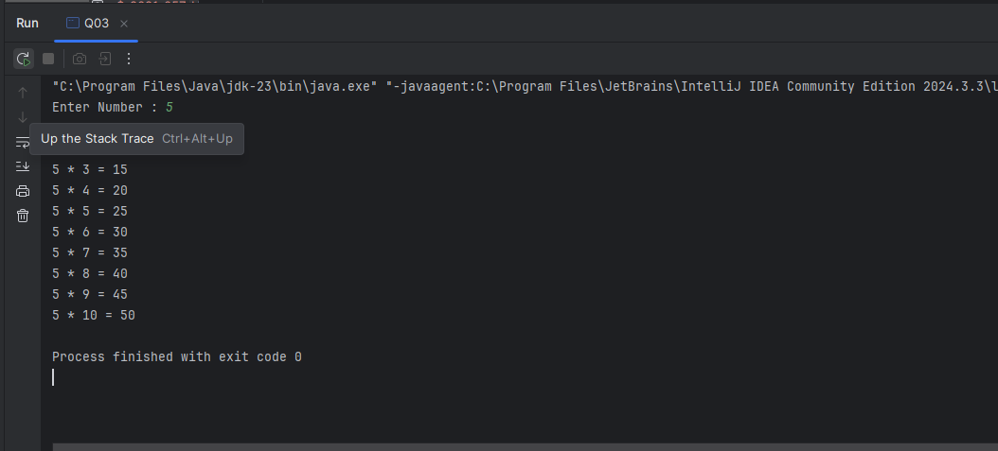

Q4.

Code:

|  |
| --- |
| ***package LW_05;  import java.util.Scanner;  public class Q04 {  public static void main(String[] args) {  int num = 0;  Scanner scanner = new Scanner(System.in);  System.out.print("Enter number of rows : ");  num = scanner.nextInt();    for(int i = 0; i <= num; i++){   for (int s = num - i; s > 0; s--){  System.out.print(" ");  }  for(int j = 1; j <= i; j++){  System.out.print(" * ");  }  System.out.println();  }  } }*** |

Output:

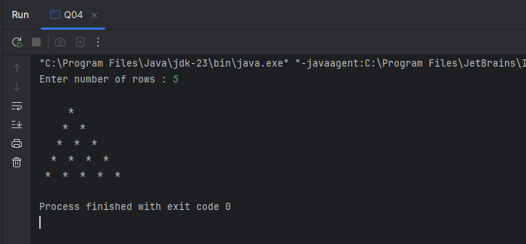

Q5.

Code:

|  |
| --- |
| ***package LW_05;  import java.util.Scanner;  public class Q05 {  public static boolean palindrome(String word){  word = word.replaceAll("[^a-zA-Z09]","").toLowerCase();   int left = 0;  int right = word.length() - 1;   while (left<right){  if(word.charAt(left) != word.charAt(right)){  return false;  }  left++;  right--;   }  return true;  }   public static void main(String[] args) {   Scanner scanner = new Scanner(System.in);  System.out.print("Enter word : ");  String word = scanner.nextLine();   System.out.println(word);   if (palindrome(word)){  System.out.println(word + " is a Palindrome");  }  else {  System.out.println(word + " is not a Palindrome");  }  }  }*** |

Output:

Q6.

Code:

|  |
| --- |
| ***package LW_05;  import java.util.Random; import java.util.Scanner;  public class Q06 {  public static void main(String[] args) {  Random random = new Random();  int randomNum = random.nextInt(100)+1;   Scanner scanner = new Scanner(System.in);  int guess = -1;   //System.out.println(randomNum);   while (guess != randomNum){  System.out.print("Enter your number : ");  guess = scanner.nextInt();    if(guess<randomNum){  System.out.println("Too low! Try again");  } else if (guess > randomNum) {  System.out.println("Too high! Try again");  }else {  System.out.println("Nice work! You guessed the number "+ randomNum);  }  }  } }*** |

Output:

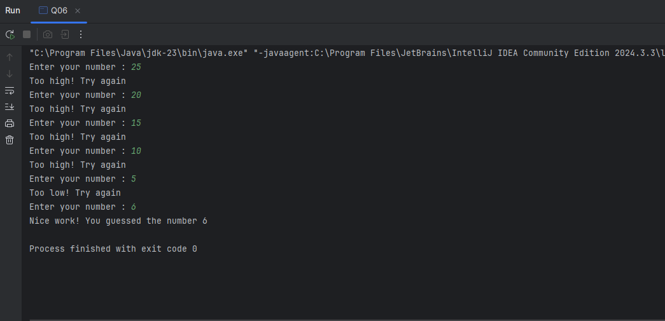

Q7.

Code:

|  |
| --- |
| ***package LW_05;  import java.util.Scanner;  public class Q07 {  public static void main(String[] args) {  Scanner scanner = new Scanner(System.in);   System.out.print("Enter a sentence: ");  String sentence = scanner.nextLine();   System.out.print("Enter the word to replace: ");  String wordToReplace = scanner.nextLine();   System.out.print("Enter the replacement word: ");  String replacementWord = scanner.nextLine();   StringBuilder newSentence = new StringBuilder();  int index = 0;   while (index < sentence.length()) {  if (index + wordToReplace.length() <= sentence.length() && sentence.substring(index, index + wordToReplace.length()).equals(wordToReplace)) {  newSentence.append(replacementWord);  index += wordToReplace.length();  } else {  newSentence.append(sentence.charAt(index));  index++;  }  }   System.out.println("Original sentence: " + sentence);  System.out.println("New sentence: " + newSentence.toString());   } }*** |

Output:

