Interactive Media – 2020 4th Year 1st Semester

Trends in Digital Media – Machine Learning assignment

IT16179486 – R.P.P.B Rajasinghe

1. Introduction to the model

In my model the process is it has content image and it has styled image. It is generating an image after 2000 image iterations and able to generate a gif during 2000 iterations. I have taken this model from the following Github resource link

URL: - <https://github.com/MuhammedBuyukkinaci/Neural-Style-Transfer-with-TensorFlow>

1. Data – Input and output images

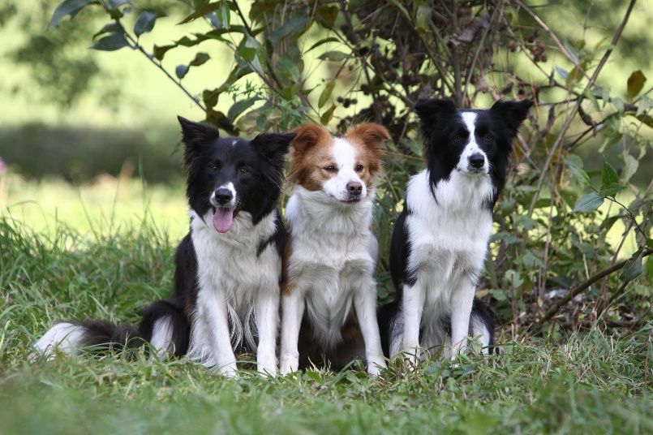

Content image

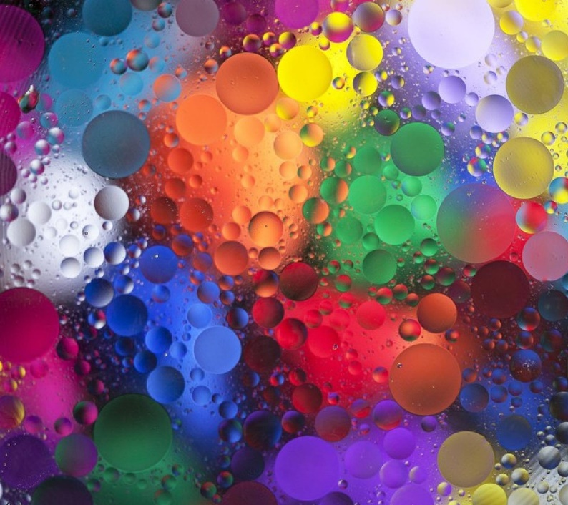

Style image

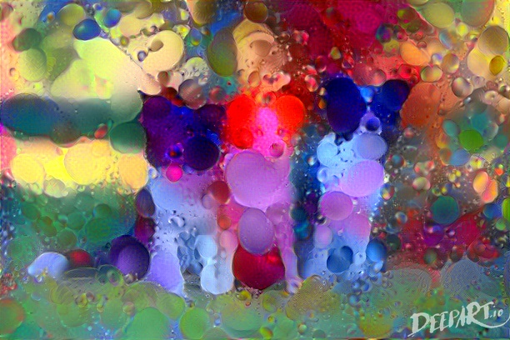

Output

1. Github submitted link: -

https://github.com/BhanukaRajasinghe/ML-Project.git

1. Reference:

[1]"MuhammedBuyukkinaci/Neural-Style-Transfer-with-TensorFlow", GitHub, 2020. [Online]. Available: https://github.com/MuhammedBuyukkinaci/Neural-Style-Transfer-with-TensorFlow. [Accessed: 13- Jun- 2020].

-End of assignment-