**Emotional Robot**

**Third Global Project Based Work-shop 2017**

|  |
| --- |
| Group Members |
| Bhanuka Rathnayaka |
| Chanaka Sanjeewa Gunasekara |
| Shinichi Onodera |
| Shota Ono |

3

Content

1. Introduction …………………………………………………………………………………….. 1
2. Implementation
   1. System diagram …………………………………………………………………….. 1
   2. Modules ………………………………………………………………………………… 2
3. Circuit diagram ………………………………………………………………………………... 4
4. Code ………………………………………………………………………………………………… 4
5. Conclusion ………………………………………………………………………………………. 4

i

1. Introduction

Speaking with your computing device is becoming commonplace. Most of us have used Apple's Siri, Google Now, Microsoft's Cortana, or Amazon's Alexa. If we can use this method for our computing device, it is very comfortable to us. Voice recognition can be use washing machine, television, radio, watches, not only that it can be used for opening or closing door, control the various type machines. However, we created basic system only. Our project is understanding the few emotional word and display the faces which is related to emotional word.

2. Implementation

1. **System diagram**

Google Speech API

Get voice

**Serial to Parallel Converter**

Raspberry pi 3 Board

**Display Emotional Face in 8 x 8 LED Matrix**

1

1. **Modules**

* **Raspberry pi 3**

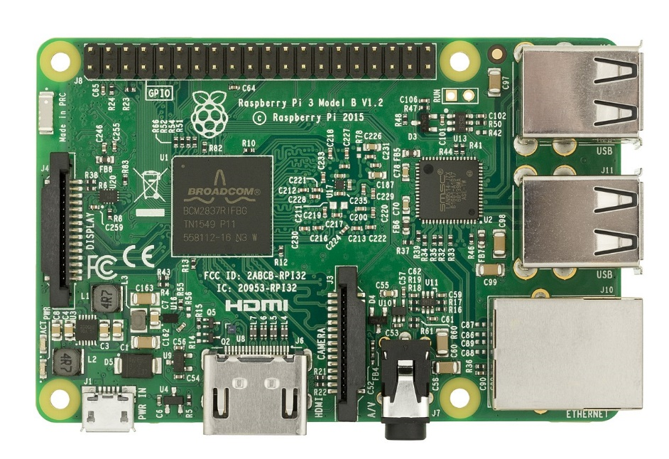

Single-board computer with Wi-Fi, LAN and Bluetooth connectivity. In our project, we use Wi-Fi Connection to connect with Google Speech API to convert Voice to Text.

* 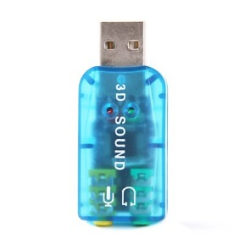**Sound card**

We use sound card for our raspberry pi board because there is no in-built sound card in the board. We get Mic input through Sound Card.

2

* **74HC595 Shift Register**

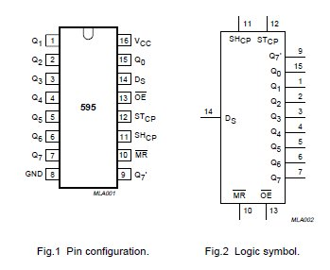

We use this IC to convert serial to parallel and give output to LED Matrix.

* **Led matrix board**

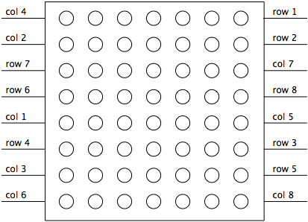

We use 8x8 LED Matrix to Display Emotional Faces.

**3. Circuit Diagram**

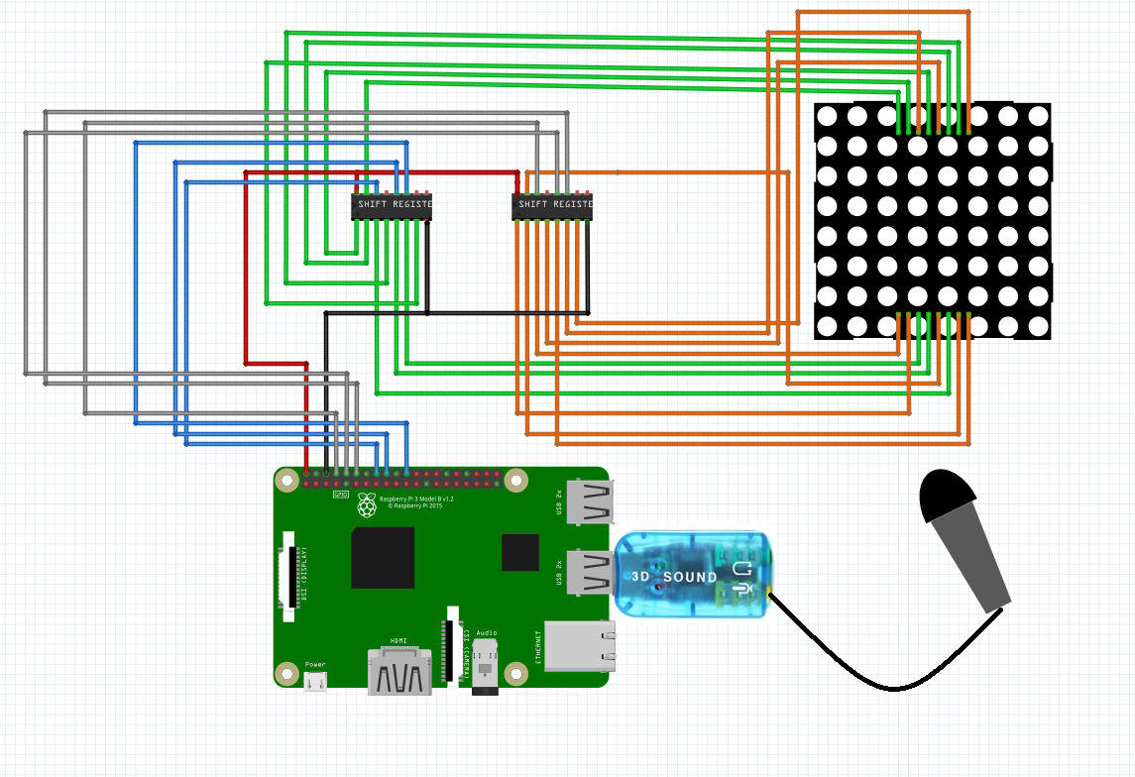

**4. Code**

Code URL: <https://goo.gl/wC8X4Z>

**5. Conclusion**

We get Human Voice input through Sound card to Raspberry PI Board. Then We process that voice and send it to Google Speech API Server and get respective text. And if there are any emotional word, we display respective emotional face on matrix display. We use “speech recognition” Library for this process.

4