Innovation Tracker CI/CD on Bamboo:

To Build:

-- Need Plugin MS Build

-- To build the application use .csproj

InnovationTracker.csproj

Deploy:

Required:

1) publish file

D:\InnovationTracker\InnovationTracker\Properties\PublishProfiles

Option

/p:Configuration=Release;DeployOnBuild=True;PublishProfile=PublishononlocalServer;ProfileTransformWebConfigEnabled=False;AllowUntrustedCertificate=true

Mention the Publish Profiles name.

/p:Configuration=Release;DeployOnBuild=True;PublishProfile=PublishononlocalServer;ProfileTransformWebConfigEnabled=False;AllowUntrustedCertificate=true

2) Required Solution file.

D:\InnovationTracker\InnovationTracker.sln

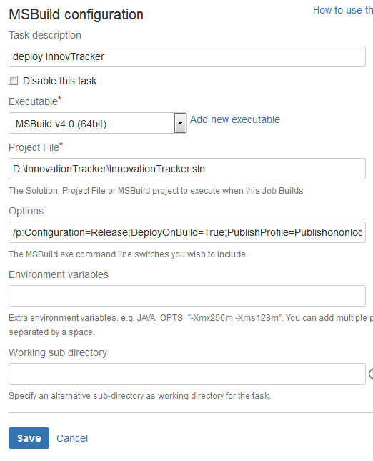

3) install WebBdeploy

4) Add Application in IIS Server and enable the all option of IIS Server.

