Run the batch file

Goto🡪apache-jmeter-3.1**->**bin**->**jmeter.bat

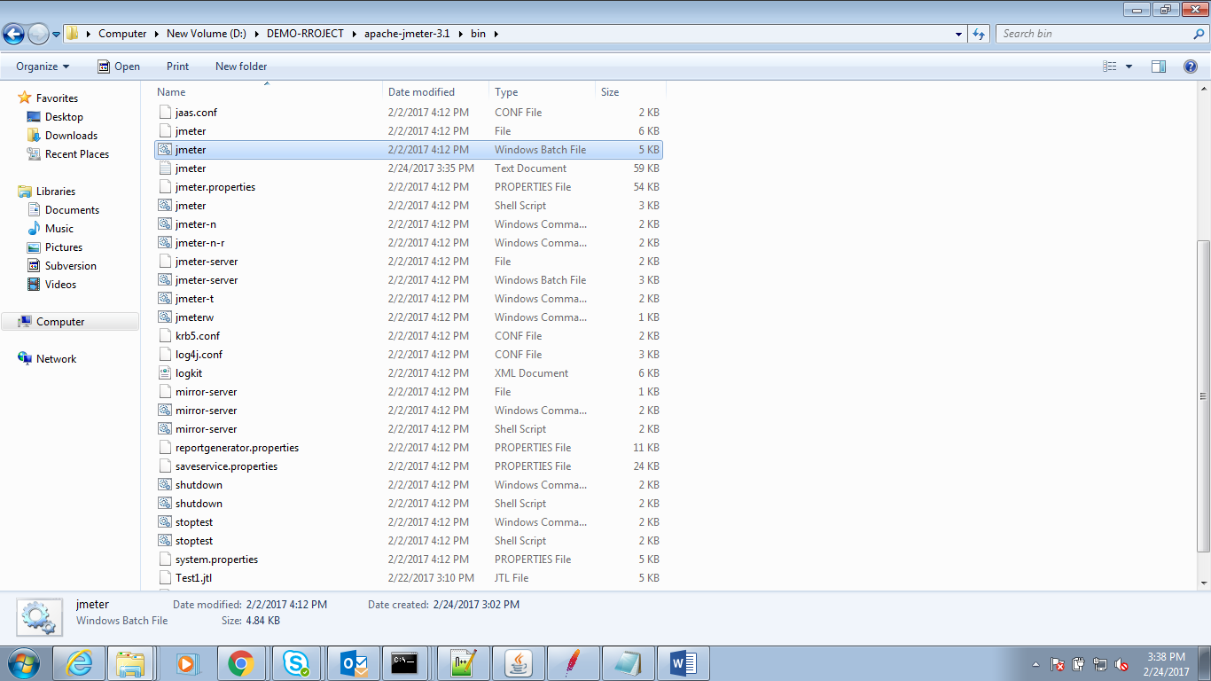

TestPlan

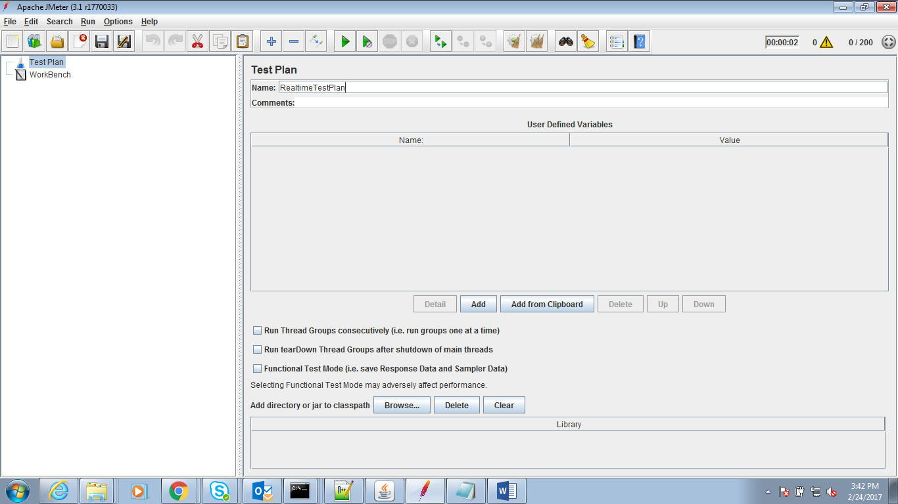

Add the Thread Group

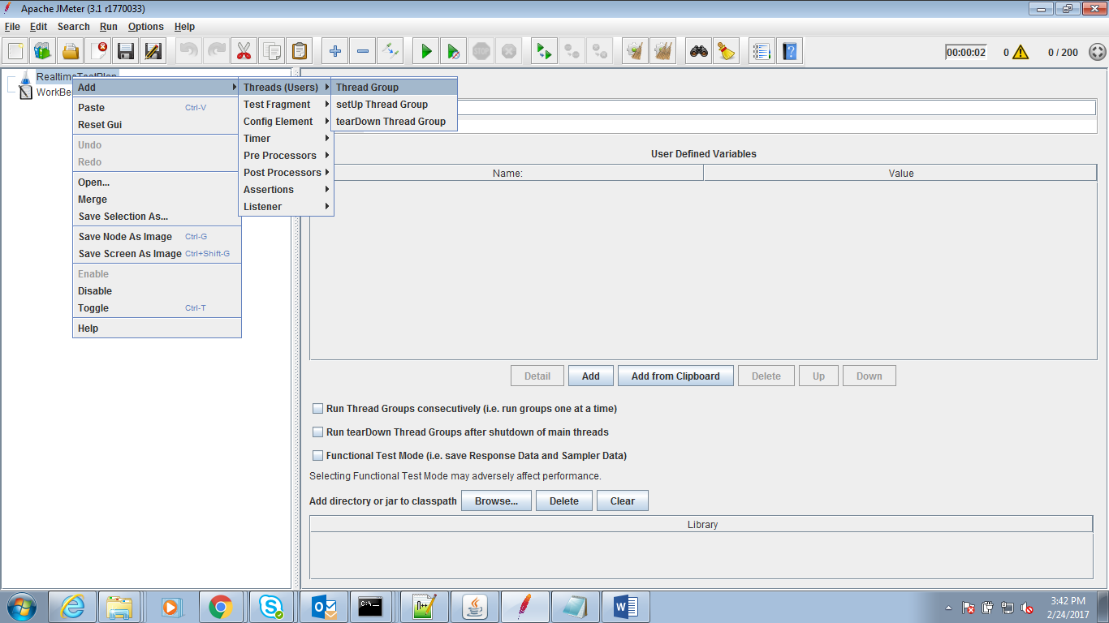

Enter Number of threads

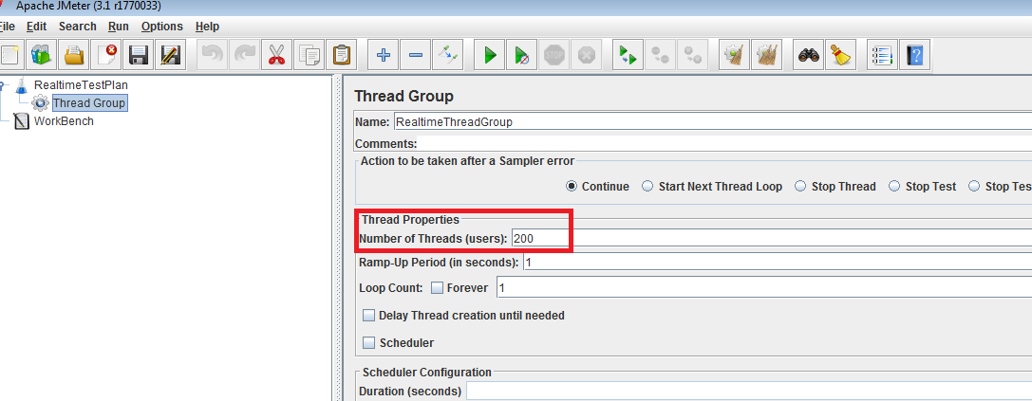

Add Sampler

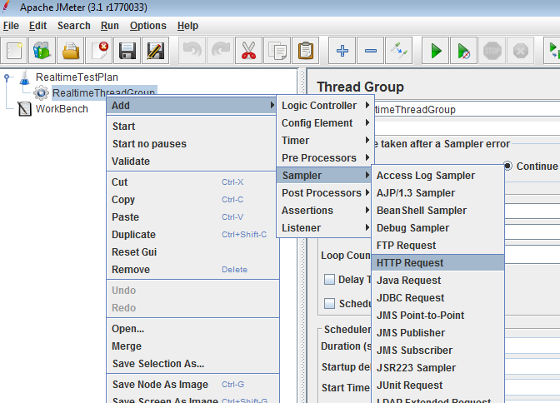

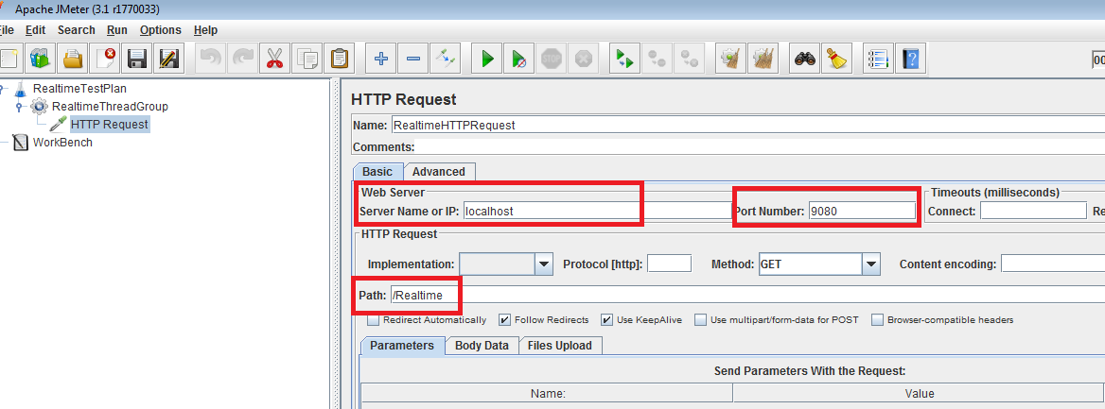

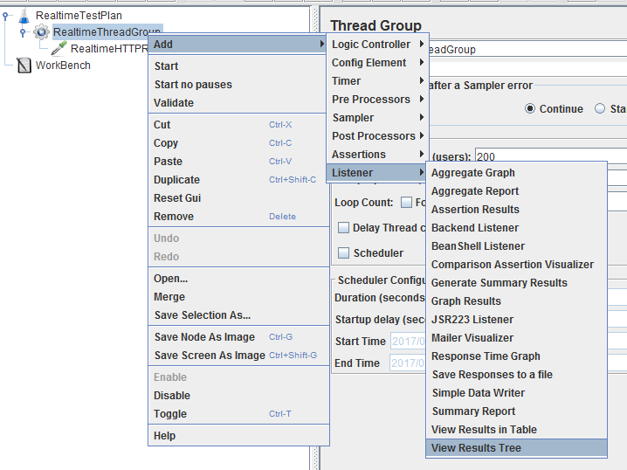

Provide the Output file to generate the report.

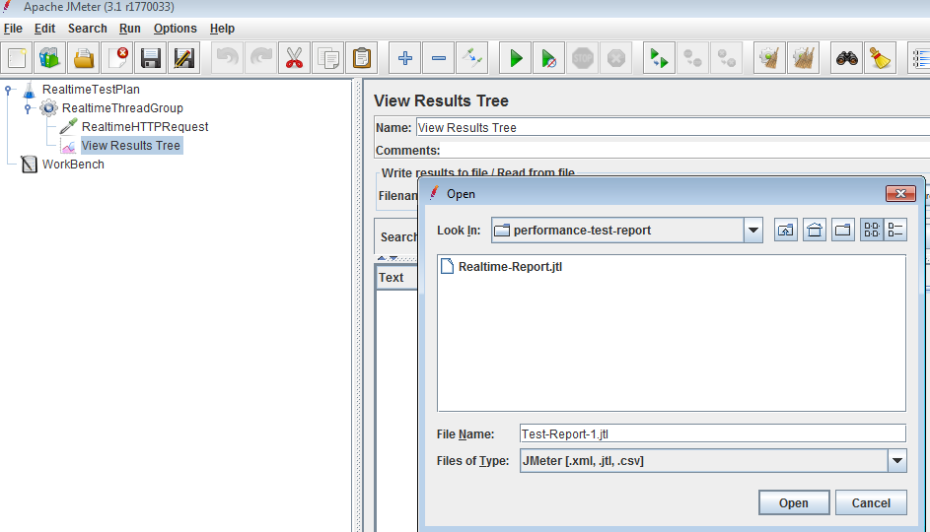

Provide the input file to generate report

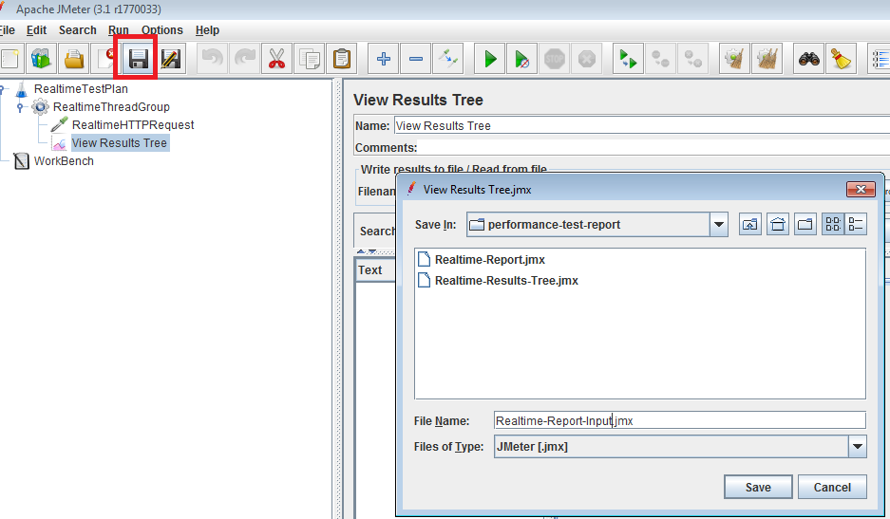

Run below command

cd D:\Jmeeter\apache-jmeter-3.1\bin

jmeter -n -t D:\DEMO-RROJECT\performance-test-report\Realtime-Results-Tree.jmx -l D:\DEMO-RROJECT\performance-test-preport\Realtime-R