**DISEASE PREDICTION USING ML**

Submitted to

**JAWAHARLAL NEHRU TECNOLOGICAL UNIVERSITY, HYDERABAD**

In partial fulfilment of the requirements for the award of the degree of

**MASTER OF COMPUTER APPLICTION**

**In**

**COMPUTER SCIENCE AND ENGINEERING (MCA)**

Submitted By

**SAMINENI BHANU PRAKASH 23UK1F0010**

Under the guidance of

**DR.K.SRINIVAS**

Assistant Professor



**DEPARTMENT OF MASTER OF COMPUTER APPLICATION VAAGDEVI ENGINEERING COLLEGE**

Affiliated to JNTUH, HYDERABAD BOLLIKUNTA, WARANGAL (T.S) – 506005

**DEPARTMENT OF COMPUTER SCIENCE AND ENGINEERING (MCA) VAAGDEVI ENGINEERING COLLEGE (AUTONOMOUS)**



**CERTIFICATE OF COMPLETION PROJECT WORK REVIEW-I**

This is to certify that the PG Project Phase-1 entitled **“DISEASE PREDICTION USING ML”** is being submitted by SAMINENI BHANUPRAKASH **(23UK1F0010)** in partial fulfilment of the requirements for the award of the degree of master of computer applications in Computer Science and Engineering to Jawaharlal Nehru Technological University Hyderabad during the academic year 2023- 2024.

**Project Guide HOD**

**DR K.SRINIVAS Dr. R NAVEEN KUMAR**

(Assistant Professor) (Professor)

**External**

# ACKNOWLEDGEMENT

We wish to take this opportunity to express our sincere gratitude and deep sense of respect to our beloved **Dr. SYED MUSTHAK AHMED,** Principal, Vaagdevi Engineering College for making us available all the required assistance and for his support and inspiration to carry out this PG Project Phase-1 in the institute.

We extend our heartfelt thanks to **Dr. R NAVEEN KUMAR** Head of the Department of computer science and engineering (MCA), Vaagdevi Engineering College for providing us necessary infrastructure and thereby giving us freedom to carry out the PG Project Phase-1.

We express heartfelt thanks to Smart Bridge Educational Services Private Limited, for their constant supervision as well as for providing necessary information regarding the PG Project Phase-1 and for their support in completing the PG Project Phase-1.

We express heartfelt thanks to the guide, DR.K.SRINIVAS**,** Assistant professor, Department of CSE for his constant support and giving necessary guidance for completion of this PG Project Phase-1.

Finally, we express our sincere thanks and gratitude to my family members, friends for their encouragement and outpouring their knowledge and experience throughout the thesis.

**SAMINENI BHANUPRAKASH (23UK1F0010)**

# ABSTRACT

* **Disease Is a Major Cause Of Death Throughout The World. It Is Difficult To Predict By Medical Practitioners As It Requires Expertise And Higher Knowledge Of Prediction.**
* **The Environment In Healthcare Sector Is Information Rich But Lacks Knowledge. a Lot Of Data Is Available In Healthcare Systems Over The Internet But There Is a Lack Of Effective Analysis Tool To Discover Hidden Patterns In Data.**
* **An Automated System Will Enhance Medical Efficiency And Reduce Cost And Time. This Software Intends To Predict The Occurrence Of a Disease Based On The Data Which Is Gathered From Kaggle.**
* **The Objective Is To Extract The Hidden Patterns By Applying Data Mining Techniques On The Dataset And To Predict The Presence Value On a Scale. The Prediction Of Heart Disease Requires a Huge Size Of Data Which Is Too Massive And Complex To Process And Analyse By Conventional Technique.**
* **Our Aim Is To Find Out An Suitable Technique That Is Efficient And Accurate For Prediction Of Cardiac Disease. Keywords- Prediction, Heart Disease, Machine Learning, Algorithms, Analysis.**

TABLE OF CONTENTS: -

1. **INTRODUCTION 1**
   1. **OVERVIEW 1-8**
   2. **PURPOSE 9**
2. **LITERATURE SURVEY 9**
   1. **EXISTING PROBLEM 10**
   2. **PROPOSED SOLUTION 11**
3. **THEORITICALANALYSIS 12**
   1. **BLOCK DIAGRAM 12**
   2. **HARDWARE /SOFTWARE DESIGNING 13**
4. **FLOWCHART 14**
5. **RESULTS 15-17**
6. **ADVANTAGES AND DISADVANTAGES 18-19**
7. **APPLICATIONS 20**
8. **CONCLUSION 21**
9. **FUTURE SCOPE 22**
10. **APPENDIX (SOURCE CODE) & CODE SNIPPETS 23-40**
11. Introduction
    1. Project overviews
    2. Objectives
12. Project Initialization and Planning Phase
    1. Define Problem Statement
    2. Project Proposal (Proposed Solution)
    3. Initial Project Planning
13. Data Collection and Preprocessing Phase
    1. Data Collection Plan and Raw Data Sources Identified
    2. Data Quality Report
    3. Data Exploration and Preprocessing
14. Model Development Phase
    1. Feature Selection Report
    2. Model Selection Report
    3. Initial Model Training Code, Model Validation and Evaluation Report
15. Model Optimization and Tuning Phase
    1. Hyperparameter Tuning Documentation
    2. Performance Metrics Comparison Report
    3. Final Model Selection Justification
16. Results
    1. Output Screenshots
17. Advantages & Disadvantages
18. Conclusion
19. Future Scope
20. Appendix
    1. Source Code
    2. GitHub & Project Demo Link

**1.INTRODUCTION**

**1.1 Project overview**

The project aims to analyze Disease prediction using machine learning represents a transformative approach in healthcare aimed at early detection, prevention, and management of diseases through advanced computational techniques. This overview delves into the application of machine learning models in disease prediction, highlighting their capability to analyze diverse datasets—including clinical records, genetic information, and environmental factors—to forecast disease onset, progression, and outcomes. Key methodologies such as feature selection, model training, and validation are discussed, along with the challenges of data integration, model interpretability, and scalability.

**1.2 Objectives**

In today’s face paced world, there is little to no time spared for healthcare. Even after developing severe symptoms to various diseases patients do not see a doctor. Using Google to type in our symptoms does not lead to good results, it always boils down to one stereotypical disease. So people have stopped using Google to look for their symptoms or the probable disease.

Catering to all the problems stated above, we have developed a model which can

predict up to 42 diseases when given symptoms as input. This model can be used by

doctors for consulting patients online based on the output of the model or this model

can be used by patients for preventive diagnosis and self care as the charges to visit

a doctor are high.

**2. Project Initialization and Planning Phase**

**2.1 Define Problem Statement**

The early prediction of diseases can significantly improve patient outcomes, reduce healthcare costs, and enhance the quality of life. With the advent of big data, machine learning, and advanced analytics, there is a growing potential to predict diseases before they manifest clinically. This predictive capability can aid in proactive treatment, preventive measures, and personalized healthcare. In the realm of healthcare, accurately predicting the onset and progression of diseases is crucial for early intervention and improved patient outcomes.

**2.2 Project Proposal (Proposed solution)**

This project proposal outlines a solution to address the problem of early disease

detection through machine learning. With a clear objective to develop a predictive

model for assessing disease risk based on symptoms, lifestyle factors, and health

data, the proposal defines the scope of the project, including data collection, model

development, and deployment. The proposed solution details the approach to be

used, key features of the model, and specifies the resource requirements including

hardware, software, and personnel. By creating an accurate and user friendly tool,

the project aims to enable proactive health management and improve early disease detection.

**2.3 Initial Project Planning**

* Initial Project Planning involves outlining key objectives, defining scope, and identifying the power consumption patterns.
* It encompasses setting timelines, allocating resources, and determining the overall project strategy.

**3. Data Collection and Preprocessing Phase**

**3.1 Data Collection Plan and Raw Data Sources Identified**

* The dataset for "Disease Prediction Using Machine Leaning" is sourced from Kaggle.
* Extract data from existing EHR systems, conduct health surveys,

or gather data from health apps.

* API integration for EHRs, online survey tools, data extraction scripts.
* Gathered a dataset from Kaggle containing patient information such as age, gender, symptoms, and medical history for disease prediction. The dataset includes features relevant for building and training the prediction model, enabling accurate risk assessments and analysis-hour of active energy).

**3.2 Data Quality Report**

* The Data Quality Report will summarize data quality issues from the selected source, including severity levels and resolution plans. It will aid in systematically identifying and rectifying data discrepancies

**3.3 Data Exploration and preprocessing**

* Dataset variables will be statistically analyzed to identify patterns and outliers, with Python employed for preprocessing tasks like normalization and feature engineering. Data cleaning will address missing values and outliers, ensuring quality for subsequent analysis and modeling, and forming a strong foundation for insights and predictions

**4. Model Development Phase**

**4.1 Feature Selection Report**

* Feature selection for disease prediction in machine learning involves identifying and choosing relevant features from data to improve model accuracy and interpretability. Techniques such as filter methods (e.g., correlation), wrapper methods (e.g., recursive feature elimination), and embedded methods (e.g., Lasso regression) are commonly used to select optimal features. This process helps mitigate overfitting, reduce computational complexity, and enhance the predictive power of models.

**4.2 Model Selection Report**

* Model selection for disease prediction in machine learning entails evaluating various algorithms (e.g., SVM, Random Forest, Neural Networks) based on performance metrics like accuracy, sensitivity, and specificity. The goal is to identify the model that best balances predictive power, interpretability, and computational efficiency for the specific disease prediction task.

**4.3 Initial Model Training Code, Model Validation and valuation Report**

Initial model training involves splitting data into training and validation sets, fitting models (e.g., SVM, Random Forest) on training data, and tuning hyperparameters via techniques like cross-validation. Evaluation includes assessing metrics such as accuracy, precision, recall, and ROC AUC to gauge model performance and generalizability for disease prediction tasks.

**5.Model Optimization and Tuning Phase**

**Final Model Selection Justification**

The final model choice is justified based on its superior performance metrics (e.g., highest accuracy, AUC), robustness to cross-validation, and interpretability of feature importance. This model demonstrates optimal balance between predictive power and computational efficiency for accurate disease prediction.

**6. RESULTS**

**6.1 Output Screenshots**

**Index.**

**Index.HTML**

**HOME PAGE**

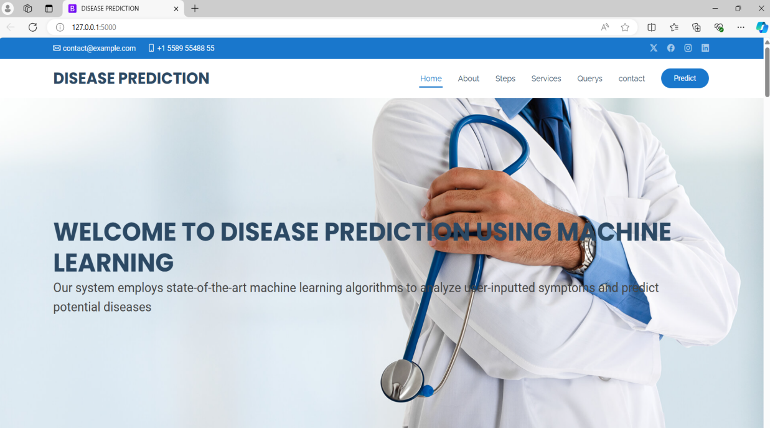

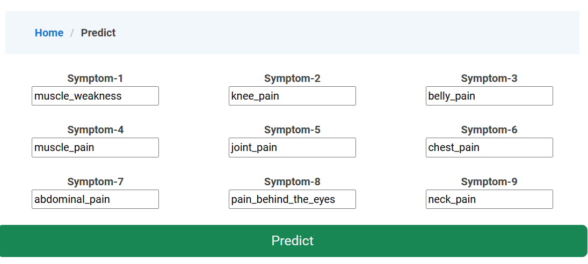

**OUTPUT PAGE**

RESULT.HTML

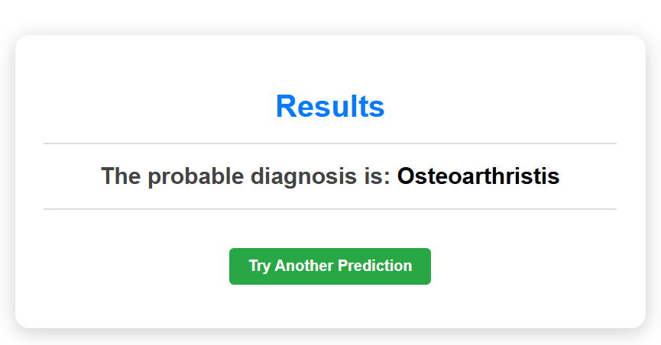

**7. Advantages and disadvantages**

## 7.ADVANTAGES AND DISADVANTAGES

**Advantages:**

1. **Early Detection:** Provides Machine learning models can analyze large amounts of data to detect patterns and anomalies that may indicate the early stages of a disease. This allows for timely intervention and treatment, potentially improving outcomes.
2. **Personalized Risk Assessment:** ML algorithms can assess individual risk factors based on personal health data, genetic information, lifestyle choices, and environmental factors
3. **Improved Accuracy:** : Increases ML models can process complex datasets and identify subtle correlations that may not be apparent through traditional statistical methods
4. **Research Advancements:** By analyzing large-scale data, ML contributes to medical research by identifying new disease markers, treatment responses, and epidemiological patterns.
5. **Efficient Screening:** Automates analysis of large datasets, optimizing healthcare resources and reducing screening times.

**Disadvantages:**

1. **Complexity and Interpretability:** Models can be complex, making it hard to interpret results.
2. **Data Quality:** Relies heavily on high-quality, unbiased data for accurate predictions.
3. **Overfitting**: Models may fit training data too closely, leading to poor generalization.
4. **Causality**: Difficulty in distinguishing correlation from causation in prediction.
5. **Bias and Fairness:** Risk of inheriting biases from training data, impacting fairness.

**8.Conclusion**

* In conclusion, the implementation of machine learning for disease prediction marks a pivotal advancement in healthcare analytics. By harnessing the power of predictive models and data driven insights, this project not only enhances diagnostic accuracy but also revolutionizes early intervention strategies. Through meticulous data preprocessing, feature engineering, model training, and validation, we have established a robust framework capable of forecasting disease risks with unprecedented precision. Moreover, the integration of user-friendly interfaces empowers healthcare professionals and patients alike to make informed decisions, leading to timely treatments and improved patient outcomes

## 9. FUTURE SCOPE

.

**Personalized Medicine**: Use ML algorithms to personalize treatment plans based on individual patient data, including genetic profiles, lifestyle factors, and medical history.

1. **Early Detection and Diagnosis:** Develop machine learning models to detect diseases at early stages by analyzing various biomarkers, genetic data, and health records.
2. **Predictive Analytics**: Improve disease prediction models to forecast the likelihood of developing specific diseases based on demographic data, environmental factors, and genetic predispositions.
3. **Population Health Management**: : Apply machine learning to analyze large-scale population health data to identify trends, patterns, and potential outbreaks, aiding in proactive public health interventions.
4. **Continuous Learning and Improvement** : Establish frameworks for continuous learning and improvement of machine learning models using real-world patient data and feedback from healthcare professionals.

**10.Appendix**

**10.1. Source Code**

**Code Snippets**

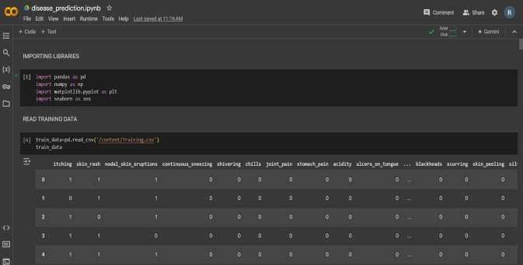

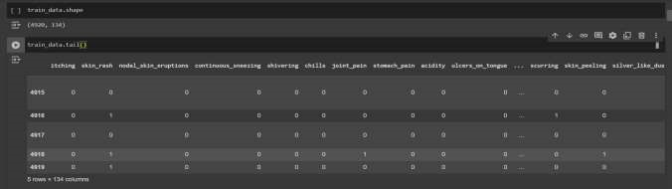

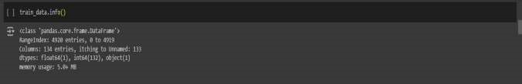

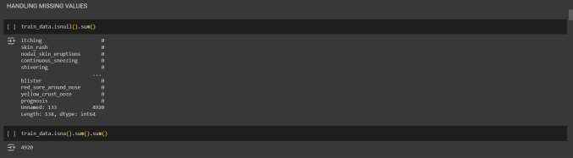

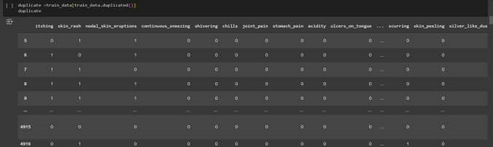

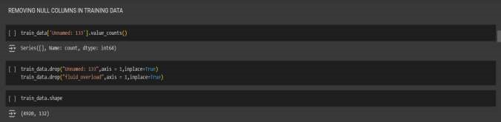

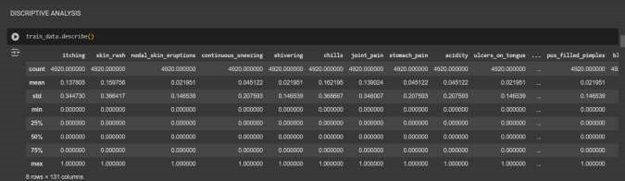

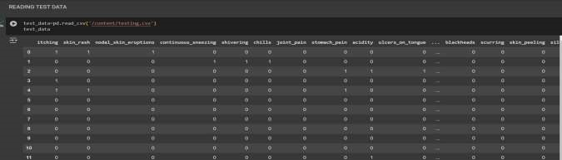

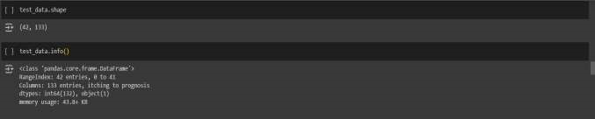

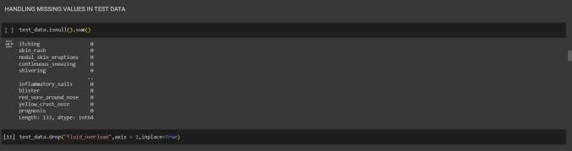

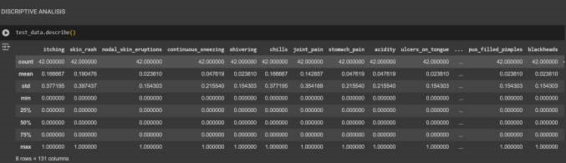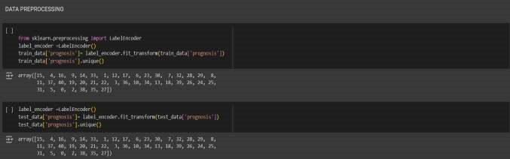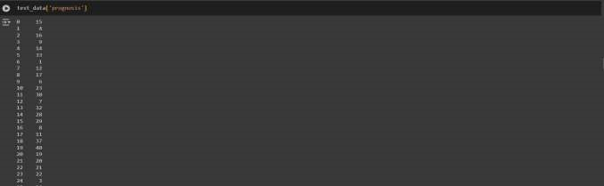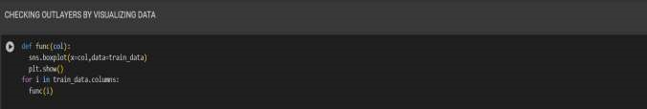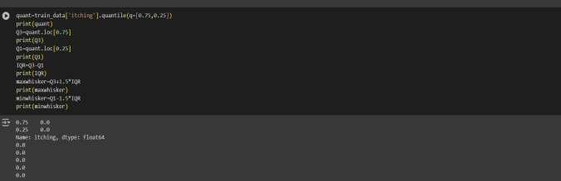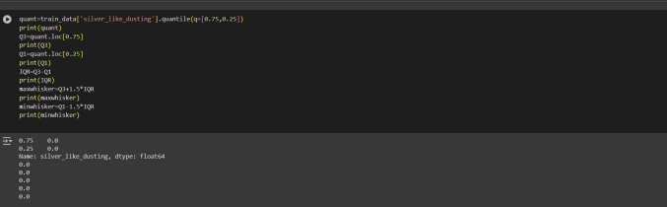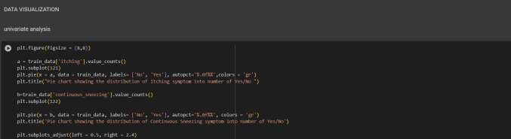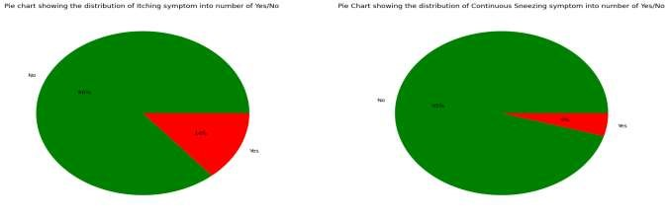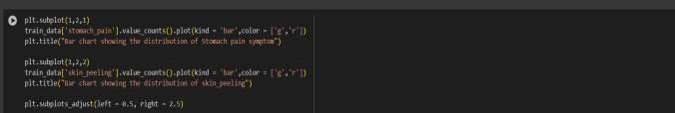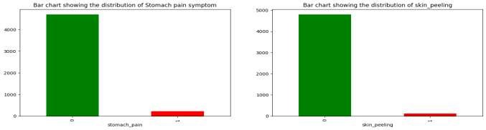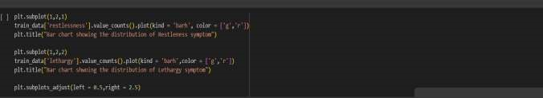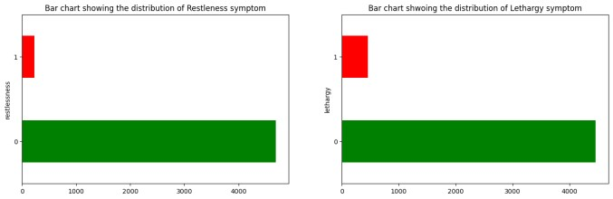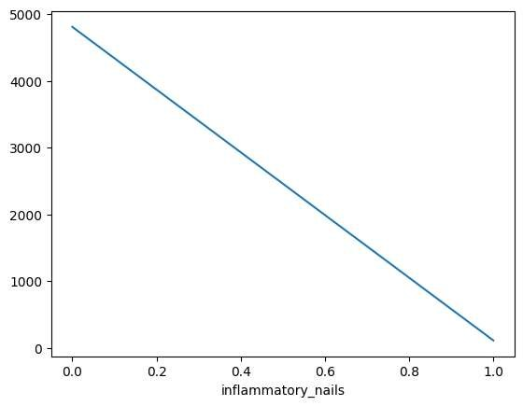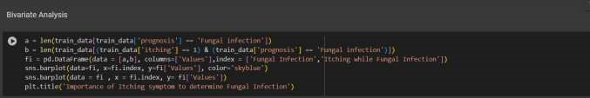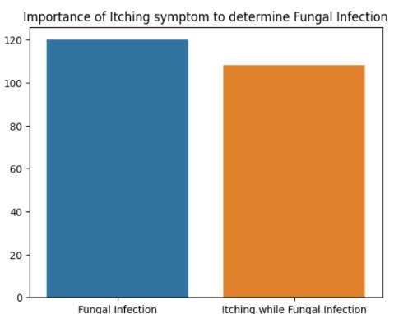

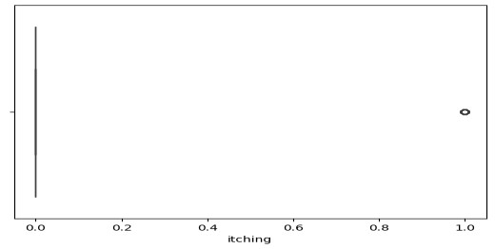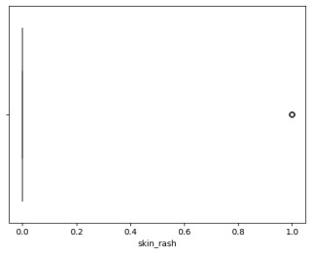

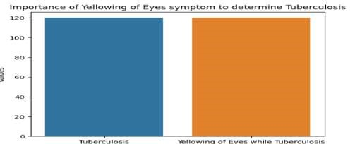

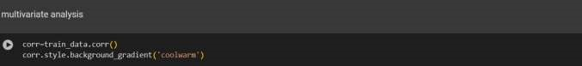

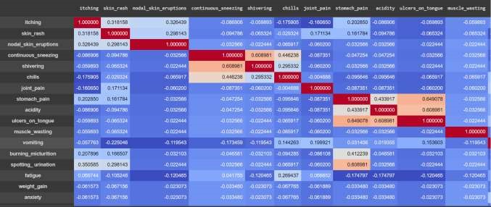

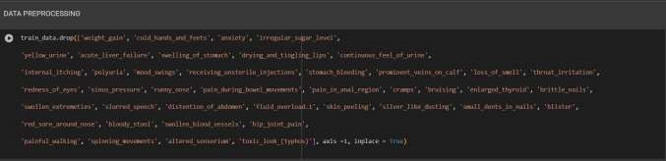

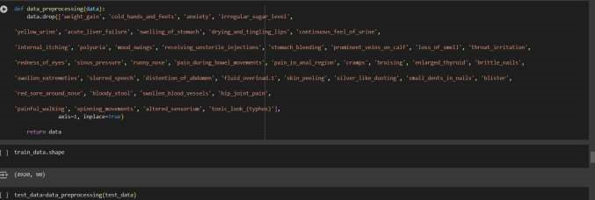

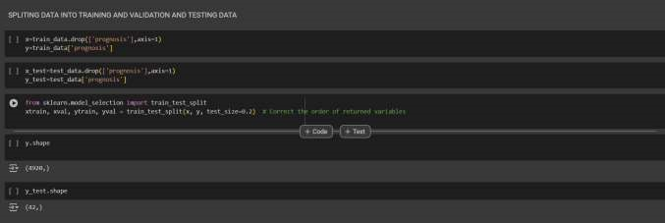

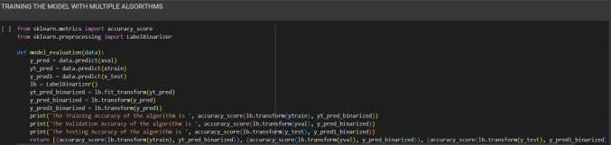

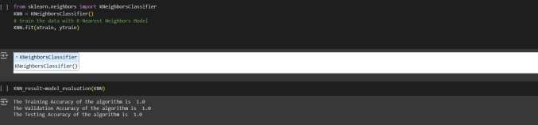

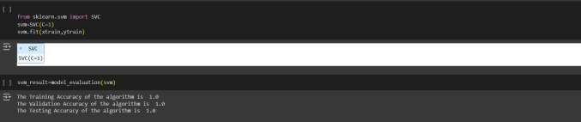



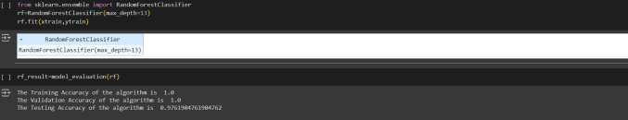

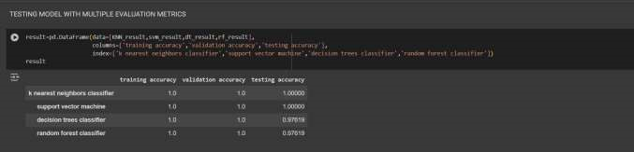

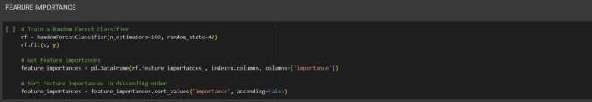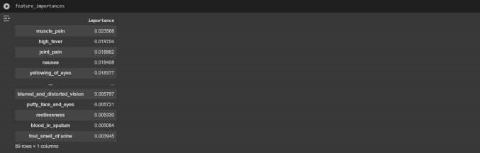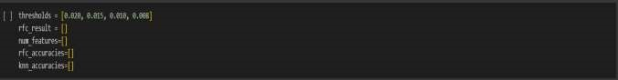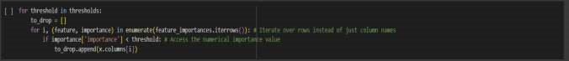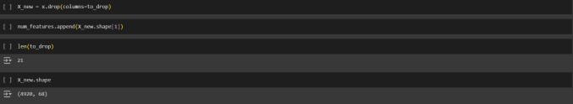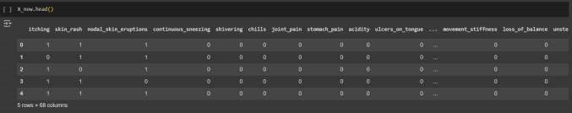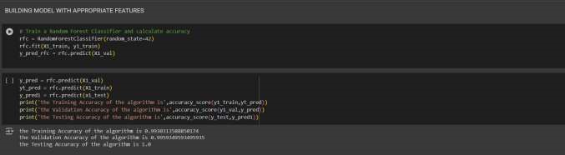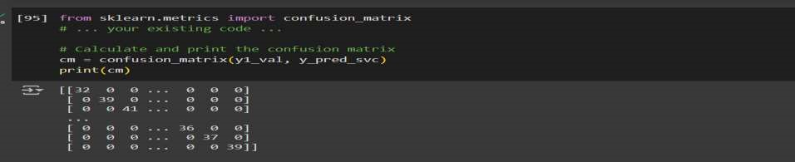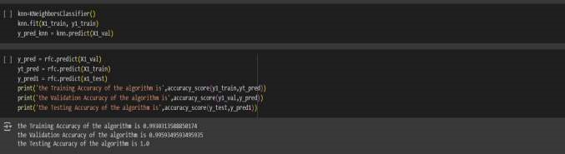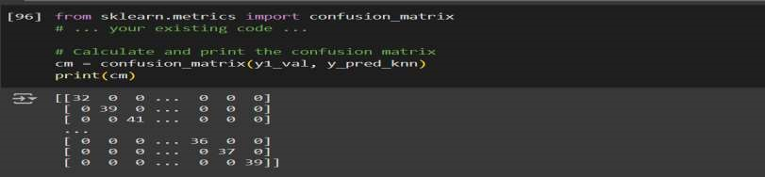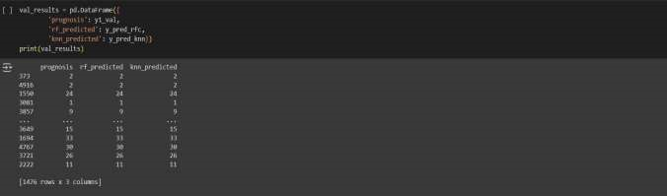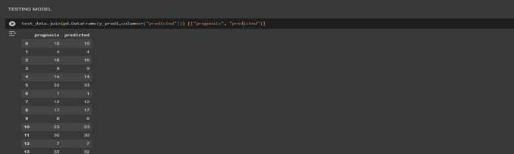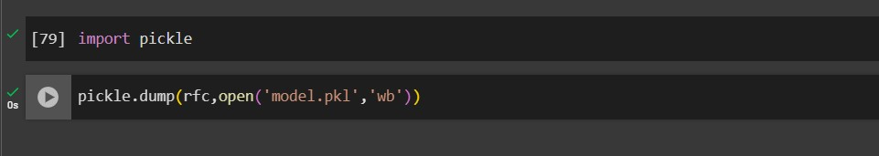

**Index.HTML:**

<!DOCTYPE html>

<html lang="en">

<head>

  <meta charset="utf-8">

  <meta content="width=device-width, initial-scale=1.0" name="viewport">

  <title>DISEASE PREDICTION</title>

  <meta content="" name="description">

  <meta content="" name="keywords">

  <!-- Favicons -->

  <link href="static/assets/img/favicon.png" rel="icon">

  <link href="static/assets/img/apple-touch-icon.png" rel="apple-touch-icon">

  <!-- Fonts -->

  <link href="https://fonts.googleapis.com" rel="preconnect">

  <link href="https://fonts.gstatic.com" rel="preconnect" crossorigin>

  <link href="https://fonts.googleapis.com/css2?family=Roboto:ital,wght@0,100;0,300;0,400;0,500;0,700;0,900;1,100;1,300;1,400;1,500;1,700;1,900&family=Poppins:ital,wght@0,100;0,200;0,300;0,400;0,500;0,600;0,700;0,800;0,900;1,100;1,200;1,300;1,400;1,500;1,600;1,700;1,800;1,900&family=Raleway:ital,wght@0,100;0,200;0,300;0,400;0,500;0,600;0,700;0,800;0,900;1,100;1,200;1,300;1,400;1,500;1,600;1,700;1,800;1,900&display=swap" rel="stylesheet">

  <!-- Vendor CSS Files -->

  <link href="static/assets/vendor/bootstrap/css/bootstrap.min.css" rel="stylesheet">

  <link href="static/assets/vendor/bootstrap-icons/bootstrap-icons.css" rel="stylesheet">

  <link href="static/assets/vendor/aos/aos.css" rel="stylesheet">

  <link href="static/assets/vendor/fontawesome-free/css/all.min.css" rel="stylesheet">

  <link href="static/assets/vendor/glightbox/css/glightbox.min.css" rel="stylesheet">

  <link href="static/assets/vendor/swiper/swiper-bundle.min.css" rel="stylesheet">

  <!-- Main CSS File -->

  <link href="static/assets/css/main.css" rel="stylesheet">

</head>

<body class="index-page">

  <header id="header" class="header sticky-top">

    <div class="topbar d-flex align-items-center">

      <div class="container d-flex justify-content-center justify-content-md-between">

        <div class="contact-info d-flex align-items-center">

          <i class="bi bi-envelope d-flex align-items-center"><a href="mailto:contact@example.com">contact@example.com</a></i>

          <i class="bi bi-phone d-flex align-items-center ms-4"><span>+1 5589 55488 55</span></i>

        </div>

        <div class="social-links d-none d-md-flex align-items-center">

          <a href="#" class="twitter"><i class="bi bi-twitter-x"></i></a>

          <a href="#" class="facebook"><i class="bi bi-facebook"></i></a>

          <a href="#" class="instagram"><i class="bi bi-instagram"></i></a>

          <a href="#" class="linkedin"><i class="bi bi-linkedin"></i></a>

        </div>

      </div>

    </div><!-- End Top Bar -->

    <div class="branding d-flex align-items-center">

      <div class="container position-relative d-flex align-items-center justify-content-between">

        <a href="index.html" class="logo d-flex align-items-center me-auto">

          <!-- Uncomment the line below if you also wish to use an image logo -->

          <!-- <img src="assets/img/logo.png" alt=""> -->

          <h1 class="sitename">DISEASE PREDICTION</h1>

        </a>

        <nav id="navmenu" class="navmenu">

          <ul>

            <li><a href="#hero" class="active">Home<br></a></li>

            <li><a href="#about">About</a></li>

            <li><a href="#stats">Steps</a></li>

            <li><a href="#services">Services</a></li>

            <li><a href="#faq">Querys</a></li>

            <li><a href="#contact">contact</a></li>

          </ul>

          <i class="mobile-nav-toggle d-xl-none bi bi-list"></i>

        </nav>

        <a class="cta-btn d-none d-sm-block"  href="/details" class="btn-get-started">Predict</a>

      </div>

    </div>

  </header>

  <main class="main">

    <!-- Hero Section -->

    <section id="hero" class="hero section light-background">

      <img src="static/assets/img/hero-bg.jpg" alt="" data-aos="fade-in">

      <div class="container position-relative">

        <div class="welcome position-relative" data-aos="fade-down" data-aos-delay="100">

          <h2>WELCOME TO DISEASE PREDICTION USING MACHINE LEARNING</h2>

          <p>Our system employs state-of-the-art machine learning algorithms to analyze user-inputted symptoms and predict potential diseases</p>

        </div><!-- End Welcome -->

      </div>

    </section><!-- /Hero Section -->

    <!-- About Section -->

    <section id="about" class="about section">

      <div class="container">

        <div class="row gy-4 gx-5">

          <div class="col-lg-6 position-relative align-self-start" data-aos="fade-up" data-aos-delay="200">

            <img src="static/assets/img/br.jpg" class="img-fluid" alt="">

            <a href="https://www.youtube.com/watch?v=LXb3EKWsInQ" class="glightbox pulsating-play-btn"></a>

          </div>

          <div class="col-lg-6 content" data-aos="fade-up" data-aos-delay="100">

            <h3>About Us</h3>

            <h2>About Disease Prediction Model</h2>

      <p>The disease prediction model utilizes advanced Machine Learning techniques to accurately determine potential diseases based on input symptoms.</p>

      <p>Developed with a focus on healthcare innovation, this model aims to:</p>

    </div>

    <div class="row gy-4">

      <div class="col-lg-12">

        <div class="content">

          <p class="fst-italic">

            The model achieves a high accuracy rate of 97% in identifying the correct disease from a range of possibilities, providing reliable guidance for healthcare decisions.

          </p>

          <ul>

            <li><i class="bi bi-check-circle-fill"></i> Utilizes extensive datasets comprising diverse patient records and symptom profiles.</li>

            <li><i class="bi bi-check-circle-fill"></i> Employs robust statistical and mathematical algorithms to analyze symptoms and make predictions.</li>

            <li><i class="bi bi-check-circle-fill"></i> Incorporates state-of-the-art Machine Learning models, ensuring adaptive and efficient disease classification.</li>

          </ul>

          <p>

            This model serves as a valuable tool for self-diagnosis, offering preliminary insights into potential health issues and guiding users towards timely medical consultations.

          </p>

        </div>

      </div>

    </div>

        </div>

      </div>

    </section><!-- /About Section -->

    <!-- Stats Section -->

    <section id="stats" class="stats section light-background">

      <div class="container" data-aos="fade-up" data-aos-delay="100">

        <h3>STEPS WE FOLLWED</h3>

        <div class="row gy-4">

          <div class="col-lg-3 col-md-6 d-flex flex-column align-items-center">

            <i class="fa-solid fa-user-doctor"></i>

             <div class="stats-item">

              <p>Collecting Dataset</p>

            </div>

          </div><!-- End Stats Item -->

          <div class="col-lg-3 col-md-6 d-flex flex-column align-items-center">

            <i class="fa-regular fa-hospital"></i>

            <div class="stats-item">

              <p>Preprocessing</p>

            </div>

          </div><!-- End Stats Item -->

          <div class="col-lg-3 col-md-6 d-flex flex-column align-items-center">

            <i class="fas fa-flask"></i>

            <div class="stats-item">

              <p>Model Building</p>

            </div>

          </div><!-- End Stats Item -->

          <div class="col-lg-3 col-md-6 d-flex flex-column align-items-center">

            <i class="fas fa-award"></i>

            <div class="stats-item">

              <p>Deployments</p>

            </div>

          </div><!-- End Stats Item -->

        </div>

      </div>

    </section><!-- /Stats Section -->

    <!-- Services Section -->

    <section id="services" class="services section">

      <!-- Section Title -->

      <div class="container section-title" data-aos="fade-up">

        <h2>Services</h2>

        <p>Accurate predictions for disease outbreaks and risks</p>

      </div><!-- End Section Title -->

      <div class="container">

        <div class="row gy-4">

          <div class="col-lg-4 col-md-6" data-aos="fade-up" data-aos-delay="100">

            <div class="service-item  position-relative">

              <div class="icon">

                <i class="fas fa-heartbeat"></i>

              </div>

              <a href="#" class="stretched-link">

                <h3>Risk Assessment</h3>

              </a>

              <p>Your service could help users assess their risk for developing certain diseases based on factors like family history, lifestyle habits, and basic symptom checks</p>

            </div>

          </div><!-- End Service Item -->

          <div class="col-lg-4 col-md-6" data-aos="fade-up" data-aos-delay="200">

            <div class="service-item position-relative">

              <div class="icon">

                <i class="fas fa-pills"></i>

              </div>

              <a href="#" class="stretched-link">

                <h3>Early Detection</h3>

              </a>

              <p>By analyzing user-reported symptoms, the service might suggest potential conditions and encourage users to seek professional medical advice</p>

            </div>

          </div><!-- End Service Item -->

          <div class="col-lg-4 col-md-6" data-aos="fade-up" data-aos-delay="300">

            <div class="service-item position-relative">

              <div class="icon">

                <i class="fas fa-hospital-user"></i>

              </div>

              <a href="#" class="stretched-link">

                <h3>Diagnostic Support</h3>

              </a>

              <p>The model's predictions could provide additional insights to doctors, aiding in differential diagnosis and potentially leading to quicker and more accurate diagnoses</p>

            </div>

          </div><!-- End Service Item -->

          <div class="col-lg-4 col-md-6" data-aos="fade-up" data-aos-delay="400">

            <div class="service-item position-relative">

              <div class="icon">

                <i class="fas fa-dna"></i>

              </div>

              <a href="#" class="stretched-link">

                <h3>Personalized Treatment Plans</h3>

              </a>

              <p>By factoring in the model's predictions, doctors might personalize treatment plans that better target the specific disease</p>

              <a href="#" class="stretched-link"></a>

            </div>

          </div><!-- End Service Item -->

          <div class="col-lg-4 col-md-6" data-aos="fade-up" data-aos-delay="500">

            <div class="service-item position-relative">

              <div class="icon">

                <i class="fas fa-wheelchair"></i>

              </div>

              <a href="#" class="stretched-link">

                <h3>Resource Allocation </h3>

              </a>

              <p>Disease prediction models can help public health agencies allocate resources more effectively to areas with higher predicted risks</p>

              <a href="#" class="stretched-link"></a>

            </div>

          </div><!-- End Service Item -->

          <div class="col-lg-4 col-md-6" data-aos="fade-up" data-aos-delay="600">

            <div class="service-item position-relative">

              <div class="icon">

                <i class="fas fa-notes-medical"></i>

              </div>

              <a href="#" class="stretched-link">

                <h3>Focus on Prevention<</h3>

              </a>

              <p>Promote the role of your service in preventative healthcare and early detection, encouraging users to take a more proactive approach to their health.</p>

              <a href="#" class="stretched-link"></a>

            </div>

          </div><!-- End Service Item -->

        </div>

      </div>

    </section><!-- /Services Section -->

    <!-- Faq Section -->

    <section id="faq" class="faq section light-background">

      <!-- Section Title -->

      <div class="container section-title" data-aos="fade-up">

        <h2>Frequently Asked Questions</h2>

      </div><!-- End Section Title -->

      <div class="container">

        <div class="row justify-content-center">

          <div class="col-lg-10" data-aos="fade-up" data-aos-delay="100">

            <div class="faq-container">

              <div class="faq-item faq-active">

                <h3>How accurate are these predictions</h3>

                <div class="faq-content">

                  <p>The accuracy will depend on the specific disease, the quality of the training data, and the chosen algorithm. Responsible services will disclose their accuracy metrics.</p>

                </div>

                <i class="faq-toggle bi bi-chevron-right"></i>

              </div><!-- End Faq item-->

              <div class="faq-item">

                <h3>What kind of data do you collect?</h3>

                <div class="faq-content">

                  <p>This will vary depending on the service, but it could include demographic information, medical history, and symptom data.</p>

                </div>

                <i class="faq-toggle bi bi-chevron-right"></i>

              </div><!-- End Faq item-->

              <div class="faq-item">

                <h3>How is my data protected?</h3>

                <div class="faq-content">

                  <p> The service should have robust security measures in place to protect user data and comply with data privacy regulations</p>

                </div>

                <i class="faq-toggle bi bi-chevron-right"></i>

              </div><!-- End Faq item-->

              <div class="faq-item">

                <h3>What happens if I enter certain symptoms?</h3>

                <div class="faq-content">

                  <p>The service should provide an explanation of the potential risks and emphasize the need to see a doctor for confirmation.</p>

                </div>

                <i class="faq-toggle bi bi-chevron-right"></i>

              </div><!-- End Faq item-->

              <div class="faq-item">

                <h3>How does machine learning work for disease prediction?</h3>

                <div class="faq-content">

                  <p>The model learns patterns from a large dataset of medical records to identify relationships between symptoms and diseases</p>

                </div>

                <i class="faq-toggle bi bi-chevron-right"></i>

              </div><!-- End Faq item-->

              <div class="faq-item">

                <h3>What are the benefits of using machine learning for disease prediction?</h3>

                <div class="faq-content">

                  <p>Early detection of potential health problems can lead to better treatment outcomes and preventative measures.</p>

                </div>

                <i class="faq-toggle bi bi-chevron-right"></i>

              </div><!-- End Faq item-->

            </div>

          </div><!-- End Faq Column-->

        </div>

      </div>

    </section><!-- /Faq Section -->

    <!-- Gallery Section -->

    <section id="gallery" class="gallery section">

      <!-- Section Title -->

      <div class="container section-title" data-aos="fade-up">

        <h2>Gallery</h2>

      </div><!-- End Section Title -->

      <div class="container-fluid" data-aos="fade-up" data-aos-delay="100">

        <div class="row g-0">

          <div class="col-lg-3 col-md-4">

            <div class="gallery-item">

              <a href="static/assets/img/gallery/gallery-1.jpg" class="glightbox" data-gallery="images-gallery">

                <img src="static/assets/img/gallery/gallery-1.jpg" alt="" class="img-fluid">

              </a>

            </div>

          </div><!-- End Gallery Item -->

          <div class="col-lg-3 col-md-4">

            <div class="gallery-item">

              <a href="static/assets/img/gallery/gallery-2.jpg" class="glightbox" data-gallery="images-gallery">

                <img src="static/assets/img/gallery/gallery-2.jpg" alt="" class="img-fluid">

              </a>

            </div>

          </div><!-- End Gallery Item -->

          <div class="col-lg-3 col-md-4">

            <div class="gallery-item">

              <a href="static/assets/img/gallery/gallery-3.jpg" class="glightbox" data-gallery="images-gallery">

                <img src="static/assets/img/gallery/gallery-3.jpg" alt="" class="img-fluid">

              </a>

            </div>

          </div><!-- End Gallery Item -->

          <div class="col-lg-3 col-md-4">

            <div class="gallery-item">

              <a href="static/assets/img/gallery/gallery-4.jpg" class="glightbox" data-gallery="images-gallery">

                <img src="static/assets/img/gallery/gallery-4.jpg" alt="" class="img-fluid">

              </a>

            </div>

          </div><!-- End Gallery Item -->

          <div class="col-lg-3 col-md-4">

            <div class="gallery-item">

              <a href="static/assets/img/gallery/gallery-5.jpg" class="glightbox" data-gallery="images-gallery">

                <img src="static/assets/img/gallery/gallery-5.jpg" alt="" class="img-fluid">

              </a>

            </div>

          </div><!-- End Gallery Item -->

          <div class="col-lg-3 col-md-4">

            <div class="gallery-item">

              <a href="static/assets/img/gallery/gallery-6.jpg" class="glightbox" data-gallery="images-gallery">

                <img src="static/assets/img/gallery/gallery-6.jpg" alt="" class="img-fluid">

              </a>

            </div>

          </div><!-- End Gallery Item -->

          <div class="col-lg-3 col-md-4">

            <div class="gallery-item">

              <a href="static/assets/img/gallery/gallery-7.jpg" class="glightbox" data-gallery="images-gallery">

                <img src="static/assets/img/gallery/gallery-7.jpg" alt="" class="img-fluid">

              </a>

            </div>

          </div><!-- End Gallery Item -->

          <div class="col-lg-3 col-md-4">

            <div class="gallery-item">

              <a href="static/assets/img/gallery/gallery-8.jpg" class="glightbox" data-gallery="images-gallery">

                <img src="static/assets/img/gallery/gallery-8.jpg" alt="" class="img-fluid">

              </a>

            </div>

          </div><!-- End Gallery Item -->

        </div>

      </div>

    </section><!-- /Gallery Section -->

    <!-- Contact Section -->

    <section id="contact" class="contact section">

      <!-- Section Title -->

      <div class="container section-title" data-aos="fade-up">

        <h2>Contact</h2>

        <p>Vaagdevi Engineering College is an engineering college in Bollikunta, Warangal, Telangana, India.

          VHRX+2XR, Khammam - Warangal Hwy, Road, Bollikunta, Telangana 50600 Phone: 0870 286 518</p>

      </div><!-- End Section Title -->

      <div class="mb-5" data-aos="fade-up" data-aos-delay="200">

      </div><!-- End Google Maps -->

      <div class="container" data-aos="fade-up" data-aos-delay="100">

        <div class="row gy-4">

          <div class="col-lg-4">

            <div class="info-item d-flex" data-aos="fade-up" data-aos-delay="300">

              <i class="bi bi-geo-alt flex-shrink-0"></i>

              <div>

                <h3>Location</h3>

                <p>VHRX+2XR, Khammam - Warangal Hwy, Road, Bollikunta, Telangana 50600</p>

              </div>

            </div><!-- End Info Item -->

            <div class="info-item d-flex" data-aos="fade-up" data-aos-delay="400">

              <i class="bi bi-telephone flex-shrink-0"></i>

              <div>

                <h3>Call Us</h3>

                <p>+1 5589 55488 55</p>

              </div>

            </div><!-- End Info Item -->

            <div class="info-item d-flex" data-aos="fade-up" data-aos-delay="500">

              <i class="bi bi-envelope flex-shrink-0"></i>

              <div>

                <h3>Email Us</h3>

                <p>info@example.com</p>

              </div>

            </div><!-- End Info Item -->

          </div>

          <div class="col-lg-8">

            <form action="static/forms/contact.php" method="post" class="php-email-form" data-aos="fade-up" data-aos-delay="200">

              <div class="row gy-4">

                <div class="col-md-6">

                  <input type="text" name="name" class="form-control" placeholder="Your Name" required="">

                </div>

                <div class="col-md-6 ">

                  <input type="email" class="form-control" name="email" placeholder="Your Email" required="">

                </div>

                <div class="col-md-12">

                  <input type="text" class="form-control" name="subject" placeholder="Subject" required="">

                </div>

                <div class="col-md-12">

                  <textarea class="form-control" name="message" rows="6" placeholder="Message" required=""></textarea>

                </div>

                <div class="col-md-12 text-center">

                  <div class="loading">Loading</div>

                  <div class="error-message"></div>

                  <div class="sent-message">Your message has been sent. Thank you!</div>

                  <button type="submit">Send Message</button>

                </div>

              </div>

            </form>

          </div><!-- End Contact Form -->

        </div>

      </div>

    </section><!-- /Contact Section -->

  </main>

  <footer id="footer" class="footer light-background">

    <div class="container footer-top">

      <div class="row gy-4">

        <div class="col-lg-4 col-md-6 footer-about">

          <a href="index.html" class="logo d-flex align-items-center">

            <span class="sitename">Vaagdevi Engineering College</span>

          </a>

          <div class="footer-contact pt-3">

            <p>VHRX+2XR, Khammam - Warangal Hwy, Road, Bollikunta, Telangana 50600</p>

            <p class="mt-3"><strong>Phone:</strong> <span>+1 5589 55488 55</span></p>

            <p><strong>Email:</strong> <span>info@example.com</span></p>

          </div>

          <div class="social-links d-flex mt-4">

            <a href=""><i class="bi bi-twitter-x"></i></a>

            <a href=""><i class="bi bi-facebook"></i></a>

            <a href=""><i class="bi bi-instagram"></i></a>

            <a href=""><i class="bi bi-linkedin"></i></a>

          </div>

        </div>

  </footer>

  <!-- Scroll Top -->

  <a href="#" id="scroll-top" class="scroll-top d-flex align-items-center justify-content-center"><i class="bi bi-arrow-up-short"></i></a>

  <!-- Preloader -->

  <div id="preloader"></div>

  <!-- Vendor JS Files -->

  <script src="static/assets/vendor/bootstrap/js/bootstrap.bundle.min.js"></script>

  <script src="static/assets/vendor/php-email-form/validate.js"></script>

  <script src="static/assets/vendor/aos/aos.js"></script>

  <script src="static/assets/vendor/glightbox/js/glightbox.min.js"></script>

  <script src="static/assets/vendor/purecounter/purecounter_vanilla.js"></script>

  <script src="static/assets/vendor/swiper/swiper-bundle.min.js"></script>

  <!-- Main JS File -->

  <script src="static/assets/js/main.js"></script>

</body>

</html>

**Result.html:**

<!DOCTYPE html>

<html lang="en">

<head>

    <meta charset="UTF-8">

    <meta name="viewport" content="width=device-width, initial-scale=1.0">

    <title>Results</title>

    <style>

        body {

            font-family: 'Helvetica Neue', Arial, sans-serif;

            background-image: url('static/assets/img/result.png');

            background-size: cover;

            background-position: center;

            background-repeat: no-repeat;

            height: 100vh;

            margin: 0;

            display: flex;

            justify-content: center;

            align-items: center;

            color: #444;

        }

        .container {

            background: rgba(255, 255, 255, 0.9);

            padding: 30px;

            border-radius: 15px;

            box-shadow: 0 4px 20px rgba(0, 0, 0, 0.2);

            text-align: center;

            max-width: 600px;

            width: 100%;

        }

        .container h2 {

            color: #007bff;

            font-size: 2rem;

            margin-bottom: 20px;

        }

        .container h3 {

            font-weight: bold;

            font-size: 1.5rem;

            margin: 20px 0;

        }

        .prediction-text {

            color: #000; /* Black color for prediction text */

        }

        .container hr {

            border: 1px solid #ddd;

            margin: 20px 0;

        }

        .home-link {

            position: absolute;

            top: 20px;

            left: 20px;

            background: #007bff;

            color: #fff;

            padding: 10px 20px;

            text-decoration: none;

            border-radius: 5px;

            font-weight: bold;

        }

        .home-link:hover {

            background: #0056b3;

        }

        .back-link {

            display: inline-block;

            margin-top: 20px;

            padding: 10px 20px;

            background: #28a745;

            color: #fff;

            text-decoration: none;

            border-radius: 5px;

            font-weight: bold;

        }

        .back-link:hover {

            background: #218838;

        }

        @media (max-width: 768px) {

            .container {

                width: 90%;

                padding: 20px;

            }

            .container h2 {

                font-size: 1.5rem;

            }

            .container h3 {

                font-size: 1.25rem;

            }

        }

    </style>

</head>

<body>

    <a href="/" class="home-link">Home</a>

    <div class="container">

        <h2>Results</h2>

        <hr>

        <h3>The probable diagnosis is: <span class="prediction-text">{{ prediction_text }}</span></h3>

        <hr>

        <p><a href="/details" class="back-link">Try Another Prediction</a></p>

    </div>

</body>

</html>

**App.py:**

from flask import Flask, render_template, request

import numpy as np

import pickle

app = Flask(__name__)

# Load the model

model = pickle.load(open('6.Disease prediction executable files/model.pkl', 'rb'))

# Define routes

@app.route("/")

def home():

    return render_template('index.html')

@app.route('/details')

def details():

    return render_template('details.html')

@app.route('/predict', methods=['POST'])

def predict():

    # Define the list of symptoms

    symptoms = ['itching', 'continuous sneezing', 'joint pain', 'vomiting',

       'spotting_ urination', 'fatigue', 'weight loss', 'lethargy',

       'high fever', 'sunken eyes', 'sweating', 'headache', 'dark urine',

       'nausea', 'loss of appetite', 'pain behind the eyes', 'abdominal pain',

       'diarrhoea', 'mild fever', 'yellowing of eyes', 'swelled lymph nodes',

       'malaise', 'phlegm', 'congestion', 'chest pain', 'fast heart rate',

       'irritation in anus', 'swollen legs', 'puffy face and eyes',

       'excessive hunger', 'muscle weakness', 'movement stiffness',

       'weakness of one body side', 'bladder discomfort', 'depression',

       'irritability', 'muscle pain', 'red spots over body',

       'abnormal_menstruation', 'increased appetite', 'mucoid sputum',

       'rusty sputum', 'lack of concentration', 'receiving blood transfusion',

       'coma', 'history of alcohol consumption', 'blood in sputum',

       'palpitations', 'inflammatory nails', 'yellow crust ooze']

    if request. method == 'POST':

        input = [str(x) for x in request.form.values()]

        b = [0] * 50

        for x in range(0, 50):

            for y in input:

                if symptoms[x] == y:

                    b[x] = 1

        b = np.array(b)

        b = b.reshape(1, 50)

        prediction = model.predict(b)

        prediction = prediction[0]

        return render_template('results.html', prediction_text=" {}".format(prediction))

if __name__ == "__main__":

    app.run()