**Smart Edge-Based Driver Drowsiness Detection in Mobile Crowdsourcing**

**ABSTRACT: -**

According to current data, sleepy drivers are responsible for an estimated 15.5% of fatal traffic accidents, which presents a serious threat to public safety. This research presents a unique solution to Driver Drowsiness Detection utilising Custom Convolutional Neural Networks (CNN) combined with Flask for image/live input in order to handle this problem and take use of the extensive use of mobile devices. With this two-step technique, mobile devices in the car record and evaluate the driver's present state while protecting their privacy. As a decision-maker, the smart edge verifies drowsiness whether the data from the mobile client matches the real-time input that was observed. The suggested framework includes a data fusion technique and is centred on the distributed edge architecture, which guarantees effective administration of the area of interest. This method uses flask manual input or real-time input of the car environment and the Custom CNN model to identify driver fatigue locally based on facial expressions. With an average accuracy of 99.1%, the framework's sleepiness detection performance is remarkable.

|  |  |
| --- | --- |
| **EXSISTING SYSTEM** | **PROPOSED SYSTEM** |
| * In today's world, combating the threat of drunk driving has become essential for everyone's safety. Current technologies frequently struggle to effectively stop accidents brought on by sleepy drivers. Although several solutions have been put forth, a recurring shortcoming is the absence of a complete distributed architecture that sufficiently satisfies these applications' requirements while protecting the privacy of the drivers. * Furthermore, current approaches frequently fail to take use of cutting-edge technology like smart edge computing to improve the precision and speed of sleepiness detection. Because of this, it is still difficult to strike the ideal balance between privacy issues and the efficiency of sleepiness detection systems. | * The suggested method offers a novel approach to Driver Drowsiness Detection with the goal of improving public safety by mitigating the risk of accidents brought on by sleepy drivers. Our solution uses a two-stage method that uses Convolutional Neural Networks (CNN) connected with Flask for image/live input, taking advantage of the widespread use of mobile devices. * Without sacrificing privacy, mobile devices within the car covertly record and evaluate the driver's present state. Using a smart edge as a decision-maker, the system validates sleepiness when it receives real-time data from the mobile client and compares it with observable input. |
| **EXISTING ALGORITHM**   * YOLOv5 | **PROPOSED ALGORITHM: -**   * Custom Convolutional Neural Networks (CNN) |
| * The current method known as You Only Look Once version 5, or YOLOv5, is a cutting-edge object identification algorithm that is frequently utilised for real-time applications, such as driver assistance systems. The way YOLOv5 operates is by creating a grid out of the input picture and allocating bounding boxes and class predictions to different areas of the grid. To enable real-time object detection, it uses a deep neural network, more precisely a Convolutional Neural Network (CNN), to process the whole image in a single forward pass. Compared to its predecessors, YOLOv5 has enhancements that increase both the speed and accuracy of object detection in images. * Because of the algorithm's skill in classifying items, it may be applied to tasks such as tracking and identifying objects in the vicinity of a vehicle, which is important for determining the driver's environment in drowsiness detection systems. Despite its efficacy, privacy problems and the necessity for a distributed architecture customised to the unique requirements of such applications may make it difficult to integrate YOLOv5 inside the current sleepiness detection frameworks. | **ALGORITHM DEFINITION: -**   * Our suggested method entails putting in place a reliable Driver Drowsiness Detection system that makes use of state-of-the-art technology. Our method's main component is the merging of Flask for image/live input and Convolutional Neural Networks (CNN) for real-time facial expression analysis that detects indicators of sleepiness. This two-step method quietly records and processes the driver's condition using mobile devices within the car, protecting their privacy. * In its capacity as a decision-maker, the smart edge verifies sleepiness by comparing the observed input with real-time data from the mobile client. By offering a dependable and precise method of identifying driver fatigue, this methodology greatly enhances public safety. |
| **DRAWBACKS: -**   * Because of the substantial computing power needed for its real-time object detection, its use on devices with limited resources may be restricted. * Difficulties in handling occlusions or overlapping objects in crowded scenes. * If image processing is limited to a single forward pass, accuracy for small or far-off objects may suffer. | **ADVANTAGES: -**   * Preventing the need to gather, interpret, and send large amounts of visual data from the driver's environment. * Helping to identify tiredness more quickly and accurately than with conventional techniques. * Expertise in capturing complex face traits enables more accurate and subtle identification. |

**SYSTEM ARCHITECTURE:**

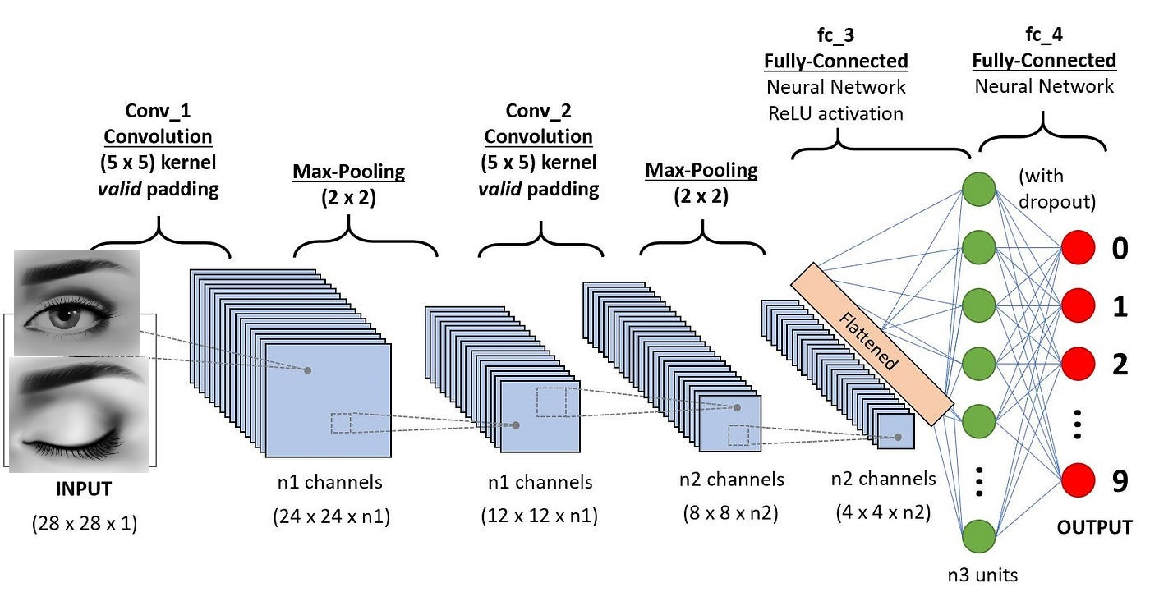

Fig:- proposed model

**MINIMUMSYSTEM REQUIREMENTS**

**HARDWARE REQUIREMENTS**

* PROCESSOR : Pentium i3 Processor
* RAM : 2GB DD RAM
* HARD DISK : 250 GB

**SOFTWARE REQUIREMENTS**

* BACK END : PYTHON
* OPERATING SYSTEM : WINDOWS 7
* IDE : Spyder3/VS code
* Framework : Flask
* FRONT END : HTML, CSS
* DATABASE : MySql