Biggest_element_array.js
const array = [115,5,40,8,145];
let largest = array[0];

array.forEach(element => {
if (element > largest) {
largest = element;
}
});
console.log("Largest element:", largest);
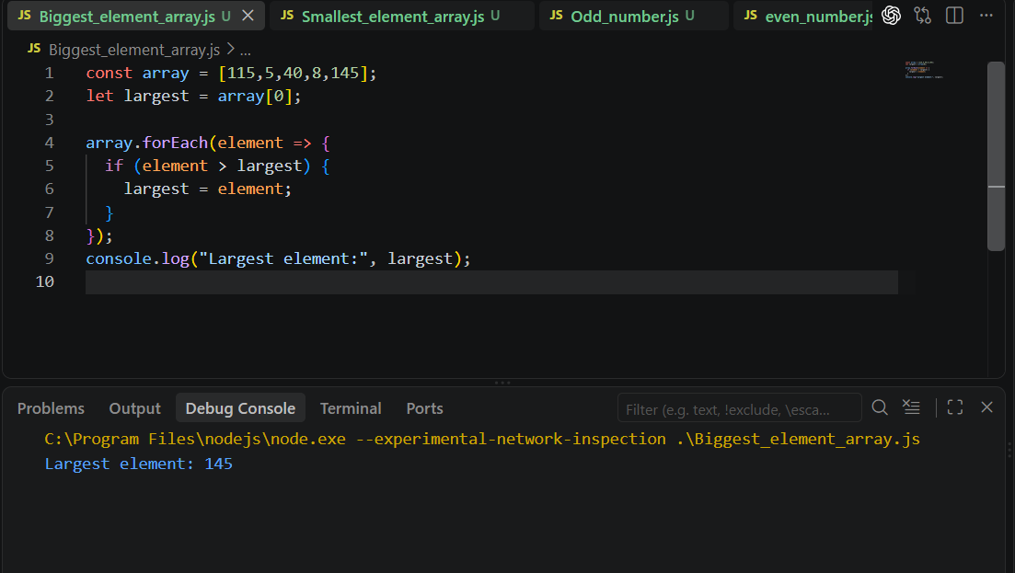

Smallest_element_array.js

const array = [115,5,40,8,145];
let smallest = array[0];

array.forEach(element => {
if (element < smallest) {
smallest = element;
}
});
console.log("Smallest element:", smallest);

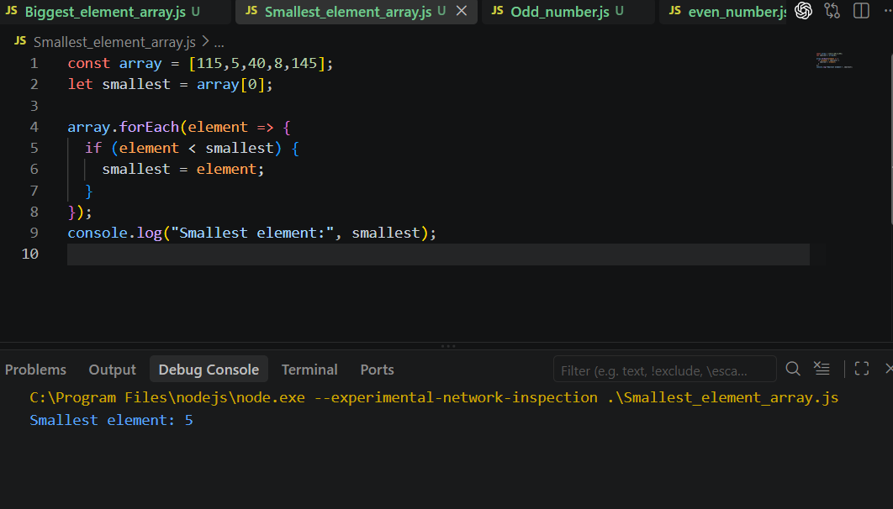

Odd_numbers_array.js
const array = [1, 2, 3, 4, 5, 6, 7, 8, 9, 10];

for (let i = 0; i < array.length; i++) {
if (array[i] % 2 !== 0) {
console.log(array[i]);
}
}
console.log("Odd numbers in the array:", array.filter(num => num % 2 !== 0));

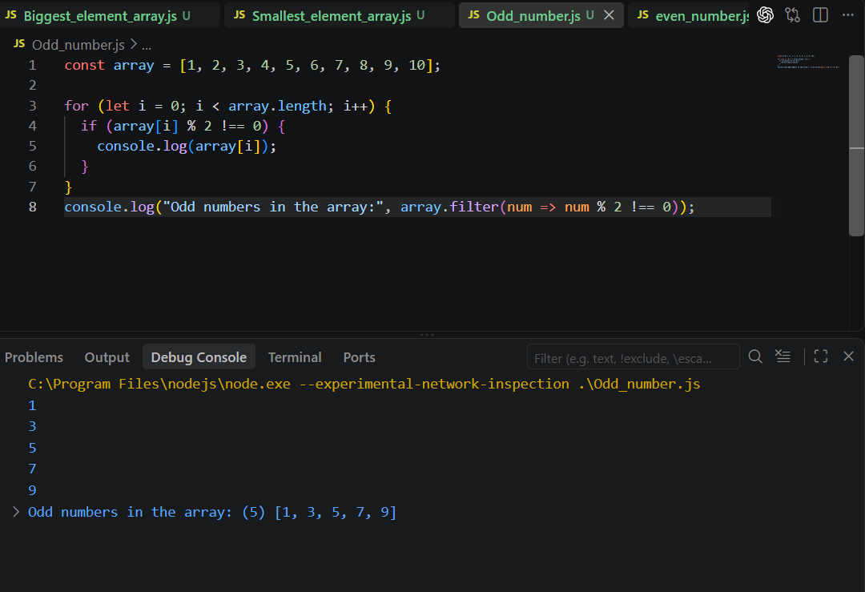

Even_numbers_array.js
const array = [1, 2, 3, 4, 5, 6, 7, 8, 9, 10];

for (let i = 0; i < array.length; i++) {
if (array[i] % 2 == 0) {
console.log(array[i]);
}
}
console.log("Even numbers in the array:", array.filter(num => num % 2 == 0));
