Steps to set up and run Blockchain based test player

Prerequisites to run Nethirium API

1. Make sure you have installed the following softwares in your system and visual studio 2017.

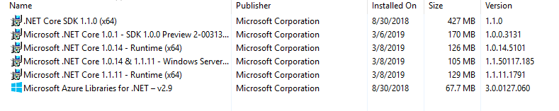

1. Open the Application [DontNetApplicationAPI].
2. Build and run the API to ensure everything is running upfront.

Prerequisites to run Solidity contracts

1. Install and update VSCode for the latest updates.
2. Install the following solidity language support, solidity debugger and solidity extensions

Name: Solidity Language Support

Id: kodebox.solidity-language-server

Description: A language server for Solidity language

Version: 0.1.6

Publisher:Kodebox

Link: <https://marketplace.visualstudio.com/items?itemName=kodebox.solidity-language-server>

Name: Solidity Debugger

Id: hosho.solidity-debugger

Description: Debugger for Solidity smart contracts - powered by the Meadow testing and development tool suite

Version: 0.2.1

Publisher: Meadow

Link: <https://marketplace.visualstudio.com/items?itemName=hosho.solidity-debugger>

Name: solidity

Id: juanblanco.solidity

Description: Ethereum Solidity Language for Visual Studio Code

Version: 0.0.42

Publisher: Juan Blanco

VSMarketplacs

Link: <https://marketplace.visualstudio.com/items?itemName=JuanBlanco.solidity>

1. Install ganache-cli
   1. npm install -g ganache-cli
2. Run ganache-cli in command prompt as a administrator.
3. Open Solidity App[SolidityContractsApp] in VS code.
4. To compile :
   1. press ctrl+shift+p ,
   2. Type compile in > terminal search bar
   3. Enter
   4. Bin folder is generated.
5. To deploy
   1. In terminal : truffle.cmd deploy --reset --network ganache
   2. Check transactions in ganache-cli.
6. Copy and paste the contract address(Assessment’s address),contract ABI(in bin folder) and host URL with of ganache-cli to appplication.json file in our API.
7. Copy and paste any of the account address to home.html[User Address]

from ganache-cli

10 . Run clientapp and check for the transaction in ganache-cli