AIM:Design an automatic night lighting sytem.

a.Below 50% value of full brightness all leds constantly on.

b.above 50% value of full brightness only one led will on.

Circuit Diagram:

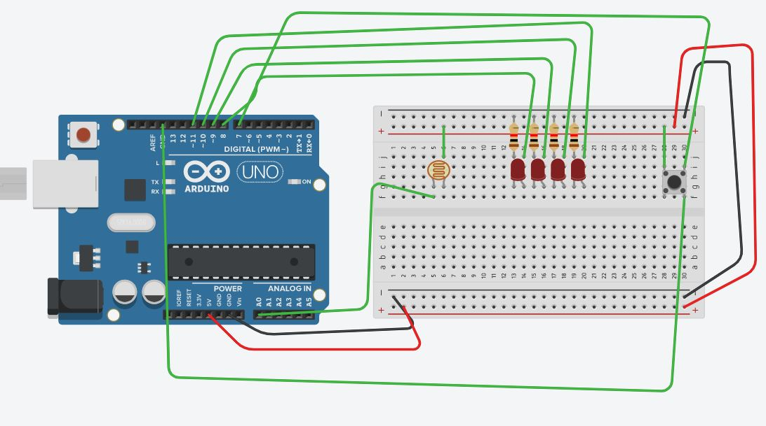

Concept used:

1.Arduino is used for whole task,it plays main role in this task.

2.Light dependent resistor is used.

3.switch is used to on leds.

4.Leds are use for lighting.

5.Void setup,loop,if condition is used for implementation of program.

Learning And Observations:

1.I leant how to connect circuits and what the pins I have to use.

2.I learnt what the purspose of sensor.

3. I leant what the purpose of arduino

4.I observed how Arduino will in this task.

5.I observed that connections I made properly or not.

6.I learnt components in ardunio.

**Problems and trouble shooting:**

1.While making circuit connection some wrong connections I found and I corrected immediately.

2.while compling the program I got some error I resolved it my own.

Precautions:

1.Attach USB carefully.

2.Connect the wires very carefully.

3.Once USB cable has been inserted then ardunio will not be touched with bare hands.

Learning Outcomes:

1.I learnt how to connect the wires to breadboard and ardunio.

2.I learnt how to use LDR and brightness control by using switch.