**Keycloak Document**

Once you've installed Keycloak, you'll need an administrator account to serve as a super admin. This super admin account comes with full permissions to manage Keycloak. You can use this account to access the Keycloak Admin Console, where you can create realms, manage users, and register applications that will be secured by Keycloak.

### 1. Creating a Administrator account on the local host

If your server is accessible from the localhost, then perform these steps.

Procedure

1. In a web browser, go to the [http://localhost:8080](http://localhost:8080/) URL.
2. Enter username , password and password confirmation

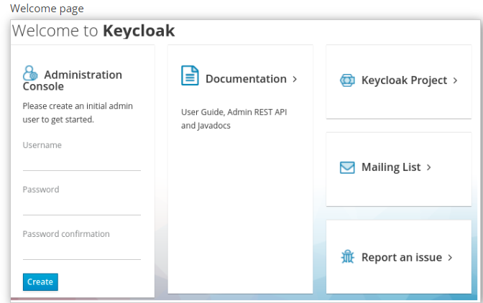

3 . Click on create

4. Click on Administrator console(This will redirect on login page)

2. Configuring realms

Once you have an administrative account for the Admin Console, you can configure realms. A realm is a space where you manage objects, including users, applications, roles, and groups. A user belongs to and logs into a realm. One Keycloak deployment can define, store, and manage as many realms as there is space for in the database.  
  
  
  
(2.1) Loging here by

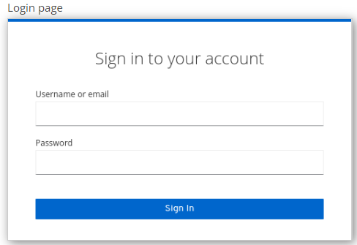

Enter the username and password you created on the Welcome Page or the add-user-keycloak script in the bin directory. This action displays the Admin Console.

A page similar to the following is displayed.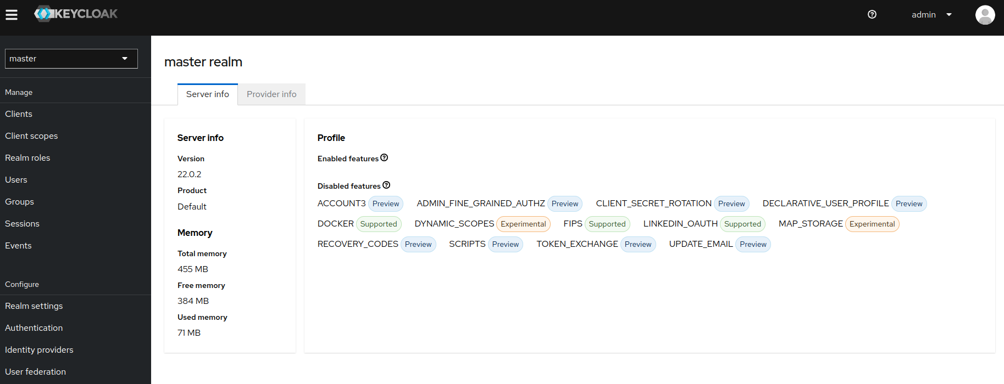

### 3. Creating a realm

You create a realm to provide a management space where you can create users and give them permissions to use applications.  
  
 (3.1) Point to the top of the left pane.

(3.2) Click **Create Realm**.

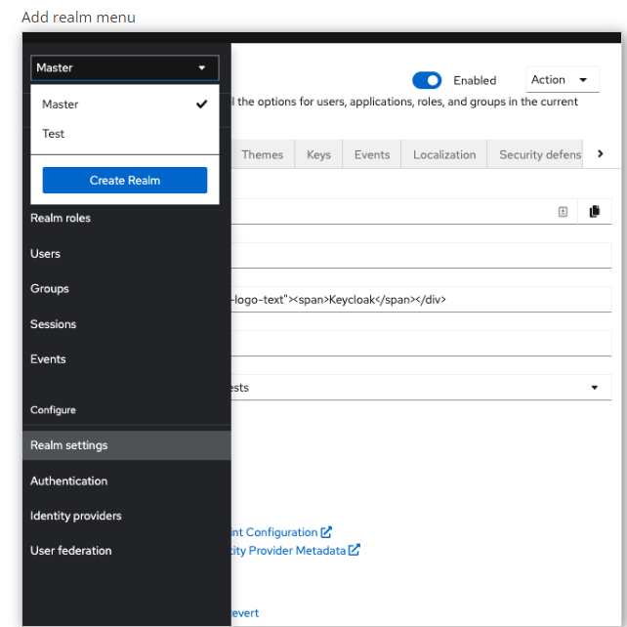

(3.3) Enter the name for the realm.

(3.4) Click **Create**.

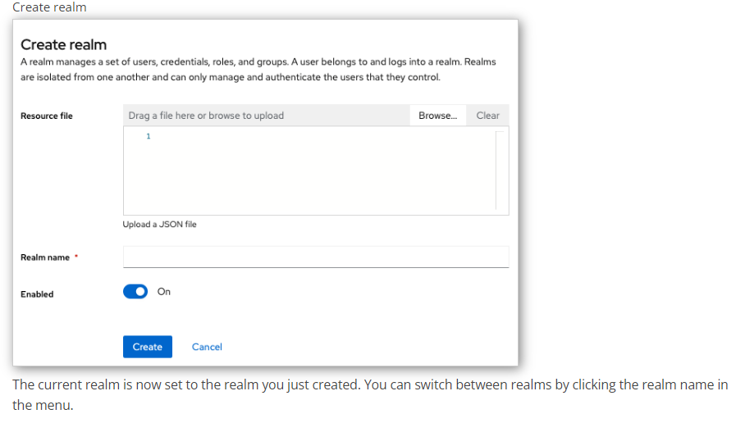

### 4. Creating a client application

The first step to enable Keycloak Authorization Services is to create the client application that you want to turn into a resource server.

Procedure

(4.1) Select Client menu

* 1. Click on Create client

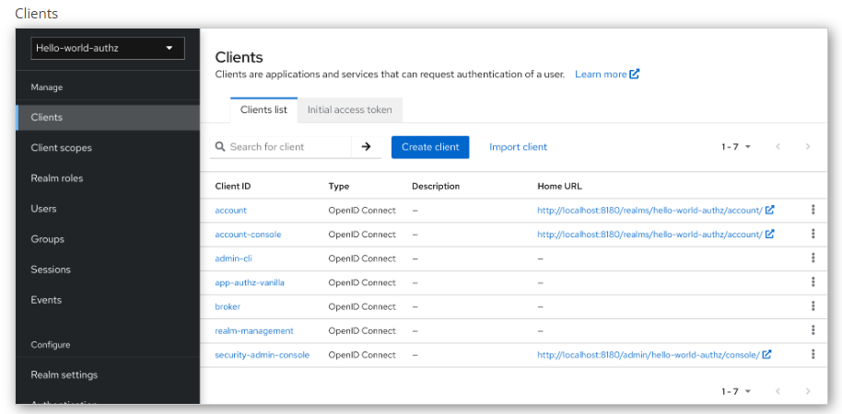

On this page  
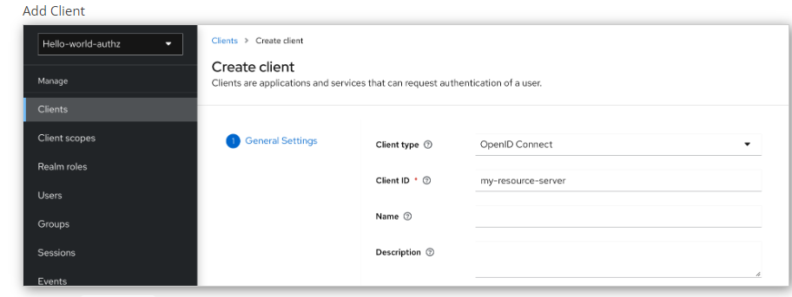

Type the Client ID of the client. For example, *my-resource-server*.

* 1. Click **Next**.
  2. Toggle **Client authentication** to ON.
  3. Click **Save**.  
       
     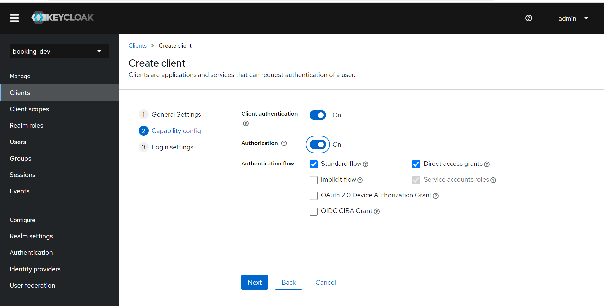

**Now all clients will be show .We can see a page similar to the following is displayed**

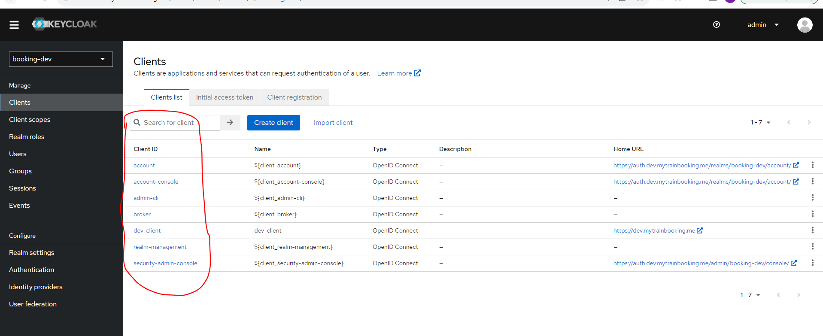

Inside Client Section select your created client, As I am selecting dev-Client then a page similar to the following is displayed

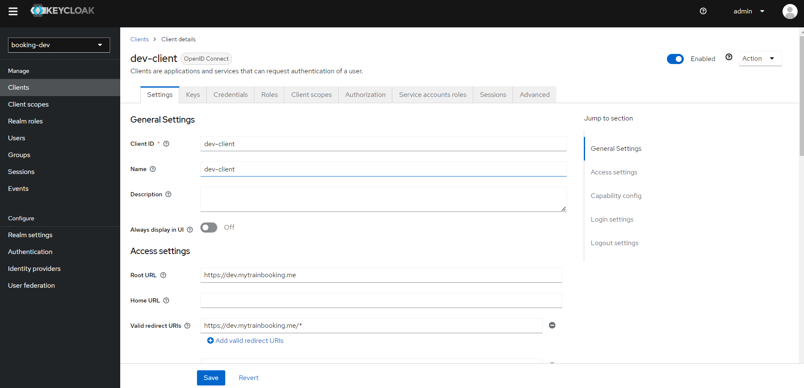

5.Role Creation for client

A Roles tab is displayed for this client. Click the **ROLES** tab and a page similar to the following is displayed:

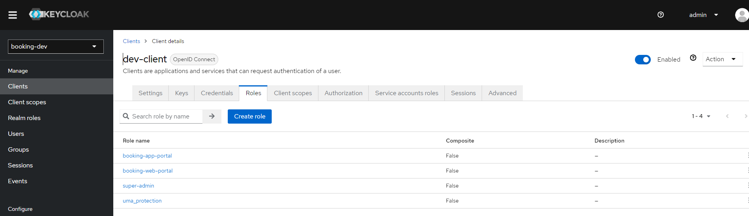

(5.1) Click on Create role

Web page

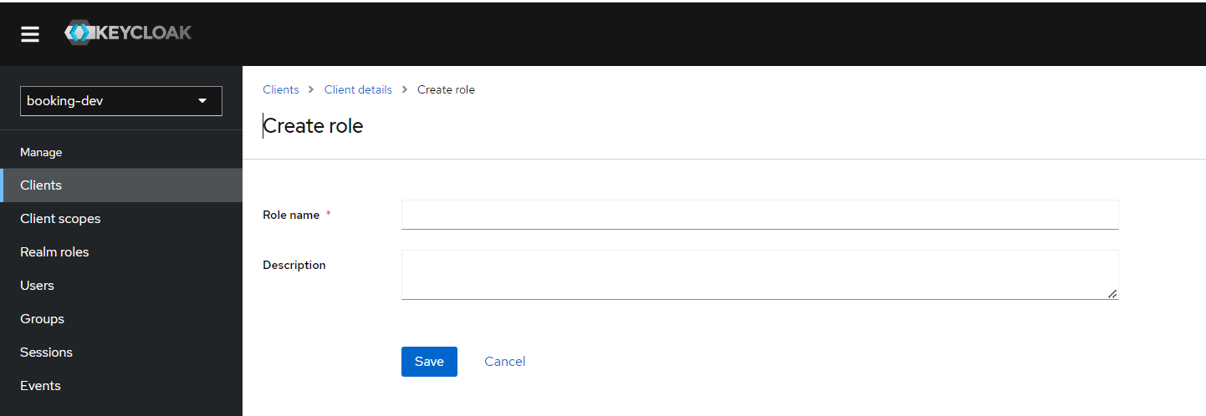

Enter Role name and Description then click on save .  
(**you can repeat this process for create multiple role**)

### 6. Set Authorization for Selected client

* 1. Click on **Authorization**  tab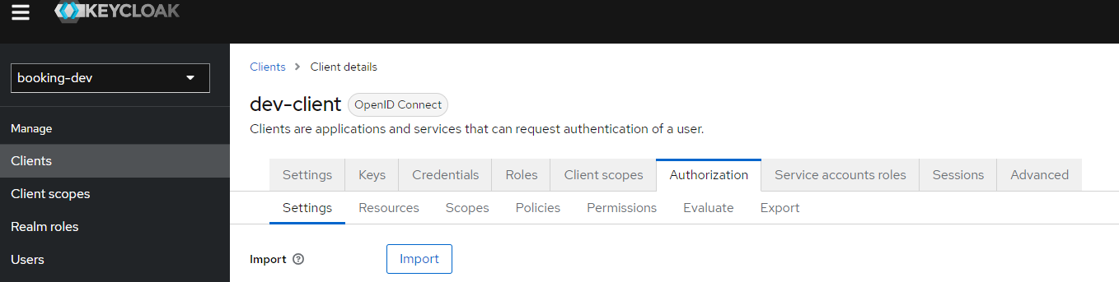

A Authorization tab is displayed for this client . Authorization page similar to the following is displayed. Authorization tab contain multiple tab also.

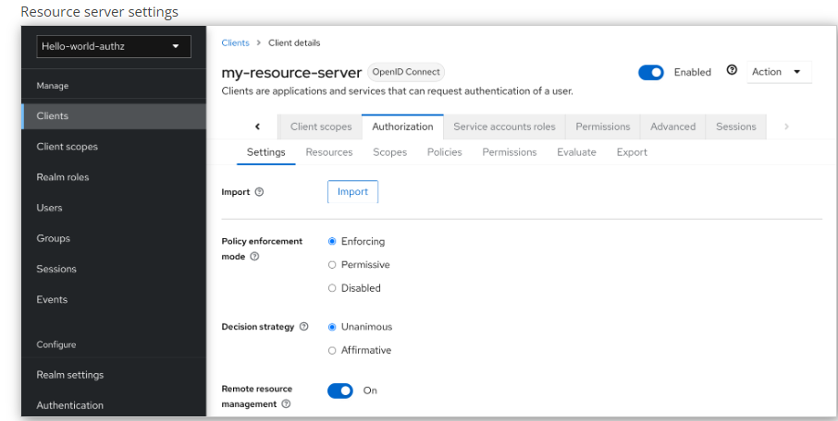

The Authorization tab contains additional sub-tabs covering the different steps that you must follow to actually protect your application’s resources. Each tab is covered separately by a specific topic. Here is a quick description about each one:

* **Settings**

General settings for your resource server. For more details about this page see the [Resource Server Settings](https://www.keycloak.org/docs/latest/authorization_services/index.html" \l "resource_server_settings) section.

* **Resource**

From this page, you can manage your application’s [resources](https://www.keycloak.org/docs/latest/authorization_services/index.html" \l "_resource_overview).

* **Authorization Scopes**

From this page, you can manage [scopes](https://www.keycloak.org/docs/latest/authorization_services/index.html" \l "_resource_overview).

* **Policies**

From this page, you can manage [authorization policies](https://www.keycloak.org/docs/latest/authorization_services/index.html" \l "_policy_overview) and define the conditions that must be met to grant a permission.

* **Permissions**

From this page, you can manage the [permissions](https://www.keycloak.org/docs/latest/authorization_services/index.html" \l "_permission_overview) for your protected resources and scopes by linking them with the policies you created.

* **Evaluate**

From this page, you can [simulate authorization requests](https://www.keycloak.org/docs/latest/authorization_services/index.html" \l "_policy_evaluation_overview) and view the result of the evaluation of the permissions and authorization policies you have defined.

* **Export Settings**

From this page, you can [export](https://www.keycloak.org/docs/latest/authorization_services/index.html" \l "_resource_server_import_config) the authorization settings to a JSON file.

### 7. Create a resource

### (7.1) Click on Create resource

After clicked on Create resource ,A page similar to the following is displayed.

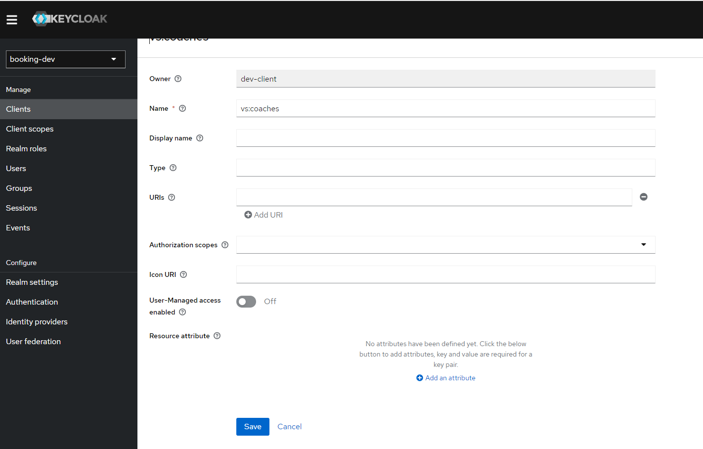

(7.2) Enter the name of resource  
(7.3) select required authorization scope (Frist we need to create scope ,I mentioned below how to create resource)

(7.4 ) click on save

8. Creating Scope

(8.1) Click on Create authentication  scope

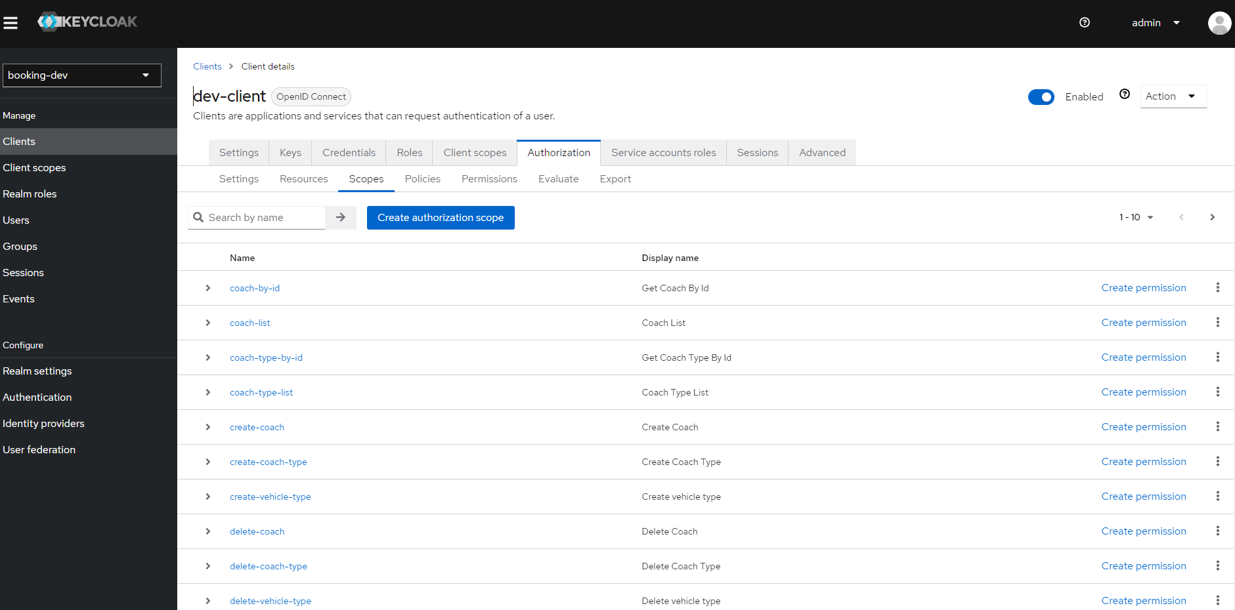

After clicked on A page similar to the following is displayed.

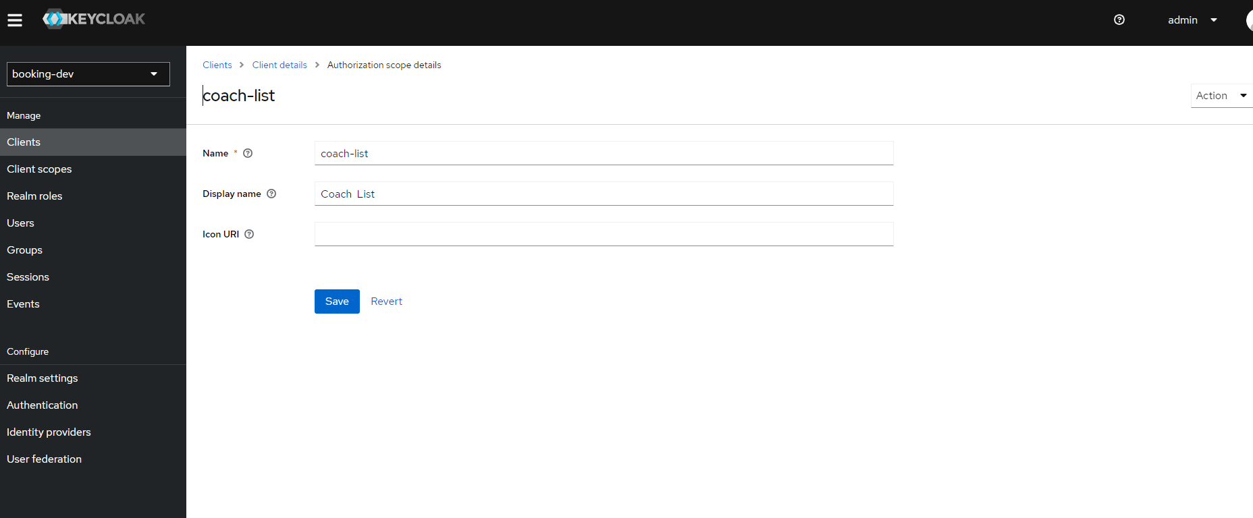  
  
(8.2) Enter the Name and Display Name of the Scope.

9. Creating policy for resource and scope

(9.1) Click on Policies tab

A page similar to the following is displayed

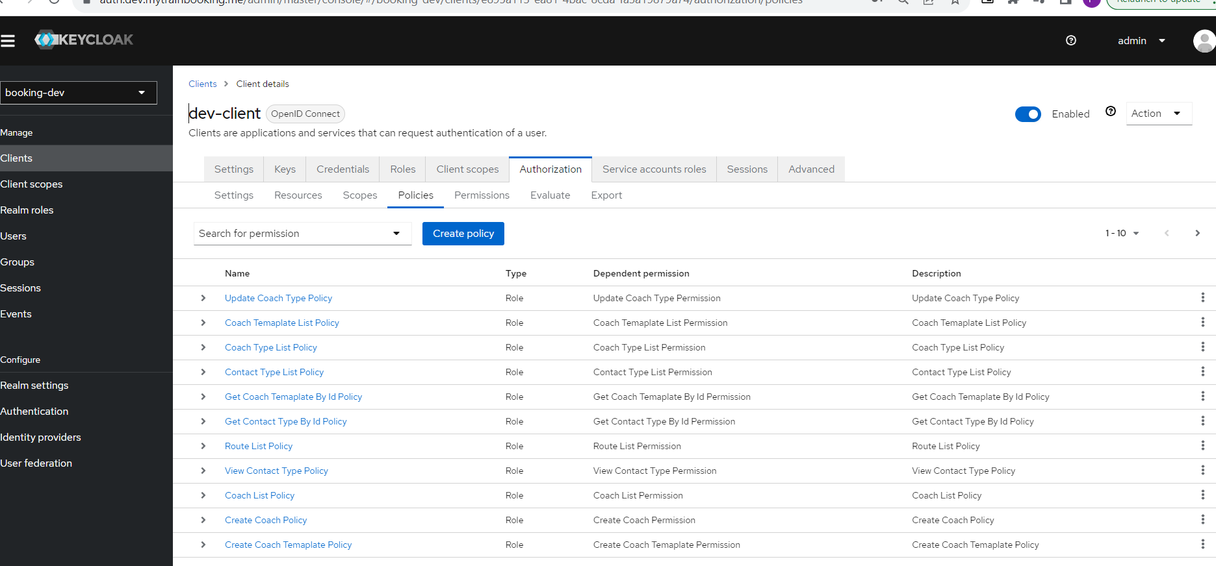

(9.2) Click on Create policy  
A pop up similar to the following is displayed  
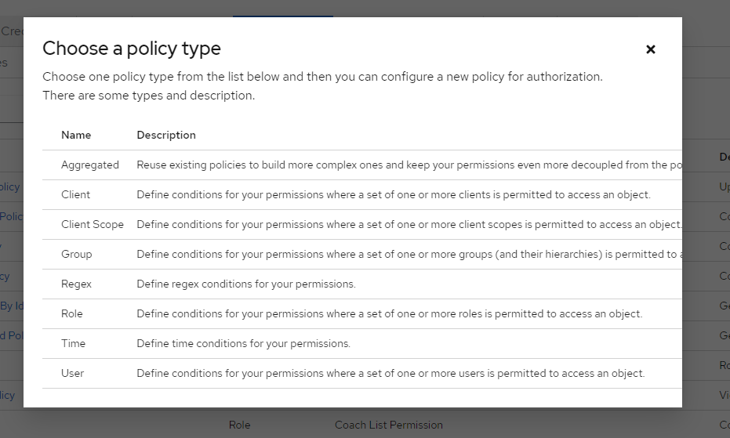

### You can create multiple type of policy

**We are creating** **Role-based policy**

Select Role

A page similar to the following is displayed 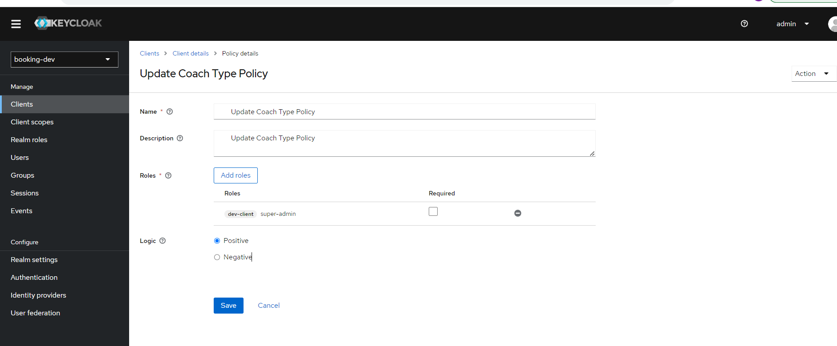

#### When creating a role-based policy, you can specify a specific role as Required. When you do that, the policy will grant access only if the user requesting access has been granted ****all**** the ****required**** roles. Both realm and client roles can be configured as such. Configuration

* **Name**

A human-readable and unique string describing the policy. A best practice is to use names that are closely related to your business and security requirements, so you can identify them more easily.

* **Description**

A string containing details about this policy.

* **Realm Roles**

Specifies which **realm** roles are permitted by this policy.

* **Client Roles**

Specifies which **client** roles are permitted by this policy. To enable this field must first select aClient.

* **Logic**

The logic of this policy to apply after the other conditions have been evaluated.

### Positive and negative logic

Policies can be configured with positive or negative logic. Briefly, you can use this option to define whether the policy result should be kept as it is or be negated.

For example, suppose you want to create a policy where only users **not** granted with a specific role should be given access. In this case, you can create a role-based policy using that role and set its **Logic** field to **Negative**. If you keep **Positive**, which is the default behavior, the policy result will be kept as it is.

## 11. Managing permissions

A permission associates the object being protected and the policies that must be evaluated to decide whether access should be granted.

After creating the resources you want to protect and the policies you want to use to protect these resources, you can start managing permissions. To manage permissions, click the **Permissions** tab when editing a resource server.

(11.1) Click on Permissions tab  
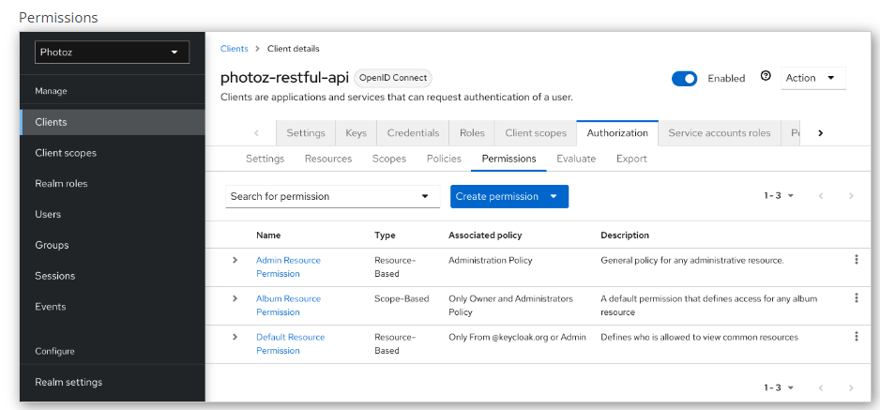

Permissions can be created to protect two main types of objects:

* **Resources**
* **Scopes**

To create a permission, select the permission type you want to create from the item list in the upper right corner of the permission listing. The following sections describe these two types of objects in more detail.

### Creating scope-based permissions

A scope-based permission defines a set of one or more scopes to protect using a set of one or more authorization policies. Unlike resource-based permissions, you can use this permission type to create permissions not only for a resource, but also for the scopes associated with it, providing more granularity when defining the permissions that govern your resources and the actions that can be performed on them.To create a new scope-based permission, select **Create scope-based permission** from the **Create permission** dropdown.

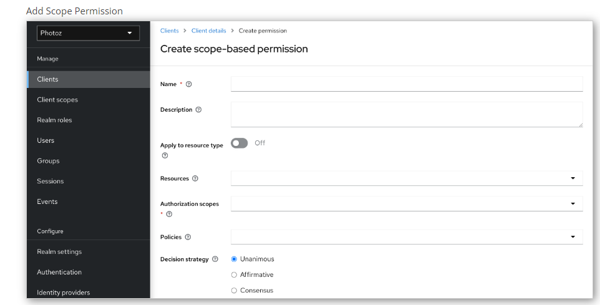

#### Configuration

* **Name**

A human-readable and unique string describing the permission. A best practice is to use names that are closely related to your business and security requirements, so you can identify them more easily.

* **Description**

A string containing details about this permission.

* **Resource**

Restricts the scopes to those associated with the selected resource. If none is selected, all scopes are available.

* **Scopes**

Defines a set of one or more scopes to protect.

* **Policy**

Defines a set of one or more policies to associate with a permission. To associate a policy you can either select an existing policy or create a new one by selecting the type of the policy you want to create.

## 12. Evaluating and testing policies

When designing your policies, you can simulate authorization requests to test how your policies are being evaluated.

You can access the Policy Evaluation Tool by clicking the Evaluate tab when editing a resource server. There you can specify different inputs to simulate real authorization requests and test the effect of your policies.

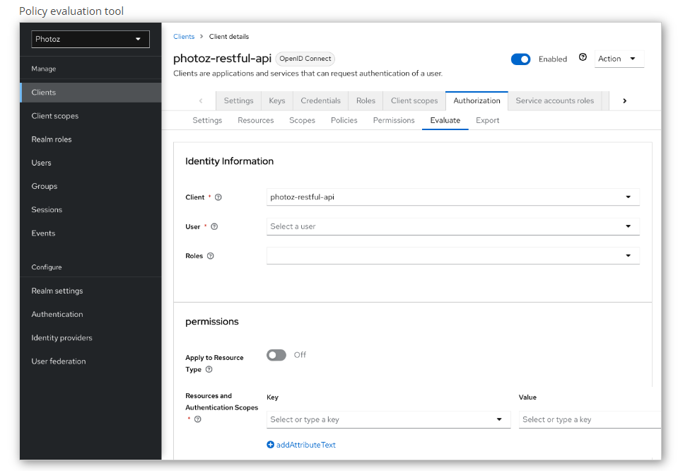

### Providing identity information

The **Identity Information** filters can be used to specify the user requesting permissions.

### Providing contextual information

The **Contextual Information** filters can be used to define additional attributes to the evaluation context, so that policies can obtain these same attributes.

### Providing the permissions

The **Permissions** filters can be used to build an authorization request. You can request permissions for a set of one or more resources and scopes. If you want to simulate authorization requests based on all protected resources and scopes, click-> **Add** without specifying any Resources or Scopes.When you’ve specified your desired values, click -> **Evaluate**.